## The Oregon Trail

Ready to travel 2000 miles across the United States to seek your fortune in Oregon?

You are now, with this faithful web-based replica of the 1990s video game The Oregon Trail. Except for a few AJAX requests at the start and end, this game engine runs entirely on Javascript. Though your journey won’t be quick or easy, gameplay will be.

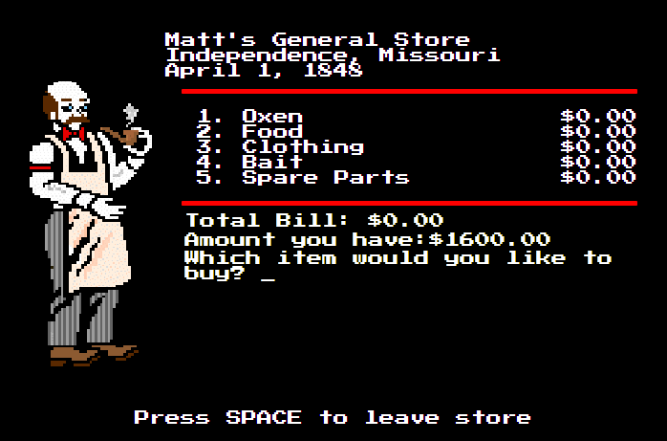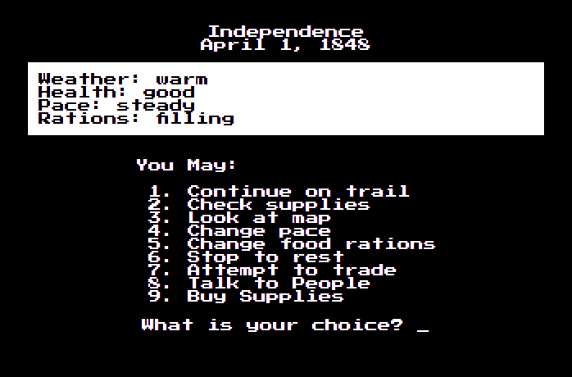Just like old times, use your keyboard to make life-changing decisions. Stock up on supplies at stores. Don’t push your party too hard. If you’re running low on supplies, trade for some.

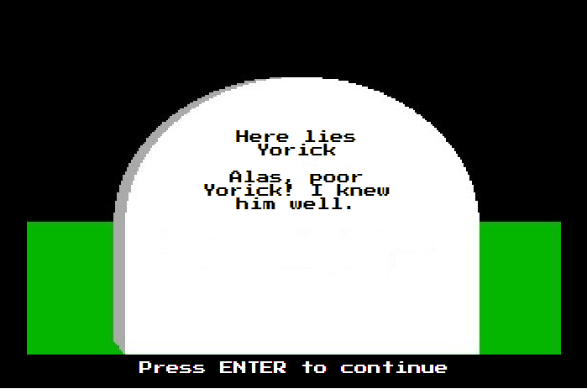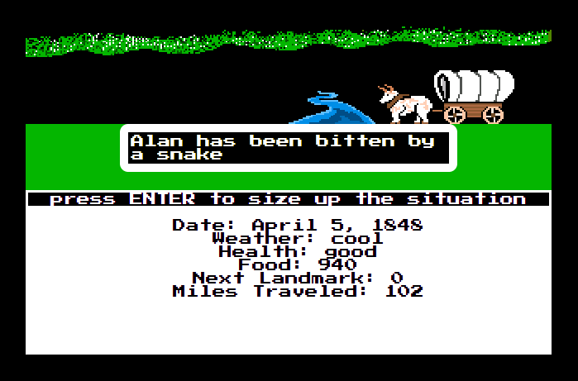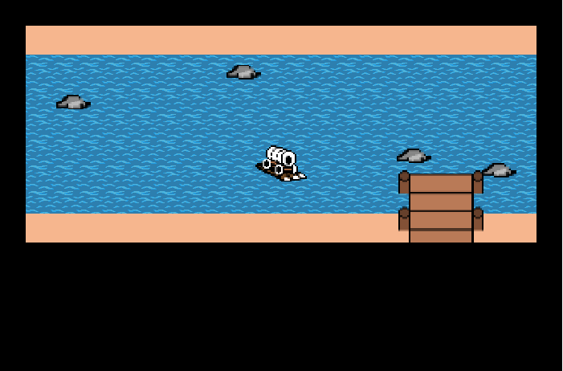The Trail is dangerous! No matter how prepared you are, snakebites, broken axles, and dysentery can occur. But the better you treat your party, the likelier their health will improve. You don’t want to end up a tombstone for future players.

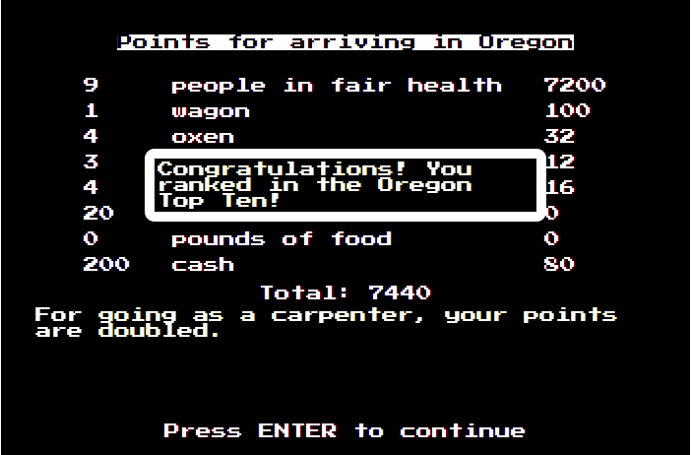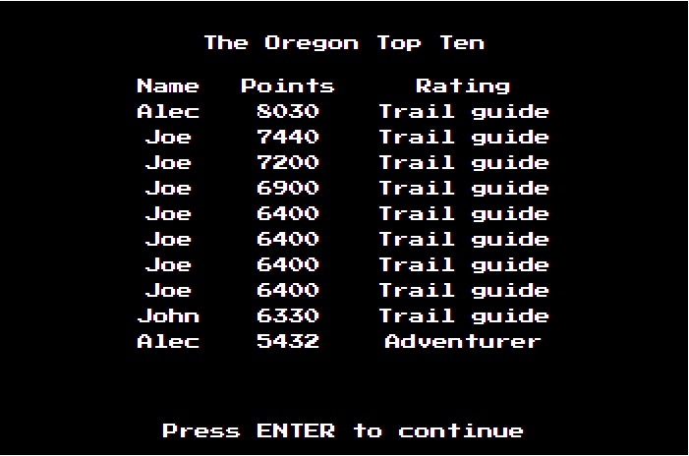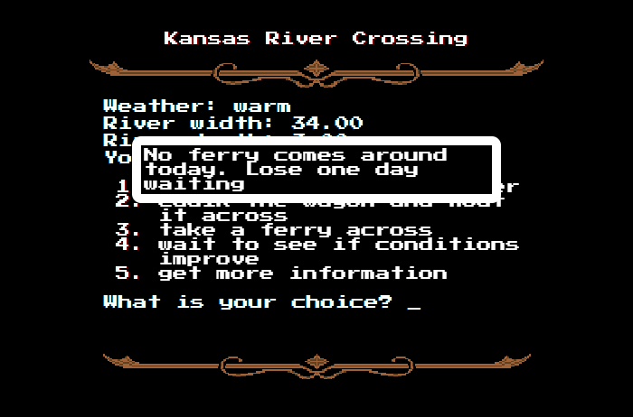Will you ford, float, or ferry your wagon across America’s great rivers? Just like the original game, rivers test your decision-making. But they can also be fun! Players navigate the Dalles River.

Reach Williamette Valley in Oregon and see how your hard work paid off. Perhaps you’ll even make the Oregon Top Ten!