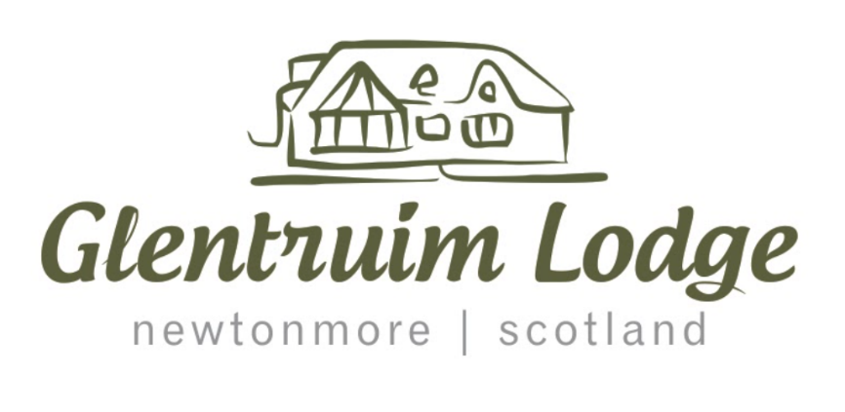

The Keepers Lodge, B&B and Eco Pod is a family run business in Newtonmore, surrounded by the world-renowned views of the Cairngorms. It is most popular among people touring Scotland and hillwalkers. It offers short and long stays at their B&B and eco pod. They also offer exclusive renting of the whole property in summer and over the Christmas and New year period.

They are looking for a friendly, professional website that reflects the welcome guests would receive upon arrival to their home. The website’s main goals are:

* To be the primary place guests’ book to avoid large cuts from booking companies, to maximise bookings, button prompts will be included in all relevant areas on the website that will take users to the booking page.
* To manage expectations and to maintain the business brand throughout, to achieve this we will; show up to date, true to life photos, include all relevant information for staying at Glentruim Lodge, and a meta reel of the guest areas will also be provided.

Users:

* People travelling up and down the A9.
* Hillwalkers.
* IT literate.
* Young professionals
* Age range mid 20’s – mid 30’s.
* Active.
* Tourists – mainly from UK, Europe and US.
* Enjoy outdoors.

Eco Pod guests:

* Mostly millennials.
* Bikers.
* Hillwalkers.
* Active.
* Enjoy outdoors.
* Looking to relax.

Client’s goals:

* Booking to come from website.
* Increase awareness of business.
* To connect to social media sites.
* Give information on local area.
* Give potential guests a good feel for how their stay will be.
* Advertise the Eco Pod and exclusive renting of the lodge.

Users’ goals

* Book a stay at the B&B and Pod.
* Get a good understanding of what to expect.
* Gather information on local area.

Non-functional Requirements:

* Responsive design.
* Accessible.
* Search engine friendly.
* Completed by 1st of June 2021.

Functional requirements:

* An accessible, easy to navigate, attractive website that appeals to target audience.
* Being able to click on images and video to enlarge them – while easily minimising them.
* Live YouTube video – squirrel cam.
* Find location of business and near-by attractions pinned on google map.
* Linking to social media.
* Meta-reel of house and rooms.
* Rooms, breakfast and facilities information.
* Being able to efficiently book a stay using the booking form.
* Contact us chat window, click to call.
* About us information.
* While relevant information on COVID-19 pandemic will be provided on website.

Competition:

Below are some local B&B businesses

<https://www.lagganglamping.co.uk/>

<https://www.rumblie.com/>

<https://www.laggan.com/guest-house-b-and-b.asp>

<https://www.dowerhousenewtonmore.com/accommodation/calder-suite/>

After researching many local B&B’s we were able to see what worked well and made you want to stay on a website, making a booking a lot more likely. This was simplicity, clearly laid out information and attractive images and colours. Many websites were too overloading with information which made it hard to navigate. We will keep these things in mind when in the design phase.

Unique qualities:

* The feel of being in the middle of nowhere while also being a 10-minute drive from the A9 making it a welcomed break for commuters.
* Being situated in a valley with stunning views all round.
* Located close to many activities and walks.
* Exclusive booking of the lodge in summer and winter.

Attracting customers to website:

* The business owners will contact local, relevant website owners to purchase advertising of their property on their page or mutual sharing of links to each other’s pages.
* Advertise property on their social media pages.
* Print off leaflets for local shops and cafes.

Constraints:

* Budget £1000.
* Completion 1 June.