Analog Lab 3:

Experiment2:

Constant Voltage Circuit/ Constant Current Circuit

Differentiator/ Integrator

Date: 2023/09/28

Class: 電機三全英班

Group: Group 11

Name: B103105006 胡庭翊

**Working Project #1 Constant Voltage Circuit**

1. Measurement Data

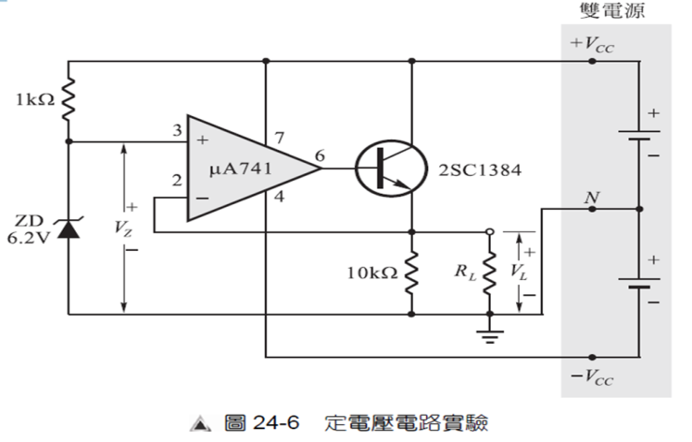

Q: Does remains constant in the following form? A: Yes.

|  |  |  |  |  |
| --- | --- | --- | --- | --- |
|  | 10kΩ | 4.7kΩ | 1kΩ | 470Ω |
|  | 6.29V | 6.28V | 6.28V | 6.28V |
| =6.29V | | | | |

1. Simulation Result

|  |  |  |  |  |
| --- | --- | --- | --- | --- |
|  | 10kΩ | 4.7kΩ | 1kΩ | 470Ω |
|  | 6.2802V | 6.2802V | 6.2802V | 6.2802V |
| =6.2790V | | | | |

1. = 10kΩ: = 6.2802V; = 6.2790V

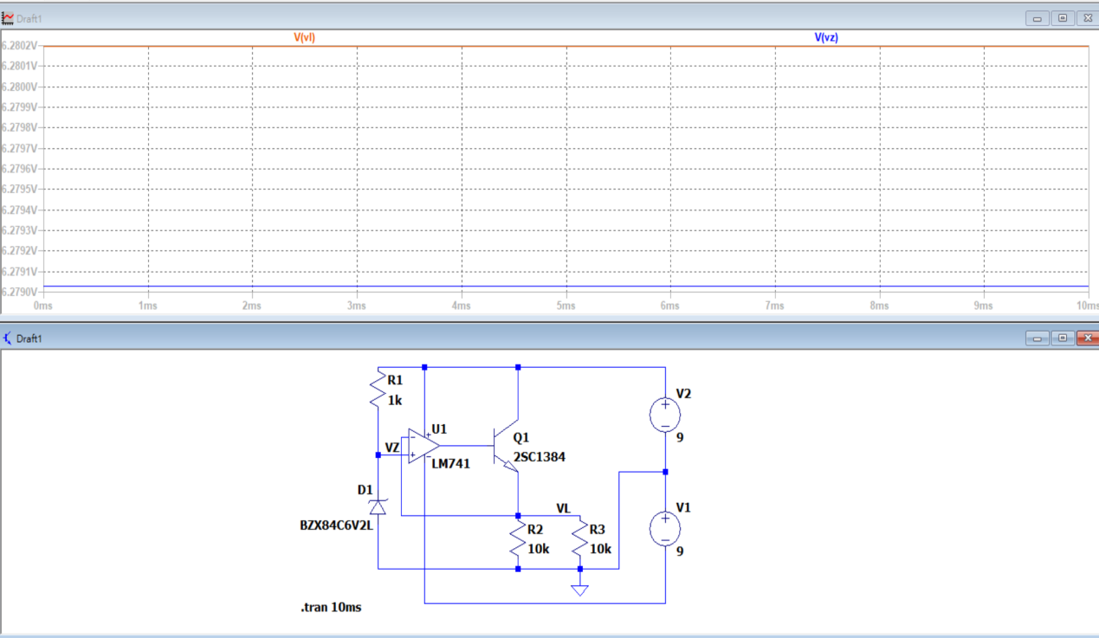

1. = 4.7kΩ: = 6.2802V; = 6.2790V

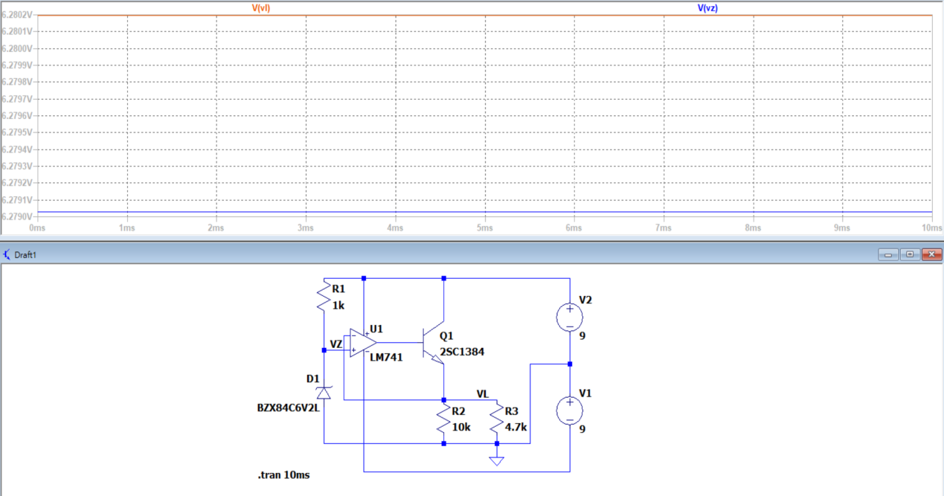

1. = 1kΩ: = 6.2802V; = 6.2790V

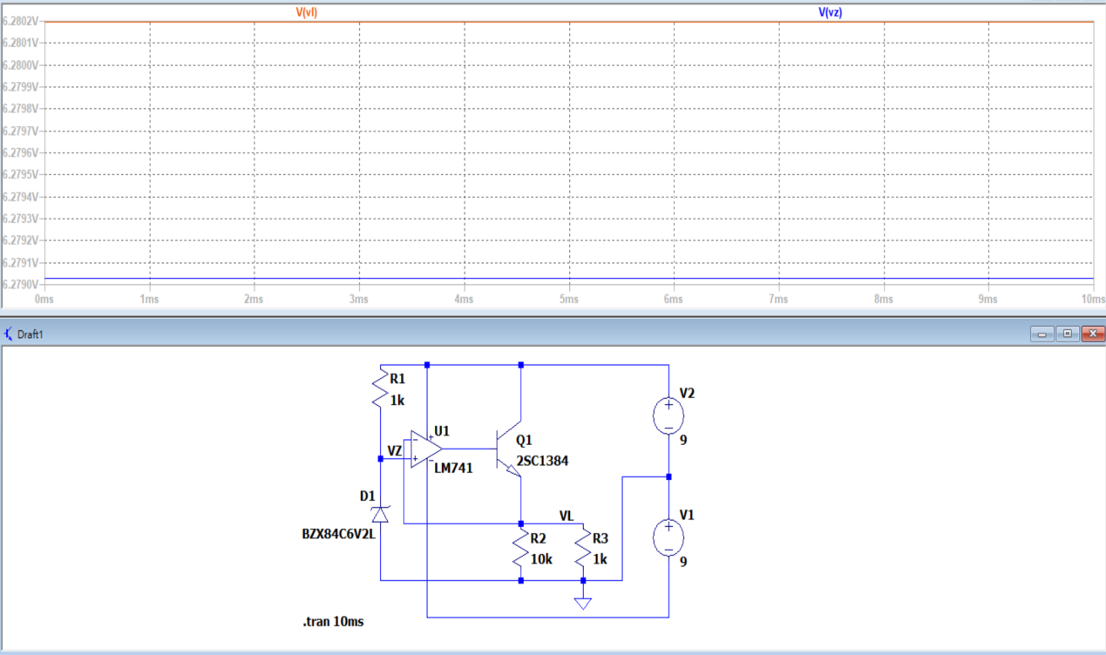

1. = 470Ω: = 6.2802V; = 6.2790V

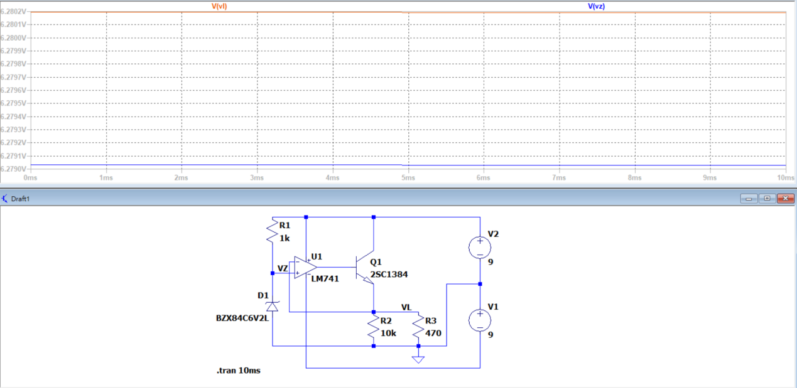

1. Observation and Discussion

Observation:

A Constant voltage circuit can provide a fixed and unchanging voltage to the load, regardless of the load current and resistance.

The basic circuit of this working project is an operational amplifier. Since the voltage at the + input terminal is generated by a zener diode, it results in a stable voltage . Therefore, the output voltage would be

Discussion:

Why

I think the inner resistor inside the opamp might affect the result. Since , might be a bit larger than

**Working Project #2Constant Current Circuit**

1. Measurement Data

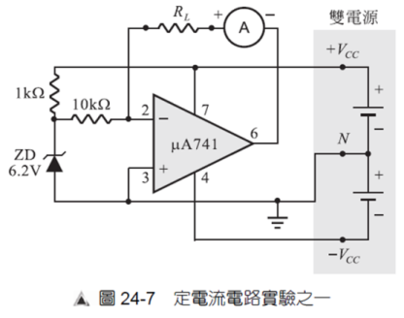

Q: Does remains constant in the following form? A: Yes.

|  |  |  |  |  |  |
| --- | --- | --- | --- | --- | --- |
|  | 0Ω | 100Ω | 470Ω | 1kΩ | 4.7kΩ |
|  | 0.63mA | 0.63mA | 0.63mA | 0.63mA | 0.62mA |

1. Simulation Result

|  |  |  |  |  |  |
| --- | --- | --- | --- | --- | --- |
|  | 0Ω | 100Ω | 470Ω | 1kΩ | 4.7kΩ |
|  | 0.6257mA | 0.6257mA | 0.6257mA | 0.6257mA | 0.6257mA |

* 1. = 0Ω: A = 0.6257mA

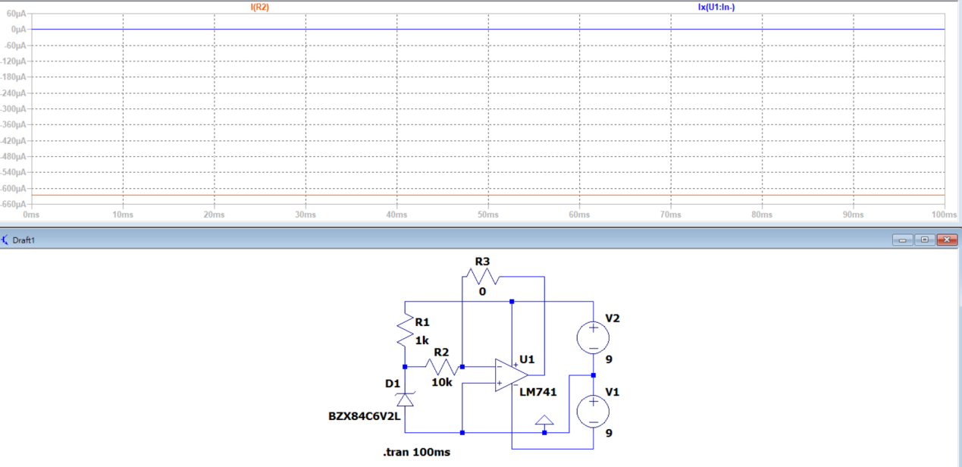

* 1. = 100Ω: A = 0.6257mA

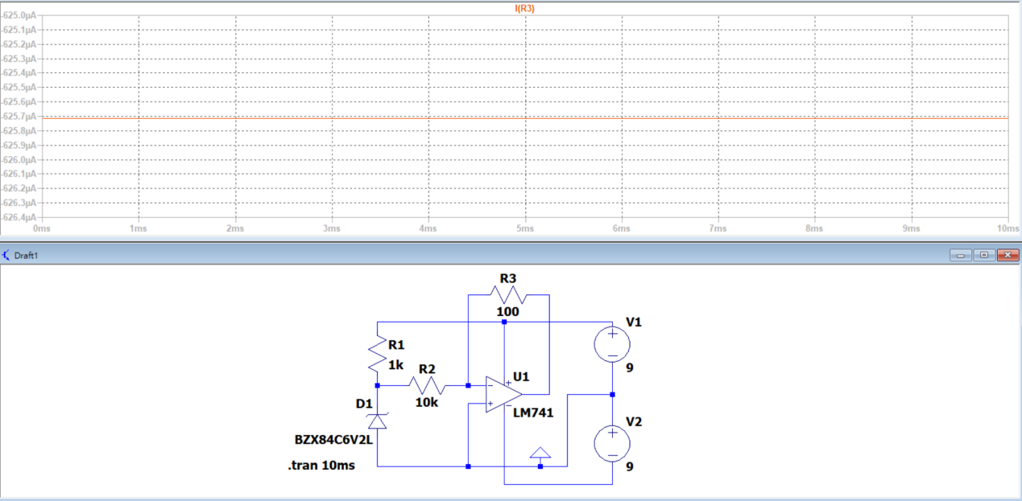

* 1. = 470Ω: A = 0.6257mA

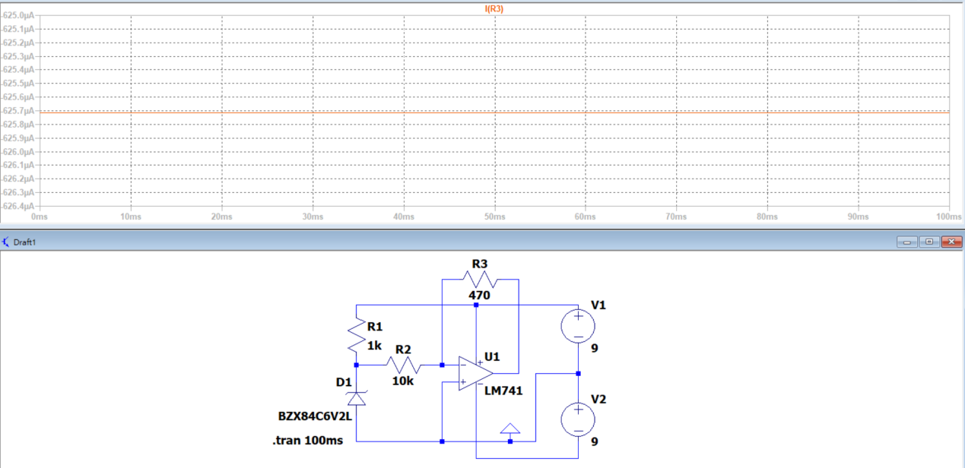

* 1. = 1kΩ: A = 0.6257mA

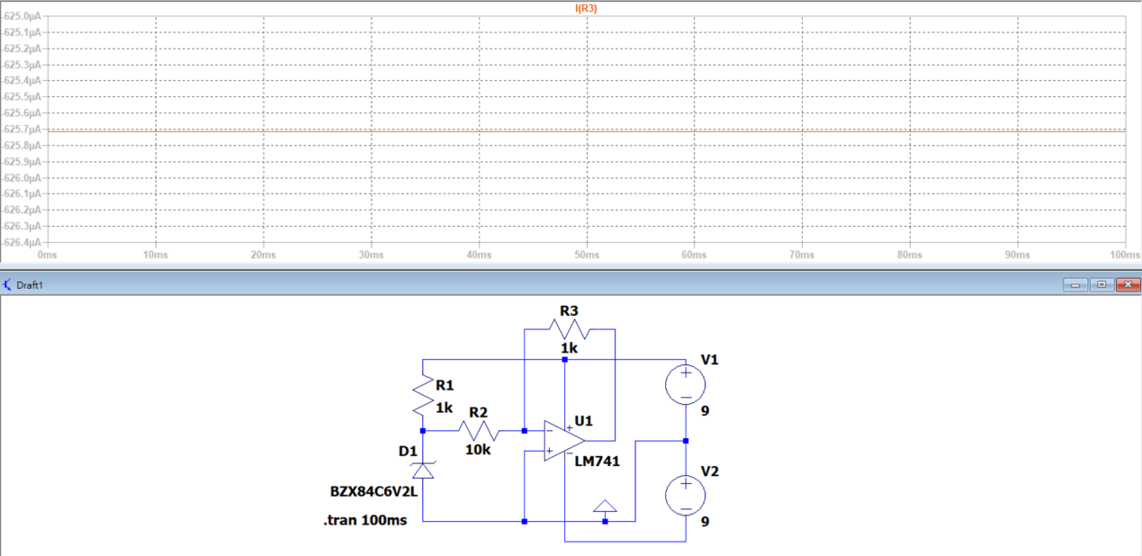

* 1. = 4.7kΩ: A = 0.6257mA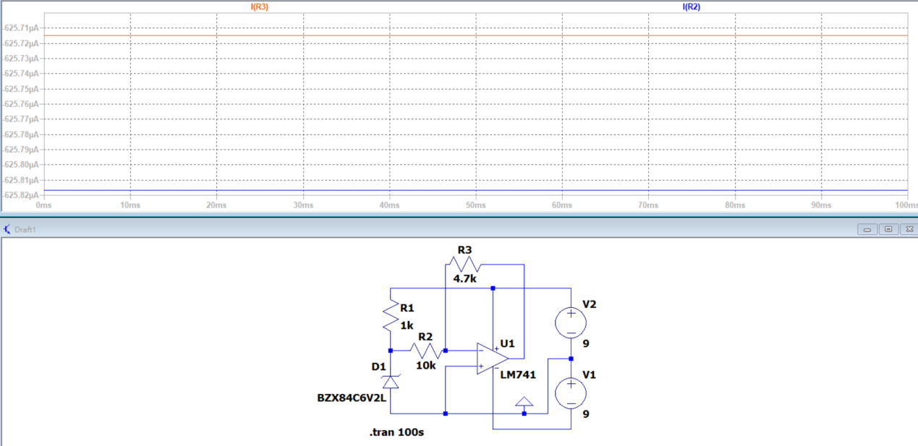

1. Observation and Discussion

Observation:

A constant current circuit can provide a fixed and unchanging current to the load, irrespective of the load resistance. Since the + and the- input terminals of the op-amp are virtually short-circuited, , and since the – terminal is virtually shorted, we get , which is irrelevant to

Discussion:

How to measure the current passing 0Ω resistor?

By KCL, I can measure the current by simply measure the current that will pass or will be passed from

1. Measurement Data

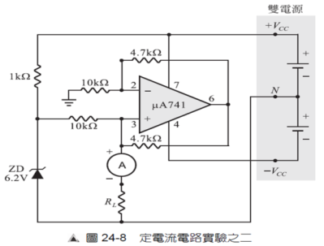

Q: Does remains constant in the following form? A: Yes.

|  |  |  |  |  |  |
| --- | --- | --- | --- | --- | --- |
|  | 0Ω | 100Ω | 470Ω | 1kΩ | 4.7kΩ |
|  | 0.63mA | 0.62mA | 0.63mA | 0.63mA | 0.63mA |

1. Simulation Result

|  |  |  |  |  |  |
| --- | --- | --- | --- | --- | --- |
|  | 0Ω | 100Ω | 470Ω | 1kΩ | 4.7kΩ |
|  | 0.626mA | 0.626mA | 0.626mA | 0.626mA | 0.626mA |

* 1. = 0Ω: A = 0.626mA

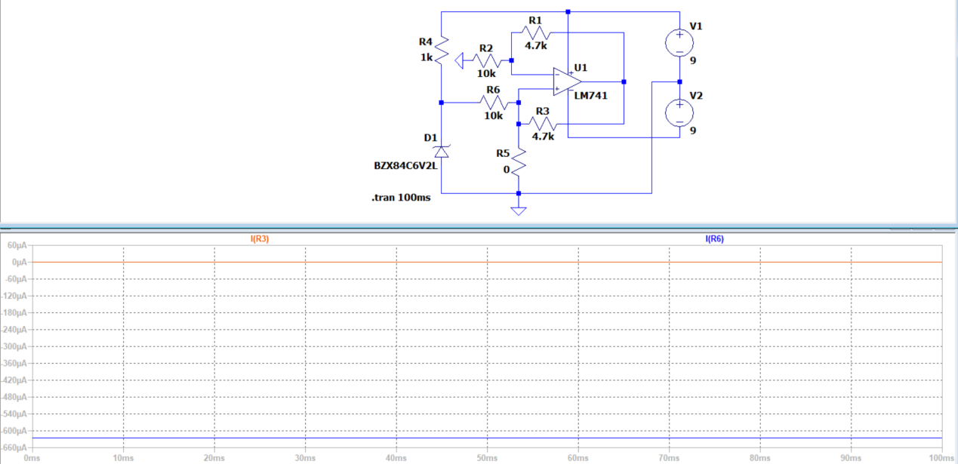

* 1. = 100Ω: A = 0.626mA

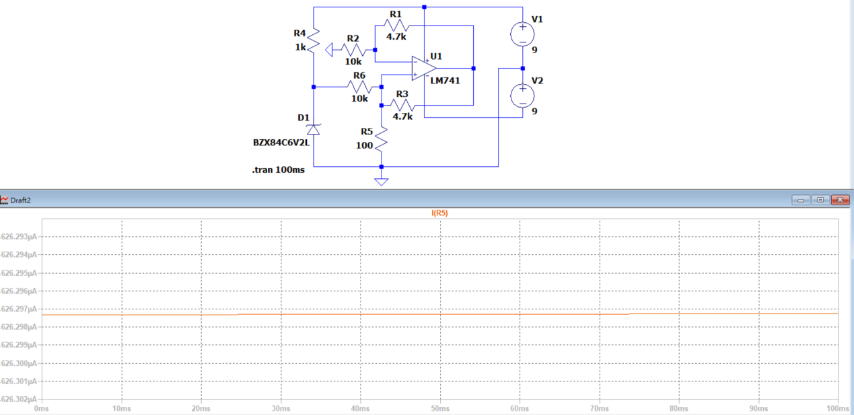

* 1. = 470Ω: A = 0.626mA

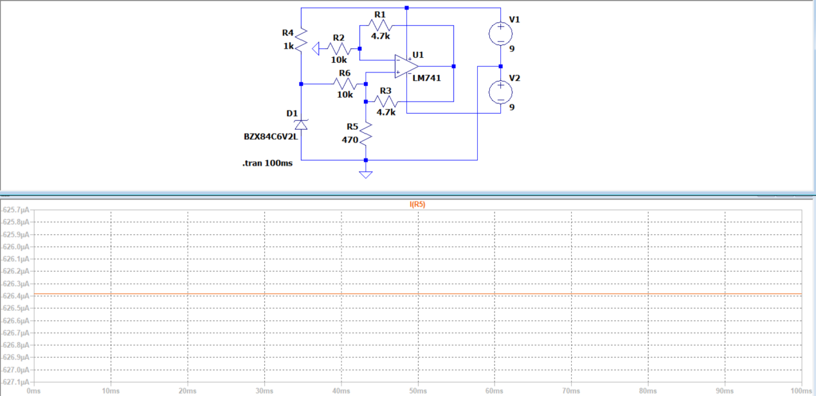

* 1. = 1kΩ: A = 0.626mA

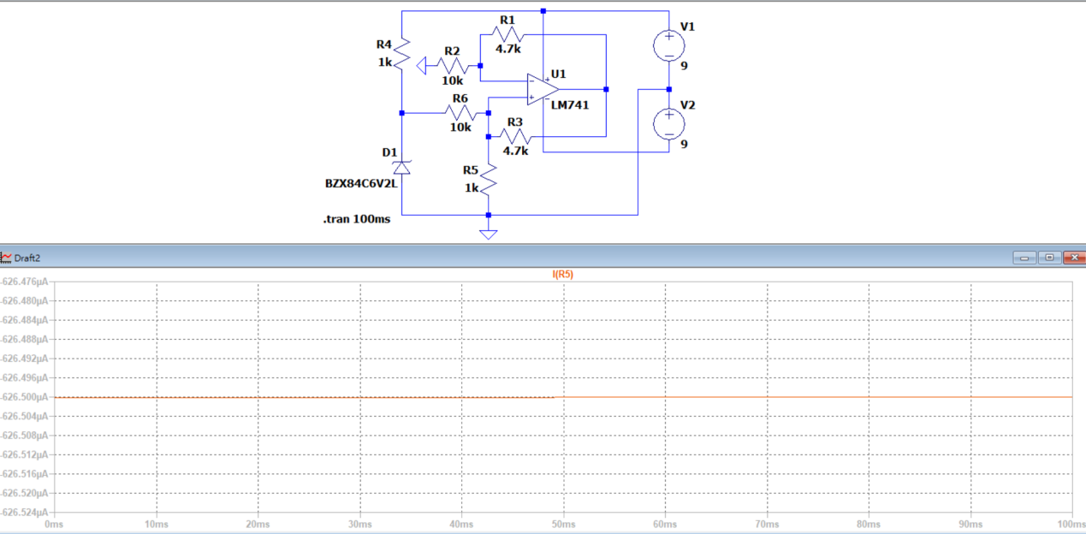

* 1. = 4.7kΩ: A = 0.627mA

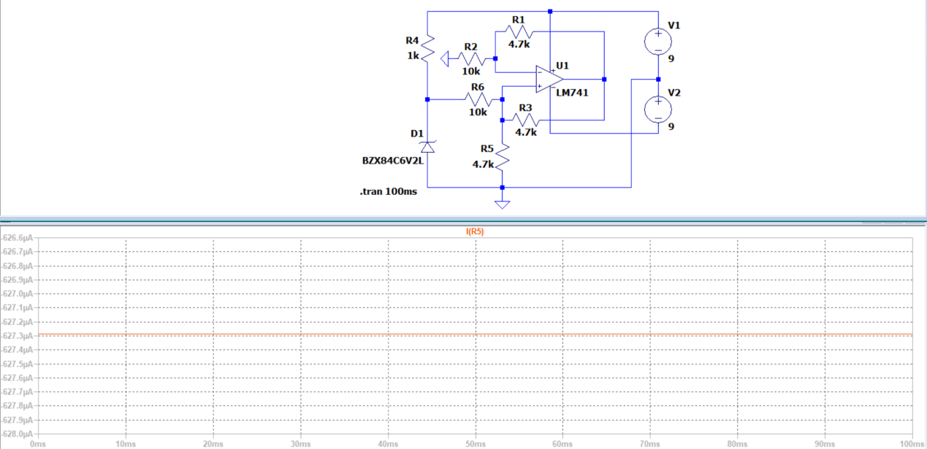

1. Observation and Discussion

Observation:

* + - 1. Since , and ,

so .

* + - 1. Then, ,

.

* + - 1. The input terminal + of the op-amp is virtually-shorted, hence,

Therefore,

Lastly, we can get , which tells that is irrelevant to

**Working Project #3Differentiator**

1. Measurement Data
   1. Square wave

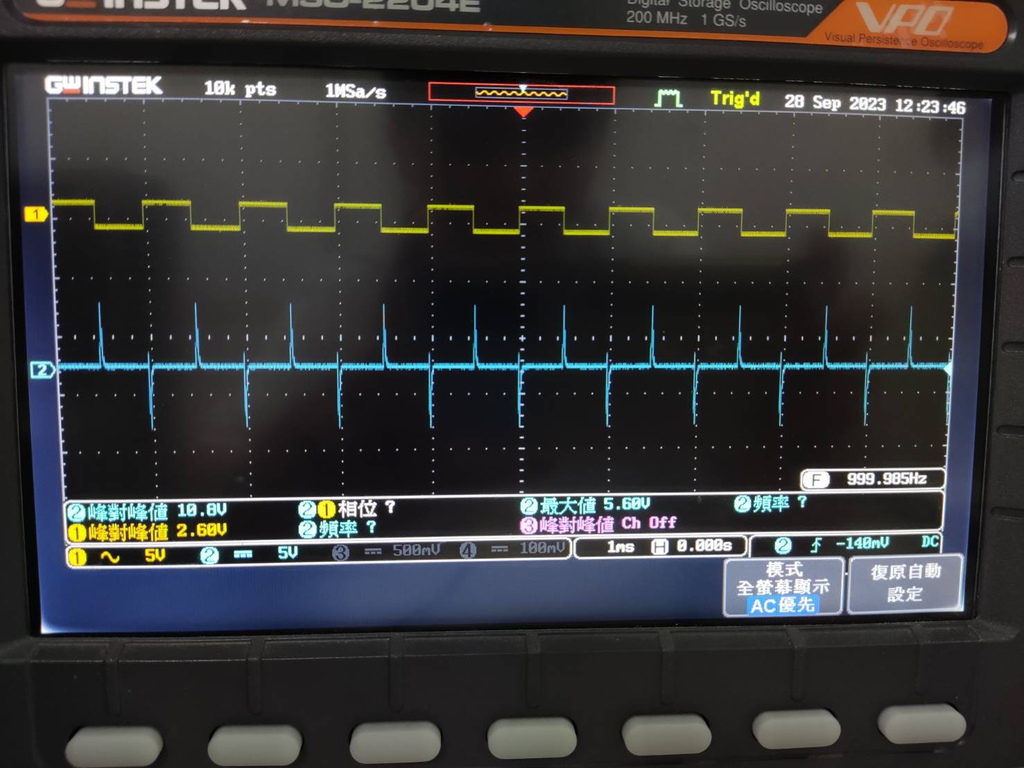

(yellow): vertical = 5V/ DIV; horizontal = 1 ms/ DIV

(blue): vertical = 5V/ DIV; horizontal = 1 ms/ DIV

* 1. Sine wave

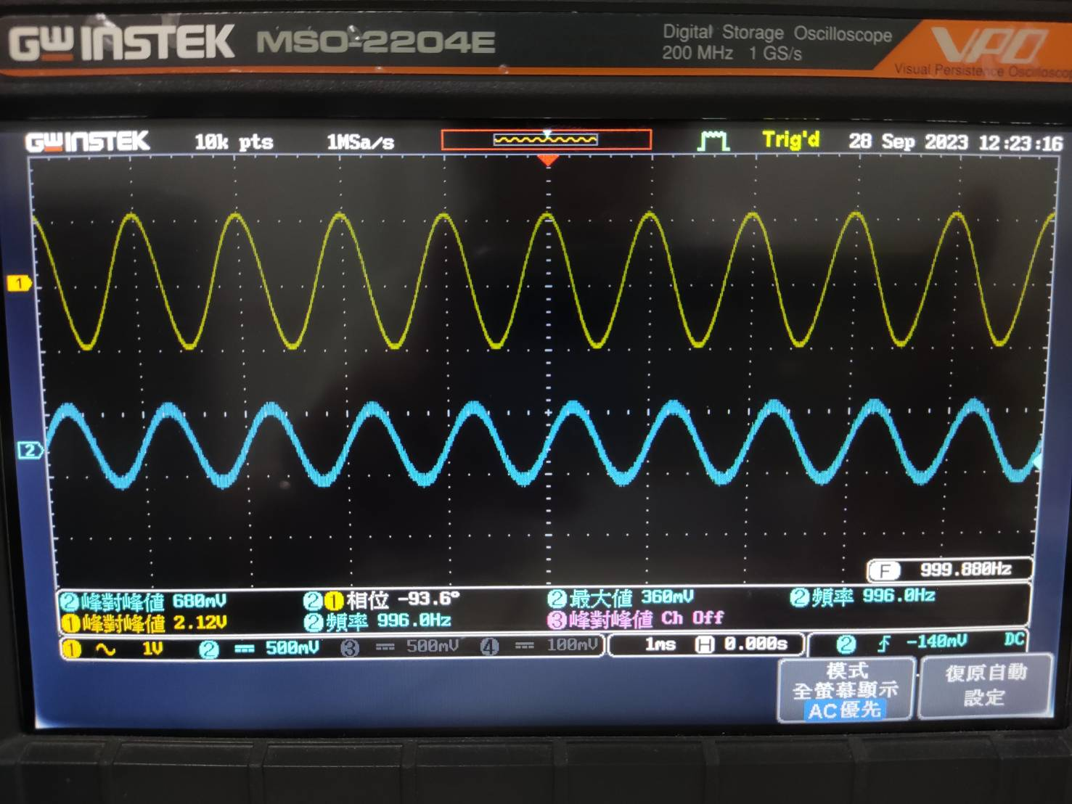

(yellow): vertical = 5V/ DIV; horizontal = 1 ms/ DIV

(blue): vertical = 5V/ DIV; horizontal = 1 ms/ DIV

From the waveform, we can tell that lags behind .

1. Simulation Result
   1. Square wave

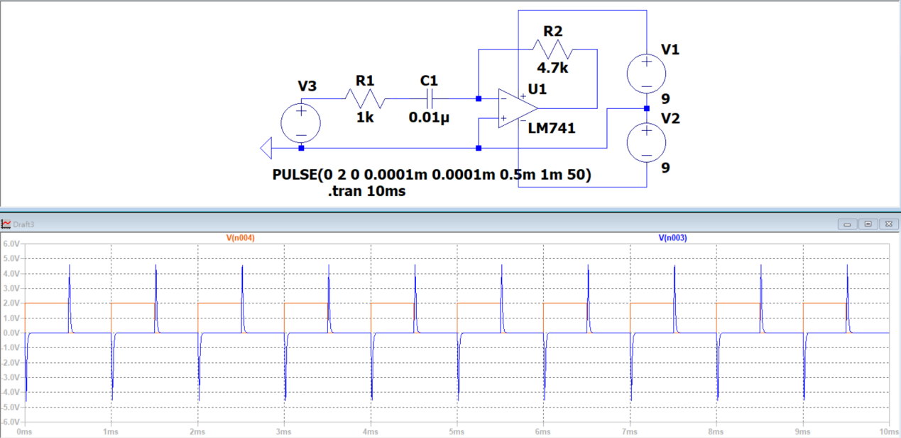

(yellow): vertical = 1V/ DIV; horizontal = 1 ms/ DIV

(blue): vertical = 1V/ DIV; horizontal = 1 ms/ DIV

* 1. Sine wave

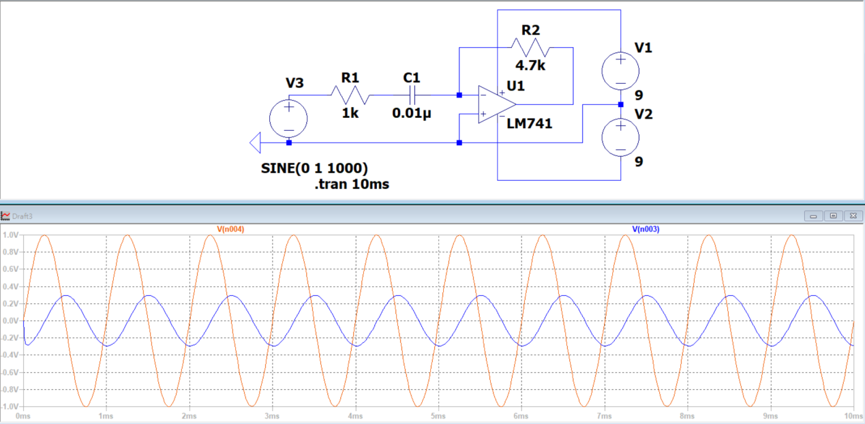

(yellow): vertical = 0.2V/ DIV; horizontal = 1 ms/ DIV

(blue): vertical = 0.2V/ DIV; horizontal = 1 ms/ DIV

From the waveform, we can tell that lags behind .

1. Observation and Discussion

This working project is called a differentiator. This circuit uses an operational amplifier to cleverly create a differentiator. The differentiator has the following characteristics:

1. It uses a capacitor as the input component and a resistor as the output component.
2. The output voltage is proportional to the rate of change of the input signal voltage.
3. The RC time constant should not be too large; otherwise, the output voltage may saturate the operational amplifier, causing the peaks of the output waveform to be flattened and losing its differentiating effect.
4. Non-sinusoidal waves passing through the differentiator circuit will result in different waveforms; for example, a square wave will become a pulse wave.
5. Sinusoidal waves passing through the differentiator circuit will not change their waveform; they will only introduce a phase shift.

**Working Project #4Integrator**

1. Measurement Data
   1. Square wave

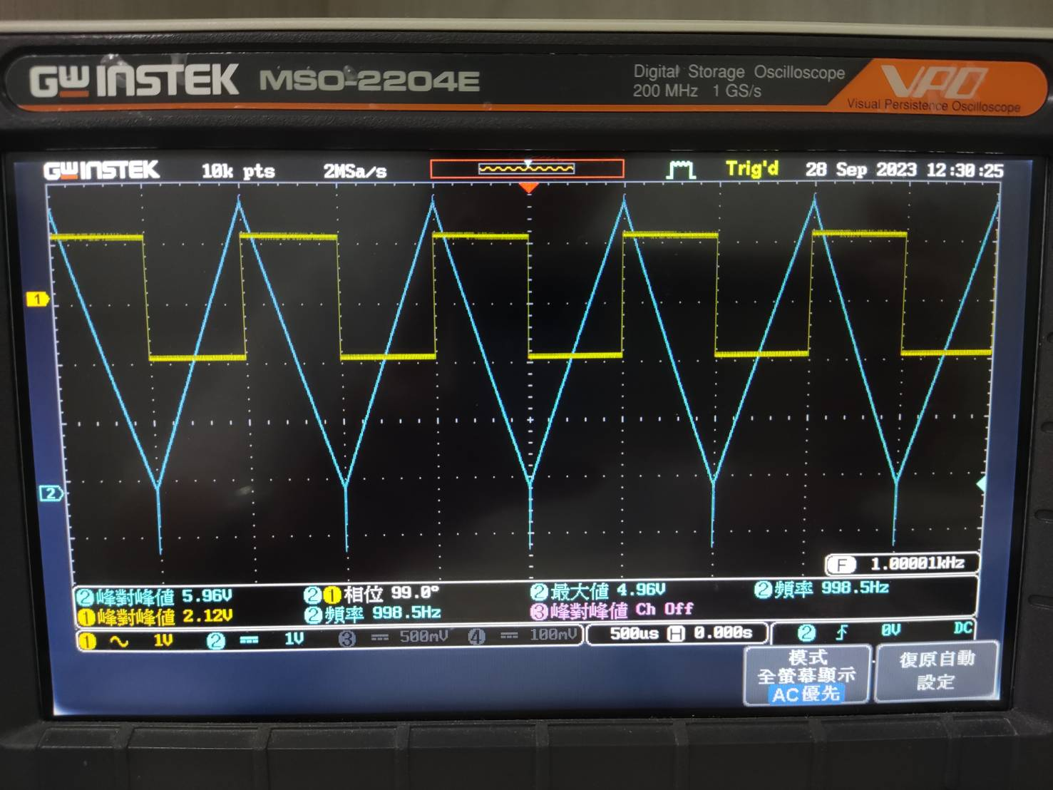

(yellow): vertical = 1V/ DIV; horizontal = 0.5 ms/ DIV

(blue): vertical = 1V/ DIV; horizontal = 0.5 ms/ DIV

* 1. Sine wave

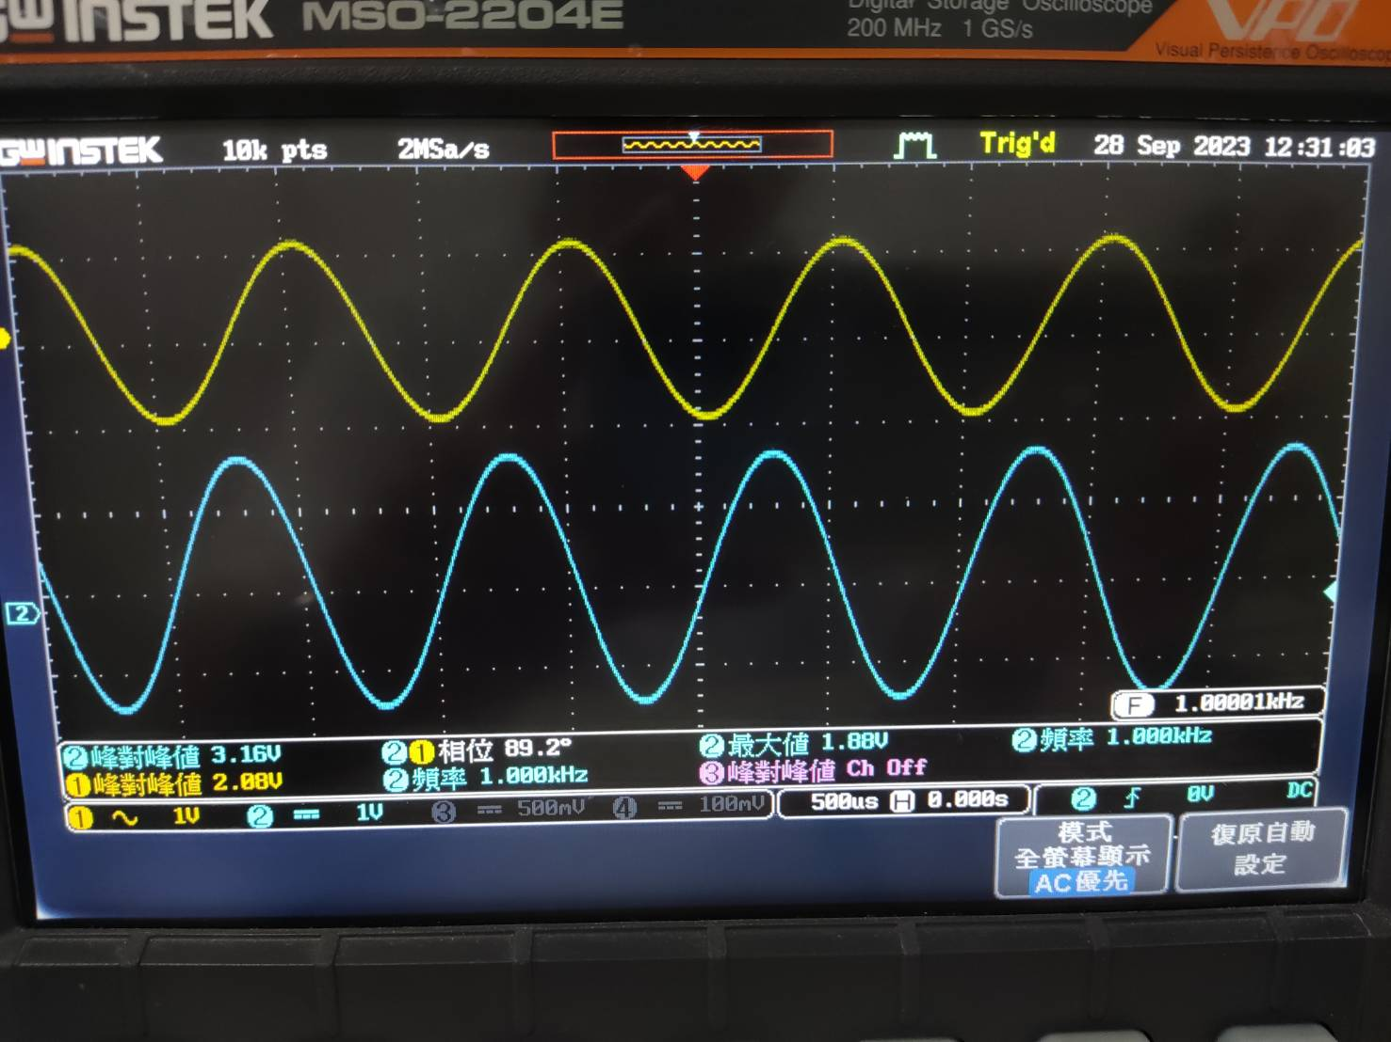

(yellow): vertical = 1V/ DIV; horizontal = 0.5 ms/ DIV

(blue): vertical = 1V/ DIV; horizontal = 0.5 ms/ DIV

From the waveform, we can tell that leads .

1. Simulation Result
   1. Square wave

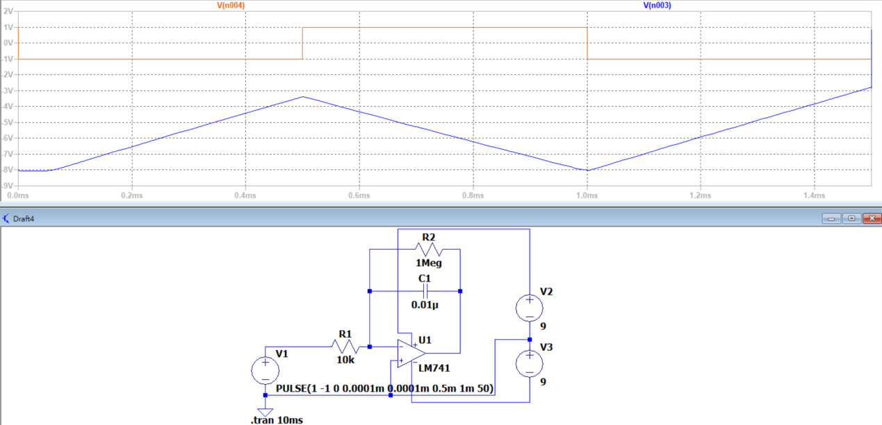

(yellow): vertical = 1V/ DIV; horizontal = 0.2 ms/ DIV

(blue): vertical = 1V/ DIV; horizontal = 0.2 ms/ DIV

* 1. Sine wave

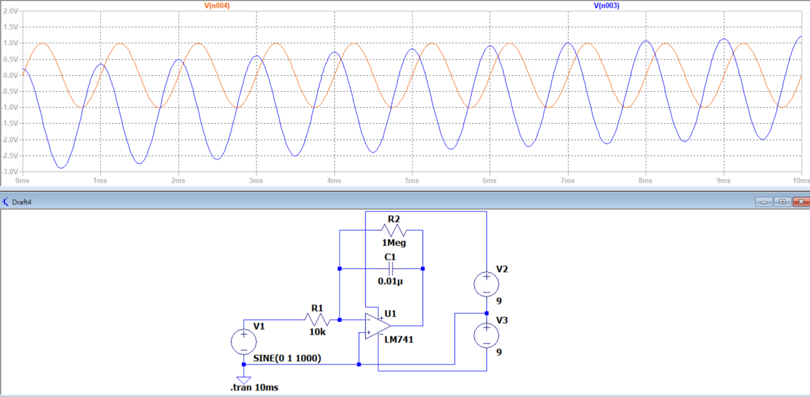

(yellow): vertical = 0.5V/ DIV; horizontal = 1 ms/ DIV

(blue): vertical = 0.5V/ DIV; horizontal = 1ms/ DIV

From the waveform, we can tell that leads .

1. Observation and Discussion

Observation:

This circuit is called integrator. The integrator has the following five main characteristics:

* + 1. It uses a resistor as the input component and a capacitor as the output component.
    2. The output voltage is proportional to the voltage and time of the input signal.
    3. The RC time constant should not be too small, as it may cause the output voltage to saturate and lose its integrating effect after the capacitor is fully charged.
    4. When a sine wave passes through the integrator circuit, its waveform remains unchanged, but a phase shift is introduced.
    5. Non-sinusoidal waves passing through the integrator circuit result in an output waveform different from the input waveform (e.g., square waves integrate to form triangular waves).

Discussion:

Why the output waveform would look like this if I set the input sine wave into , instead of ,?

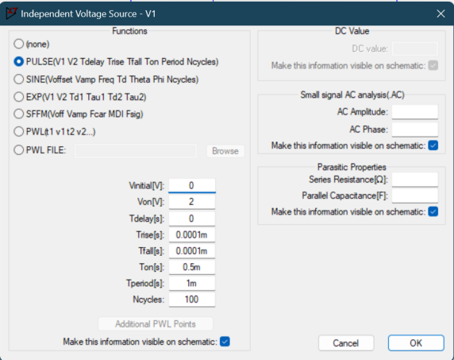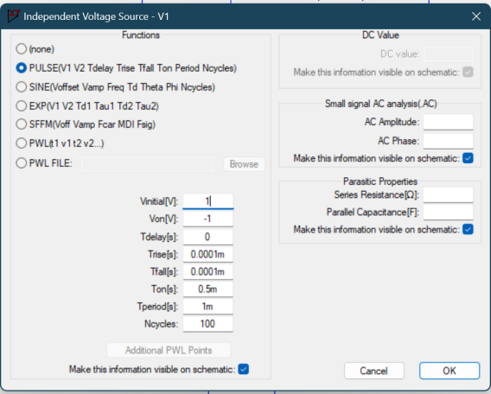

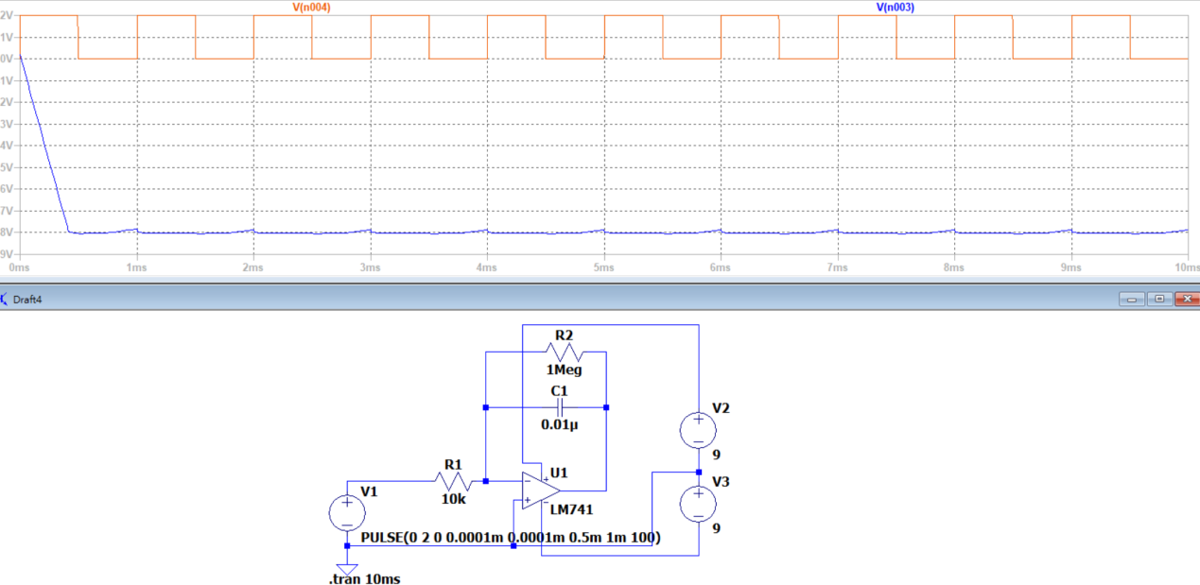

A:

Because this is an integrator, only if the input signal oscillates around 0 would the output waveform oscillates; otherwise, the capacitor would be charged and hardly change its output voltage.

**Textbook Exercise**

**Q1: What are the characteristics of constant voltage circuit?**

**A:**

The constant voltage source provides a constant voltage to the load regardless of variations or changes in the load resistance.

For this to happen, the source must have an internal resistance which is very low compared to the resistance of the load it is powering.

Some of the characteristics of an ideal constant voltage source are:

* + 1. Zero internal resistance
    2. Maintaining the same voltage regardless of variation in the amount of current drawn by load,
    3. No current flows when the circuit is not loaded (open circuited).

**Q2: What are the characteristics of constant current circuit?**

**A:**

A constant current circuit ensures a constant current gets to a load regardless of the variances and changes in a load resistance. This means that a constant current source provides a consistent output current every time.

Irrespective of the variations in resistance, this source must supply a constant current. A constant current source is a requirement for circuits with regular current.

A constant current source is a very valuable component in a constant current circuit because it offers steady current even if the resistance changes. Also, a constant current circuit requires a steady supply of current without any form of fluctuations

**Q3: If the 24-2, then what is**

**A:**

We know that , so substitute the variables, we get:

. Hence, we know

**Q4: Which type of circuit is proportional to the "rate of change of input voltage" with respect to the output voltage?**

**A:**

Differentiator is proportional to the "rate of change of input voltage" with respect to the output voltage.

**Q5:** **Which waveform remains unchanged when passed through an integrator or differentiator?**

**A:**

Sine wave remains unchanged when passed through an integrator or differentiator.

**Feedback**

In this experiment, we explored topics related to constant voltage and constant current control circuits, differentiators, and integrators. Throughout the experiment, we encountered some challenging situations.

One notable issue was when our power supply didn't provide sufficient current when connected in series, resulting in incorrect voltage output. We initially suspected incorrect circuit connections or short circuits. We spent a considerable amount of time debugging, but couldn't pinpoint the problem. Eventually, we dismantled the circuit and connected only the positive and negative terminals to a breadboard, which revealed that an aging internal component of the breadboard was causing the power supply to malfunction. Debugging was frustrating and set us back compared to other groups. We hope to avoid receiving faulty breadboards in future experiments.