Analog Lab 3:

Experiment4:

Wien-Bridge Oscillator and Phase-Shift Oscillator

Date: 2023/11/02

Class: 電機三全英班

Group: Group 11

Name: B103105006 胡庭翊

**Working Project #1 Wien-Bridge Oscillator**

1. Measurement Data

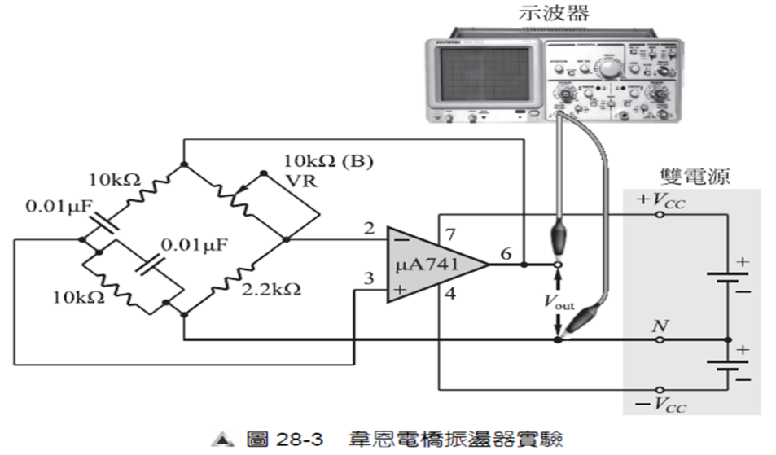

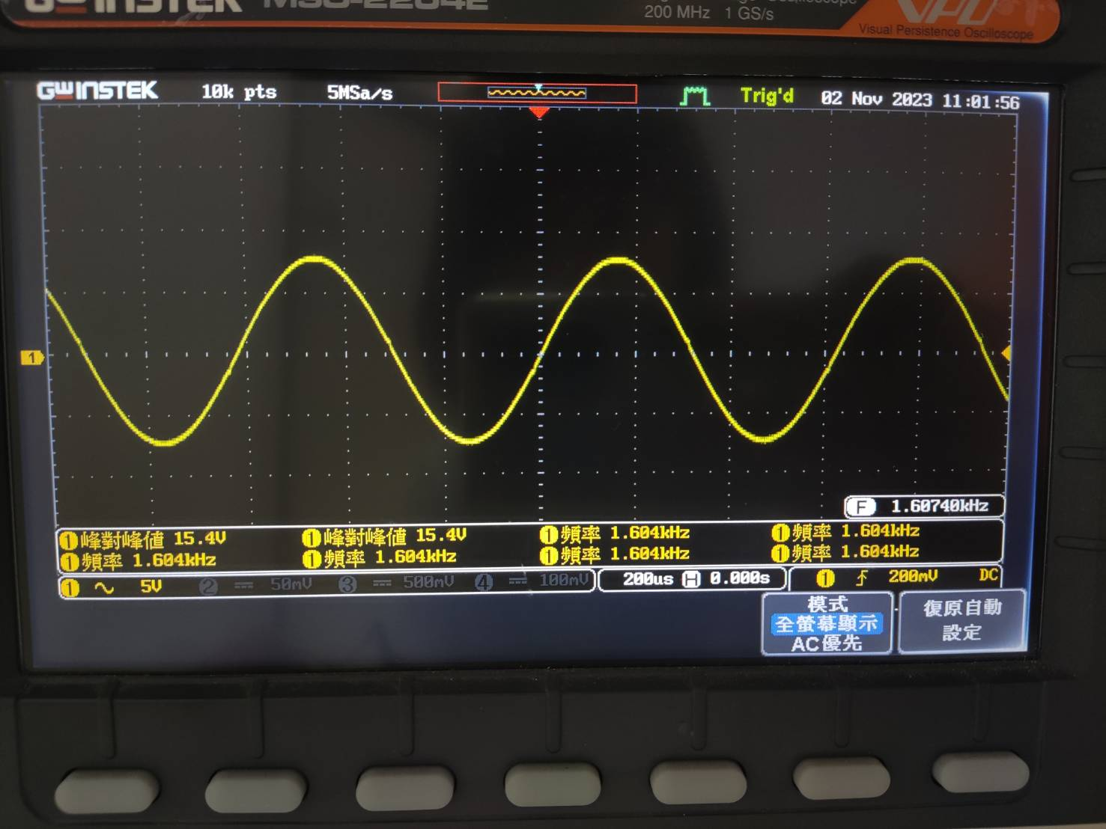

Period: 593us

Frequency: 1.684k Hz

1. Simulation Result

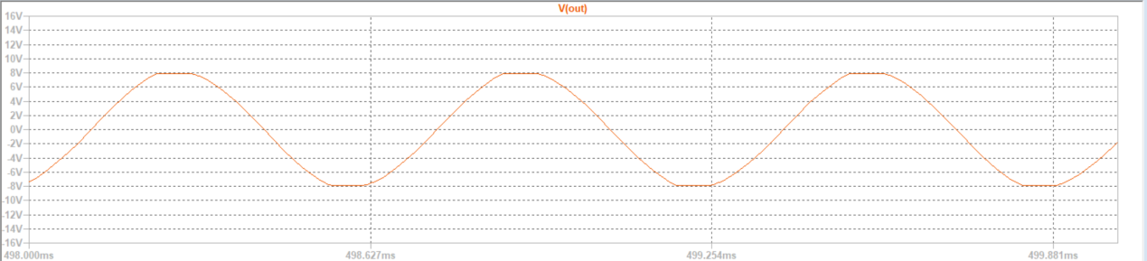

Period: 627us

Frequency: 1.592k Hz

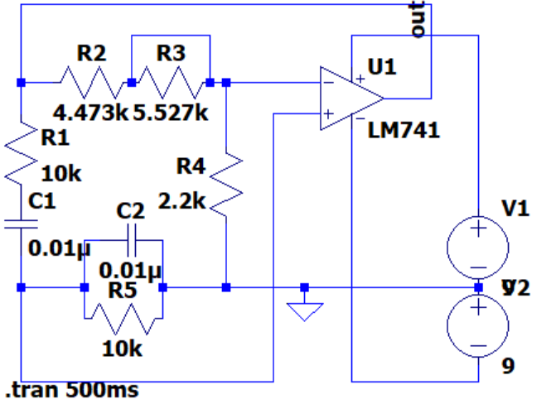

1. Observation and Discussion

Observation:

The Barkhausen stability criterion says that, if we want to make an oscillator with opamp, the following rules should be followed:

1. Positive feedback
2. A(voltage gain) B(feedback) = 1

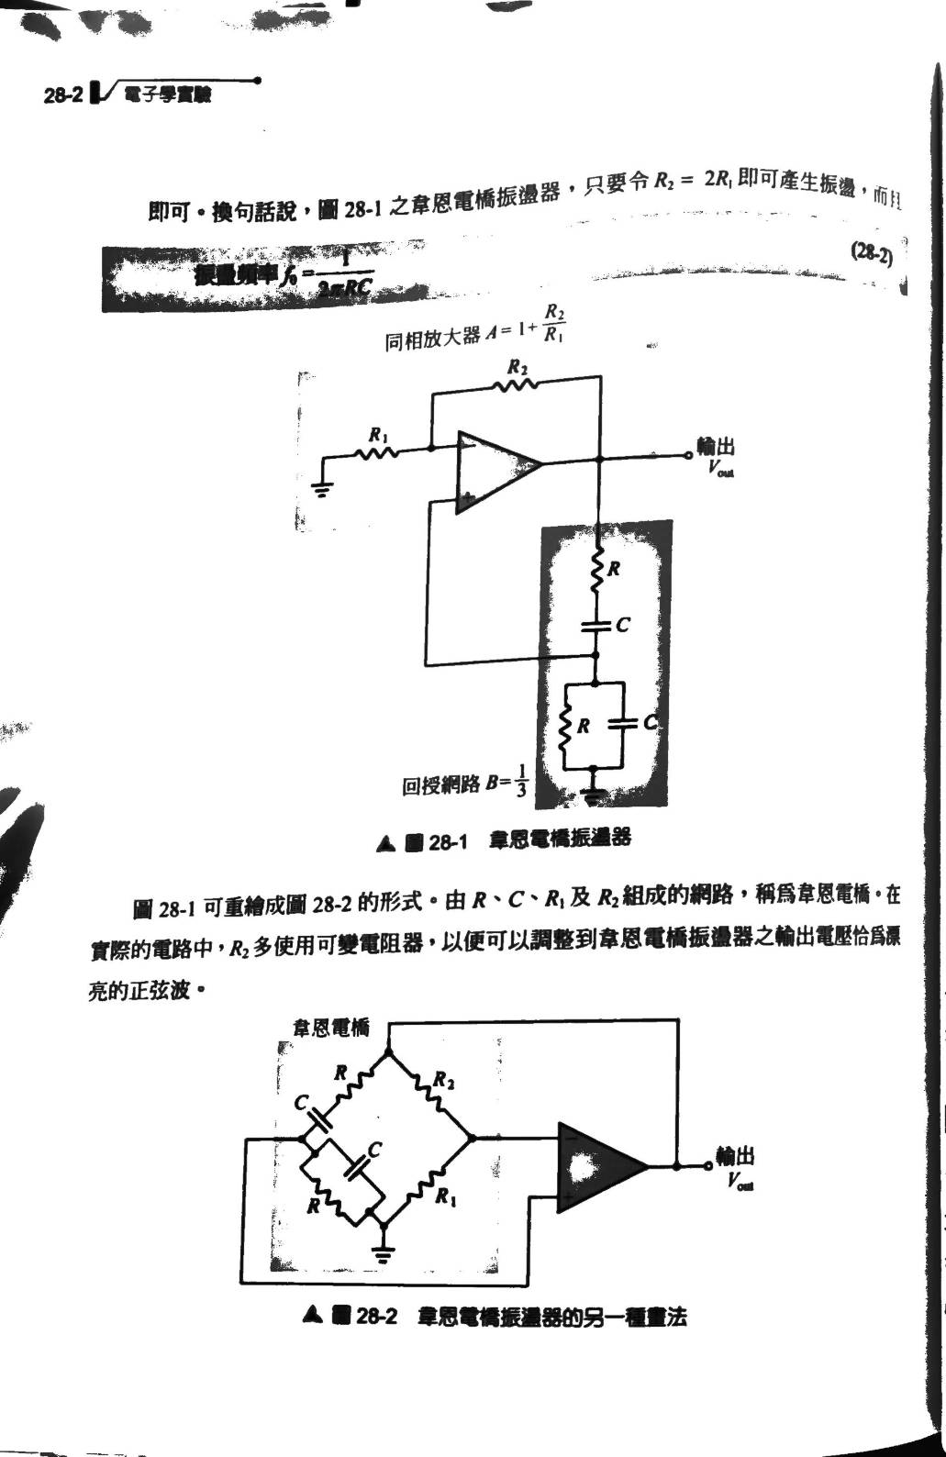

When , B = . So, we need to make A equals to 3.

Since , needs to be two times larger than .

Substitute the parameters into the functions, we know that .

Discussion:

The multiplication of A and B has three kinds of conditions:

1. AB < 1:

The gain after feedback is not enough, hence the waveform will decrease gradually and stop oscillate at the end.

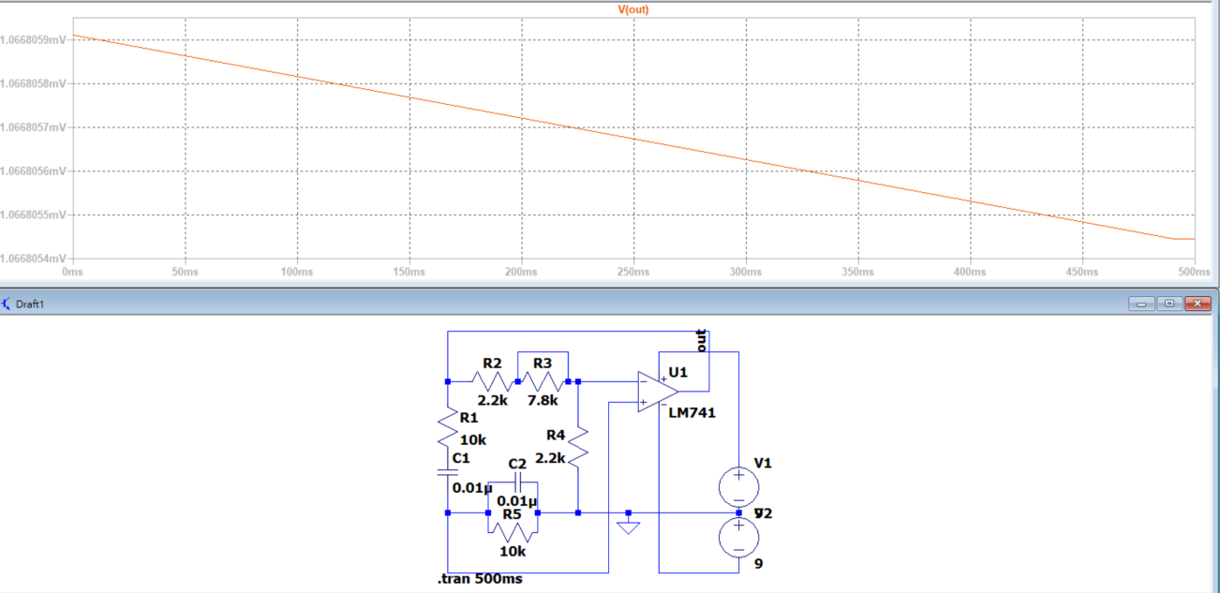

1. AB = 1:

The gain is just right, and the circuit produces a constant amplitude sine wave with no distortion.

1. AB > 1:

The gain after feedback is too big, hence the waveform will increase gradually and become square wave at the end.

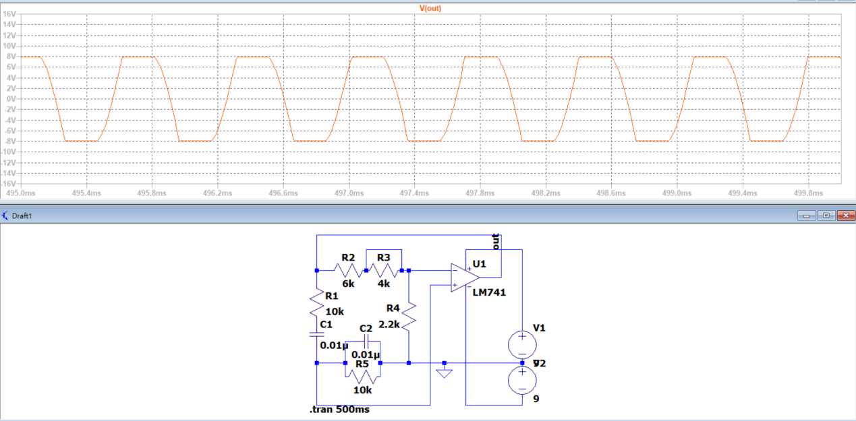

**Working Project #2Phase Shift Oscillator (Leading Phase)**

1. Measurement Data

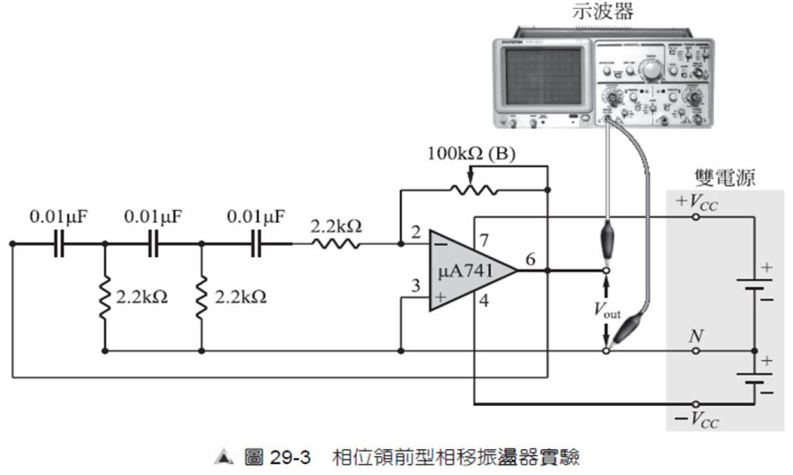

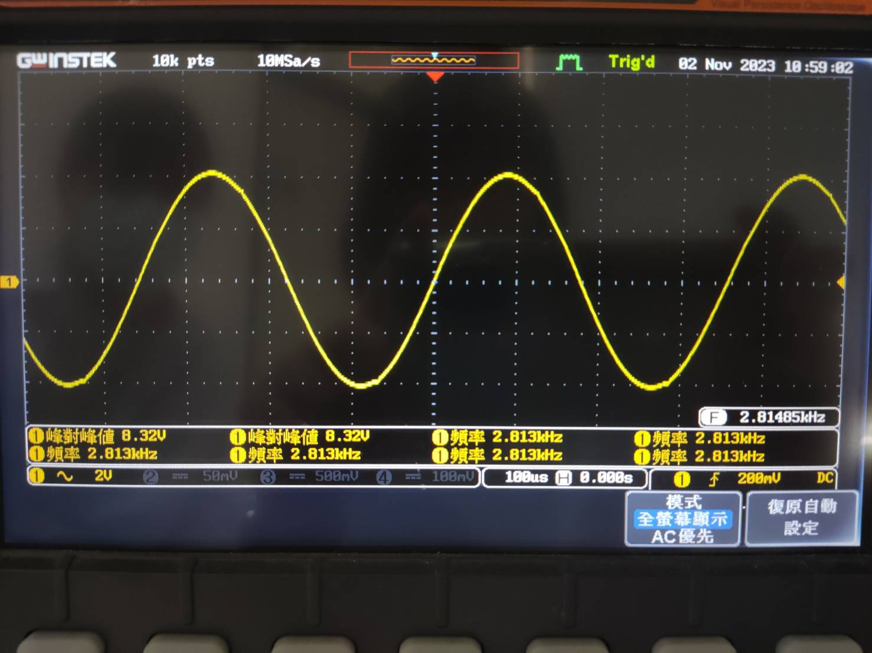

Period: 355us

Frequency: 2.813k Hz

1. Simulation Result

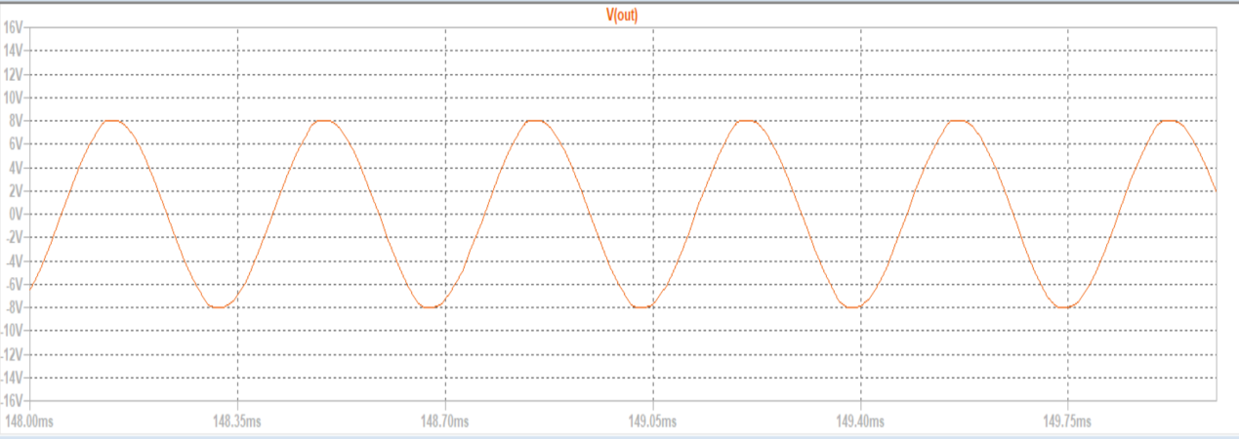

Period: 350us

Frequency: 2.957k Hz

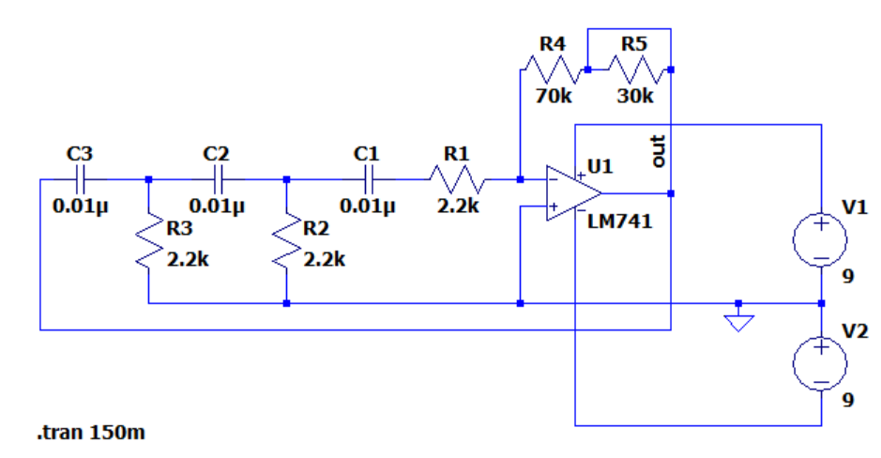

1. Observation and Discussion

It is known that three stages of RC circuit can generate a 180 degree of phase shift, and after a signal passed through a three phase RC network, its input voltage will be times of input voltage.

Hence, to generate a oscillating sine wave, the three stages RC circuit should be connected to an inverting amplifier with gain of -29.

The oscillation frequency is , and the period is T = 338us.

**Textbook Exercise**

**Q1: What conditions should a sine wave oscillator obtain?**

**A:**

To obtain a sine wave oscillator, following by Barkhausen Criteria, the following two conditions should be followed:

1. Positive feedback
2. A×B=1

**Q2: The Wein-Bridge oscillator is made of an inverting amplifier or non-inverting amplifier?**

**A:**

The Wein-Bridge oscillator is made of a non-inverting amplifier.

**Q3: When the Wein-Bridge oscillator normally functions, how big should the voltage gain be?**

**A:**

The voltage gain A should be 3 since B=.

**Q4: How much should the phase shift angle be to make a Wein-Bridge oscillator oscillate?**

**A:**

To make a Wein-Bridge oscillator, the phase shift angle should be 0 degree.

**Q5:** **As the phase shift oscillator shown in picture 29-1, if R1=R=1kΩ, then R2 should not be smaller than how much so as to oscillate?**

**A:**

R2 should not be smaller than 29kΩ.

**Q6:** **If we want to generate a 180 degree phase shift, how many stages of RC circuit should we implement?**

**A:**

We need at least 3 stages of RC circuit.

**Q7:** **As the fall behind phase shift oscillator shown in picture 29-2, what should we take care when choosing the resistance of?**

**A:**

Since the input V- of the inverting-amplifier is virtually grounded, we can view as parallel connected to C in the last stage of RC circuit, letting the oscillation frequency not accurately equal to , to decrease such influence, we can raise up the resistance of

**Feedback**

In the recent electrical engineering experiment, we constructed a Wien bridge oscillator and a phase-lead type phase-shift oscillator using operational amplifiers (op-amps). Assembling these circuits provided a hands-on understanding of oscillator design. Surprisingly, compared to other electrical engineering experiments, this one felt considerably more manageable. Completing the experiment ahead of schedule was gratifying, and it's not often that an electrical engineering lab allows for such an early sense of accomplishment.