Analog Lab 3:

Experiment6:

Phase Lock Loop

Date: 2023/11/30

Class: 電機三全英班

Group: Group 11

Name: B103105006 胡庭翊

**Working Project #1 Free Running Frequency**

1. Measurement Data

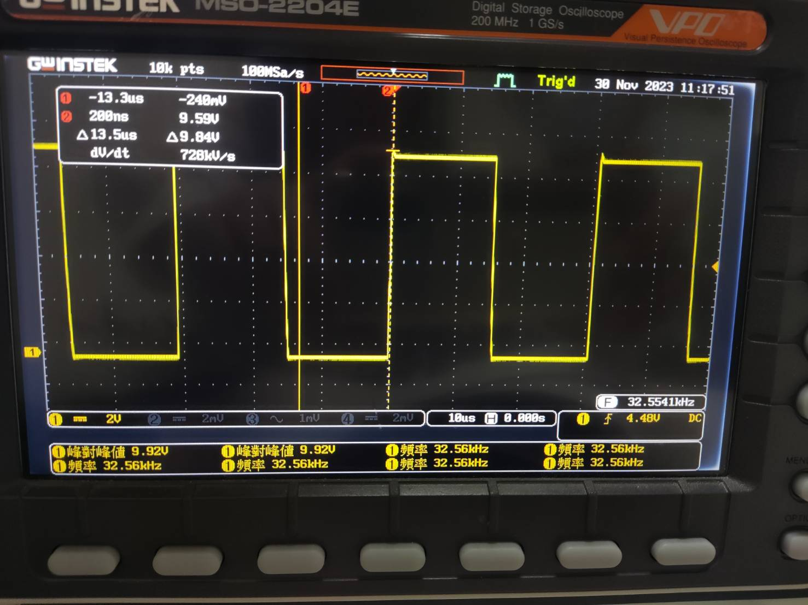

The free running frequency f0 = 32.56Hz

1. Observation and Discussion

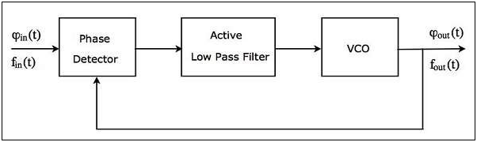

PLL is consisted of a voltage controlled oscillator, phase detector, and a lowpass filter, and the bandwidth of the lowpass filter is decided by the C7 of the 7th pin.

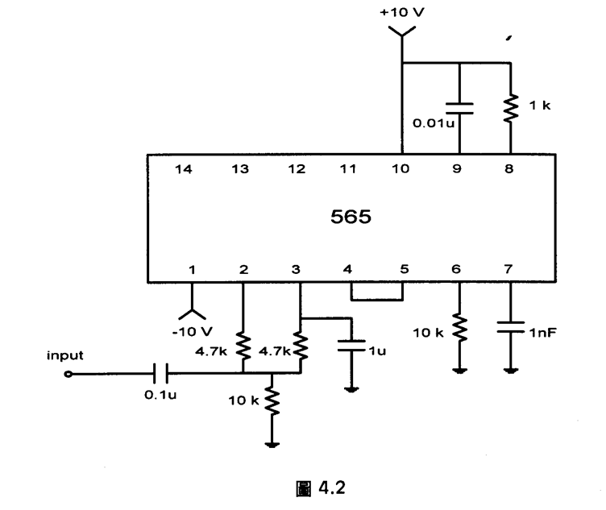

We know that f0 ≈ 0.3/R8C9 , when choosing R8 = 1kΩ, C9 = 0.01μF, f0 should be 30kHz in ideal. We connect the 4th pin to the oscillator and observe a square wave result, our measurement data is close to the ideal number.

**Working Project #2 Characteristic of VCO**

1. Measurement Data

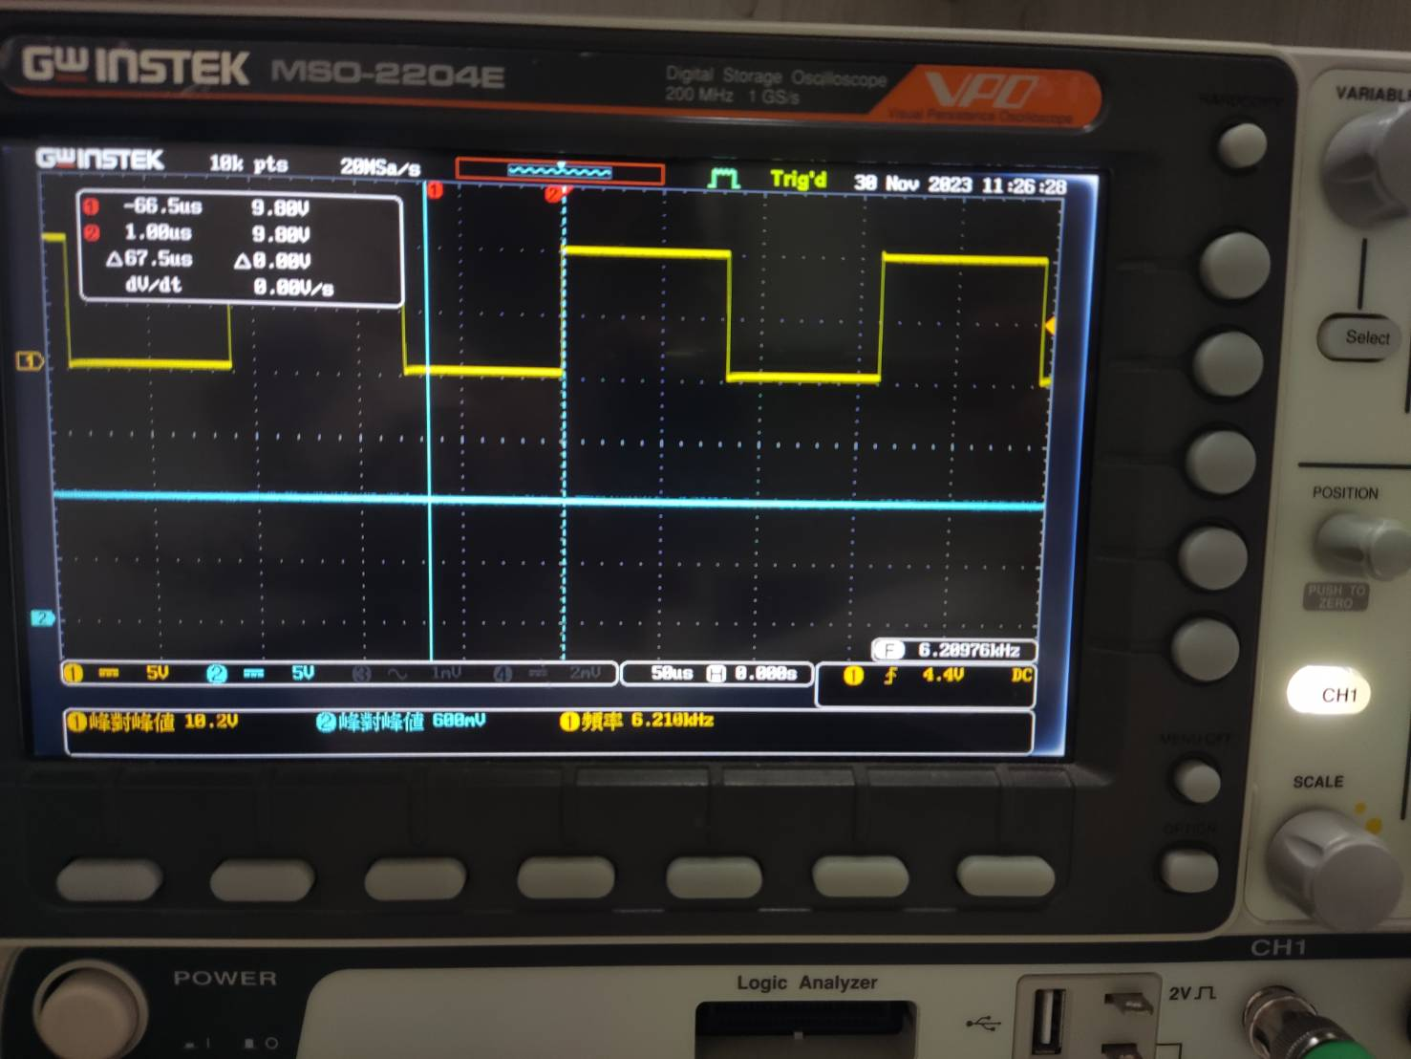

The VCO input voltage (pin7): 9.88V

The frequency output (pin4): 6.210 kHz

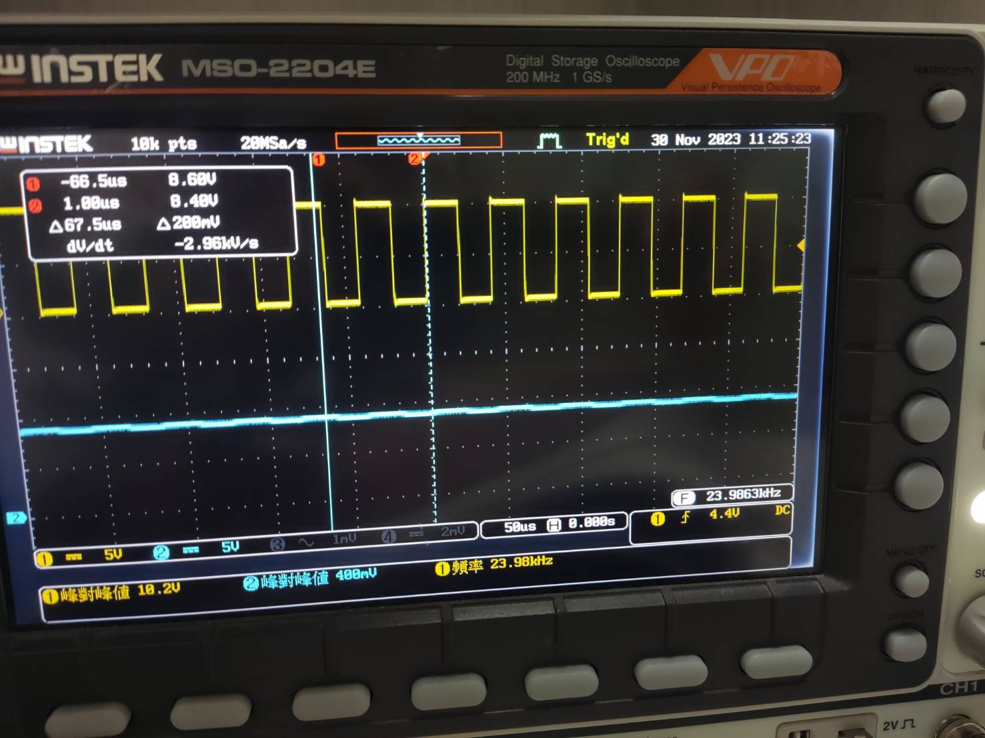

The VCO input voltage (pin7): 8.48V

The frequency output (pin4): 23.98 kHz

1. Observation and Discussion

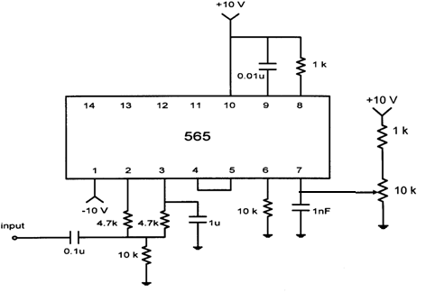

Connecting a 10k changeable register to pin7, which is, the input pin of the voltage controlled oscillator, we can simply modify the input voltage to the VCO inside the IC.

From the result, we can tell that when the changeable register converts, the output frequency f0 will also change.

**Working Project #3 Feed an Input to PLL**

1. Measurement Result

Set the function generator to output a square wave to PLL input:

Say if f0 = 30 kHz, here we set fi = 28 kHz (5 Vp-p)

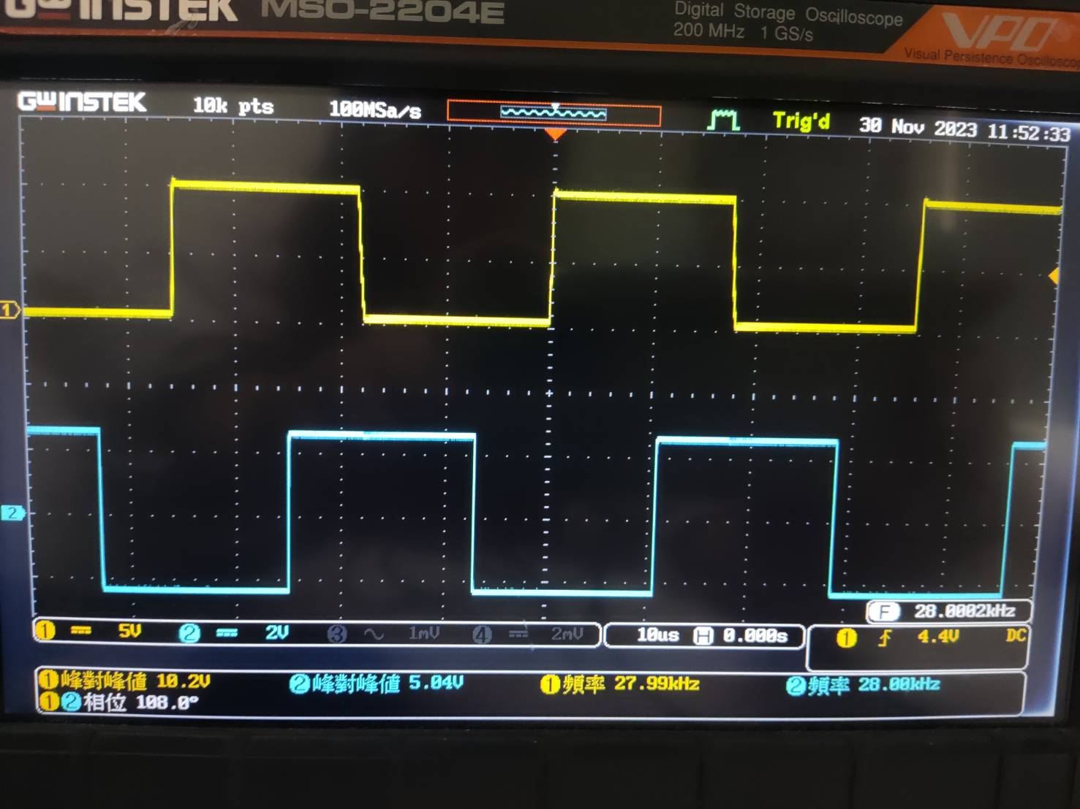

fo = fi = 28.00 kHz

The PLL can really lock the input signal.

1. Observation and Discussion



Before connecting the signal to the PLL input, we can found that it is impossible to observe f0 and fi in the same time since they have different frequency.

However, after connecting fi to the input of the circuit, the PLL will lock the input signal, f0 = fi at last.

**Working Project #4 Observe the Phase Difference**

1. Measurement Result

Set the function generator to output a square wave at measured frequency f0. Apply it to PLL input:

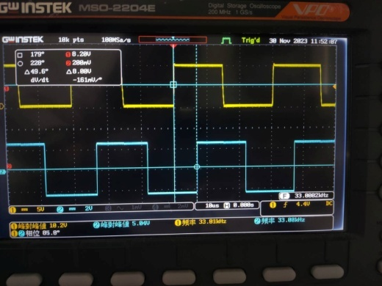

Phase difference = 85.8 $°$

1. Observation and Discussion

When phase locking fi to f0, the phase difference of the two signal = 90 $°$, which is 1/4 of the period.

**Working Project #5 Lock Range**

1. Measurement Result

|  |  |  |  |  |  |  |  |  |  |  |
| --- | --- | --- | --- | --- | --- | --- | --- | --- | --- | --- |
| frequency | 15k | 16k | 17k | 18k | 19k | 20k | 21k | 22k | 23k | 24k |
| voltage | 8.33 | 9.01 | 8.92 | 8.84 | 8.76 | 8.69 | 8.6 | 8.53 | 8.46 | 8.38 |
| phase | X | 178.9 | 170.2 | 165.1 | 159.2 | 154.5 | 146.1 | 141.4 | 136.4 | 131.0 |

|  |  |  |  |  |  |  |  |  |  |  |
| --- | --- | --- | --- | --- | --- | --- | --- | --- | --- | --- |
| frequency | 25k | 26k | 27k | 28k | 29k | 30k | 31k | 32k | 33k | 34k |
| voltage | 8.30 | 8.23 | 8.16 | 8.08 | 8.0 | 7.93 | 7.85 | 7.78 | 7.72 | 7.68 |
| phase | 126.1 | 121.2 | 116.2 | 110.7 | 105.4 | 100.7 | 97.9 | 98.1 | 89.5 | 86.2 |

|  |  |  |  |  |  |  |  |  |  |  |
| --- | --- | --- | --- | --- | --- | --- | --- | --- | --- | --- |
| frequency | 35k | 36k | 37k | 38k | 39k | 40k | 41k | 42k | 43k | 44k |
| voltage | 7.63 | 7.54 | 7.44 | 7.39 | 7.34 | 7.3 | 7.85 | 7.78 | 6.94 | 6.85 |
| phase | 83.4 | 77.2 | 70.1 | 68.2 | 63.8 | 54.0 | 44.2 | 39.4 | 33.1 | 28.9 |

|  |  |  |  |  |  |
| --- | --- | --- | --- | --- | --- |
| frequency | 45k | 46k | 47k | 48k | 49k |
| voltage | 6.78 | 6.68 | 6.61 | 6.52 | 7.0 |
| phase | 23.3 | 15.9 | 11.9 | 6.2 | X |

1. Observation and Discussion

First we find the frequency where the phase difference of fi and f0 is 90🡺at 33k Hz, the phase difference is 89.5 $°$.

Then we find the frequency of the highest and lowest phase difference.

The range of the highest and lowest lock frequency is called the Lock Range. It is the biggest range of the frequency that a PLL can lock.

**Working Project #6 Capture Range**

1. Measurement Result

|  |  |  |
| --- | --- | --- |
| Capacitance of C7 | 1uF | 10uF |
| fo | 34 kHz | 35 kHz |
| Lock range | 29 kHz ~ 39 kHz | 34 kHz ~ 36 kHz |
| Capture range | 32 kHz ~ 36 kHz | 1. kHz ~ 36 kHz |

1. Observation and Discussion

Capture range: the range of the input frequencies around the VCO center frequency in which the loop can lock the input when starting form unlocked condition.

Lock range: the range of input frequencies over which the loop can remain in the lock condition once it has captured the input signal.

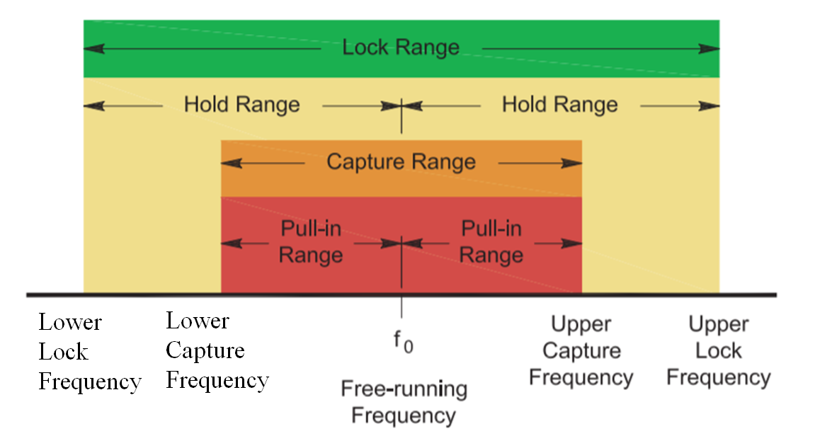

**Feedback**

This communication experiment marked our inaugural foray into the realm of phase-locked loops (PLL). The lab focused on measuring Free Running Mode, Capture Range, and Lock Range, essential parameters in PLL analysis. As a culminating project for the semester, I found the hands-on implementation of PLL to be both challenging and insightful.

However, I must admit that documenting experimental data for each frequency felt somewhat laborious. Despite the meticulous nature of the task, the experience provided a practical understanding of the intricacies involved in working with phase-locked loops. Overall, the experiment served as a valuable introduction to communication systems and the practical application of PLL concepts.