Analog Lab 5:

Darlington Circuits

Date: 2023/04/27

Class: 電機二全英班

Group: Group 8

B103105006 胡庭翊

B103105018 劉姵妤

Submitter:

B103105006 胡庭翊

1. Working Project #1: Photoelectric controller
2. Measurement Data
3. By connecting the CdS to the multimeter, and let it face to the light, we can measure and get the resistance of 3.49kΩ.
4. Using finger to cover the resistor, we measured and got the resistance of 18.30kΩ.

Q1: Using finger to cover the CdS, the LED light up.

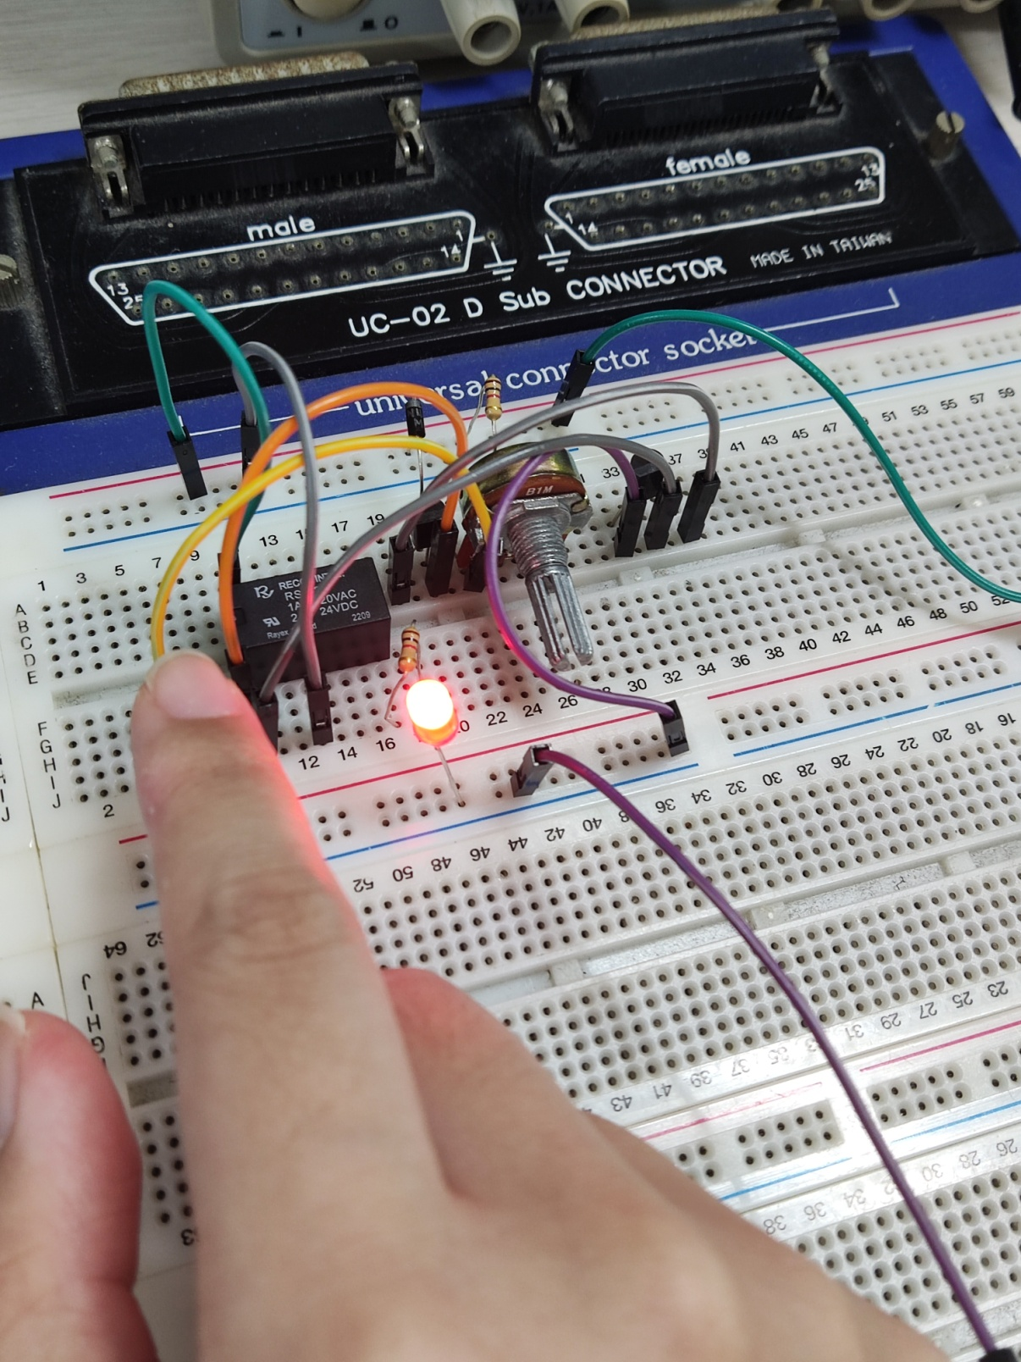

Q2: Removed finger, the LED turned down.

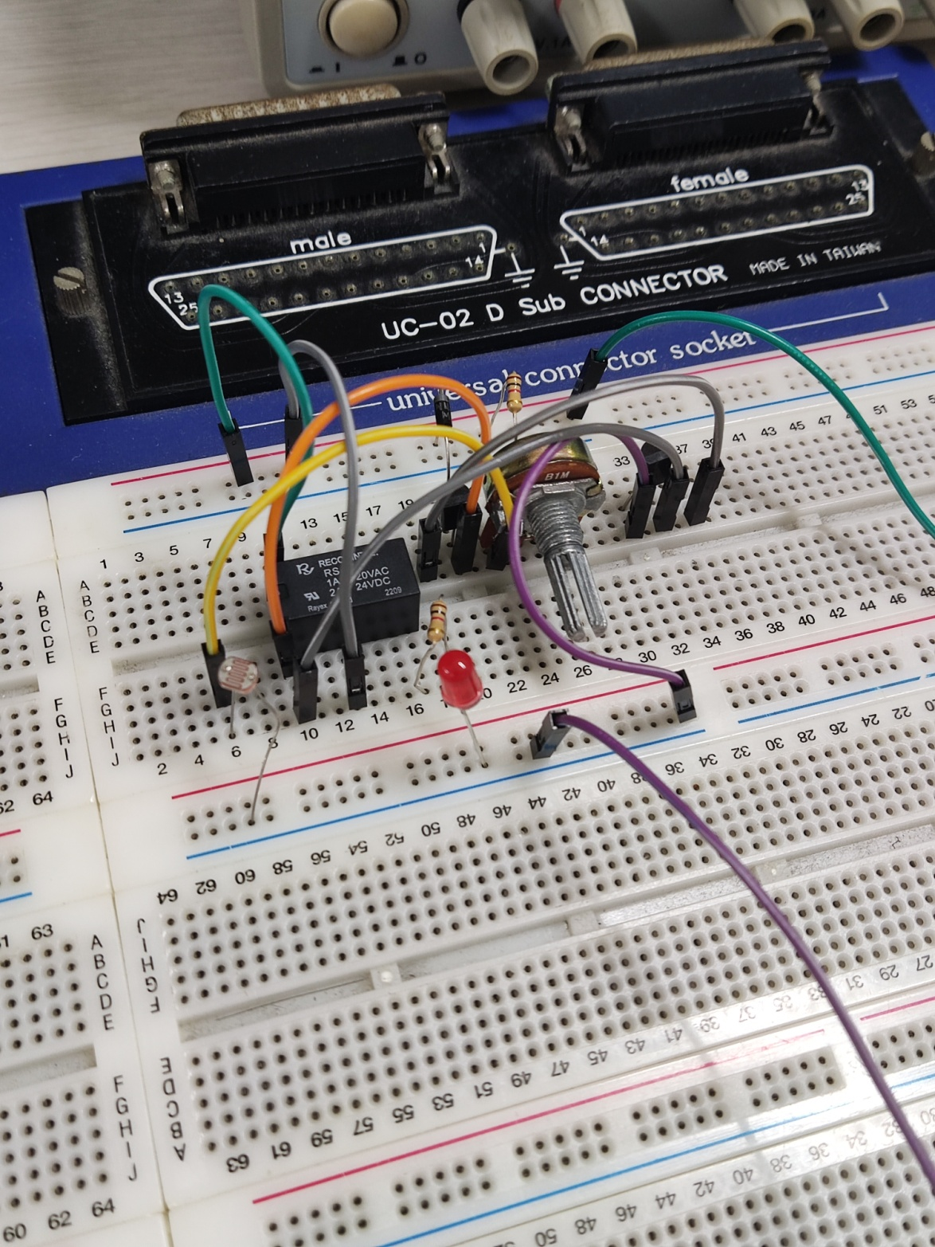

1. Simulation Result
2. Adjust the resistor right until the LED turned off. The edge resistance is 3.368kΩ.

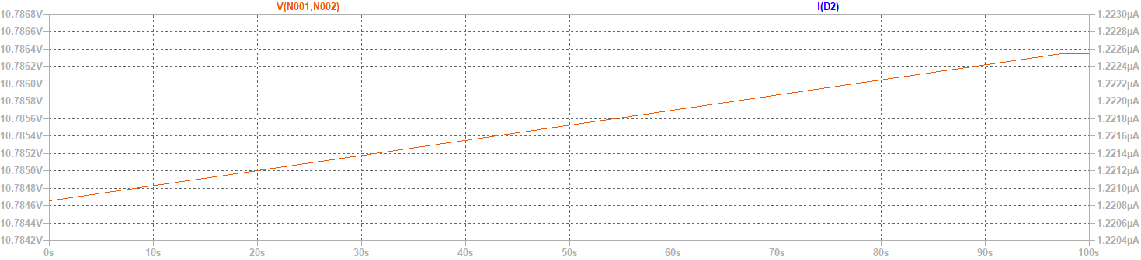

1. Use finger to cover up the CdS, which is, adjust the R5 from the measured value (uncovered: 3.49kΩ to covered: 18.30kΩ), we found the current passing through LED increased and hence the LED lighted up.



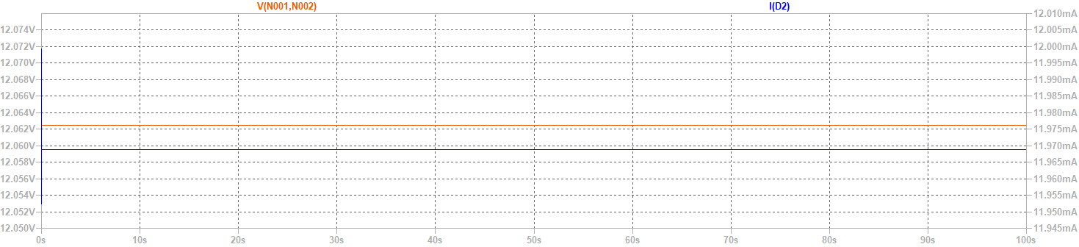

1. The LED turned off (current passing through LED dramatically decreased) again after adjusting the resistance from 18.30kΩ back to 3.49Ω, which as, removing the finger.





1. Observation and discussion

Observation:

Discussion:

Q: Why in simulation, the input voltage is 12.7V instead of 12V?

A: Since the trigger voltage of the SW is 12V, we measure the voltage across SW1, which is V (N001, N002) and adjust the input voltage from 12V to 12.7V, so as the input voltage into SW1 is , which is the very close voltage that can trigger the SW1 to work, and as the result, it gives the current passing through LED 11.968mA.

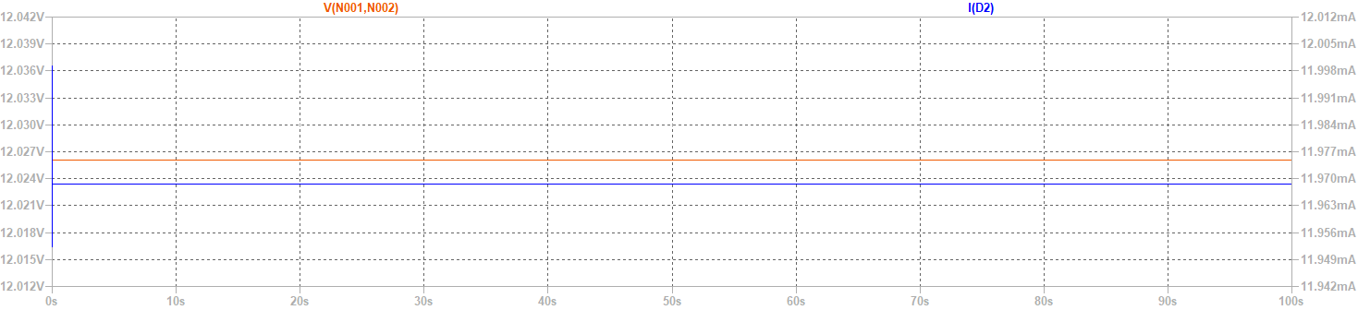

1. Working Project #2:Time Delay Relay
2. Measurement Data

Q1: After turning on the switch for a while, the relay holds and hence the LED lights up.

Q2: After turning off the switch, turn the potentiometer clockwise to the end, and then turned on the switch again, the relay holds for 0 second to light up, which means, we observed that it re-lighted up immediately.

Q3: After turning off the switch, turn the potentiometer counterclockwise to the end, and then turned on the switch again, the relay holds for 15 second to light up.

Q4: Hence we know that the relay can holds at least 0 second and at most 15 seconds.

1. Simulation Result

Q1: After turning on the switch for a while, the relay holds and hence the LED lights up.



The voltage across the diode is V (N001, N002), and the current passing through the diode is I (D1).

Also, V (n001) is the input step voltage of 13V, and V (n008) is the voltage across SW1.

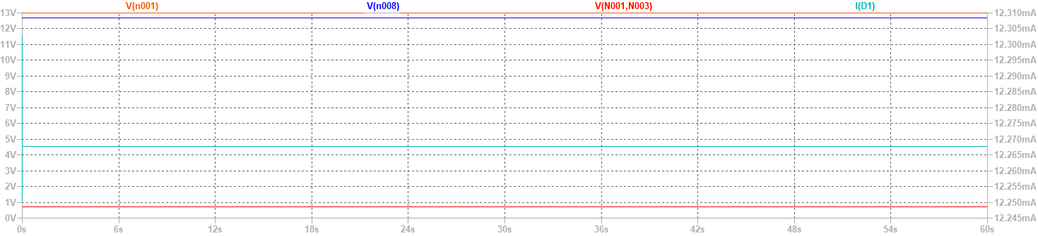

Q2: After turning off the switch, turn the potentiometer clockwise to the end, and then turned on the switch again, the relay holds for 0 second to light up, which means, we observed that it re-lighted up immediately.



V (n001) is the input step voltage of 13V with 1 second delay.

V (n008) is the voltage across SW1, and I (D1) is the current passing through the diode.

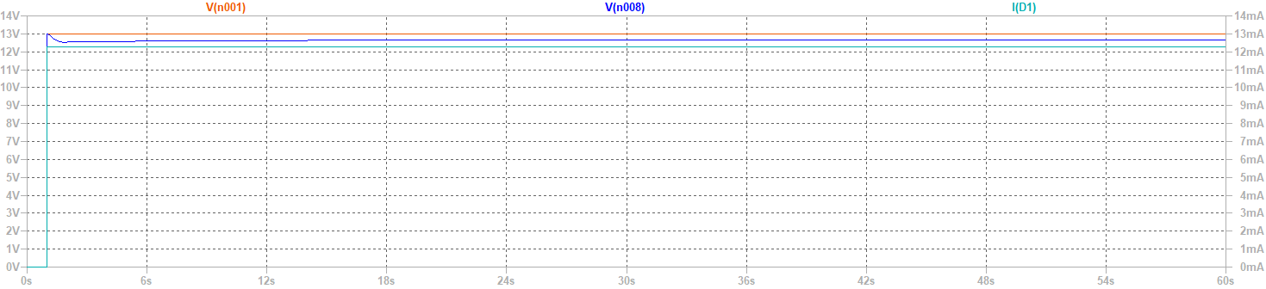

Q3: After turning off the switch, turn the potentiometer counterclockwise to the end, and then turned on the switch again, the relay holds for 30 seconds to light up.



V (n001) is the input step voltage of 13V with 1 second delay.

V (n008) is the voltage across SW1, and I (D1) is the current passing through the diode.

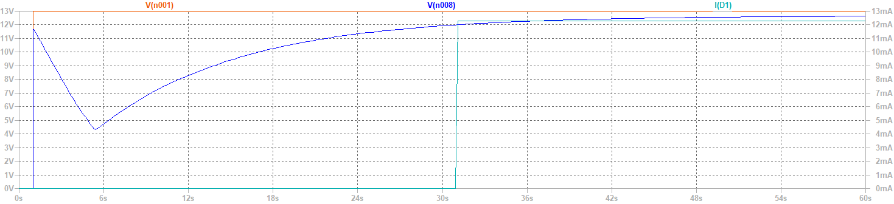

Q4: Hence we know that the relay can holds at least 0 second and at most 30 seconds.

1. Observations and Discussions

Observation:

Discussion:

Q: Why in simulation, the input voltage is 13V instead of 12V?

A: If we input 12V, the capacitor cannot actually be charged to and give the required trigger voltage 12V to SC1, hence the time delay system cannot function.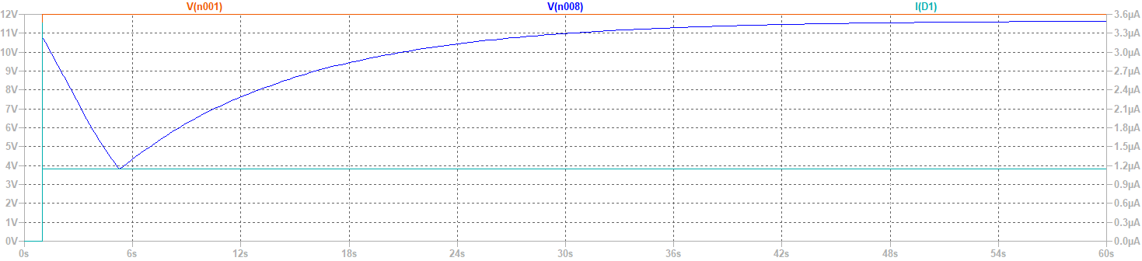

I (D1) is extremely small and the voltage across SC1 cannot meet its trigger voltage.

Q: Why the delay time in simulation differs from practical statistic?

A: The delay time depends on the speed of voltage charge from capacitor, if we given a smaller then 13V but larger then 12V voltage, the delay time, which is the time for voltage across SW1 increased to its trigger voltage, extended.

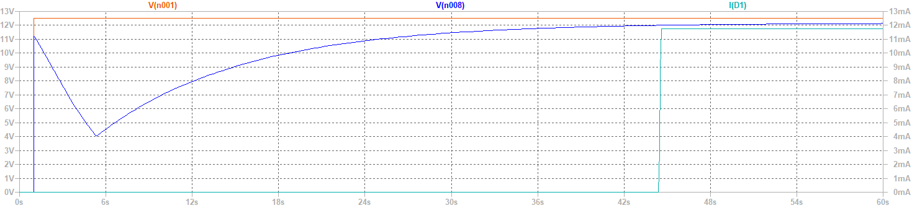

Q: What may also be the factor that can affect the delay time?

A: In the stage of practical measurement, we found that the delay time is extremely short (1 second of delay only). By checking the circuit and components, we found that the β of one of the BJT is un-normally small, which leads to the result that the capacitor charged fast and hence make the delay time short.

1. Practice Problems
2. Reflection