Project1



Q4:

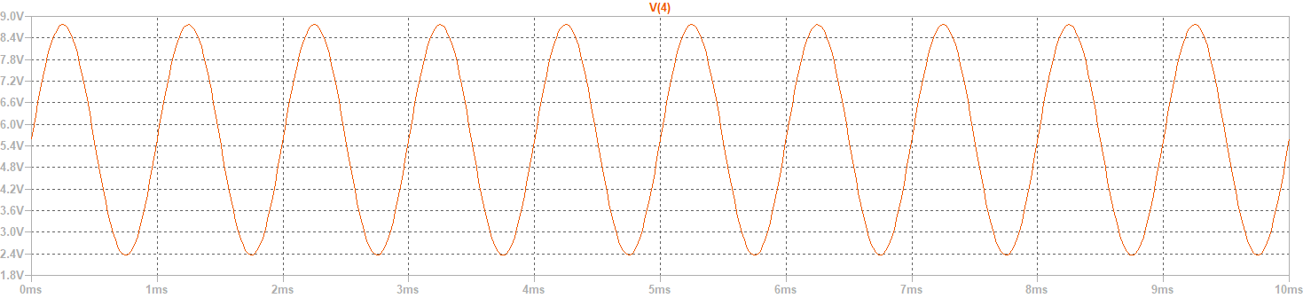V4: 8.725-2.355=6.37V

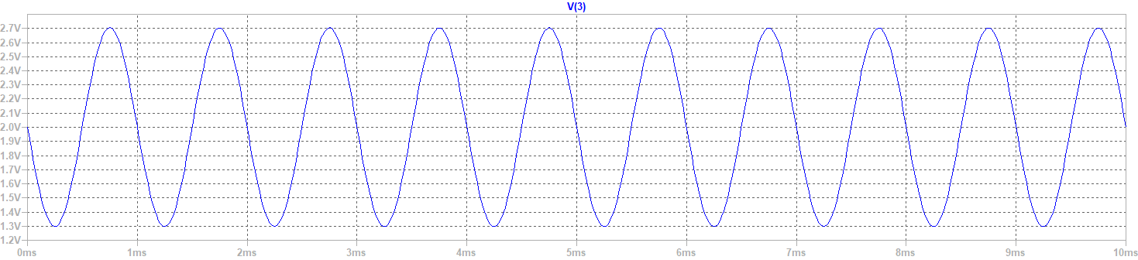

V3: 2.7-1.29=1.41V

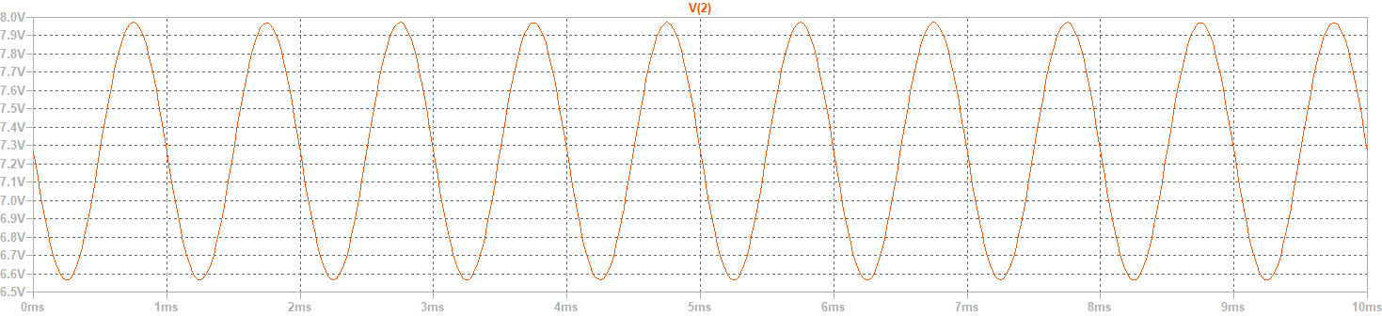

V2: 7.96-6.6=1.4V

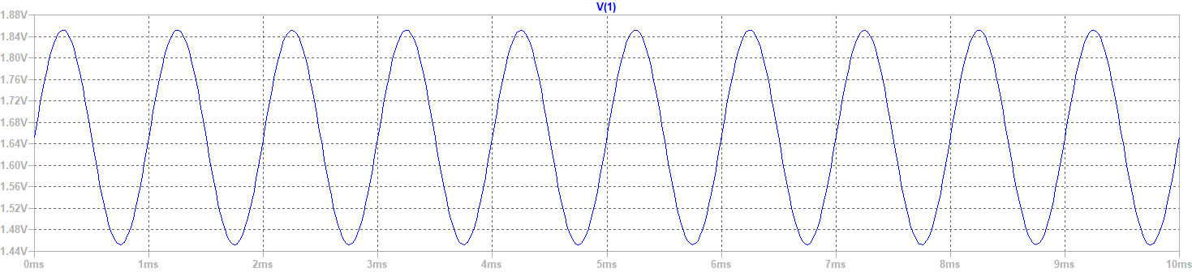

V1: 1.855-1.46=0.395V

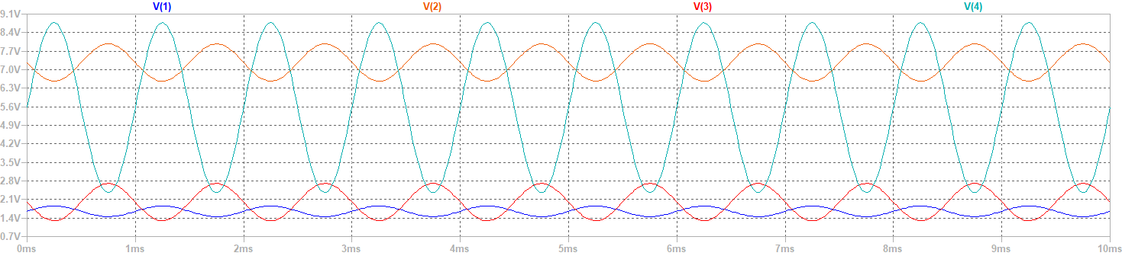

Combination

Q5:

A $V_{1}$ =3.54430V/V; A $V_{2}$ =4.5177V/V; AV=16.1265V/V

Q6:

YES

Q7:

YES

Q8:



Q9:

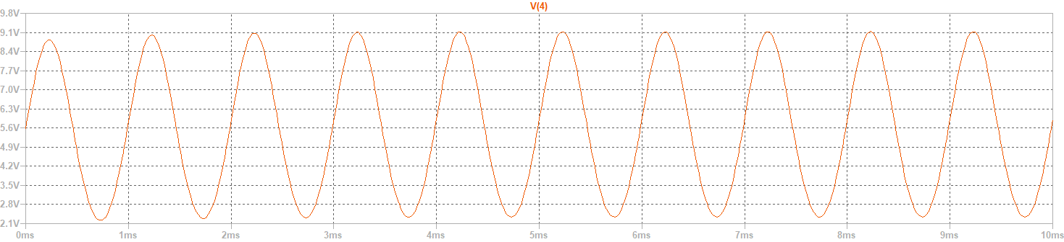

V4: 9.12-2.34=6.78

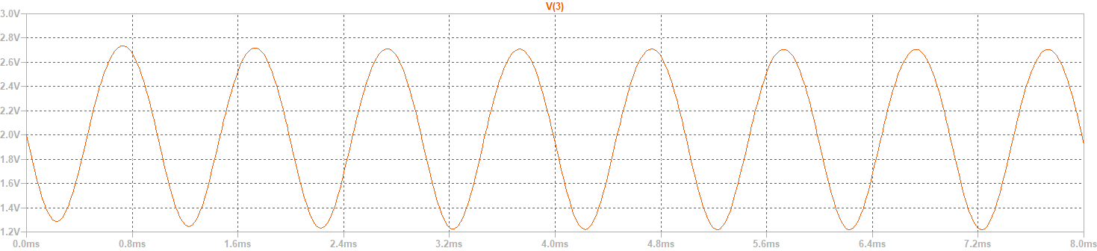

V3: 2.7-1.23=1.47

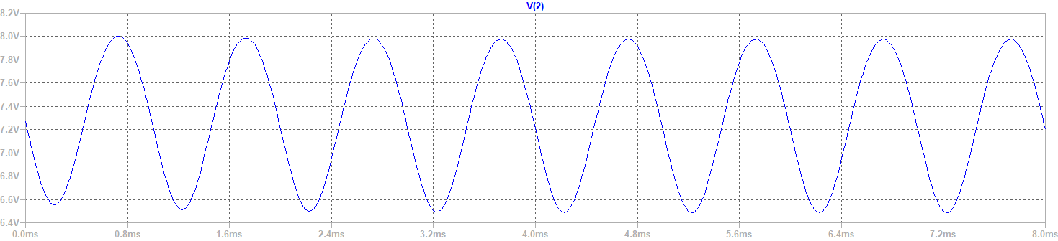

V2: 7.98-6.588=1.392

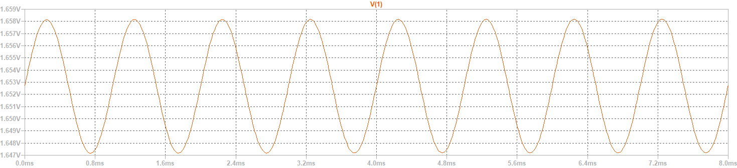

V1: 1.658-1.647=0.011

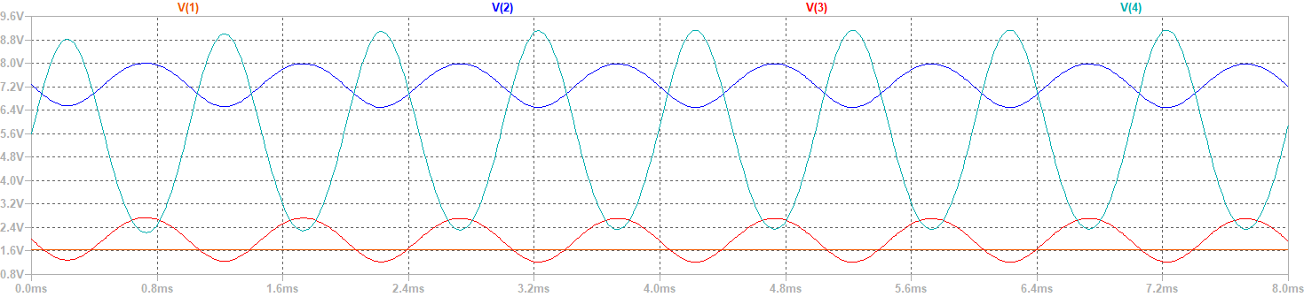

Combination

Q10:

A $V_{1}$ =126.5454V/V; A $V_{2}$ =4.6122V/V; AV=616.36V/V