Digital Lab 3:

K-map Circuit Design and Logic Simplification

Date: 2023/03/23

Class: 電機二全英班

Group: Group 8

Name: B103105006 胡庭翊

B103015018 劉姵妤

1. Purpose
   1. Use K-Map to simplify the logic equation of the digital circuit, which is able to present the high level voltage output with specified binary number input.
   2. To recall and implement K-Map in practical use and experiment, and apply the previous digital design knowledge to simplify the logic circuit, aiming to get a clear but functional circuit design without redundant loads.
2. Detail of the lab
   1. Draw the K-Map
      1. According to the student ID of one of our teammate, B103015018,the numbersdecimal 0,1,3,5,8 as input of the digital circuit are specified to get high level output voltage. 一張含有 日曆 的圖片

         自動產生的描述
      2. corresponding K-Map with the specified inputinbinary number 0000, 0001, 0011, 0101, 1000 fixed to be output 1, getting the logic equation by (A’B’C’D’)+(A’B’C’D)+(A’B’CD)+(A’BC’D)+(AB’C’D’)
      3. Combine the adjacent two numbers to simplify the equation: (B’C’D’)+A’D(C’+B’)
   2. Circuit design
      1. Circuit diagram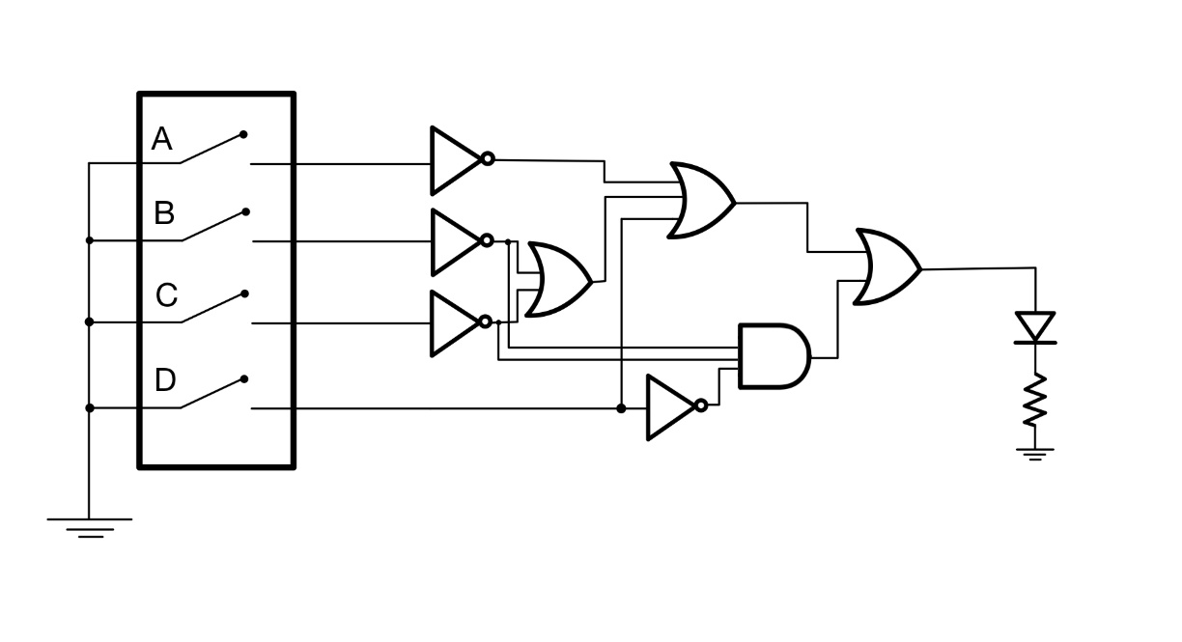
      2. Function of the circuit
         1. Switch

* + - * 1. When the switch is open, high-level voltage would become the input of the corresponding bit.
        2. When the switch is close, the terminal of the circuit would connect to the ground, low level voltage would be the input of the corresponding bit.
      1. Logic circuit

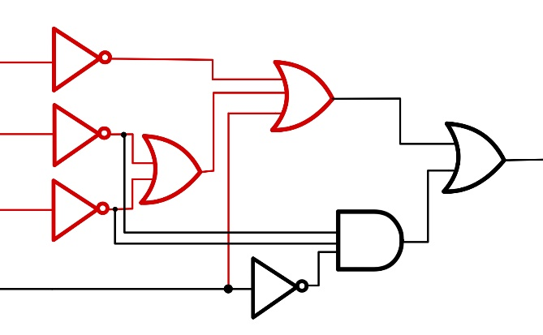

* + - * 1. Red part: present the logic of equation A’D(C’+B’)
        2. Black part: present the logic of equation (B’C’D’) and combine the red part with OR logic gate to get the entire logic equation circuit (B’C’D’)+A’D(C’+B’)
      1. LED indicator

When the input of the binary number set is corresponding to the designated number, which is 0000, 0001, 0011, 0101, 1000 in our case, the indicator is supposed to be lit up; otherwise, keeping dark.

* 1. Result
     1. According to the student ID B103015018, decimal numbers 0,1,3,5,8 as inputs are designated to light up the LED indicator ate the output terminal, which is 0000,0001,0011,0101,1000 in binary.
     2. 0000 (supposed to be bright)

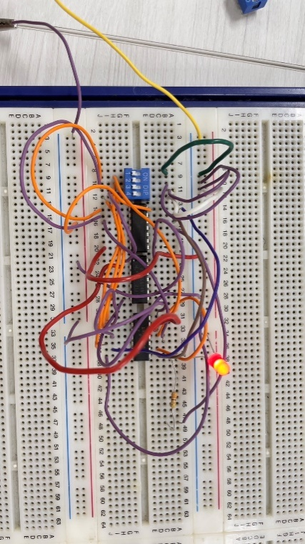

* + 1. 0001(supposed to be bright)

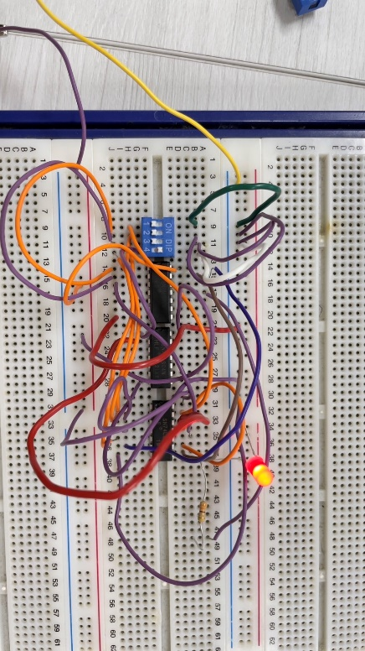

* + 1. 0010(supposed to be dark)

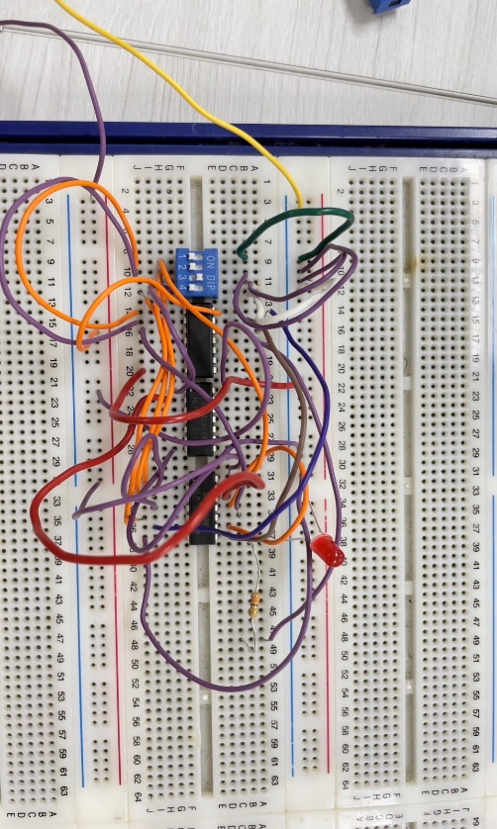

* + 1. 0011(supposed to be bright)

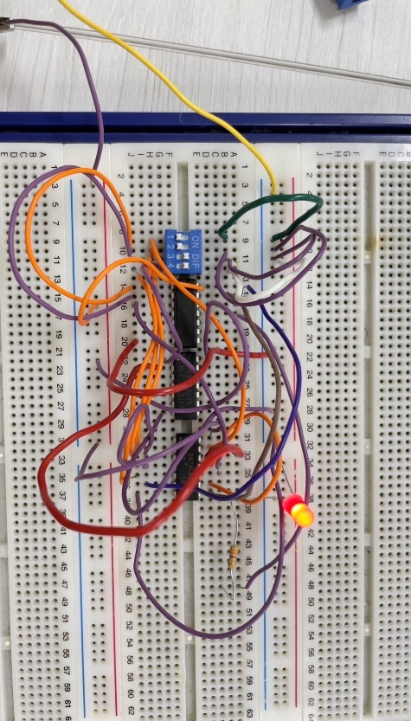

* + 1. 0100 (supposed to be dark)

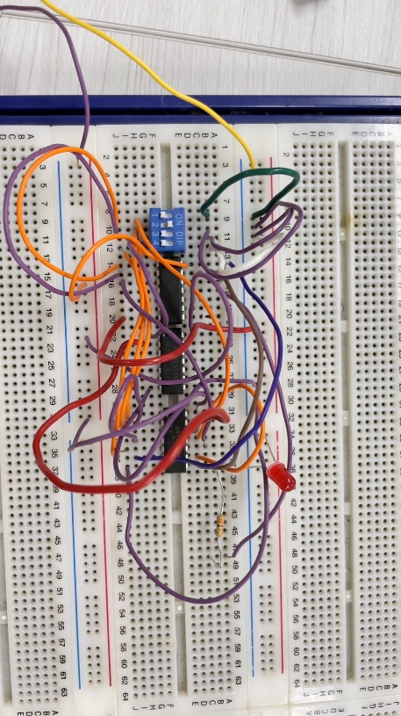

* + 1. 0101 (supposed to be bright)

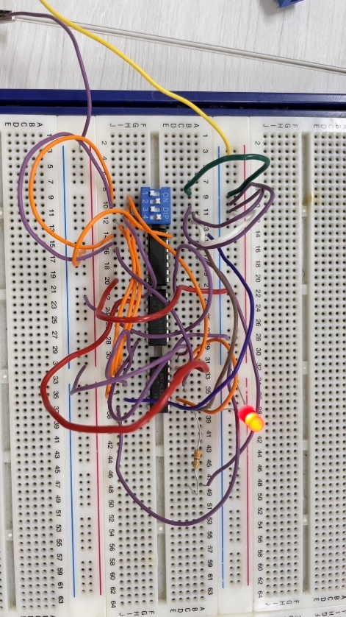

* + 1. 0110 (supposed to be dark)

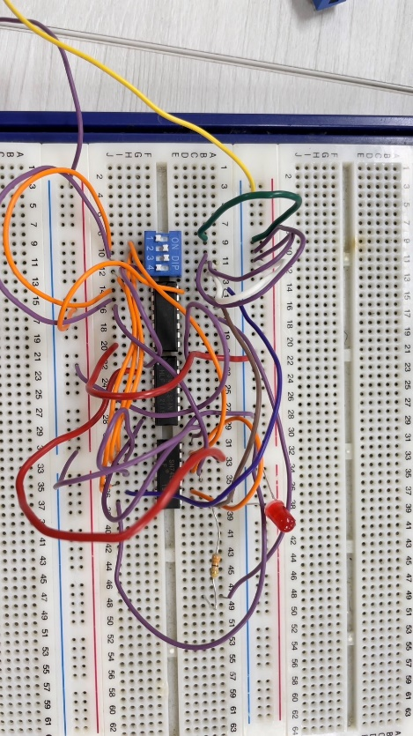

* + 1. 0111 (supposed to be dark)

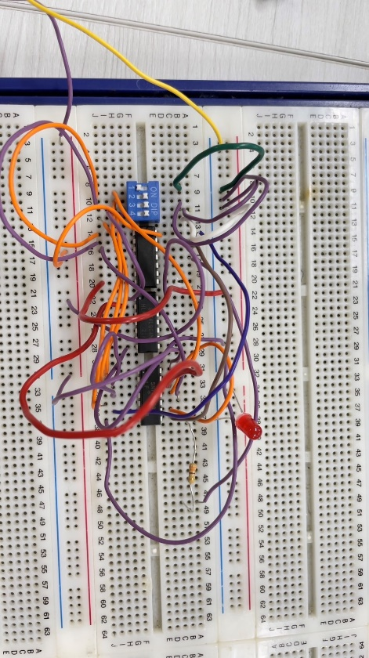

* + 1. 1000 (supposed to be bright)

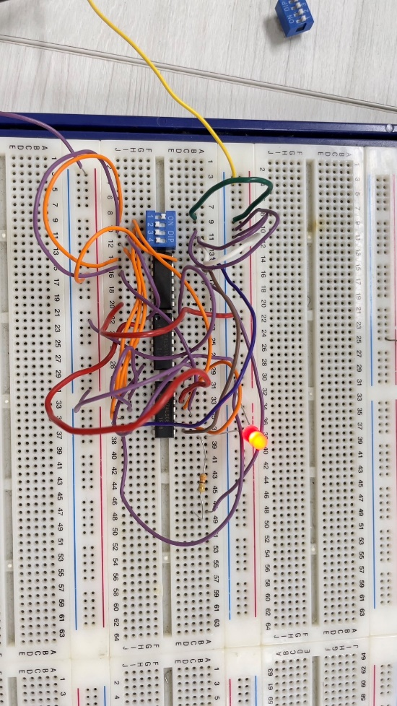

1. Checking Items
2. Test whether the LED lighting circuit functions are correct. For example:

|  |  |  |  |  |  |
| --- | --- | --- | --- | --- | --- |
|  | abcd | output(LED) |  | abcd | output(LED) |
| 0 | 0000 | light | 8 | 1000 | dark |
| 1 | 0001 | light | 9 | 1001 | light |
| 2 | 0010 | light | 10 | 1010 | dark |
| 3 | 0011 | dark | 11 | 1011 | dark |
| 4 | 0100 | dark | 12 | 1100 | dark |
| 5 | 0101 | dark | 13 | 1101 | dark |
| 6 | 0110 | light | 14 | 1110 | dark |
| 7 | 0111 | dark | 15 | 1111 | dark |

1. Each team member must implement the circuits and make measurement. Those teams who have completed the experiment must ask a TA to check, and the TA will ask one of the team members to repeat the experiment and verify the results.
2. After completing the experiments, all the components must be sorted (placed in the material box), the wires should be returned, and the instrument should be turned off. Clean up the seat and turn off the extension cord switch. After completion, you must ask a TA to check if you can leave.
3. Problem Discussion

We originally planned to use the ICs AND, OR, and NOT under specific conditions. However, due to some confusion in the wiring process, we mistakenly used the IC NOT instead of IC AND in some parts of the experiment.

It wasn't until we tested the circuit that we realized this issue. We immediately analyzed the experimental data and found that the LED would not light up regardless of how the toggle switch was toggled. Although the circuit was somewhat complex, after carefully analyzing and confirming the wiring one by one, we discovered that when using IC OR, some measurement values would exhibit irregular fluctuations, which required us to be more cautious in evaluating the experimental results.

In this experiment, we also encountered a problem, which was we were unclear about how to provide the required high voltage to the toggle switch when the input terminal is grounded. After asking TA, we learned that when the input terminal of the toggle switch is connected to ground, it creates a short circuit and provides a low voltage input to the subsequent logic IC. On the other hand, when the input terminal is open, we consider it as a high voltage input.

1. Review of Experiment

B103015006:

In this experiment, we learned about simplifying logic circuits using KMaps and implementing them using logic ICs (AND, OR, NOT). We used a set of four switches to input a four-digit binary code, and if the input code matched any digit of our student ID, the LED would light up, otherwise it would remain off. This experiment was a practical application of the concepts we learned in Digital Design in our first year of study. The KMaps made the simplification process more manageable and efficient, and we were able to see the impact of each input switch on the output. Overall, this experiment was a valuable experience in understanding how logic circuits work and how we can use them in real-world applications.

B103015018:

Through this experiment, I gained hands-on experience in simplifying logic circuits using KMaps and implementing them using logic ICs. We used a four-switch input to test for the presence of a specific digit in our student ID, and if the input matched, the LED would light up. I found the KMaps to be a useful tool in reducing the circuit complexity and making it easier to understand. I also appreciated the practical application of the concepts we learned in Digital Design in our first year of study. The experiment allowed me to consolidate my understanding of logic circuits and their applications, and I would like to thank my teammate and TA for their assistance throughout the process.