Digital Lab 4:

Experiment 1:

GPIO Control Design

Date: 2024/03/05

Class: 電機三全英班

Group: Group 11

Name: B103105006 胡庭翊

1. Annotated Code

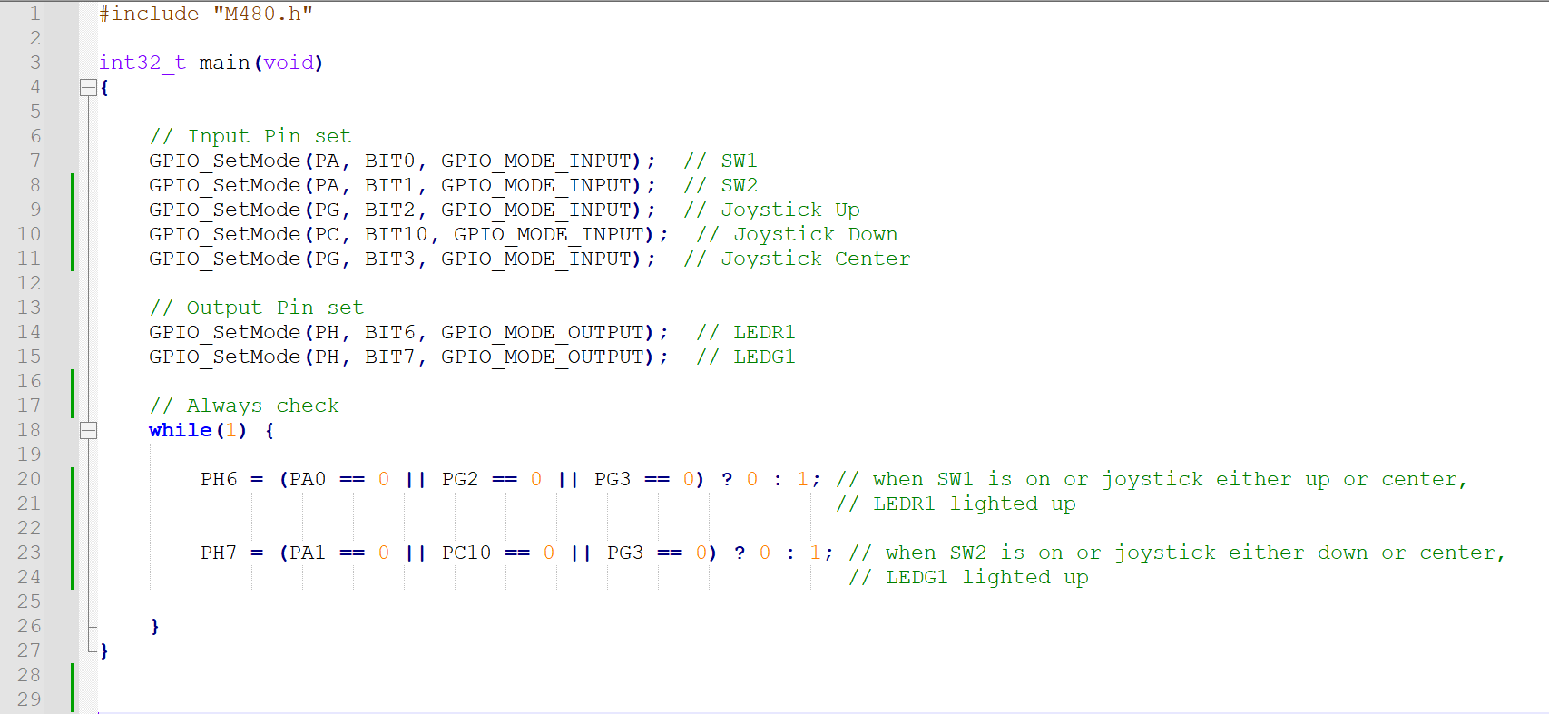

1. Program Flow

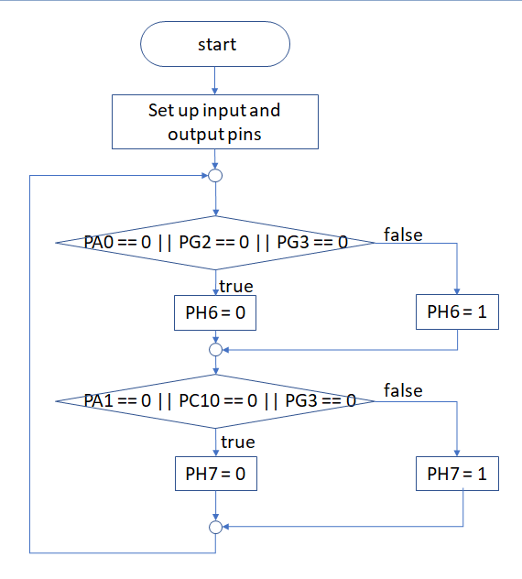

1. Thoughts

In this electrical engineering experiment, we had the opportunity to use the NuMaker-PFM-M487 series processor board and the Keil uVision development tool software, and completed a simple task using the C language. Although I had some background in C++ and Python, I still felt somewhat unfamiliar with how to accomplish tasks using C language in this environment.

The task was to control the LEDs on the board by manipulating the joystick to toggle the LEDs. While the task was relatively straightforward, it was a great starting point for me. Through this experiment, I became more familiar with the basic syntax and logical structures of the C language, and began to understand how to apply this knowledge in embedded systems.

During the experiment, I encountered some challenges, especially with the unfamiliarity of the Keil uVision software interface. However, by reading documentation and seeking help from teachers and classmates, I gradually overcame these difficulties. I also realized the importance of learning through practice, and through trial and error, I gained a deeper understanding of these tools and languages.

In the upcoming electrical engineering experiments, I look forward to further improving my skills and becoming more familiar with additional tools and technologies. I believe this experiment has laid a solid foundation for me, allowing me to tackle future challenges with more confidence.