Digital Lab 4:

Experiment 2:

Interrupt Service Routine and Clock

Date: 2024/03/19

Class: 電機三全英班

Group: Group 11

Name: B103105006 胡庭翊

1. Annotated Code

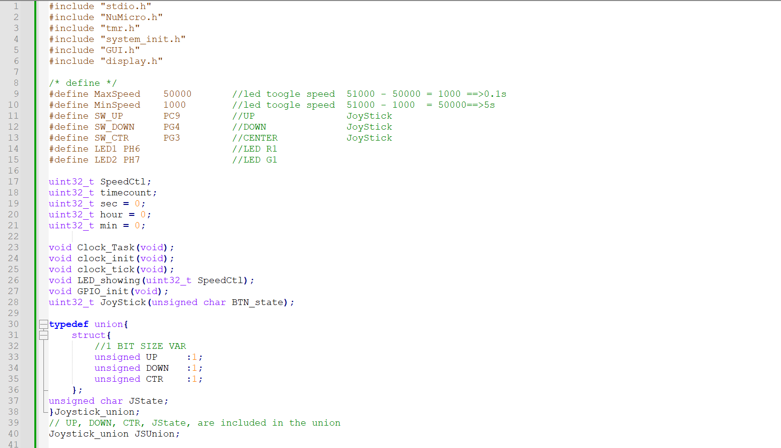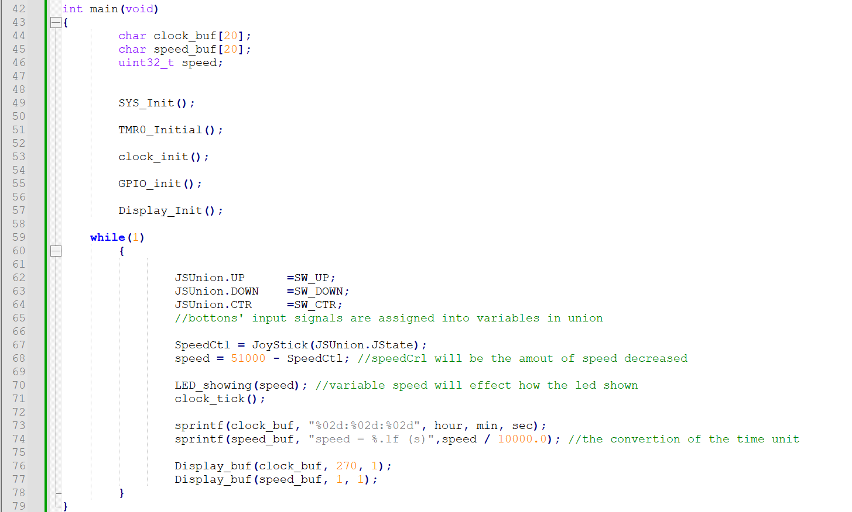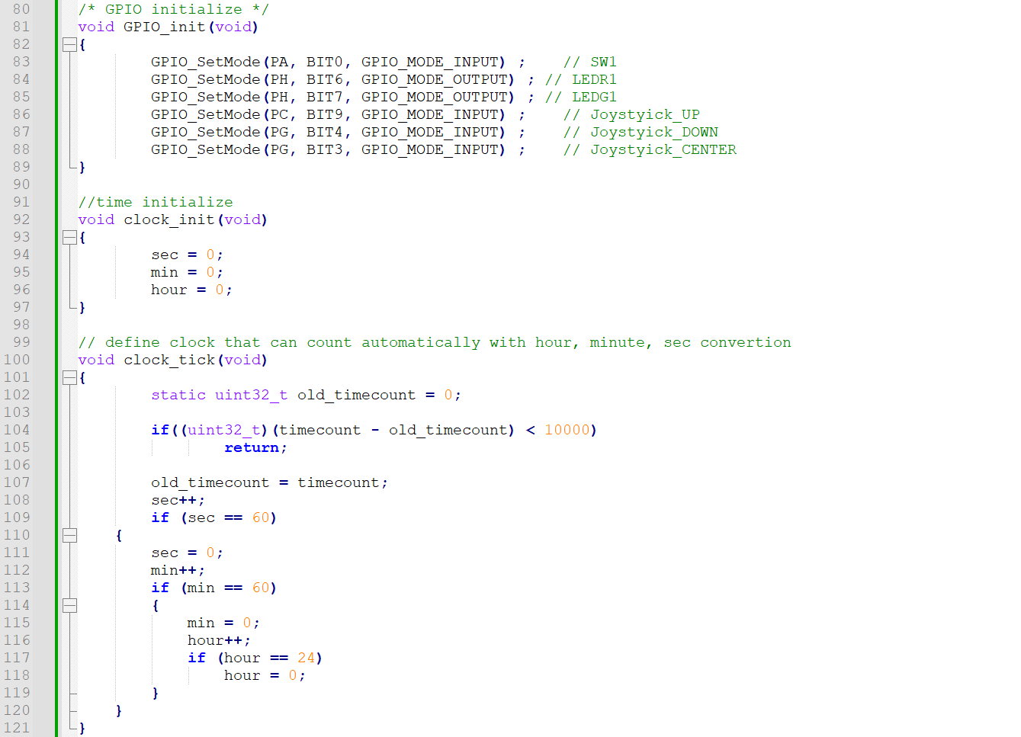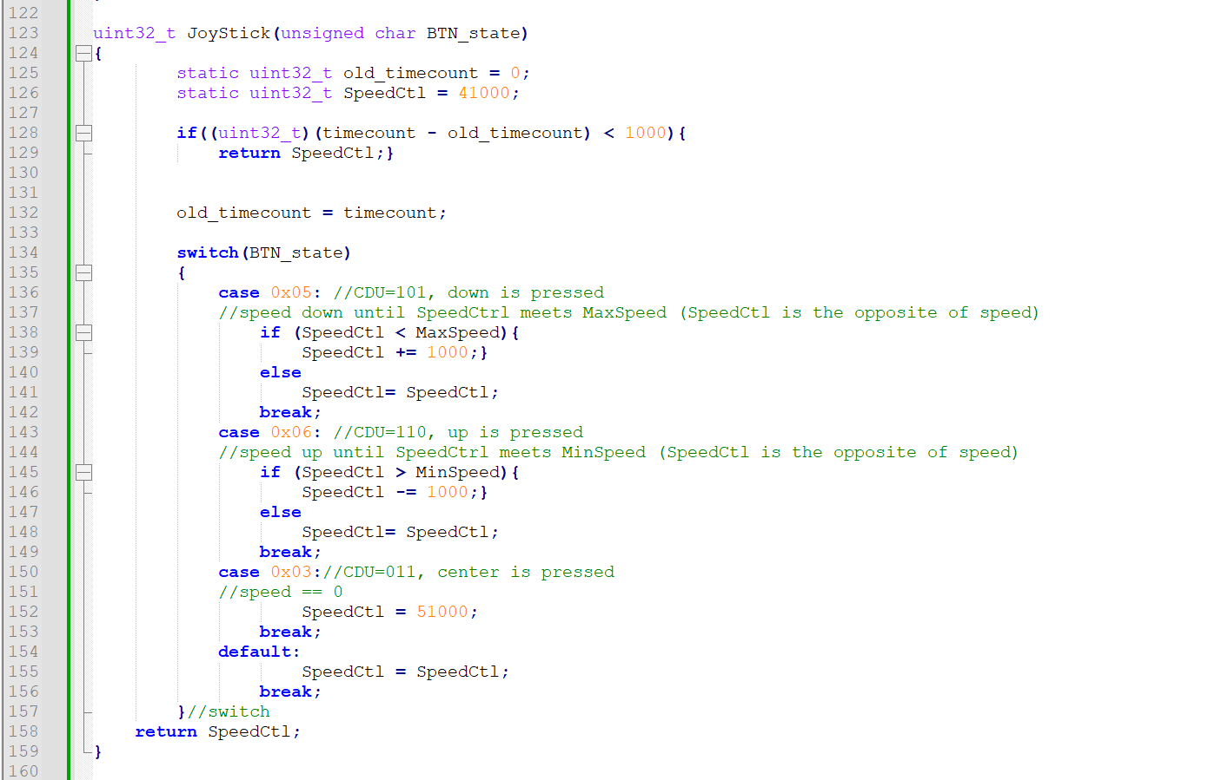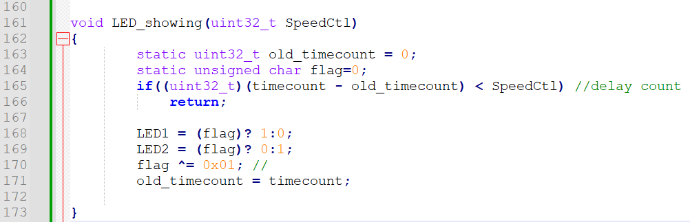

1. Program Flow

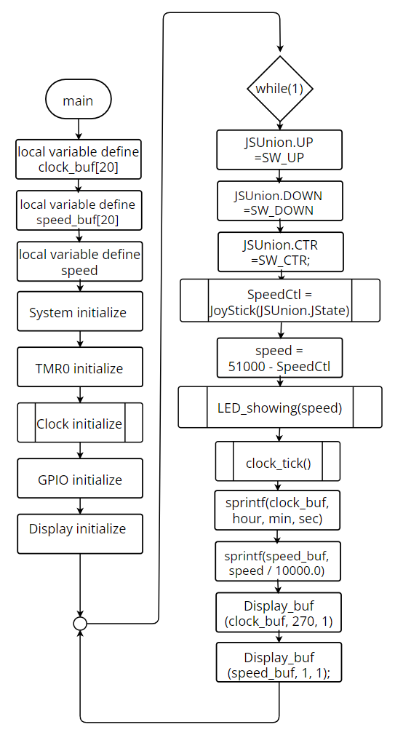

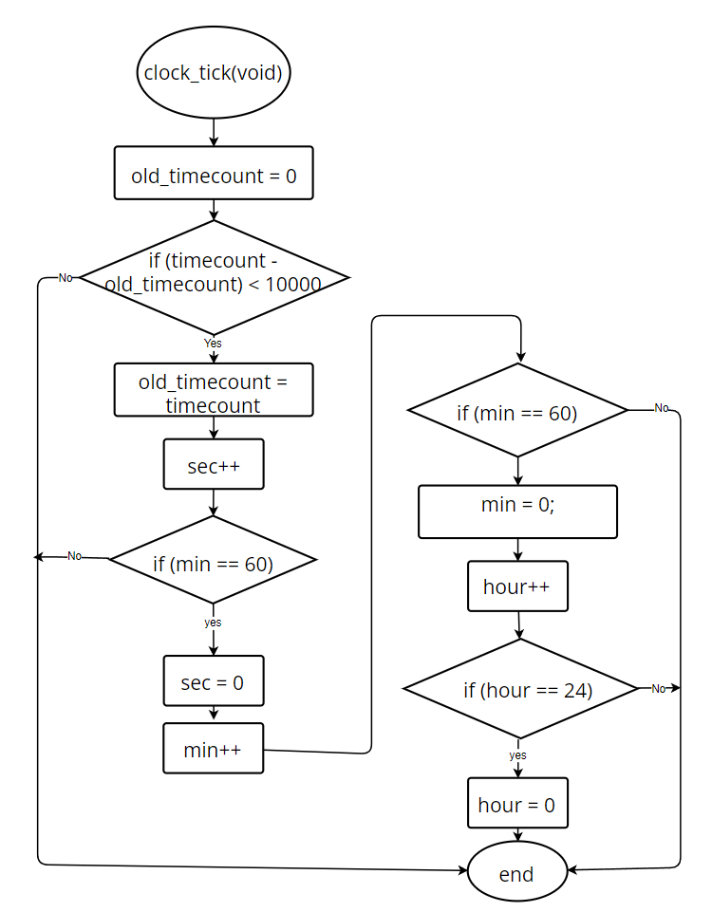

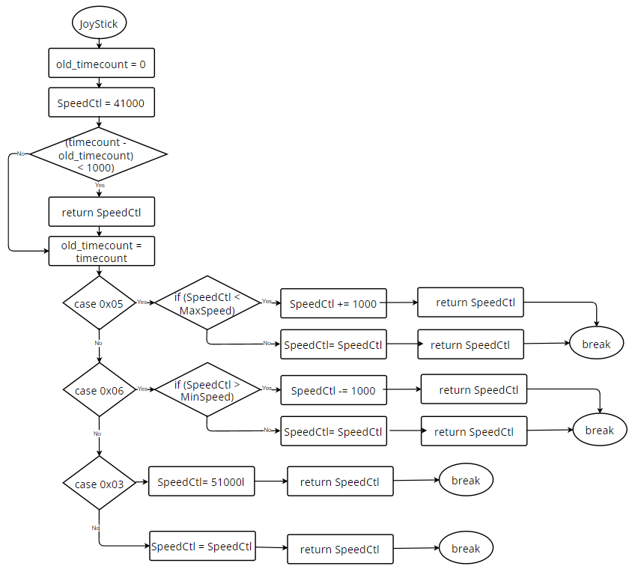

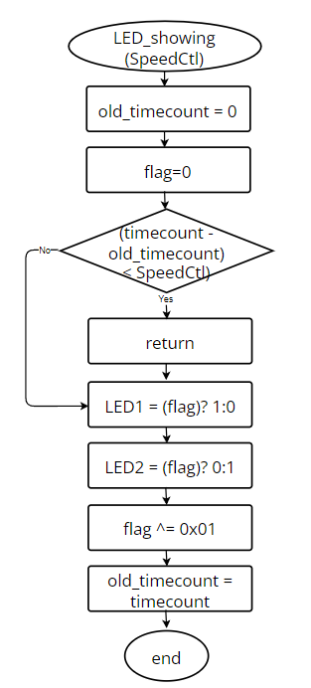

1. Thoughts

This electrical engineering experiment provided me with the opportunity to delve into the applications of Interrupt Service Routine (ISR) and Clock in embedded systems, implementing related code in C language. While initially the code seemed lengthy and the content progressively more complex, as the experiment progressed, I gained a deeper understanding of the importance of ISR and Clock and how they collaborate to ensure the proper functioning of the system.

A noteworthy achievement was reached towards the end of the experiment when we successfully utilized joystick input to adjust the blinking speed of LEDs, which was quite exhilarating for me. However, what intrigued me was the discovery that on the joystick, the button for increasing speed actually slowed down the blinking of LEDs, whereas the button for decreasing speed accelerated the blinking. This phenomenon puzzled me until the assistant explained the underlying reason.

As it turned out, the use of case in the sample code to handle button events resulted in concurrent execution. This meant that when button events occurred, the system simultaneously processed multiple events, resulting in seemingly contradictory functionalities of the buttons. This finding deepened my understanding of concurrent execution in code and taught me how to appropriately handle such situations in practical applications.

Overall, this experiment proved to be quite enriching for me. It not only deepened my understanding of ISR and Clock but also taught me how to control system functionalities using joystick input. Although there were challenges encountered during the experiment, these challenges helped me gain a deeper insight into the workings of embedded systems, laying a solid foundation for my future learning and research endeavors.