Digital Lab 4:

Experiment 3:

Stepper Motor Control

Date: 2024/04/02

Class: 電機三全英班

Group: Group 11

Name: B103105006 胡庭翊

1. Annotated Code

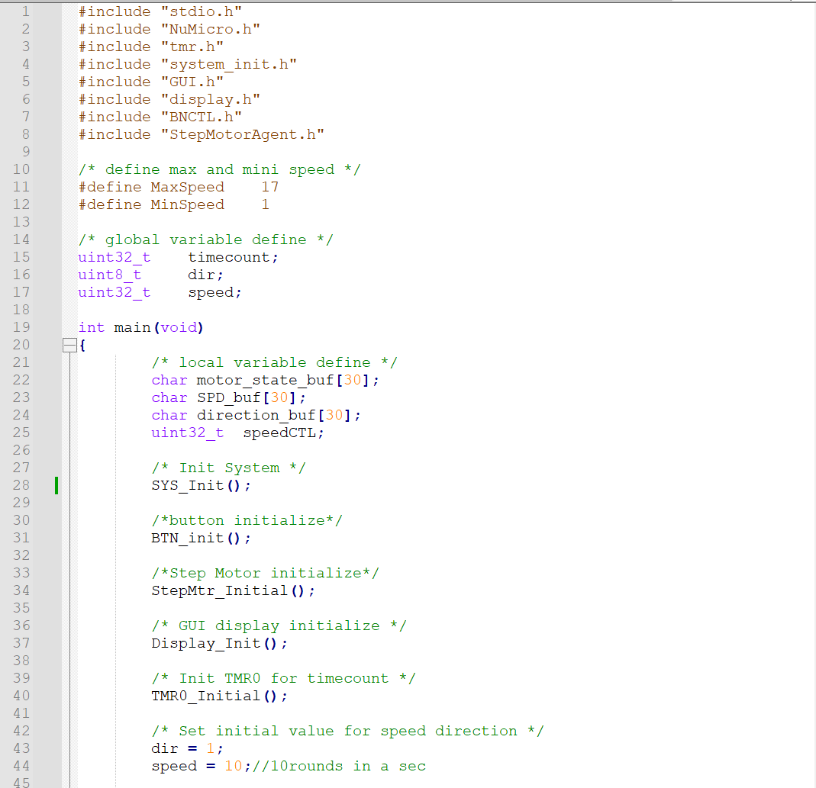

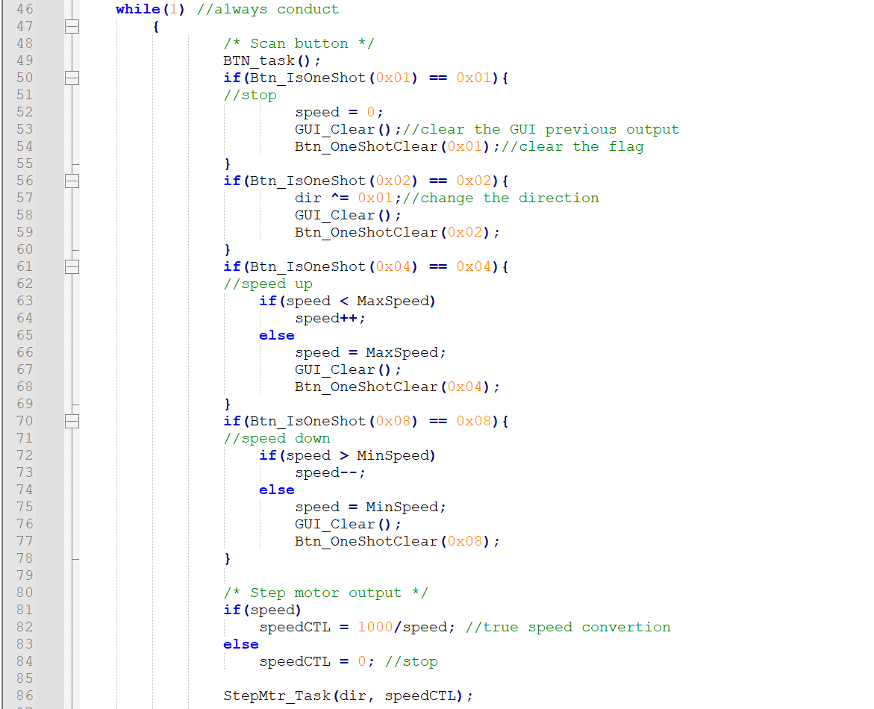

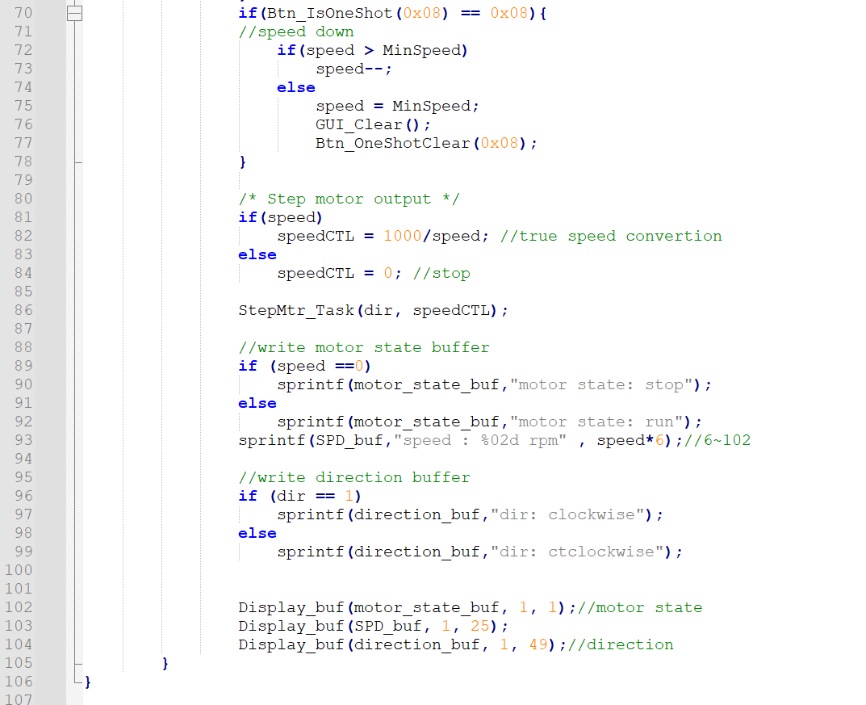

1. Program Flow

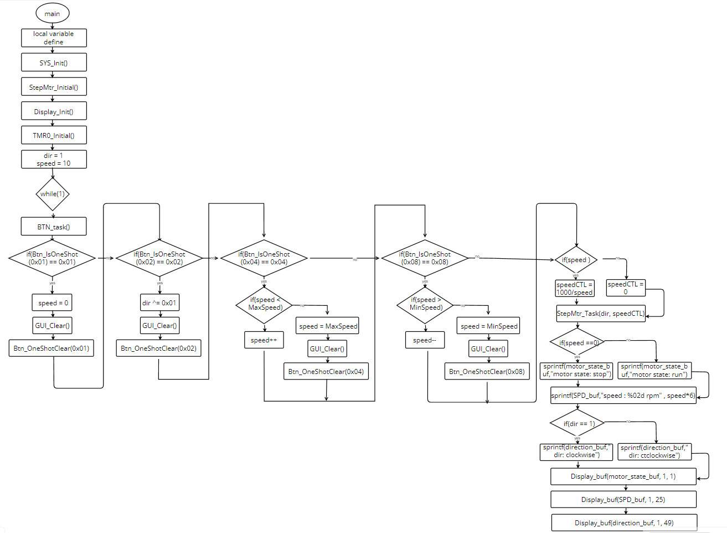



1. Thoughts

This electrical engineering experiment provided me with the opportunity to further understand the control principles of stepper motors. We used C language to control the stepper motor, building upon our familiarity with stepper motor principles from the previous semester where we worked with Verilog. This time, we utilized C language along with the one-shot function, coupled with ULN2003A and M487 boards, to control the speed and direction of the motor and display its current status on the board's screen.

During the experiment, we encountered some challenges, particularly in understanding the interaction between C language and hardware. However, through careful reading of documentation and hands-on experience, we gradually learned how to use the one-shot function to control the stepper motor and successfully achieved speed and direction control. The most exciting part was successfully displaying the current status of the stepper motor on the board's screen, which left us feeling fulfilled and proud.

Through this experiment, we not only deepened our understanding of the control principles of stepper motors but also improved our ability to interact with hardware in the C language environment. Additionally, the challenges we faced during the experiment helped us become more familiar with troubleshooting and problem-solving techniques. Overall, this experiment was a valuable learning experience that laid a solid foundation for our future research and applications in related fields.