Digital Lab 4:

Experiment 4:

Analog Interface Control

Date: 2024/04/09

Class: 電機三全英班

Group: Group 11

Name: B103105006 胡庭翊

1. Annotated Code

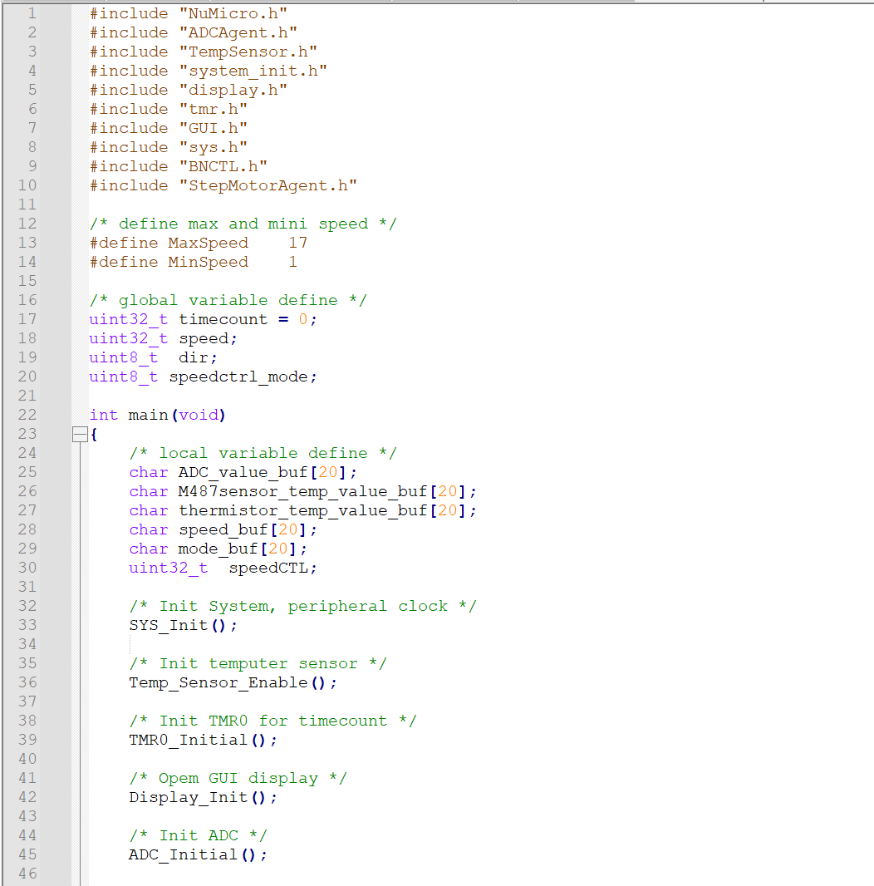

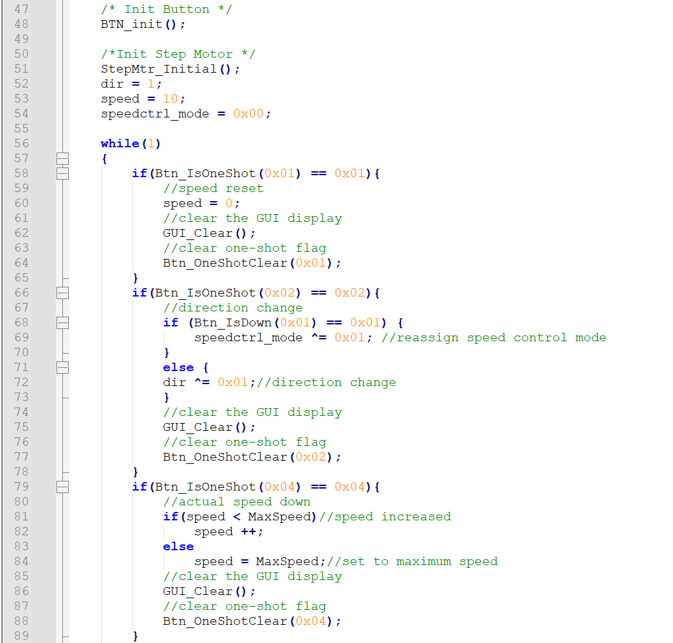

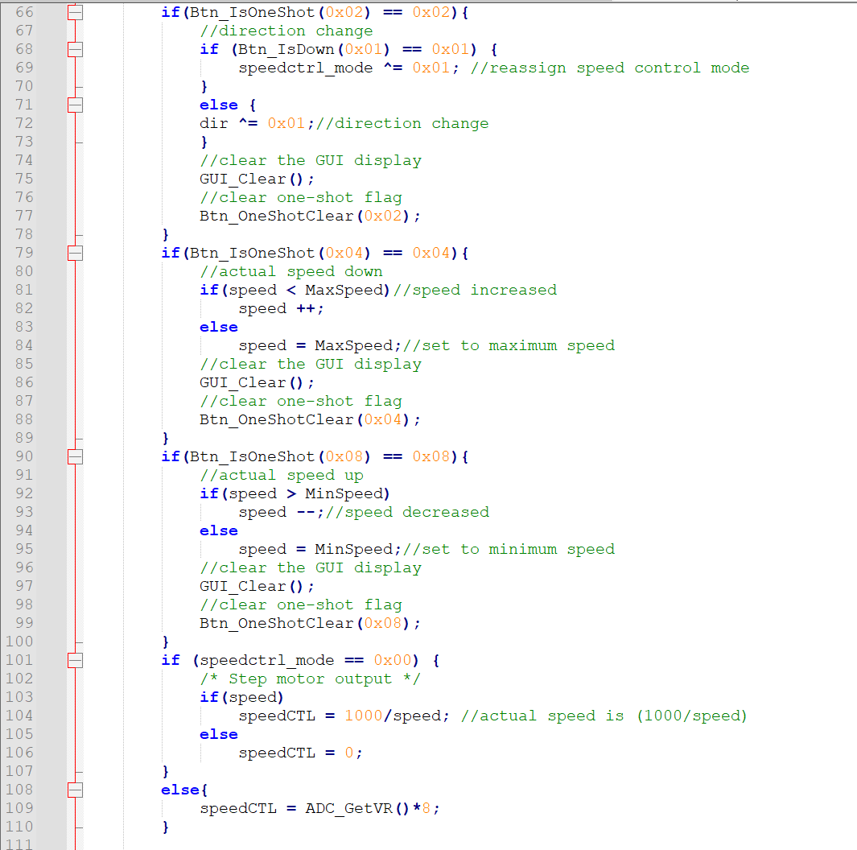

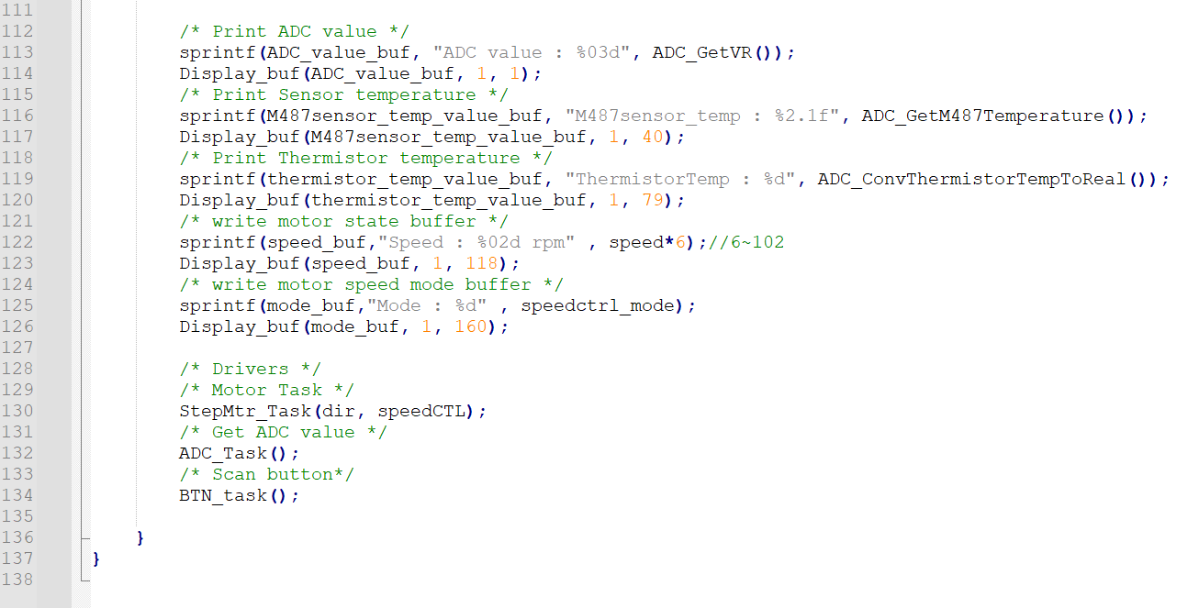

1. Program Flow

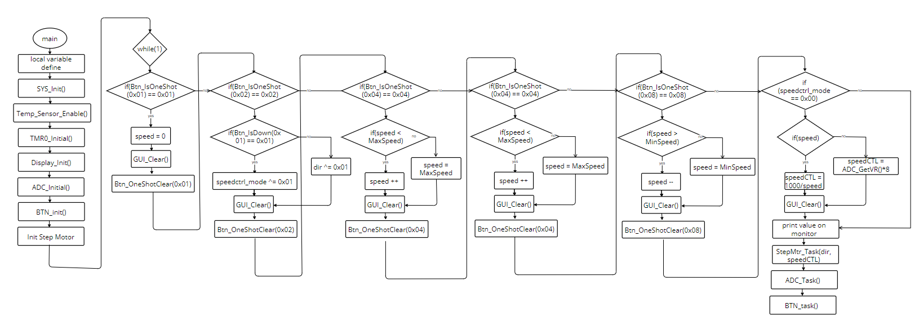

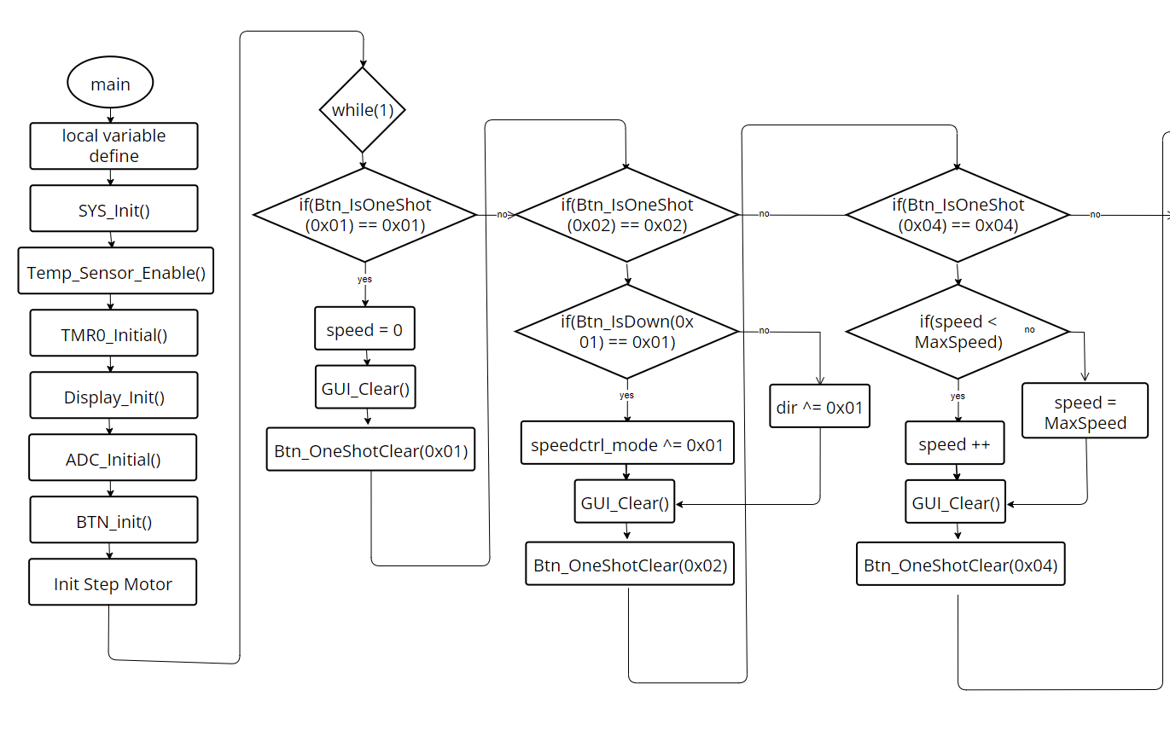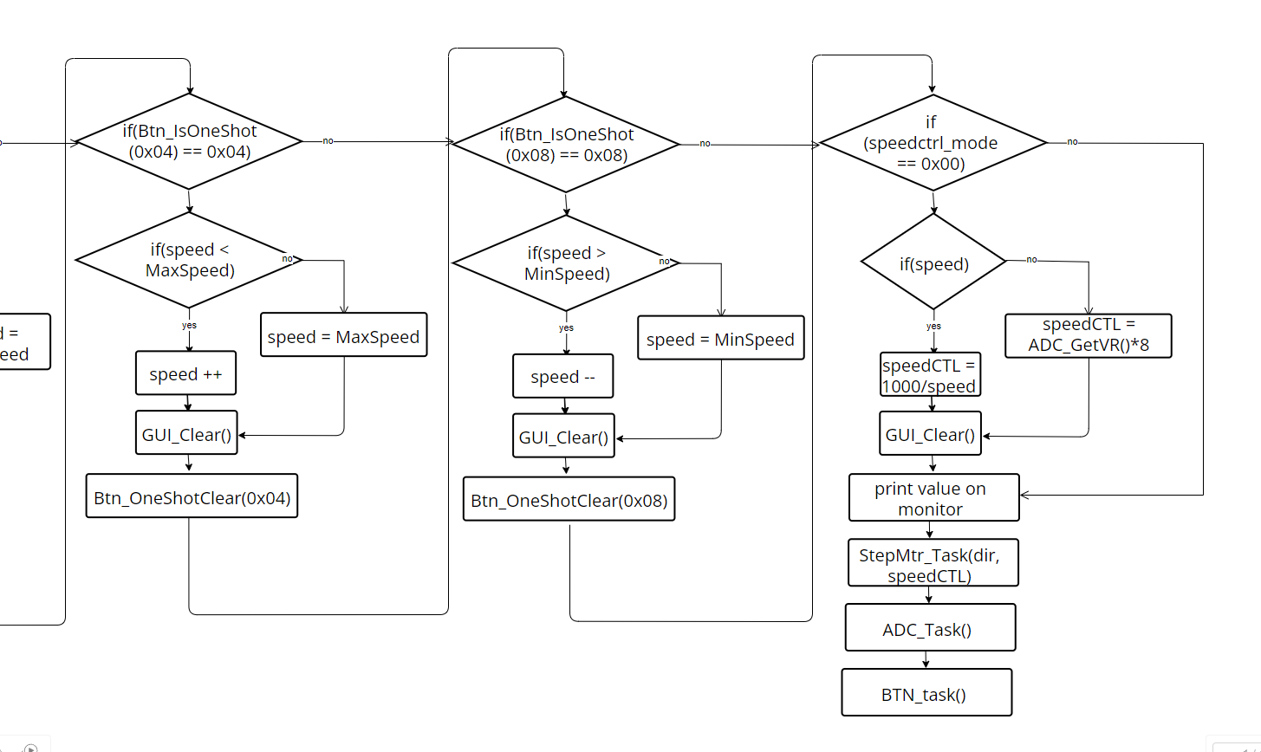

1. Thoughts

The experiment this time involved utilizing C language in conjunction with a stepper motor to achieve Analog Interface Control. Having already experimented with controlling stepper motors using C language in the previous session, this experiment provided an opportunity to further explore this field. Utilizing the same circuit board we soldered in the previous experiment, we aimed to become familiar with the embedded program structure for analog interface control and design a structured program for multiple mode control in embedded programming.

The familiarity with controlling stepper motors using C language from the previous experiment served as a solid foundation for this task. However, delving into analog interface control presented its own set of challenges. We needed to understand how to integrate analog signals into our program effectively, ensuring smooth and precise control over the stepper motor.

One of the highlights of this experiment was designing a structured program for multiple mode control in embedded programming. This required careful planning and organization of code to accommodate different control modes while maintaining efficiency and readability.

Overall, this experiment provided a valuable learning experience, allowing us to deepen our understanding of embedded programming concepts and further hone our skills in C language. By successfully completing Analog Interface Control and designing a structured program for multiple mode control, we gained valuable insights into the complexities of embedded systems and the importance of structured programming in such contexts.