Digital Lab 4:

Experiment 5:

Communication Interface

Date: 2024/04/23

Class: 電機三全英班

Group: Group 11

Name: B103105006 胡庭翊

1. Annotated Code

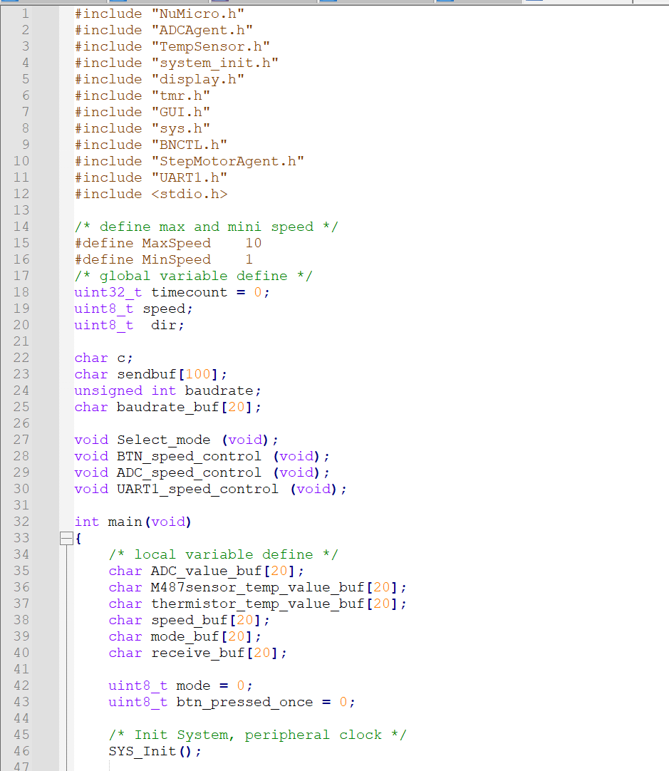

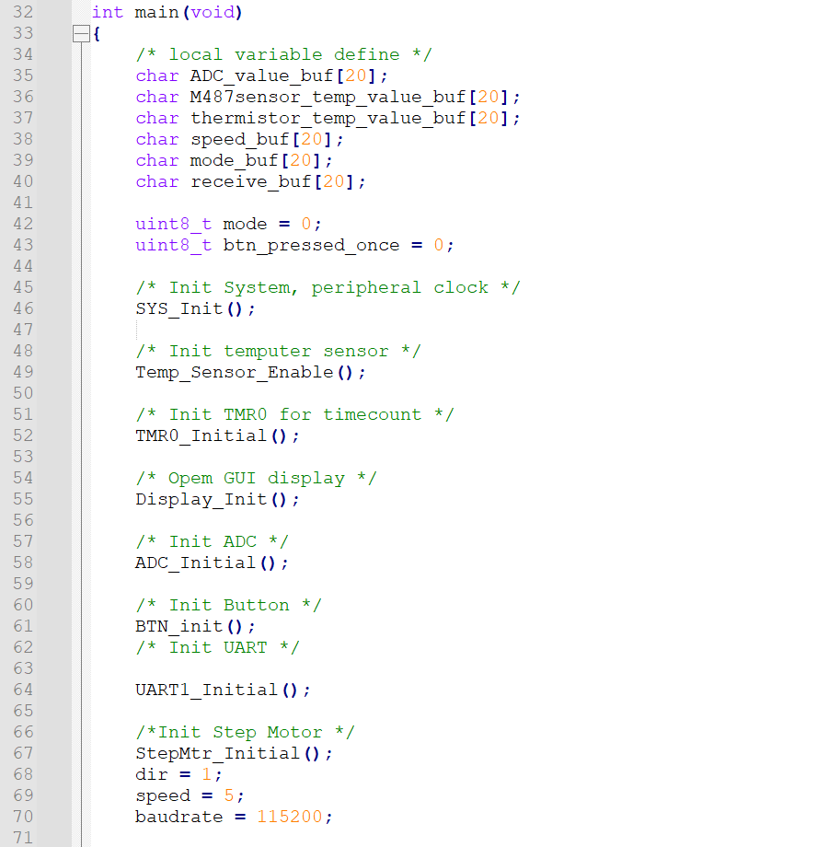

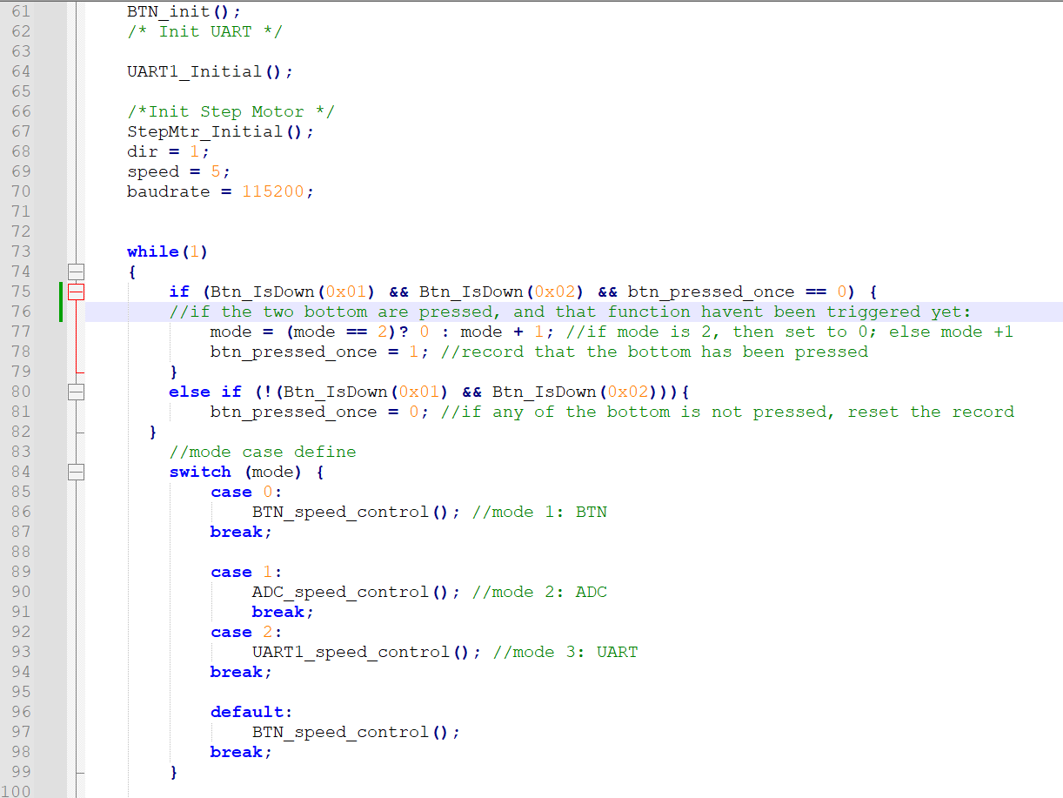

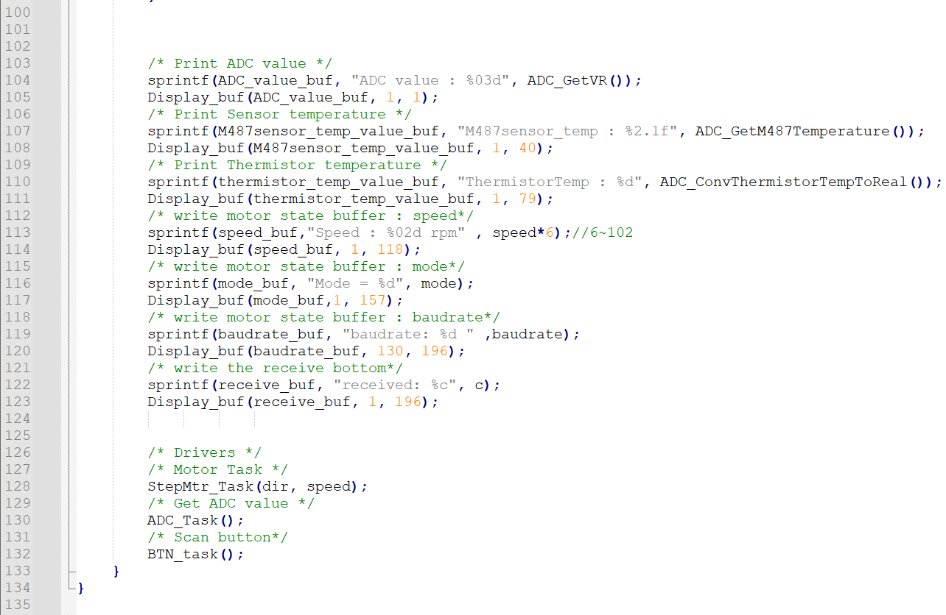

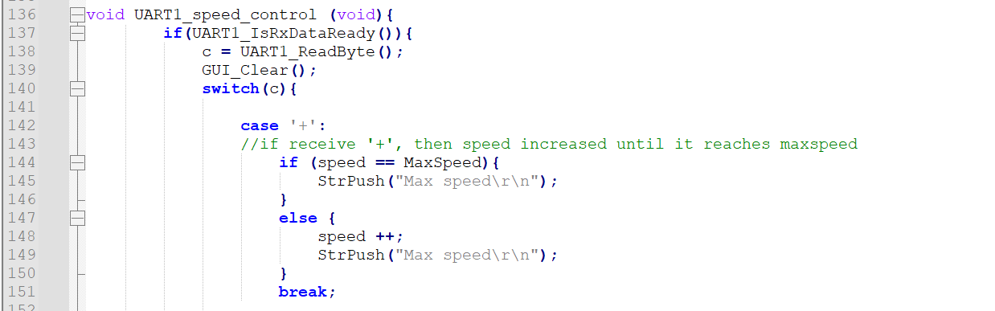

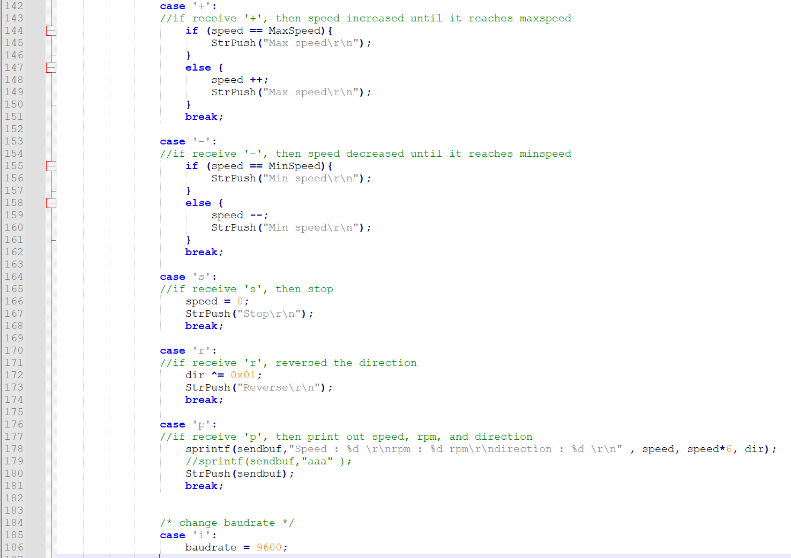

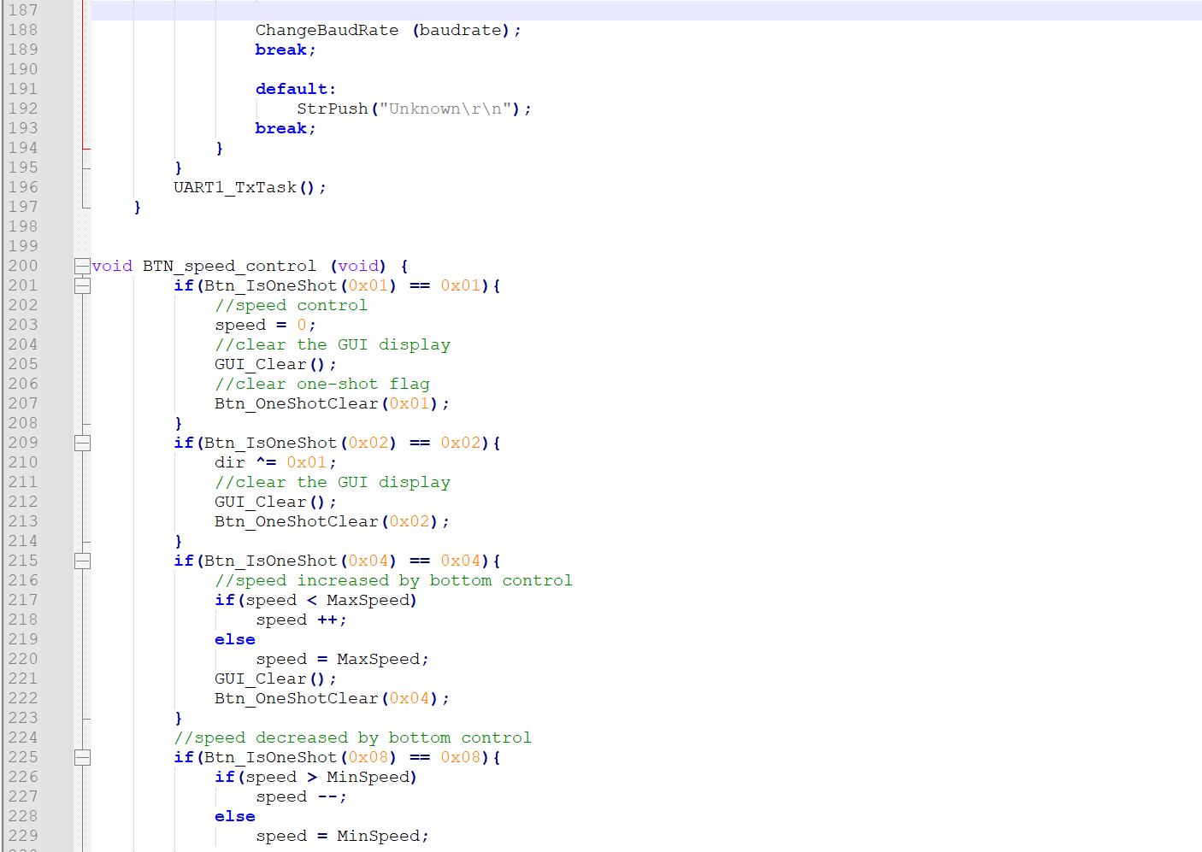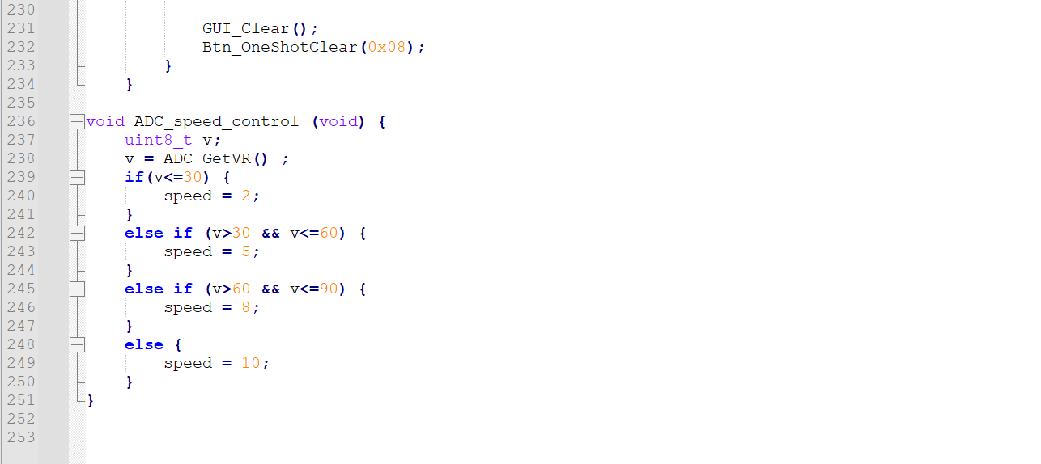

1. Program Flow

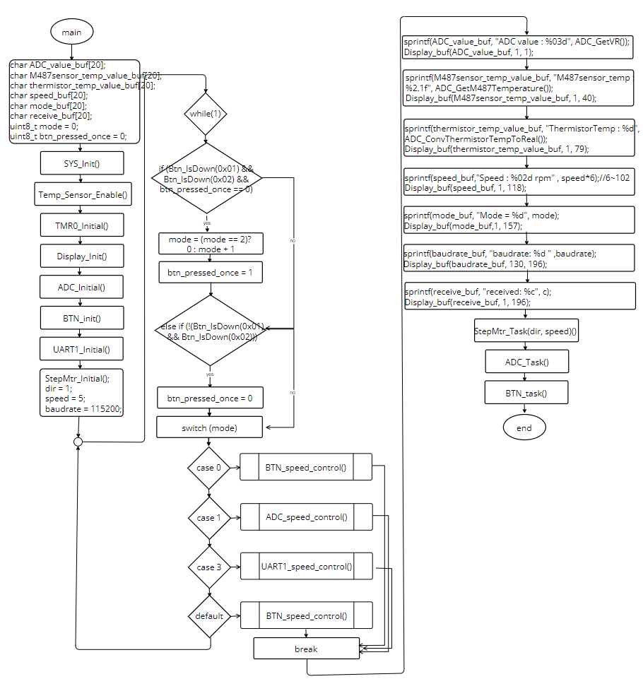

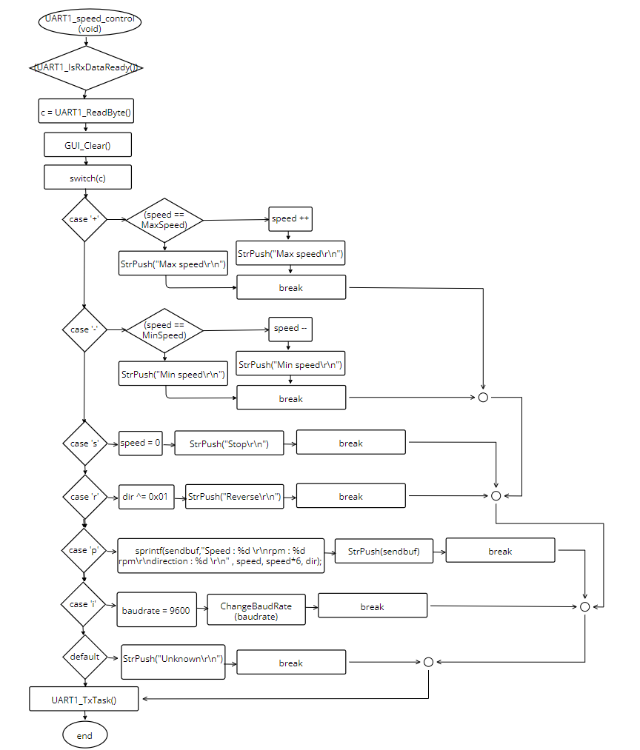

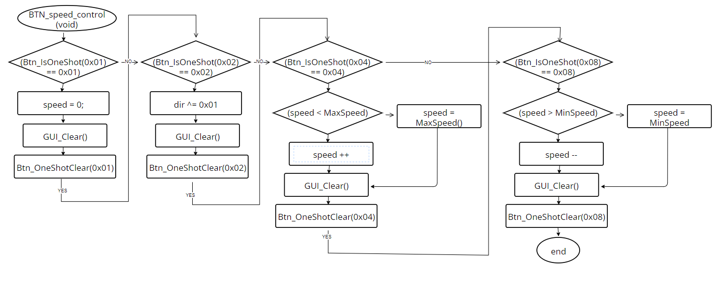

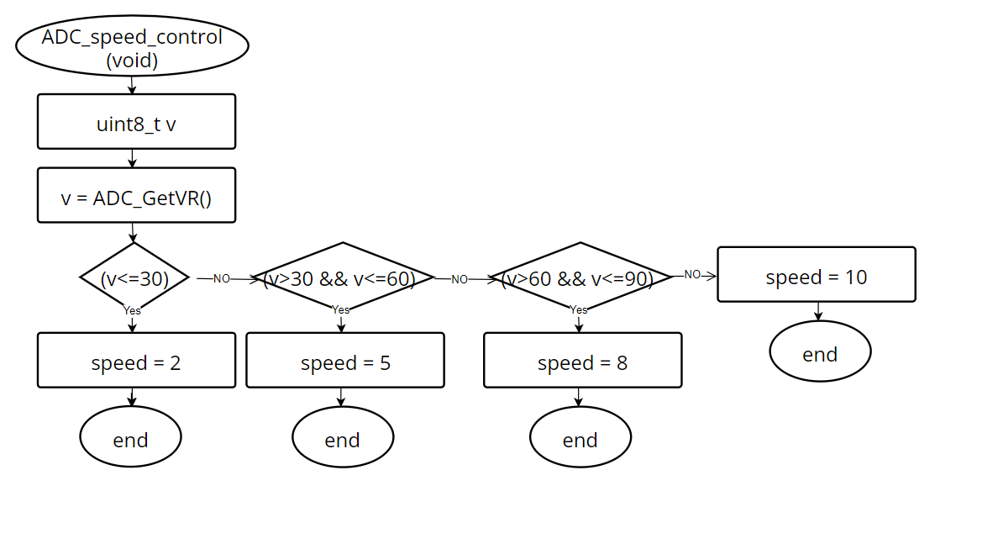

1. Thoughts

In this experiment, we delved into the realm of Communication Interface by employing C language, Stepper Motor, UART communication interface, and RealTerm Software. Having previously gained experience in controlling stepper motors using C and displaying information such as speed and direction on the board, this experiment built upon our prior knowledge. Utilizing the same circuit board we assembled in the previous experiments, we aimed to establish remote transmission control via UART and enable remote control of the stepper motor by inputting commands from a computer.

This experiment provided invaluable insights into designing communication programs in embedded programming. We learned how to establish communication channels between embedded systems and external devices, facilitating remote control and data exchange. By leveraging UART communication interface and RealTerm Software, we successfully implemented remote transmission control, enabling us to manipulate the stepper motor's actions through commands input from the computer.

Through this experiment, I realized the importance of systematic design in embedded programming, especially in communication interfaces. Each iteration of experiments contributed to the refinement and completeness of our stepper motor program. It's fascinating to witness the evolution of our stepper motor program, from its initial stages to its current state of robustness and versatility.

Overall, this experiment not only expanded our understanding of communication interfaces in embedded systems but also underscored the significance of iterative learning in engineering. It's gratifying to see how our efforts and learning experiences have contributed to the enhancement of our skills and the refinement of our projects.