Exercise: Create a React App for a Book Store
In this exercise, you'll create a simple React application that simulates a book store. The application will allow users to add new books to a collection and display them in a table. Below are the detailed instructions for each part of the app.

1. Home Page
- Create a component called Home which:
  - Displays a heading like "Welcome to Book Manager".
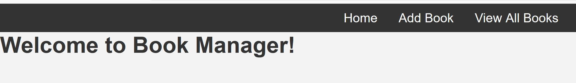

2. Add Book Page
- Create a component called AddBook.
  - This page should include a form with fields for the book title and price.
  - When the form is submitted, the new book's title and price should be added to an array and a message should be displayed like the picture below.
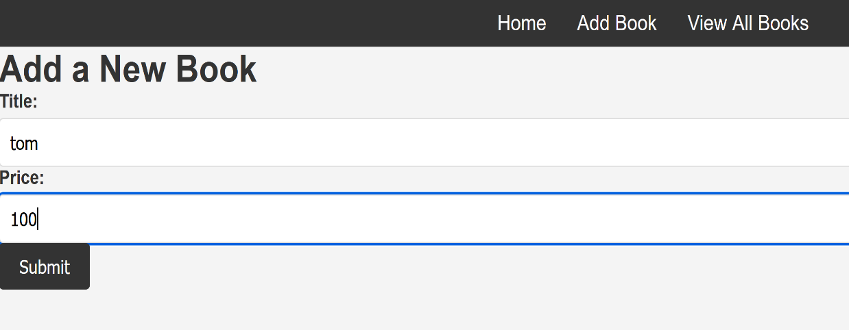

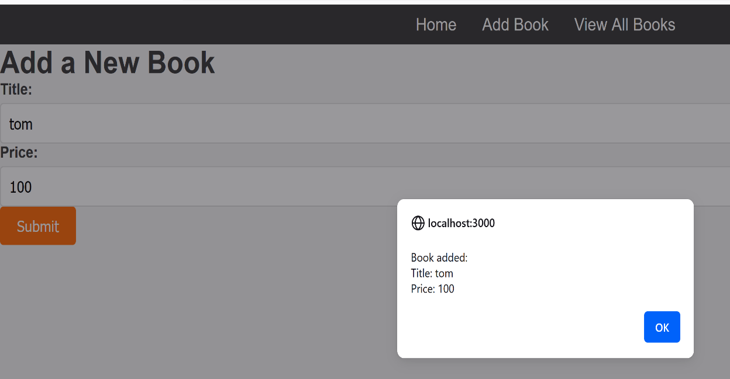

3. Display Books
- After adding a new book, the books should be displayed in a table on DisplayBooks component
