**Supplementary Material**

**Supplementary Figure 1: Rolling 14-day Average COVID-19 Cases as reported by aggregate counts to the Centers for Disease Control and Prevention and COVID-19 cases reported to person-level national COVID-19 Case Surveillance with complete race and ethnicity information, 50 U.S. States, Date Range: 04/05/2020 – 12/01/2021**

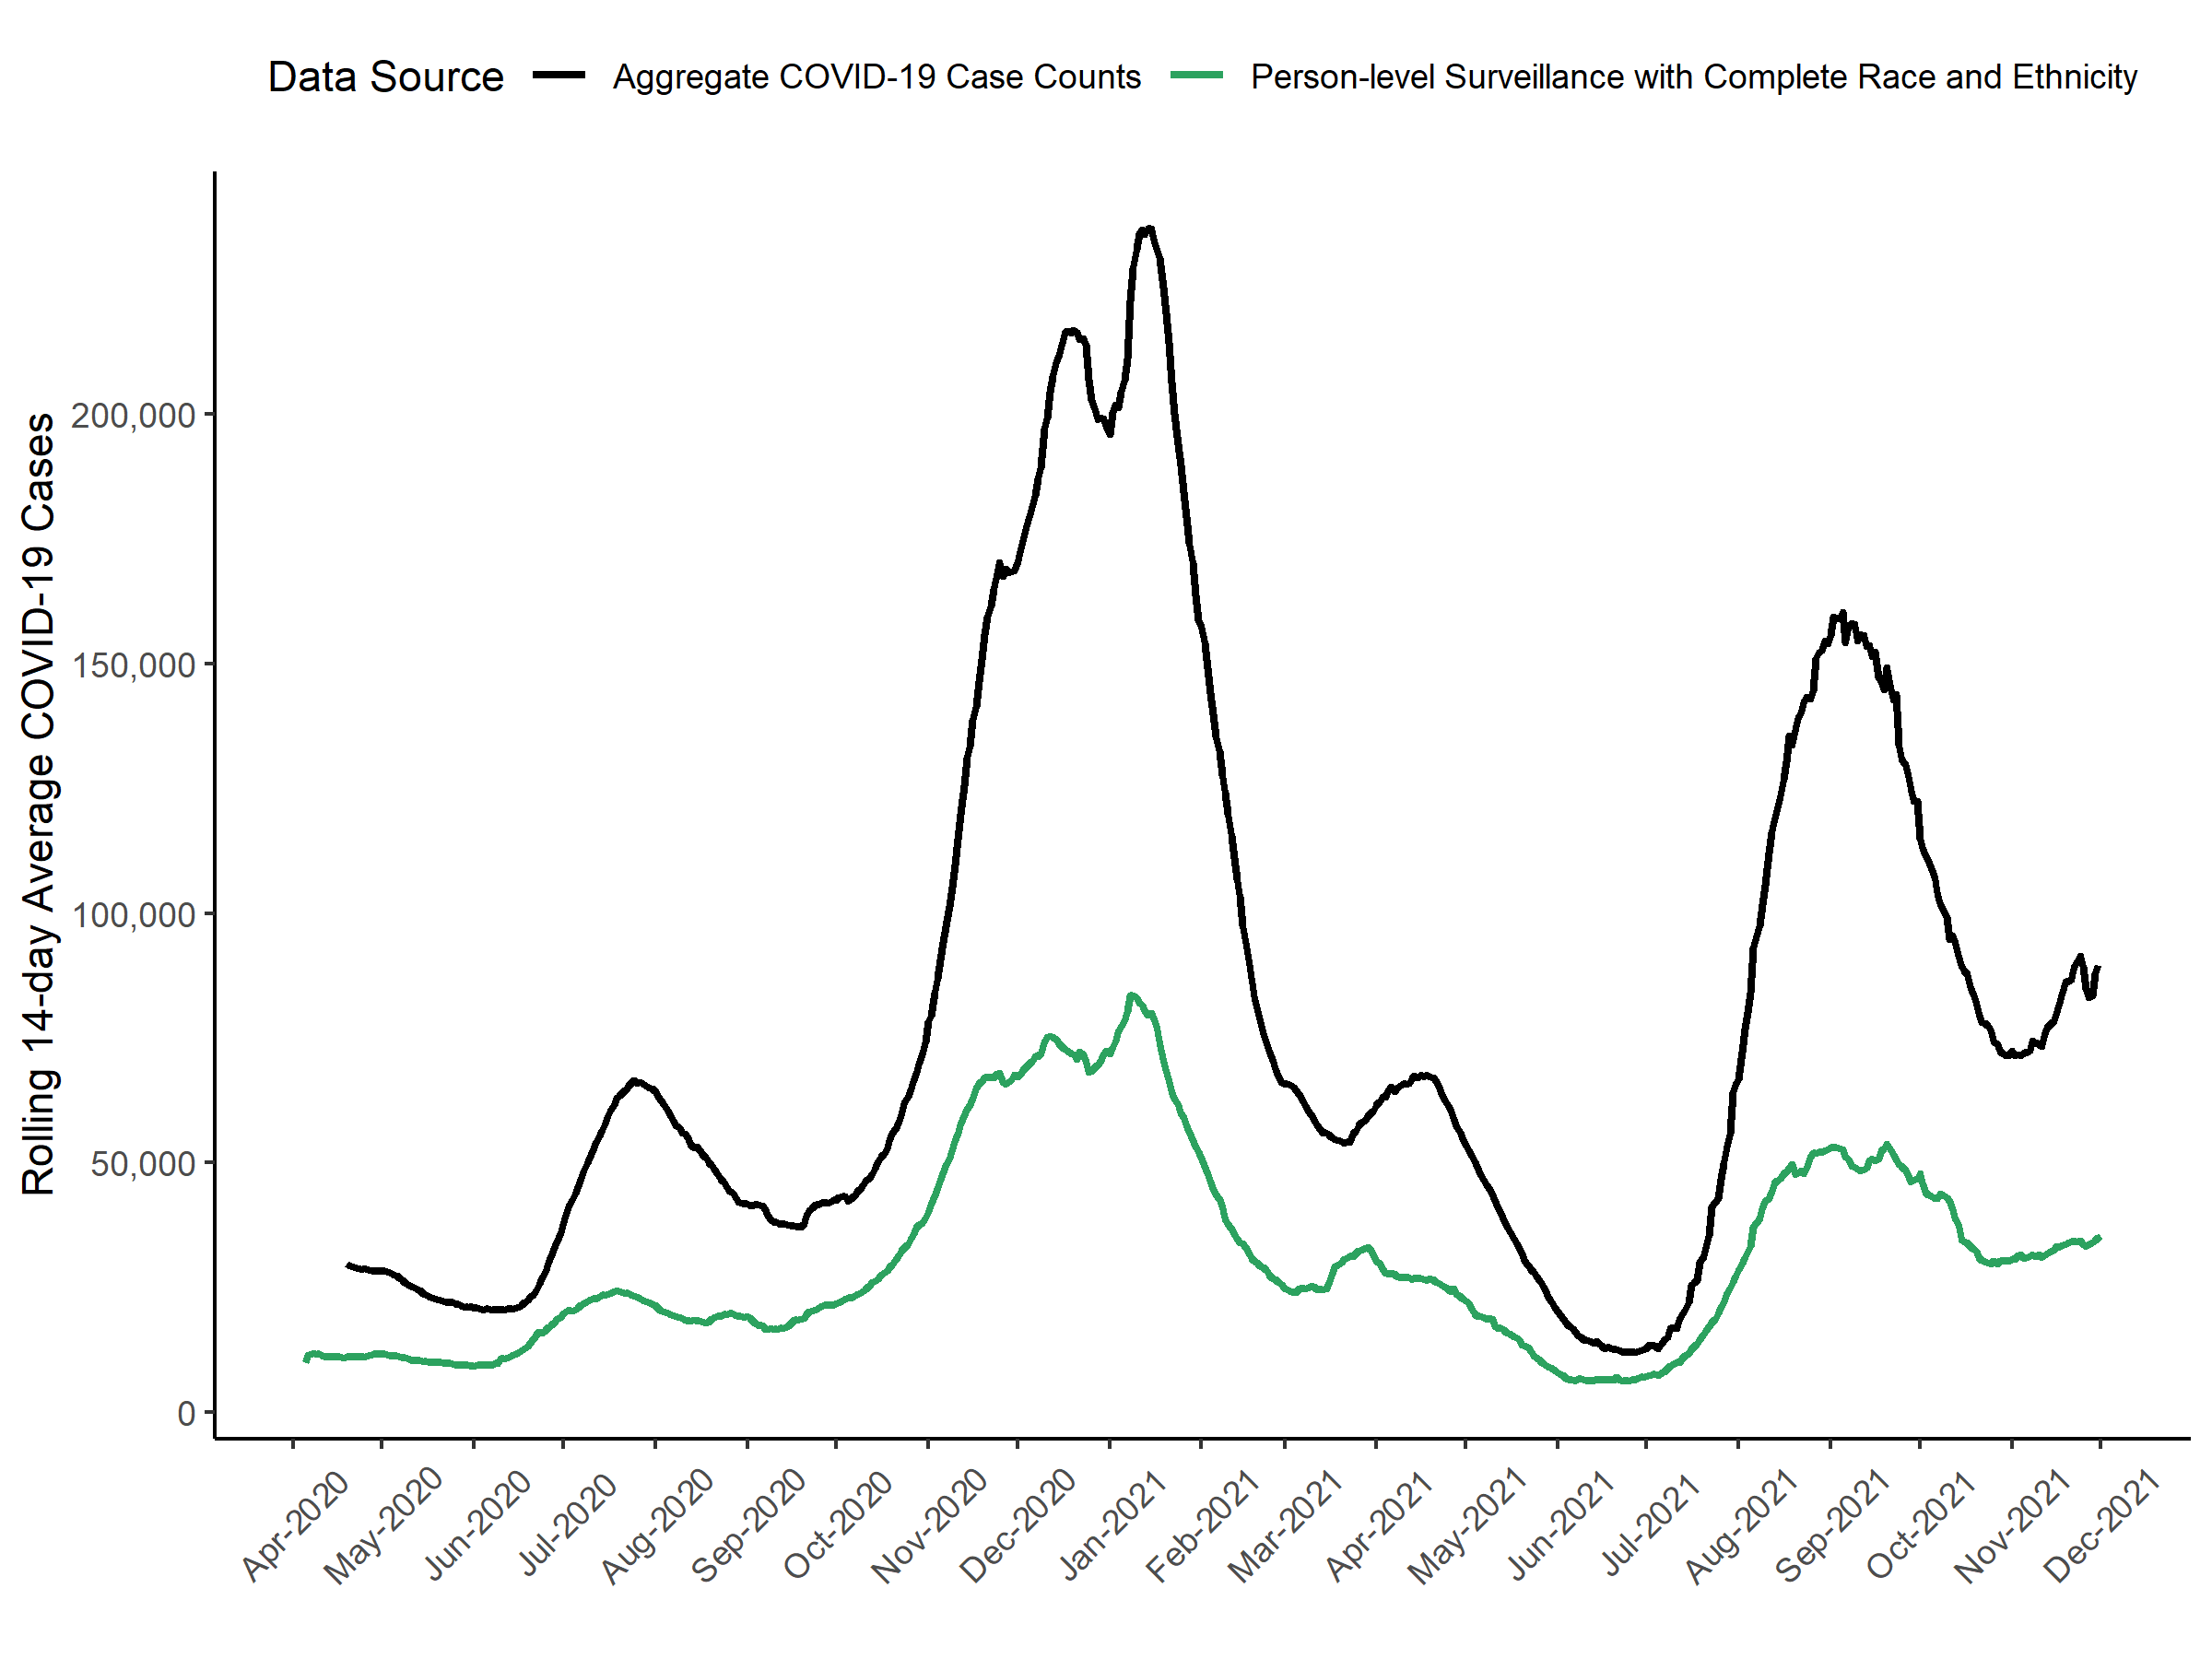

**Supplementary Figure 2: Rolling 14-day Average Percentage COVID-19 Cases of COVID-19 cases reported to person-level national COVID-19 Case Surveillance with complete race and ethnicity information, 50 U.S. States, Date Range: 04/05/2020 – 12/01/2021**

