###############-------------- ASG----------------#################

- Create one VPC in N. Virginia region.s
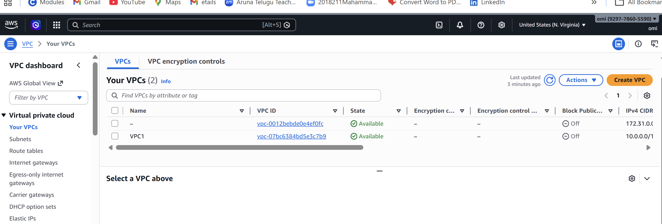
- Create two subnets: one public subnet and one private subnet.
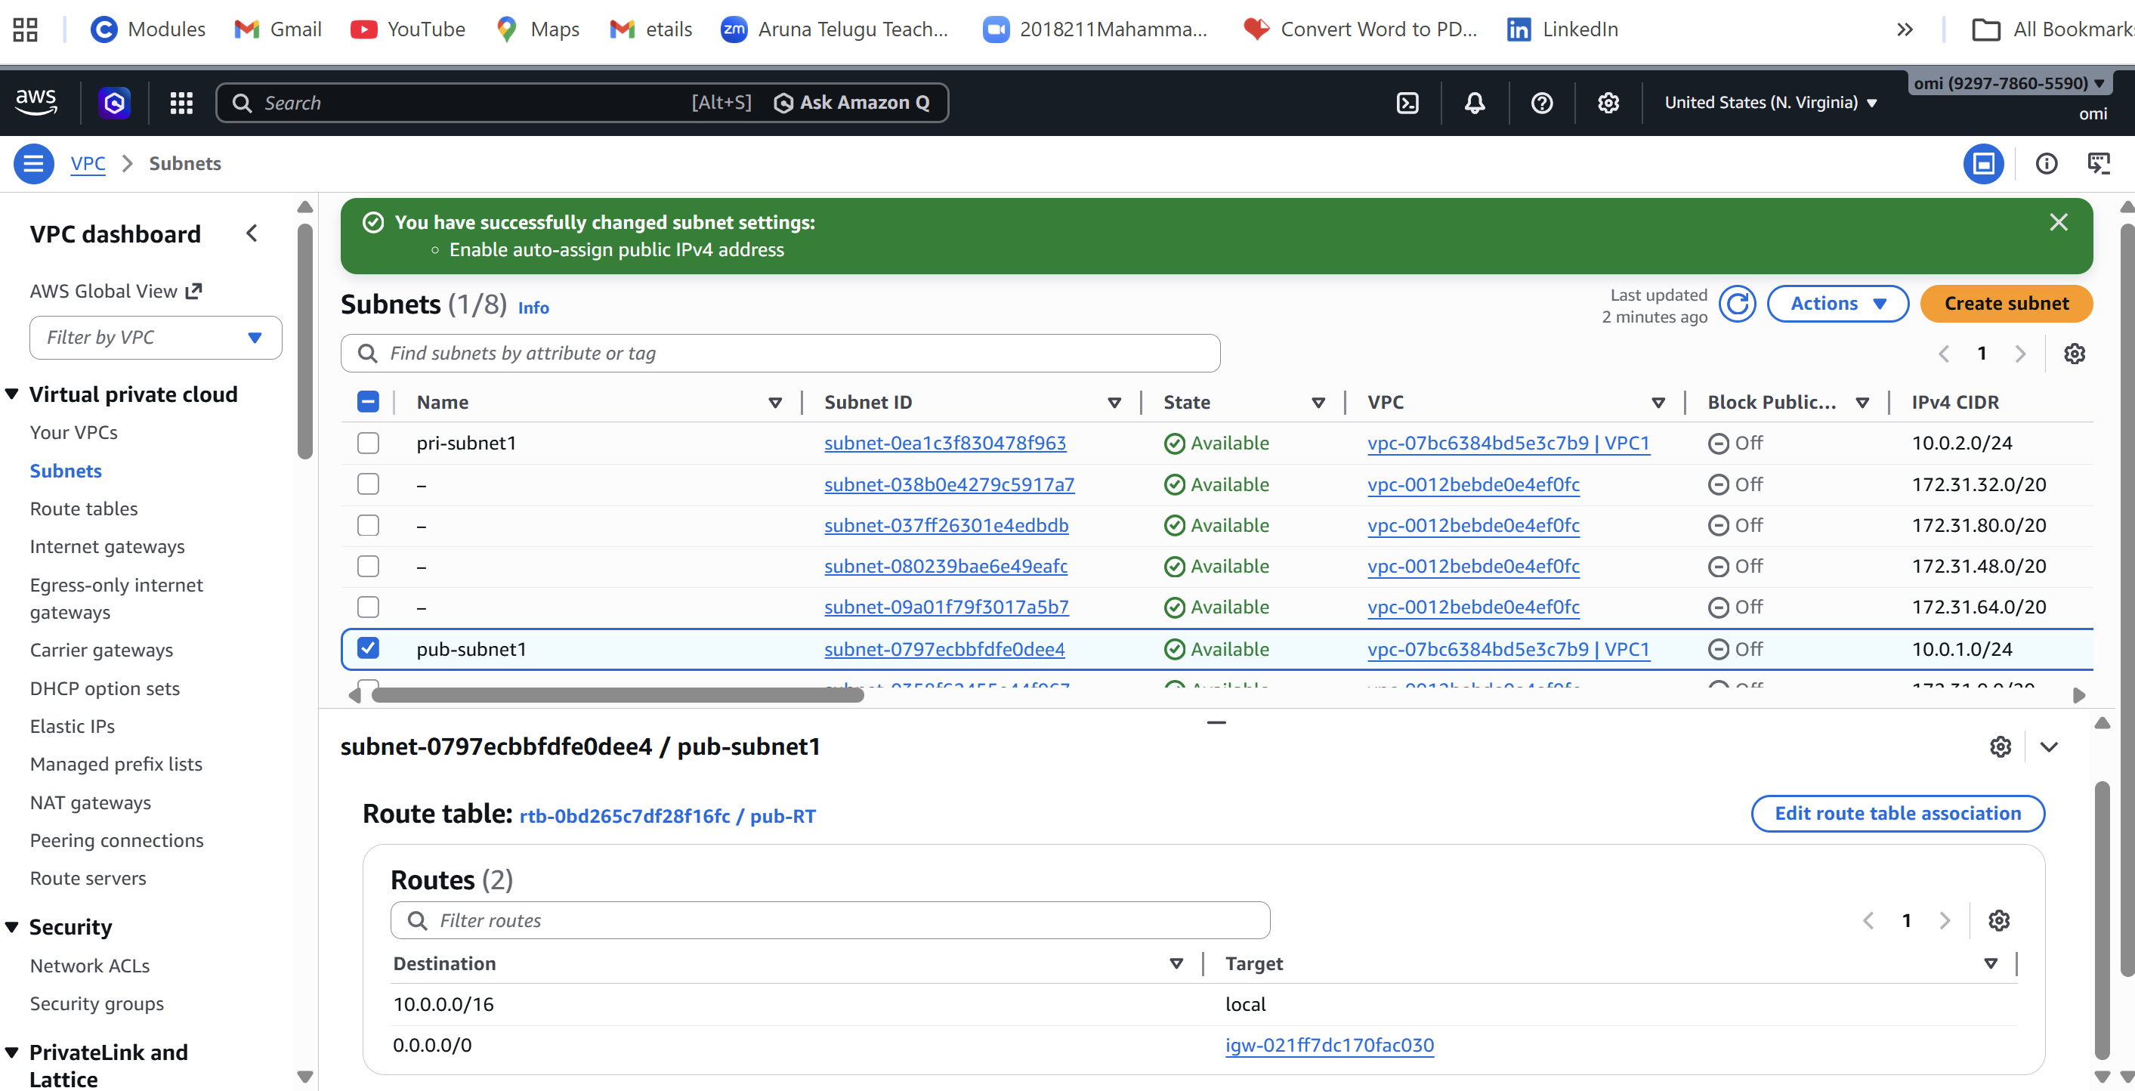
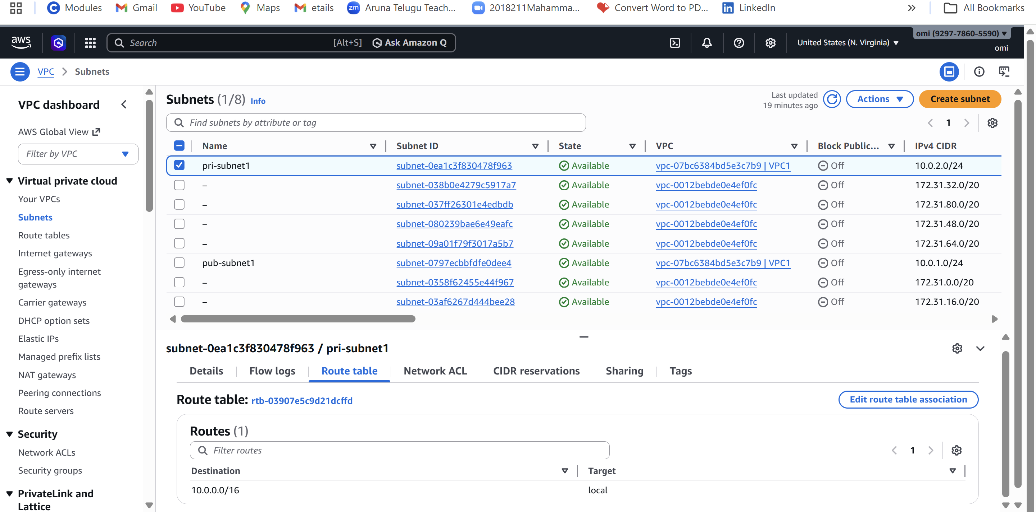
- Attach an IGW to the VPC.
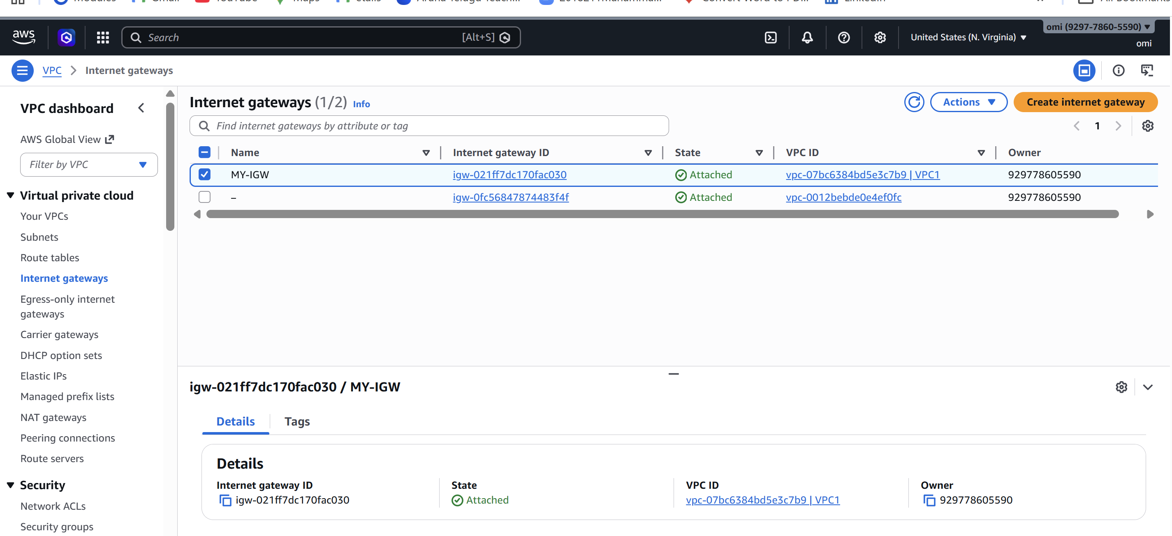
- Create one public route table (RT) and one private route table.
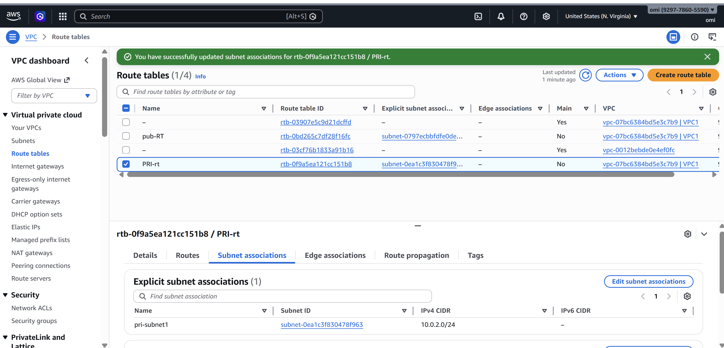
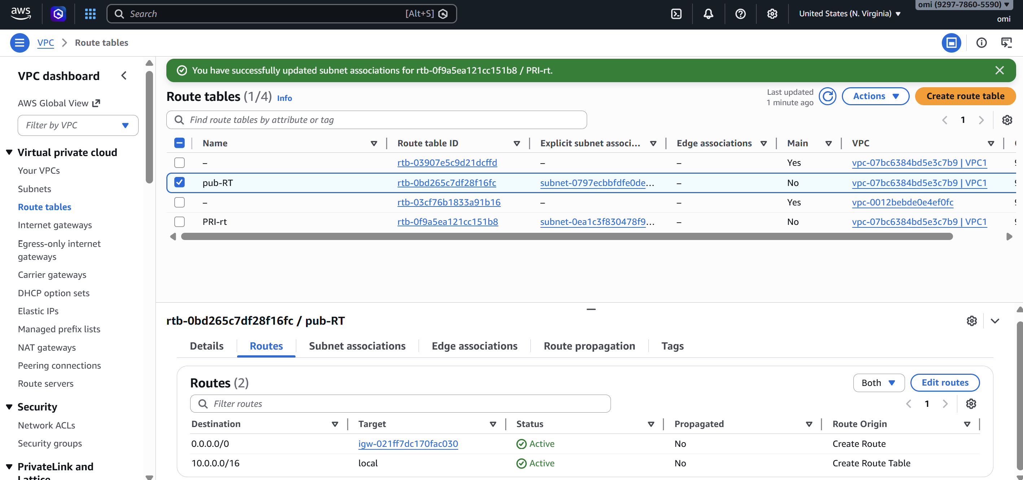
- Deploy a NAT gateway in the public subnet and attach the NAT gateway to the private subnet.
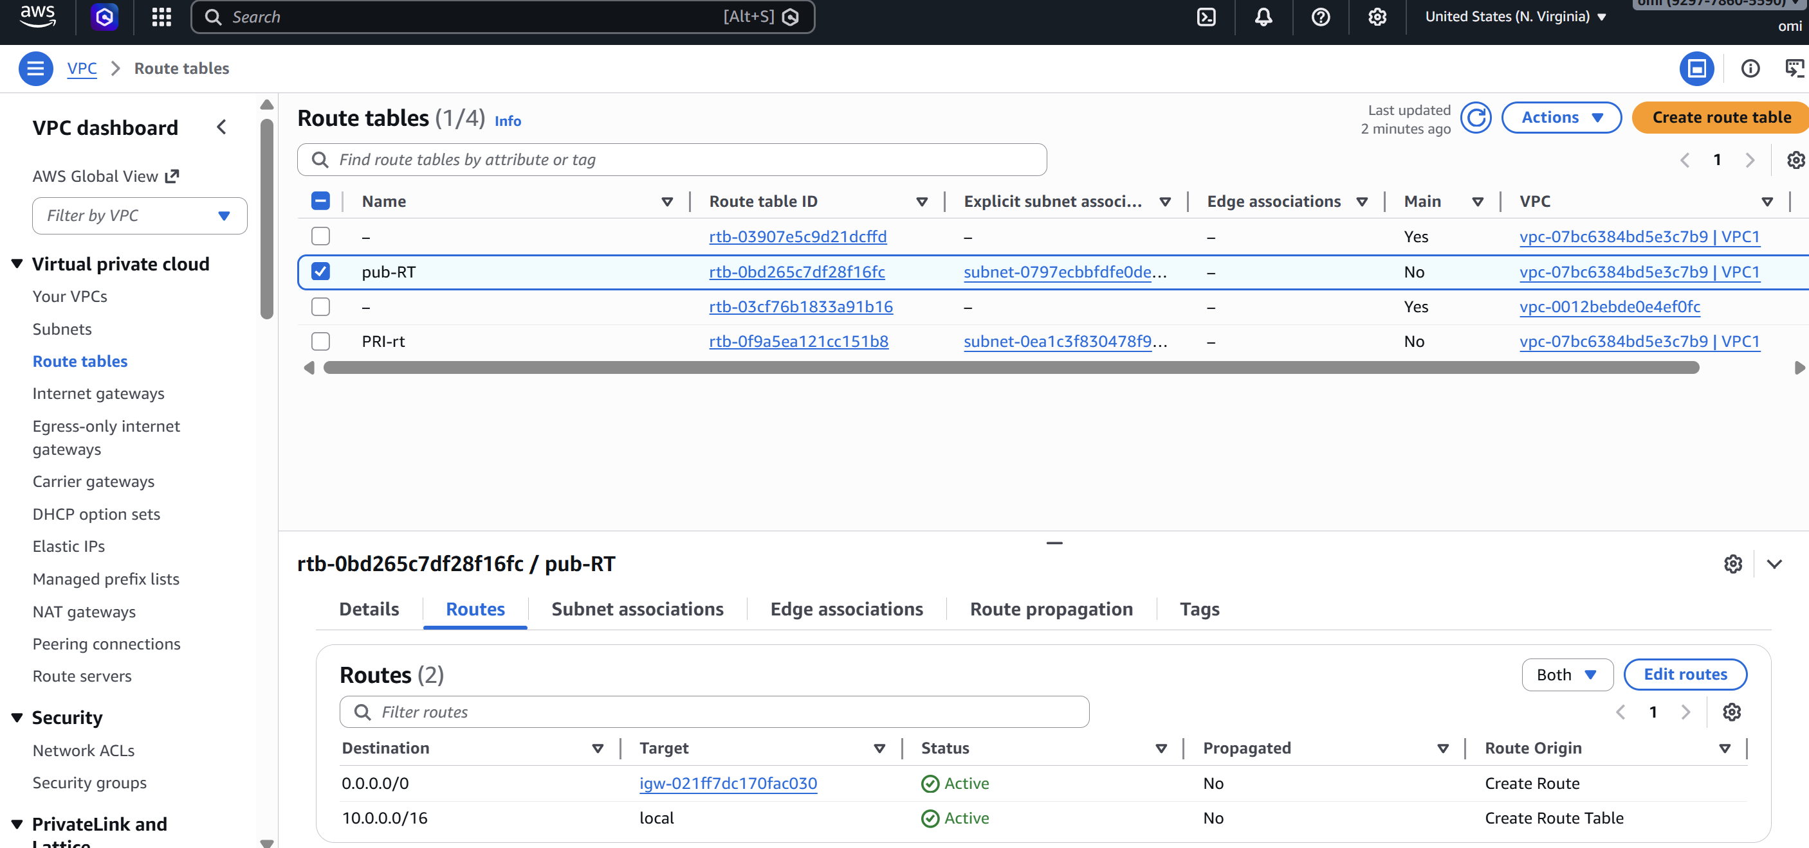
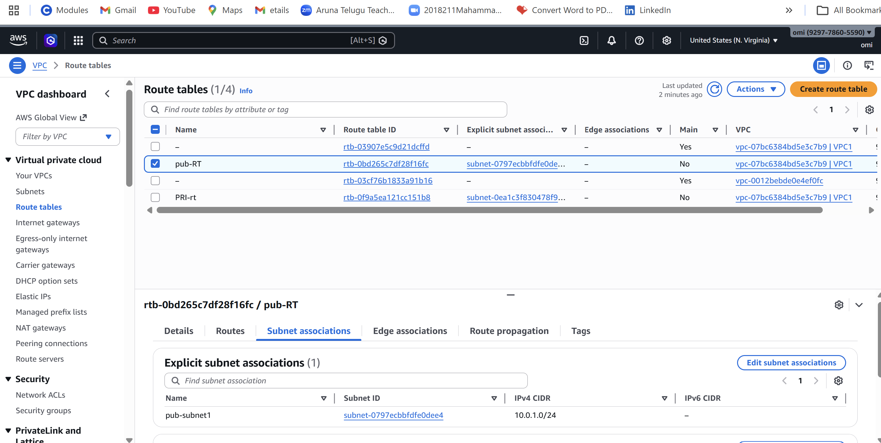

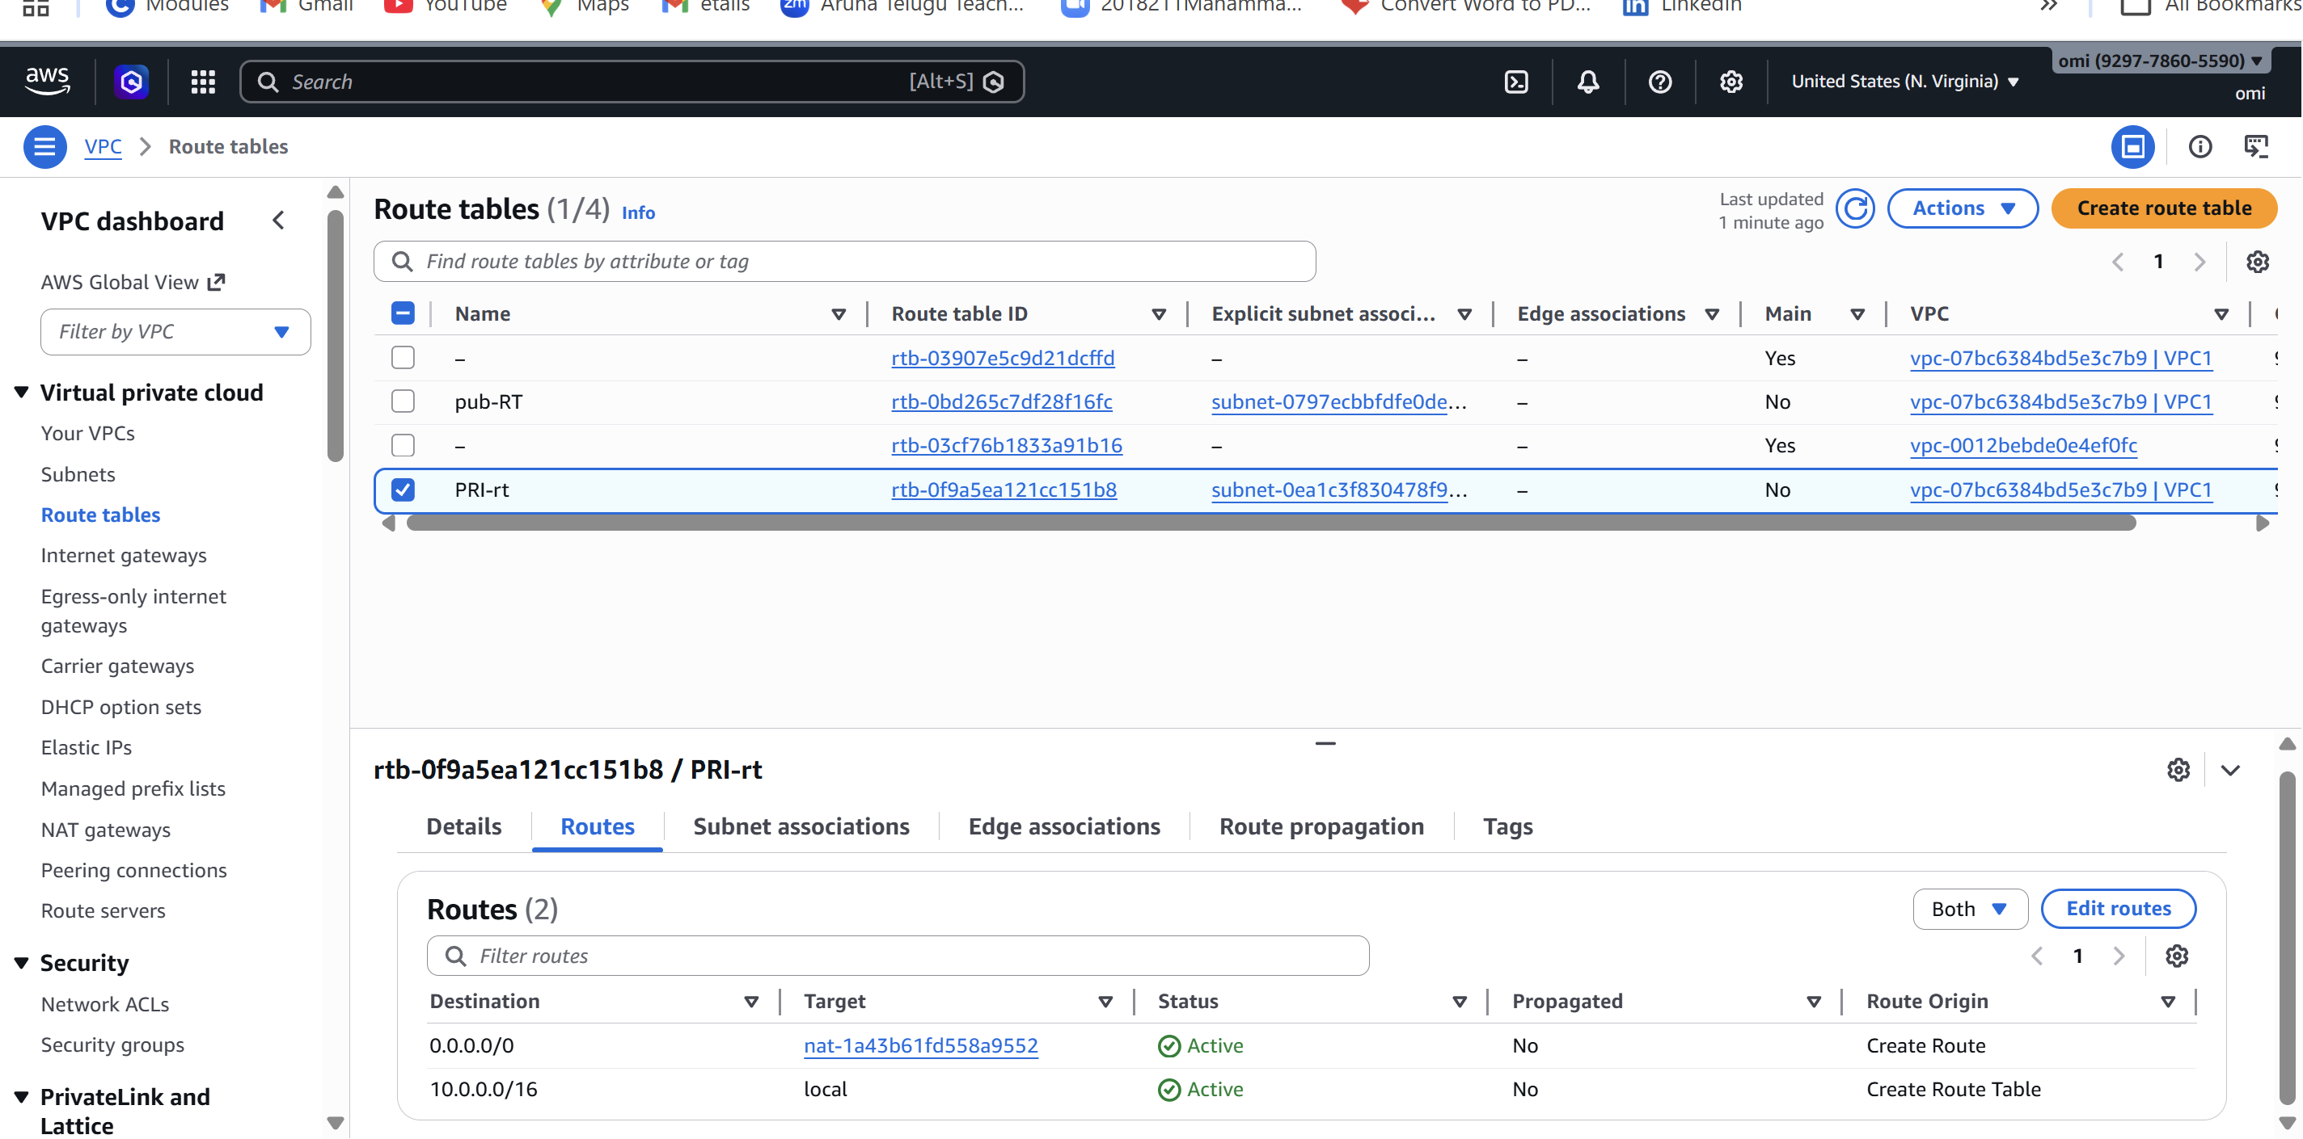
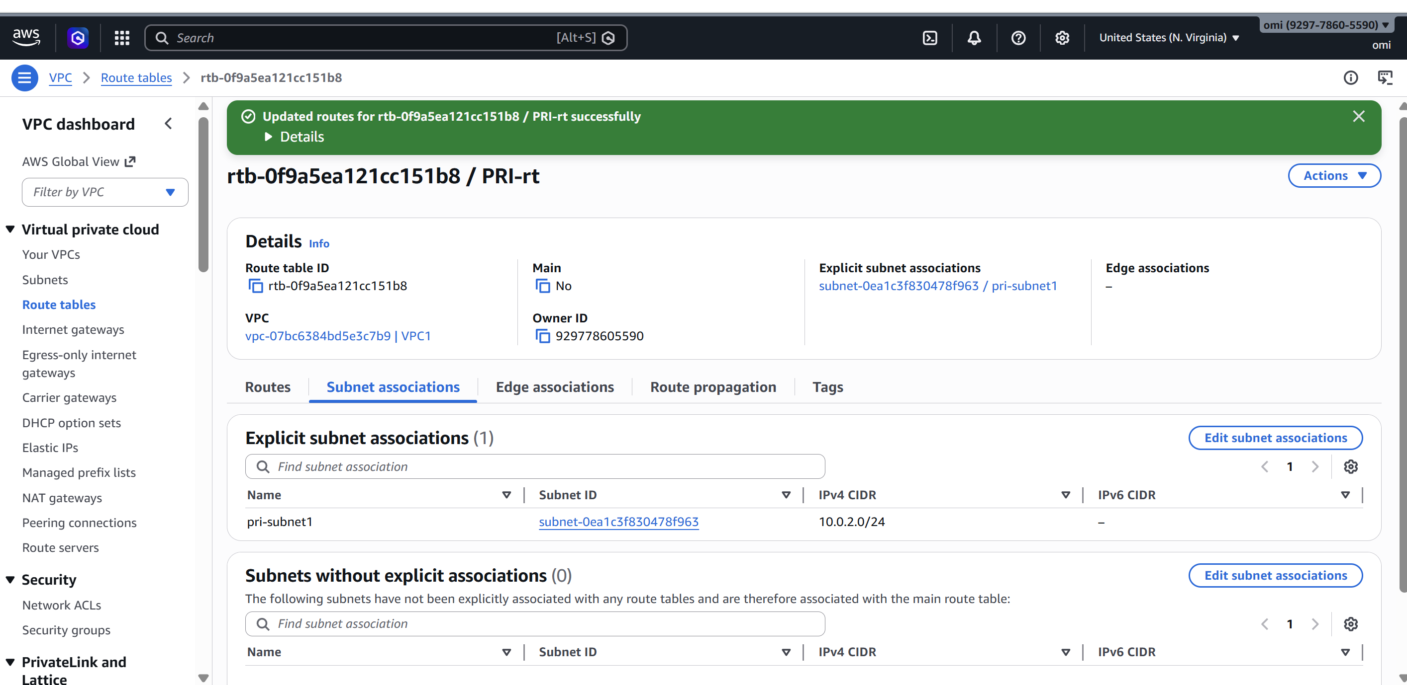
- Create two instances, one in the public subnet and one in the private subnet.
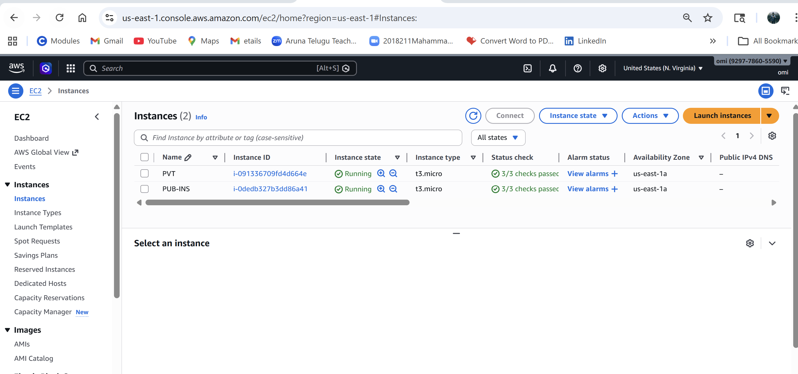
- Deploy Apache server on both EC2 instances with a sample index.html file.
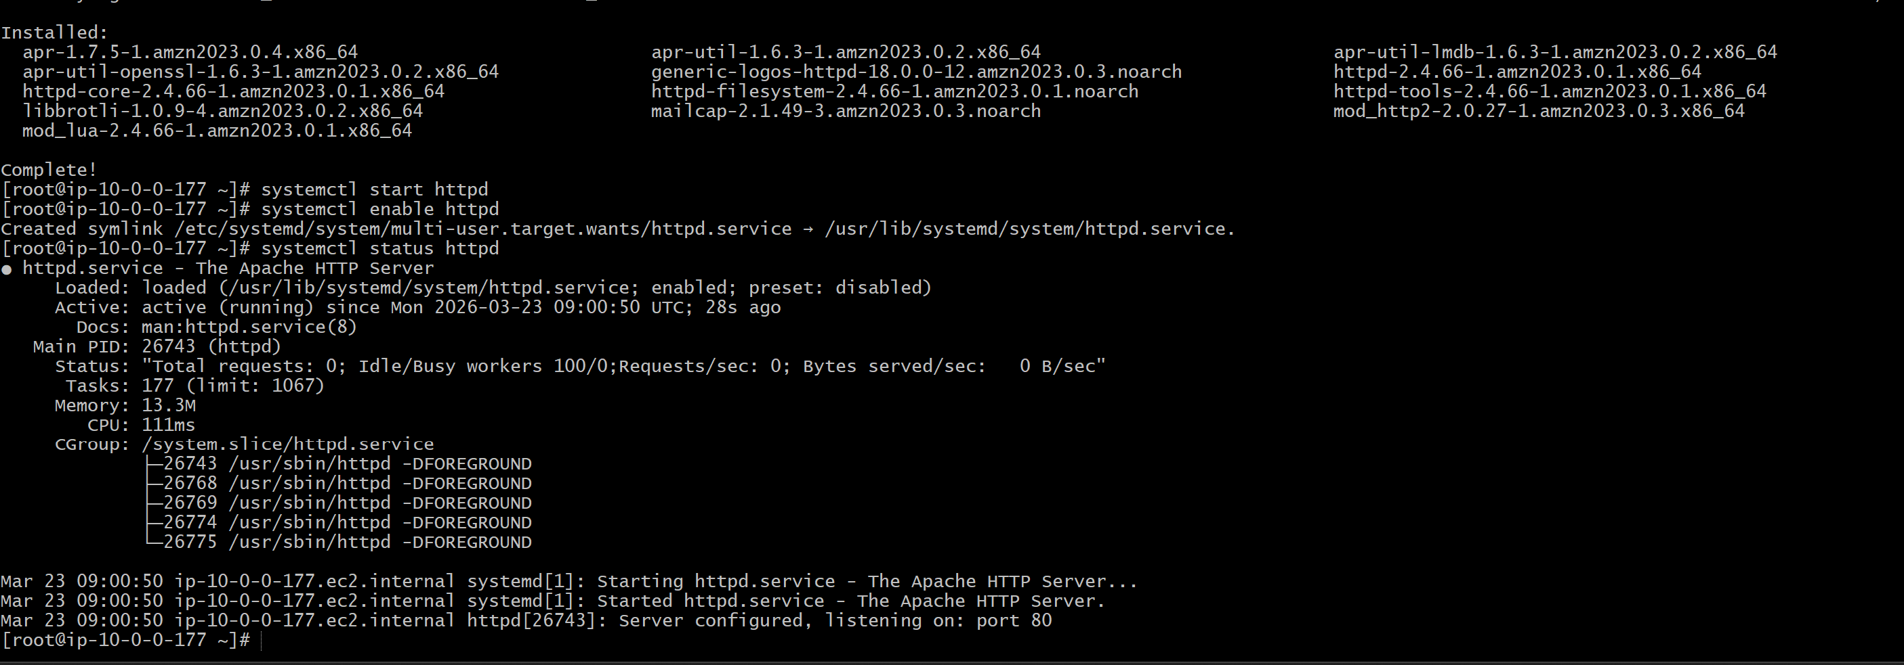
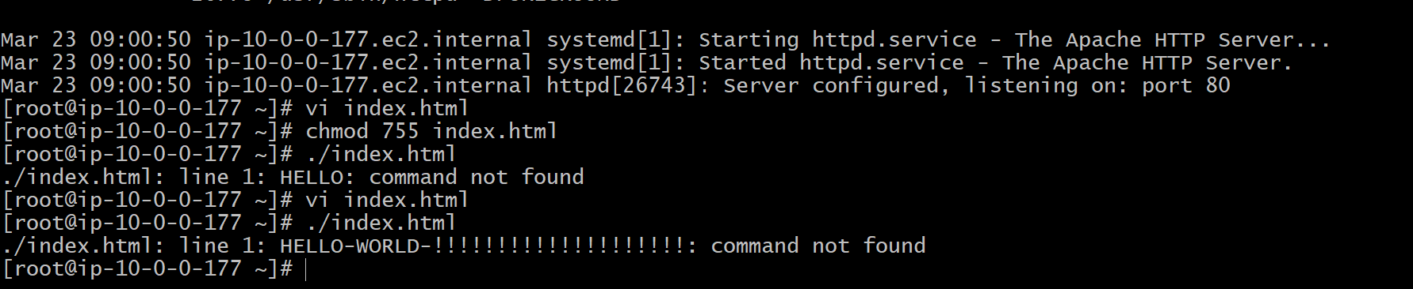
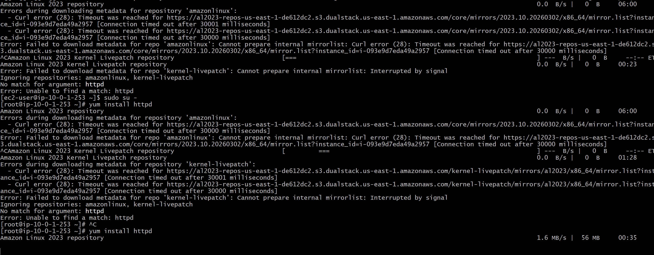
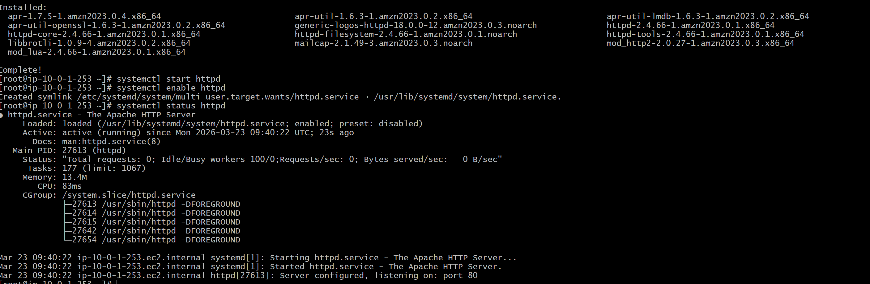
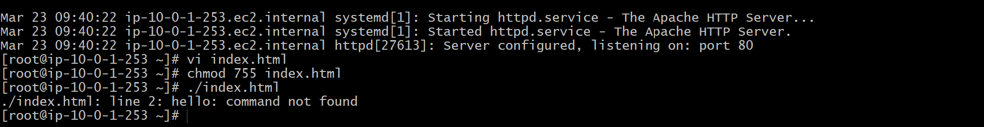
- Create one application load balancer and attach it to both EC2 instances.
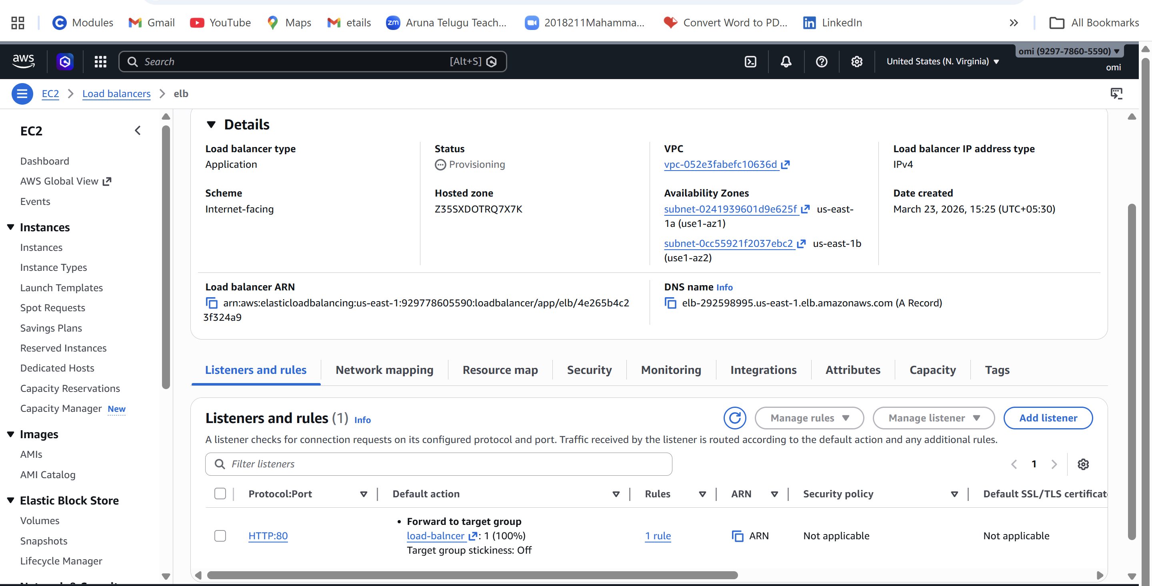
- Store application load balancer logs in S3.
- Store the VPC flow logs in a CloudWatch log group.
- Create monitoring dashboards to monitor CPU utilization and to monitor the Apache service.
- If CPU utilization is more than 70%, then it should trigger auto scaling and launch new instance.

