- Challenges :

- Launch of aws Jenkins :

Jenkins on AWS EC2 – Documentation
1. Overview
Jenkins is an open-source automation server used to implement Continuous Integration and Continuous Delivery (CI/CD) pipelines. This document explains how to install, configure, and access Jenkins on an AWS EC2 instance.

2. Architecture Overview
- AWS EC2: Virtual server to host Jenkins
- Amazon Linux 2: Operating system
- Java (OpenJDK 11): Runtime required by Jenkins
- Security Group: Controls access to Jenkins (port 8080)
- Jenkins Web UI: Browser-based interface

3. Prerequisites
- AWS account
- EC2 key pair (.pem file)
- Basic Linux and AWS knowledge

4. EC2 Instance Setup
4.1 Launch EC2 Instance
- Open AWS Management Console
- Navigate to EC2 → Launch Instance
- Select Amazon Linux 2 AMI
- Choose instance type: t2.micro
- Select or create a key pair
- Configure Security Group:
  - SSH (22) – My IP
  - Custom TCP (8080) – Anywhere
- Launch the instance

5. Connect to EC2 Instance
chmod 400 key.pem
ssh -i key.pem ec2-user@<EC2-Public-IP>

6. Install Java
sudo yum update -y
sudo amazon-linux-extras install java-openjdk11 -y
java -version

7. Install Jenkins
sudo wget -O /etc/yum.repos.d/jenkins.repo https://pkg.jenkins.io/redhat-stable/jenkins.repo
sudo rpm --import https://pkg.jenkins.io/redhat-stable/jenkins.io.key
sudo yum install jenkins -y

8. Start and Enable Jenkins
sudo systemctl start jenkins
sudo systemctl enable jenkins
sudo systemctl status jenkins

9. Access Jenkins
- Open browser:
- http://<EC2-Public-IP>:8080
- Retrieve initial admin password:
- sudo cat /var/lib/jenkins/secrets/initialAdminPassword

10. Jenkins Initial Configuration
- Unlock Jenkins using admin password
- Install suggested plugins
- Create admin user
- Complete setup

11. Security Best Practices
- Restrict port 8080 to trusted IPs
- Use IAM roles instead of AWS keys
- Enable HTTPS with ALB or Nginx
- Regularly update Jenkins and plugins

12. Common Issues & Troubleshooting
Issue | Solution
Jenkins not loading | Check port 8080 in SG
Java not found | Verify Java installation
Service failed | Check logs /var/log/jenkins/jenkins.log

13. Conclusion
Jenkins on AWS EC2 provides a flexible and scalable CI/CD solution. This setup is suitable for development, testing, and small-to-medium production workloads.

14. References
- Jenkins Official Documentation
- AWS EC2 Doc

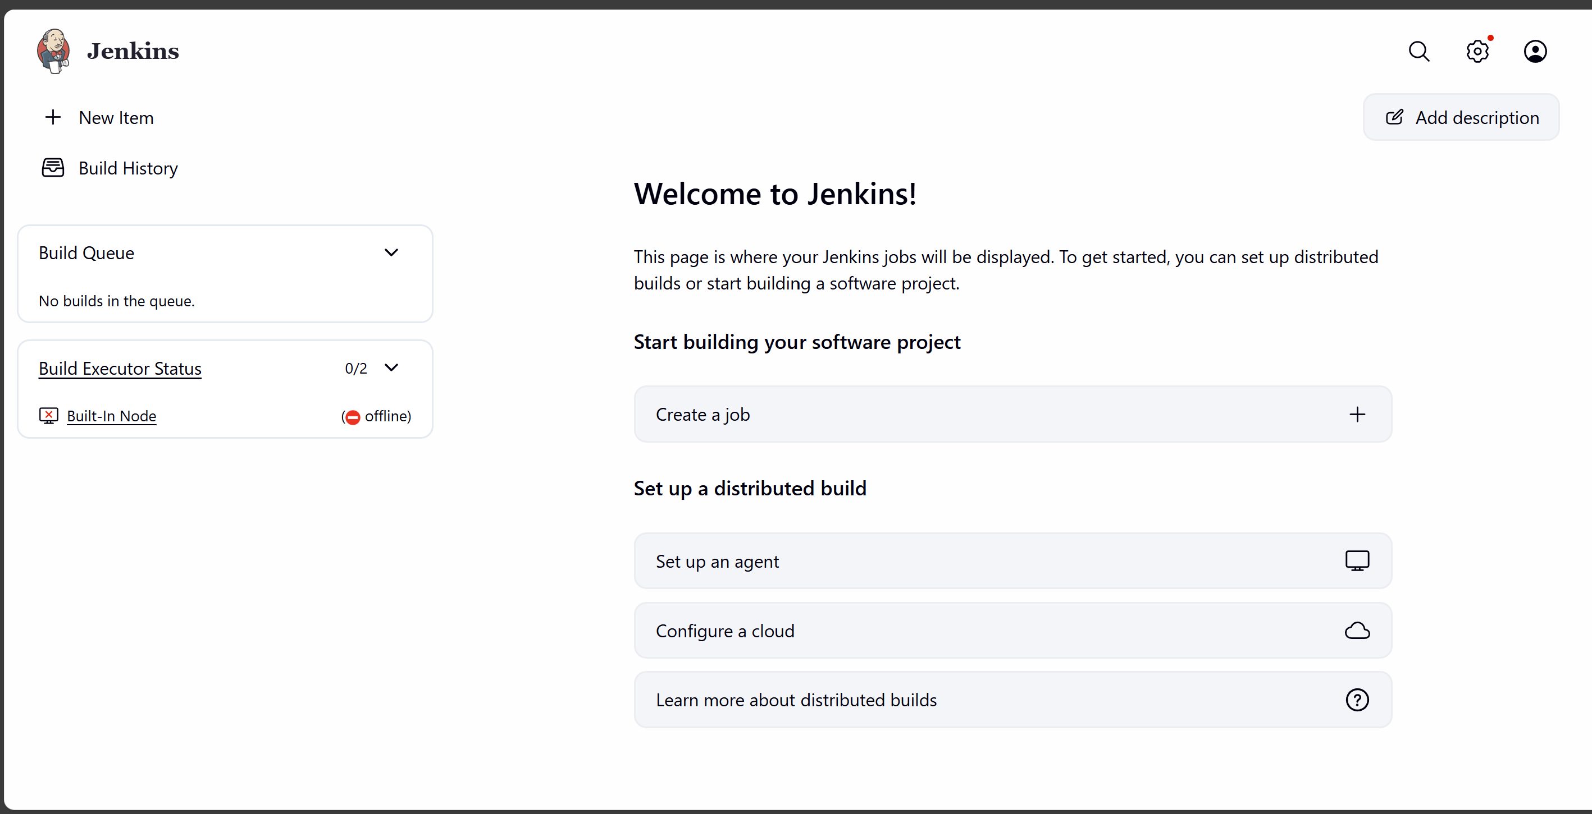

- Setup Apache Tomcat on Ubuntu Virtual Machine

1. Update System and Install Java
Tomcat requires the Java Development Kit (JDK) to run Java web applications.
- Update package index: sudo apt update.
- Install OpenJDK: Use the default version or a specific one (e.g., sudo apt install default-jdk or sudo apt install openjdk-17-jdk -y).
- Verify installation: Run java -version to confirm.
2. Create a Dedicated Tomcat User
For security, do not run Tomcat as the root user.
- Create user and group: sudo useradd -m -U -d /opt/tomcat -s /bin/false tomcat.
  - This command creates a tomcat user with a home directory at /opt/tomcat and disables direct login for safety.
3. Download and Extract Tomcat
- Download: Navigate to /tmp and use wget to get the latest version from the Apache Tomcat website (e.g., wget https://dlcdn.apache.org/tomcat/tomcat-10/v10.1.26/bin/apache-tomcat-10.1.26.tar.gz).
- Extract: Unpack the file into the /opt/tomcat directory:
sudo tar -xzf apache-tomcat-10*tar.gz -C /opt/tomcat --strip-components=1.
4. Configure Permissions
Ensure the tomcat user has ownership of the installation.
- sudo chown -R tomcat:tomcat /opt/tomcat.
- sudo chmod -R u+x /opt/tomcat/bin.
5. Create a Systemd Service File
Creating a service allows Tomcat to run in the background and start automatically on boot.
- Find Java path: sudo update-java-alternatives -l.
- Create service file: sudo nano /etc/systemd/system/tomcat.service.
- Paste configuration: Include standard blocks for [Unit], [Service], and [Install], ensuring the JAVA_HOME path matches your system.
- Start and enable:
bash
sudo systemctl daemon-reload
sudo systemctl start tomcat
sudo systemctl enable tomcat
```.

Use code with caution.

6. Adjust Firewall and Access Web UI
- Open port 8080: sudo ufw allow 8080.
- Access interface: Open a browser and go to http://<your_server_ip>:8080.
- Configure Admin (Optional): To use the Manager App, edit /opt/tomcat/conf/tomcat-users.xml to add roles (manager-gui, admin-gui) and a user with a password.
- Remove Restrictions: If accessing remotely, you must comment out the IP Valve restriction in the context.xml files located in the webapps/manager/META-INF/ and webapps/host-manager/META-INF/ directories.
- 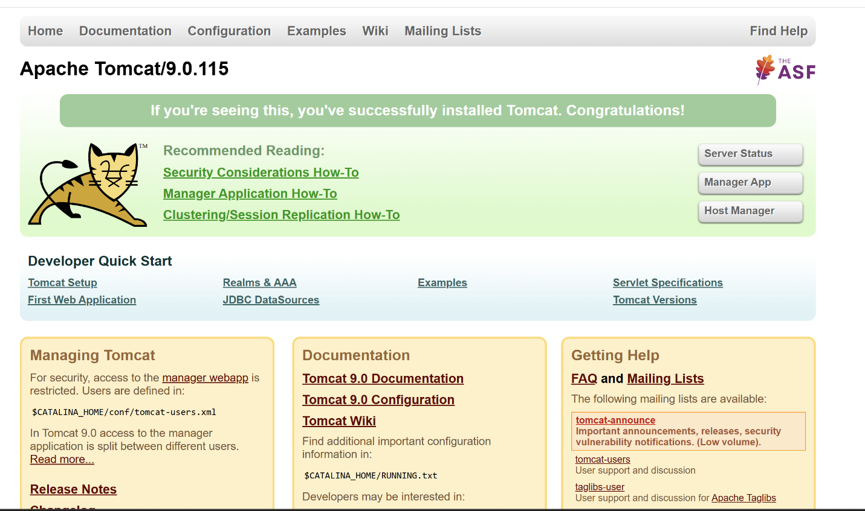

- Steps Docker Desktop on your local windows.

Step 1: Check System Requirements
Make sure your system has:
- Windows 10/11 (64-bit)
- WSL 2 support
- Virtualization enabled in BIOS
Check virtualization:
- Press Ctrl + Shift + Esc → Performance → CPU
- Look for Virtualization: Enabled

✅ Step 2: Enable WSL (Windows Subsystem for Linux)
Open PowerShell as Administrator and run:
wsl --install
Then restart your system 🔁
Verify WSL:
wsl --version

✅ Step 3: Download Docker Desktop
- Open browser
- Go to: https://www.docker.com/products/docker-desktop/
- Click Download for Windows
- Download Docker Desktop Installer.exe
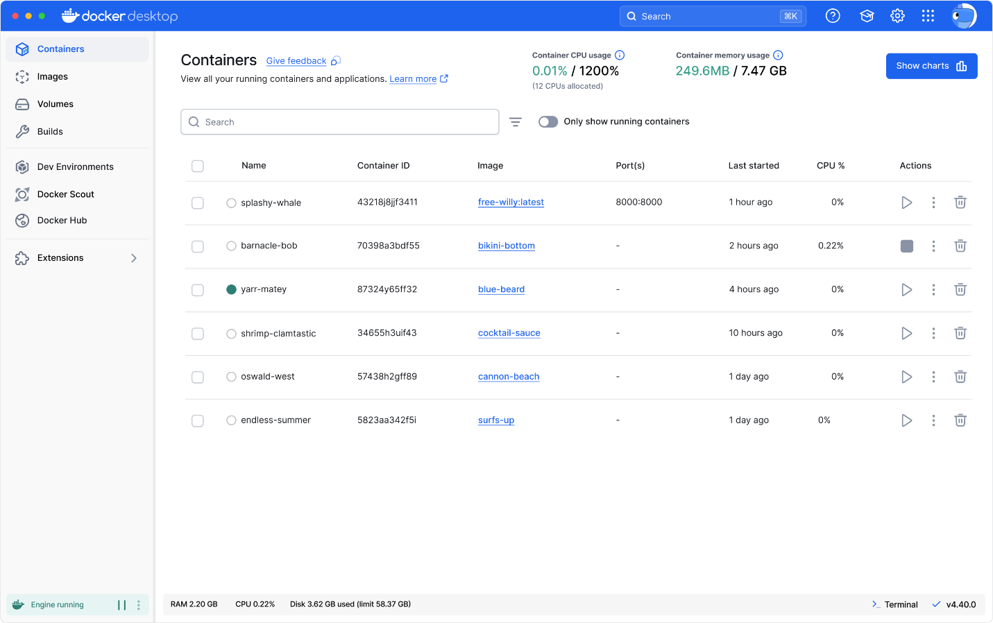
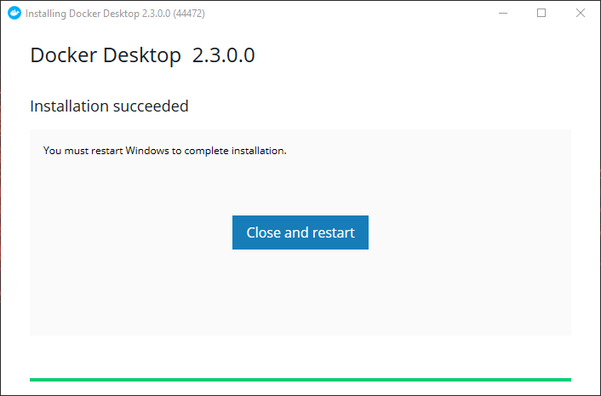

✅ Step 4: Install Docker Desktop
- Double-click Docker Desktop Installer.exe
- Select:
  - ☑ Use WSL 2 instead of Hyper-V
- Click OK / Install
- Restart if prompted

✅ Step 5: Start Docker Desktop
- Open Docker Desktop
- Wait until status shows:
- Docker Desktop is running

✅ Step 6: Verify Docker Installation
Open Command Prompt / PowerShell:
docker --version
docker compose version
Test Docker:
docker run hello-world
✅ If you see Hello from Docker! → installation successful 🎉
