----------------------------------------LINUX-02-----------------------------------------------

- Ls ---- it is ths command to find the list of the files
- mkdir directory = mkdir Omi --- it is the command to create the directory
- LL – it is the command to find the full details of the file / directory
- In above picture there is an drwxrwxrwx -is know as permissions
- Where d – difines directory
-  --- here (-) is defined as the file.
- drwxrwxrwx – directory
- -rwxrwxrwx – file
- 1st rwx – owner of the file
- 2 rwx – group premssion
- 3rd rwx – other permission
- rwx indicates read, write, excuite
- read =4
- write=2
- excute =1

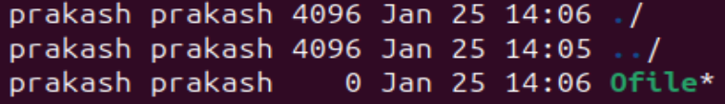
- In the above screen shot we can see prakash prakash , here first name indicates as the owner name (prakash) second name prakash indicates as (group).
- cat/etc/passwd – It is the commad is used to check the no of user available in the vm box , where cat uses to read the content of the file of passwd which is mentioned in the etc file.
- Chmod – change modification of the file permissions , it is used to change the read, write and excute access to the owner, group and others of file.
- 