
Loan Application Analyzer

Lakshmi Pr
Anees Shaik
Rachana Muvva
Monisha Udutha
Vamshi Ch

Table of Content
- Data description
- Data Features
- Scatter plot
- Analyzed Features
- Histogram, Density, and box plots
- Interpretation of plots
- Codes
- Confusion matrix
- Graphs for linear equation, y =aX+b
- Interpretation of resluts

Data description
The Loan Application Analyzer data set can be found in:
→The Loan Application Analyzer collects and analyzes applicant data, assessing creditworthiness and risk factors to facilitate informed lending decisions.
→ https://github.com/prasertcbs/basic-dataset/blob/master/Loan-Approval-Prediction.csv

Data Features
→ Loan ID
→ Gender
→ Married status
→ Education
→ Employed status
→ Applicant / co-applicant Income
→ Loan amount
→ Credit History
→ Duration of the loan
→ Residence Area
→ Loan Status

Scatter plot
Scatter plot of quantitative columns:
- Applicant Income
- Co-applicant Income
- Loan Amount
- Loan Amount term

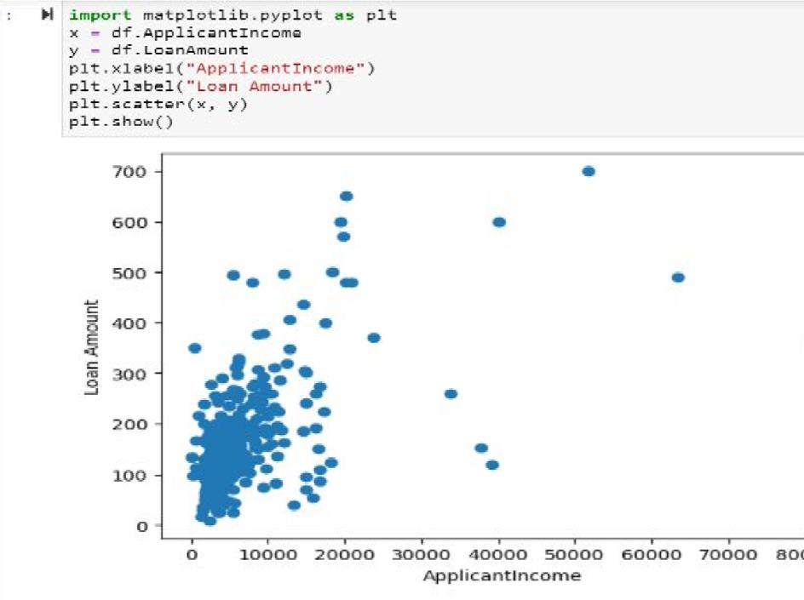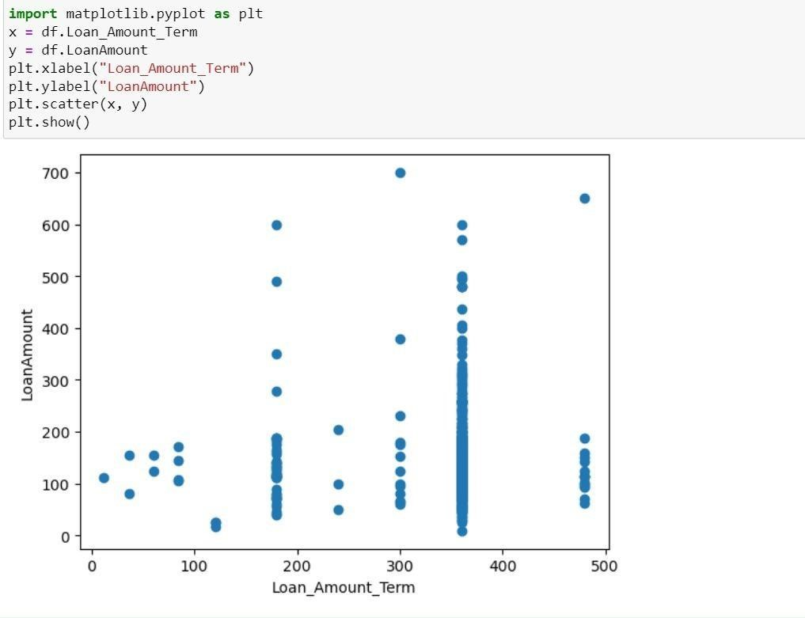

Analyzed Features
Quantitative Features:
- Applicant Income
- Co Applicant Income ● Loan Amount
- Loan Amount tenure
Qualitative Features:
- Married
- Self Employed

Inserting Features
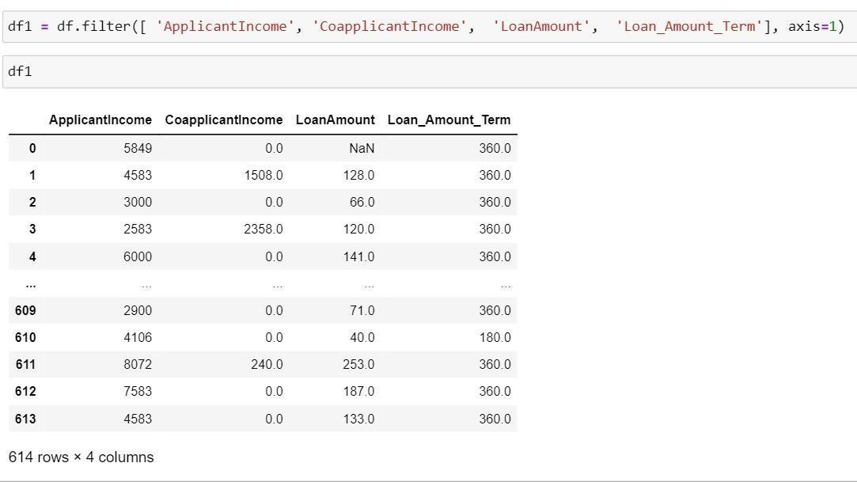

Histogram Plots
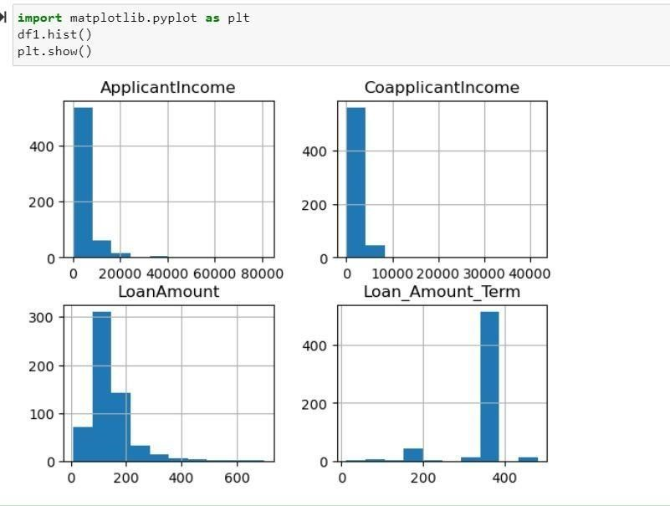

Density Plots
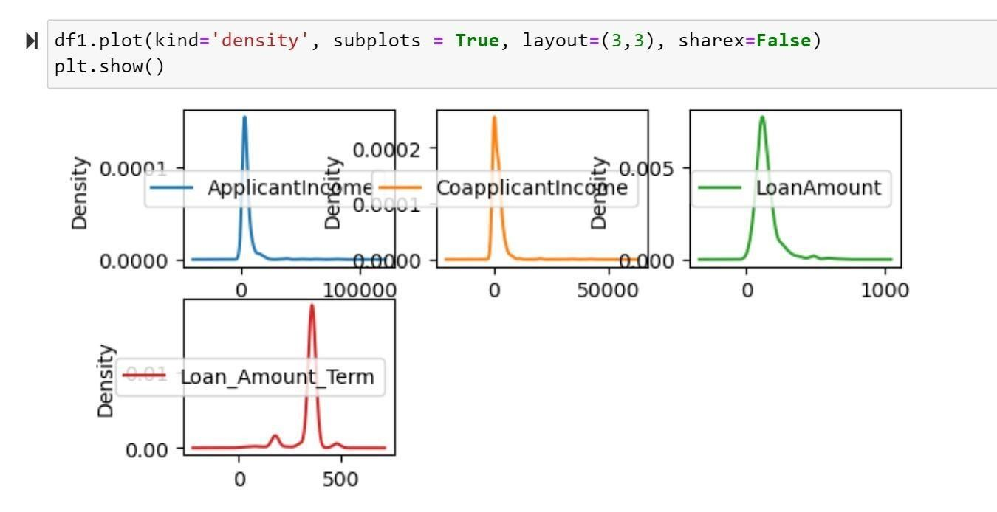

Box plots
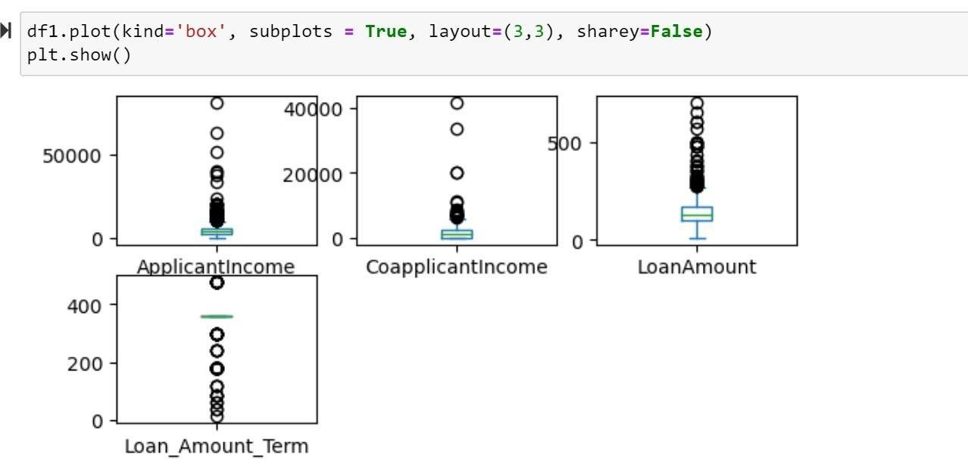

Interpretation of plots
- Scatter plots show the relationship between two quantitative variables. In this case, we're visualizing the relationship between "ApplicantIncome" and “Loan amount“ & “Loan amount” and “Loan tenure”.
- The histogram provides a visual representation of the distribution of a single variable, in this case, "Applicant Income“, “loan amount”, loan_amount_term” and "Co applicant Income.“
- The Density plot is similar to a histogram but provides a smoothed representation of the data. The density plot for "Loan Amount" provides a smoothed representation of the distribution of loan amounts requested by applicants. It confirms that there is a peak in the density plot around a specific loan amount, indicating a common loan amount that many applicants request.
- Box plots display the distribution of data and identify potential outliers.

Codes
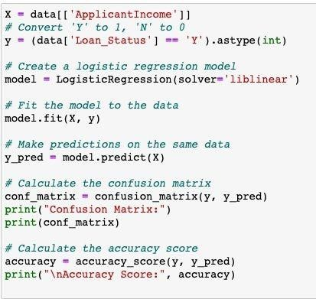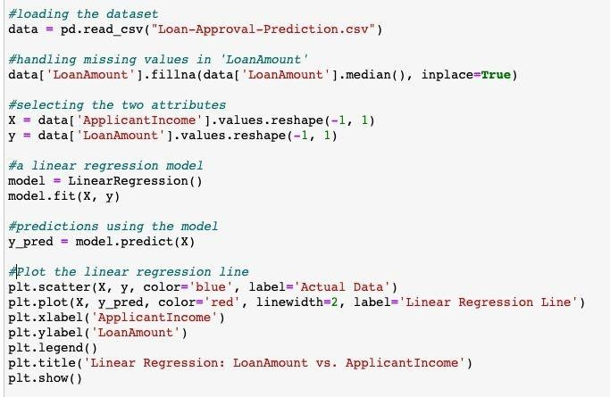

Confusion matrix
Confusion matrix: [ [ 0 192 ] [ 0 422 ] ]
- The top-left cell (0,0) represents the True Negatives (TN):
This is the number of instances that were correctly predicted as the negative class ('N' or 0). According to the results, it's 0.
- The top-right cell (0,1) represents the False Positives (FP):
This is the number of instances that were incorrectly predicted as the positive class ('Y' or 1) when they were actually the negative class. According to the results, it's 192.
- The bottom-left cell (1,0) represents the False Negatives (FN):
This is the number of instances that were incorrectly predicted as the negative class ('N' or 0) when they were actually the positive class. According to the results, it's 0.
- The bottom-right cell (1,1) represents the True Positives (TP):
This is the number of instances that were correctly predicted as the positive class ('Y' or 1). According to the results, it's 422.

Graph of linear regression, y=aX+b
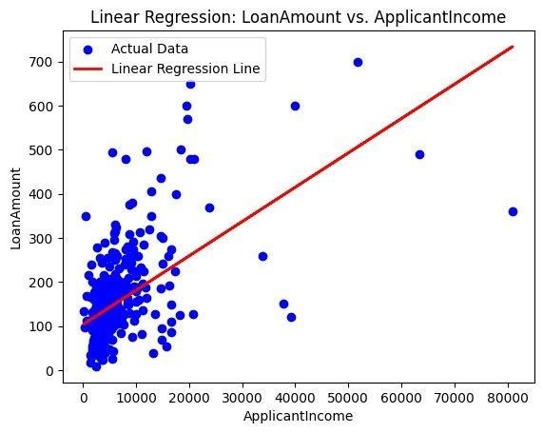

Interpretation
- The accuracy score is approximately 0.6873 or 68.73%. This means that the model correctly predicted the class labels for about 68.73% of the instances in the dataset.
- The model achieved a relatively high accuracy score, indicating that it correctly predicted the 'Y' and 'N' labels for a significant portion of the data.
- But, It seems that there is an imbalance, with a large number of instances in the 'Y' class (422) and no instances correctly predicted in the 'N' class.
- The model did not correctly predict any instances as 'N', which is a concern and may indicate that the model has a bias toward predicting the positive class.

Decision Tree Code
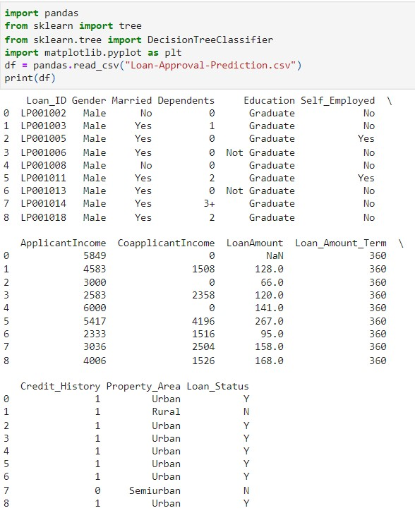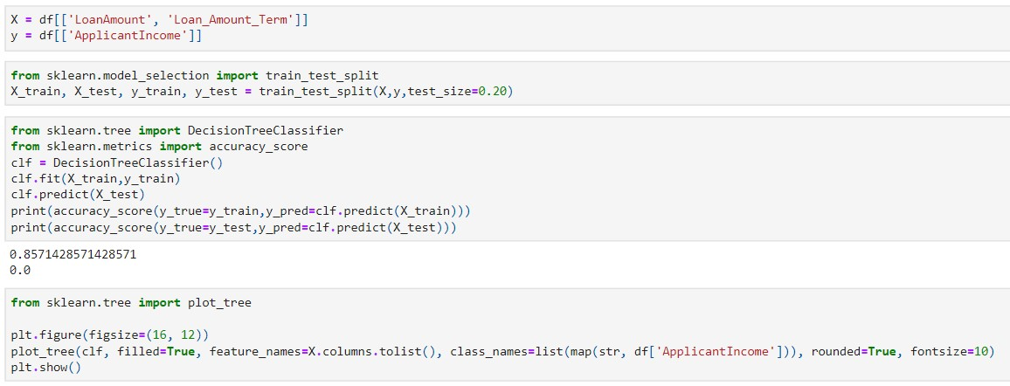

Results:
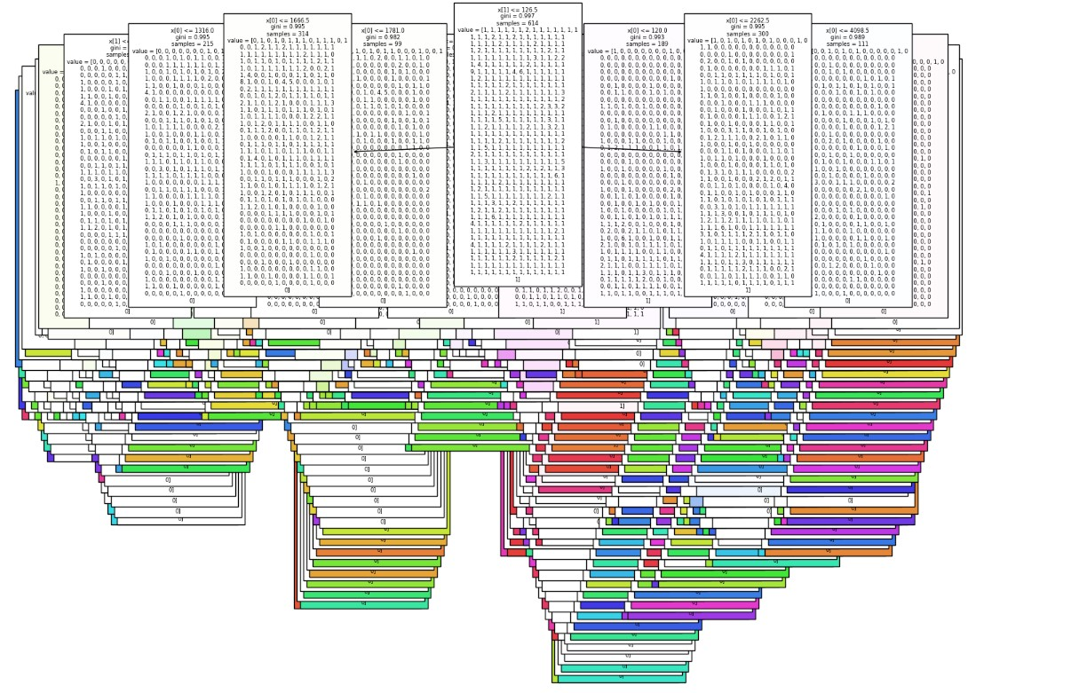
Since the dataset is exceptionally large, it can be challenging to draw meaningful conclusions from the decision tree. To address this issue, we have reduced the dataset to a more manageable size, selecting, for example, only 10 rows, to facilitate more informed decision-making.
Code after reducing the dataset:
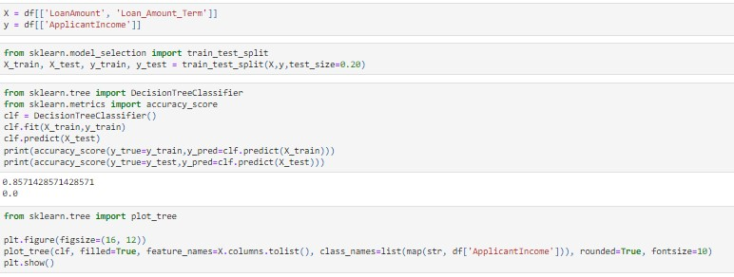

Decision Tree
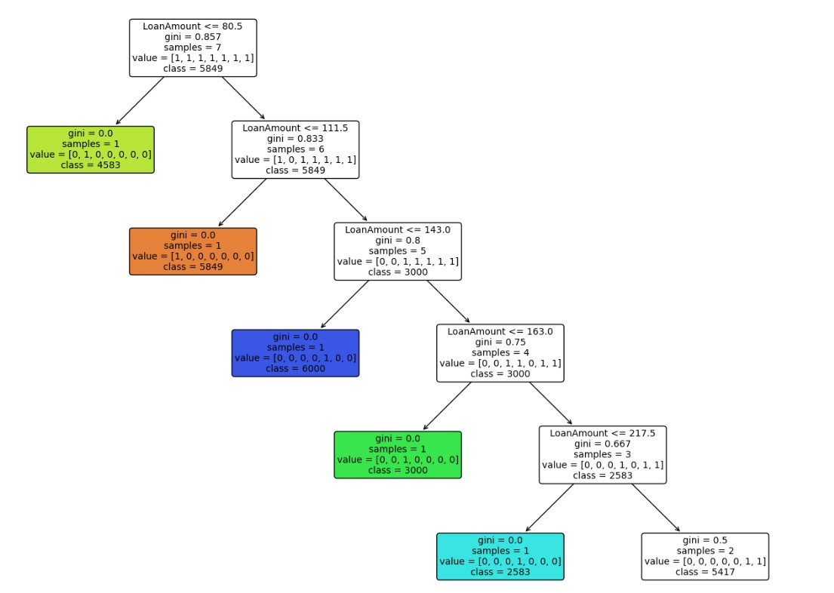

Interpretation
The tree starts with a root node that decides based on one of the features ('ApplicantIncome,' 'LoanAmount) to split the data into two or more branches.
Each subsequent node in the tree represents a decision based on a feature.
The leaf nodes of the tree represent the predicted class labels for the instances that reach them.
From the decision tree, we can observe that ‘ApplicantIncome’ and ‘LoanAmount’ are important features. Based on them the loan can be approved or rejected for an applicant.
- If LoanAmount is ≤ 80.5 and 111.5, the class is 5849.
- If LoanAmount is ≤ 143.0 and 163.0, the class is 3000.
- If LoanAmount is ≤ 217.5, the class is 2583 and further will be in the class 5417.
The decision tree uses the Gini impurity measure to make splits and determine class outcomes.

KNN
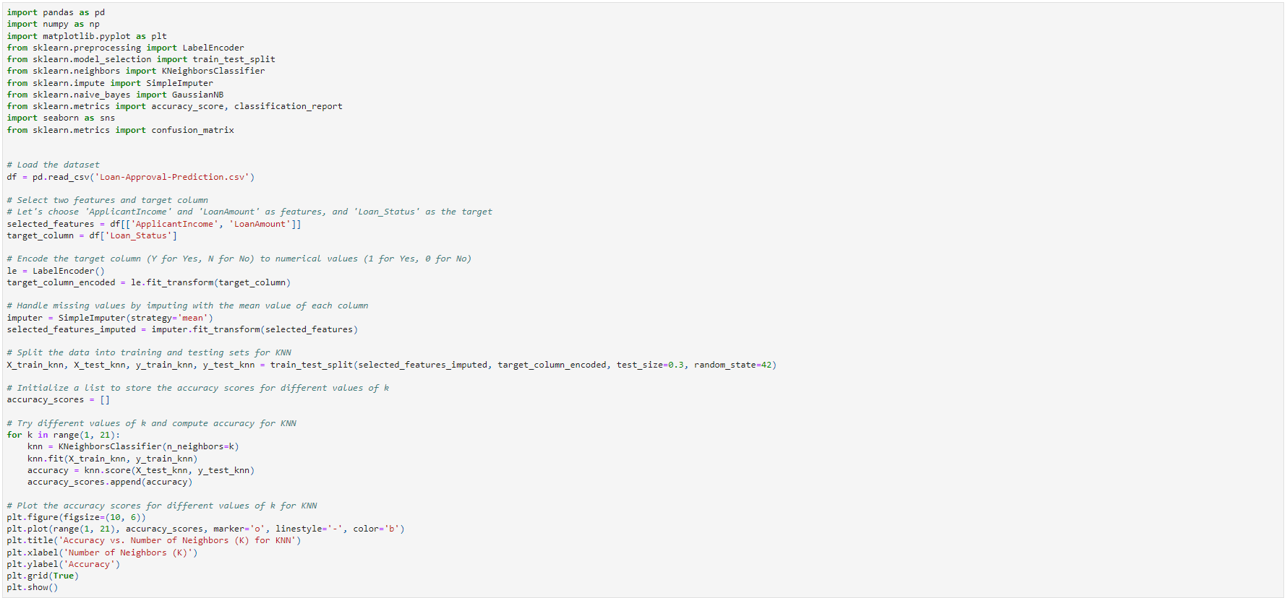

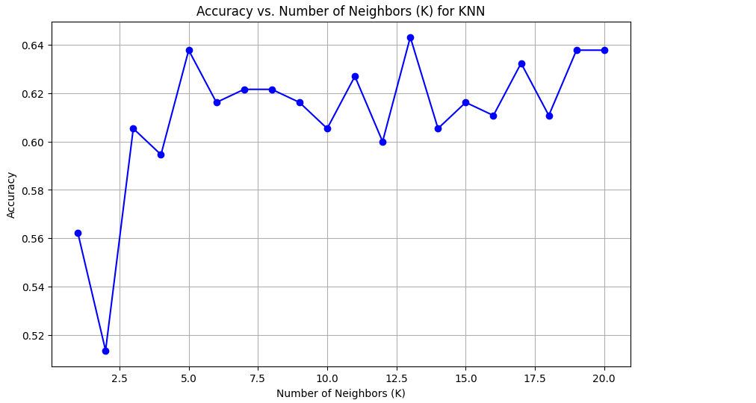
The graph displays the relationship between the number of neighbors (K) used in the K-Nearest Neighbors algorithm and the corresponding accuracy of loan approval predictions. The accuracy fluctuates as K increases, with a noticeable dip at K=2 and peaks around K=13 and K=18. The trend does not clearly indicate that increasing K leads to higher accuracy, suggesting that the optimal K value for this dataset might be around the local maxima points rather than a continuously higher K value.

According to the graph the optimal value of K for the K-Nearest Neighbors algorithm, based on the dataset, appears to be around 13 and 18, where the peaks of accuracy are observed. These points are achieves its highest accuracy, indicating they might be the best choices for the number of neighbors

Naïve Bayes

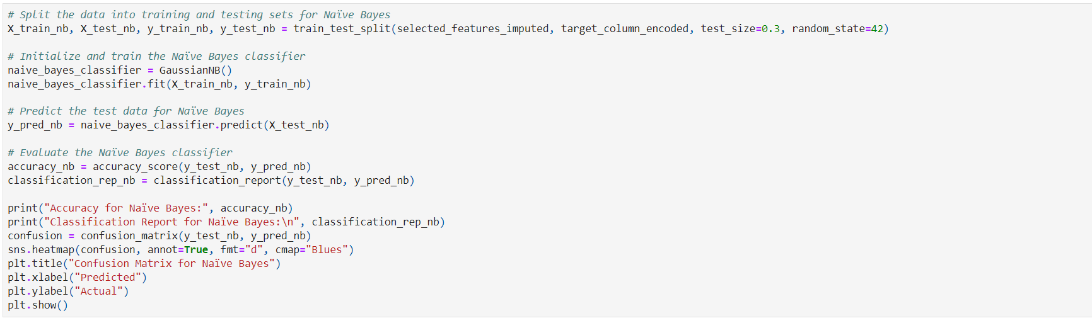

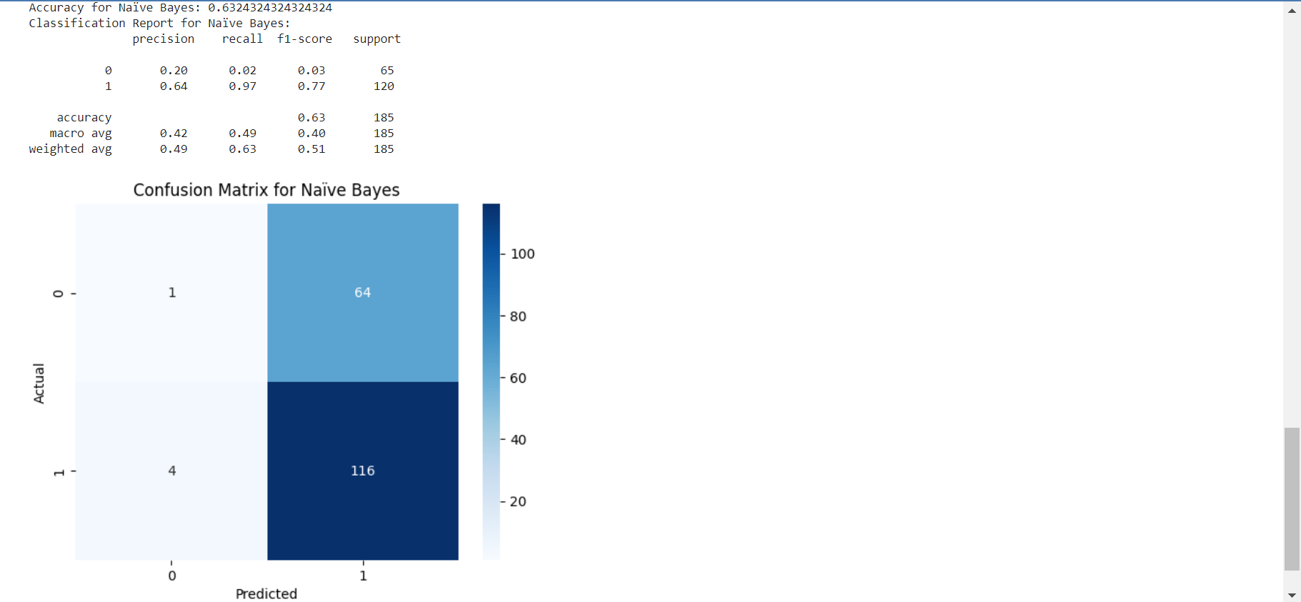
The classification report and confusion matrix for the Naïve Bayes classifier indicate that the model has an overall accuracy of about 63.24%. It performs well in correctly predicting the positive class (1) with a high recall of 0.97 but has a low precision for the negative class (0), indicating a high number of false positives. The confusion matrix shows that the model predicted the positive class correctly 116 times but had 64 false negatives, suggesting it is biased towards predicting the positive outcome.

