**Apply discount above 60(Scenario 1) Output:**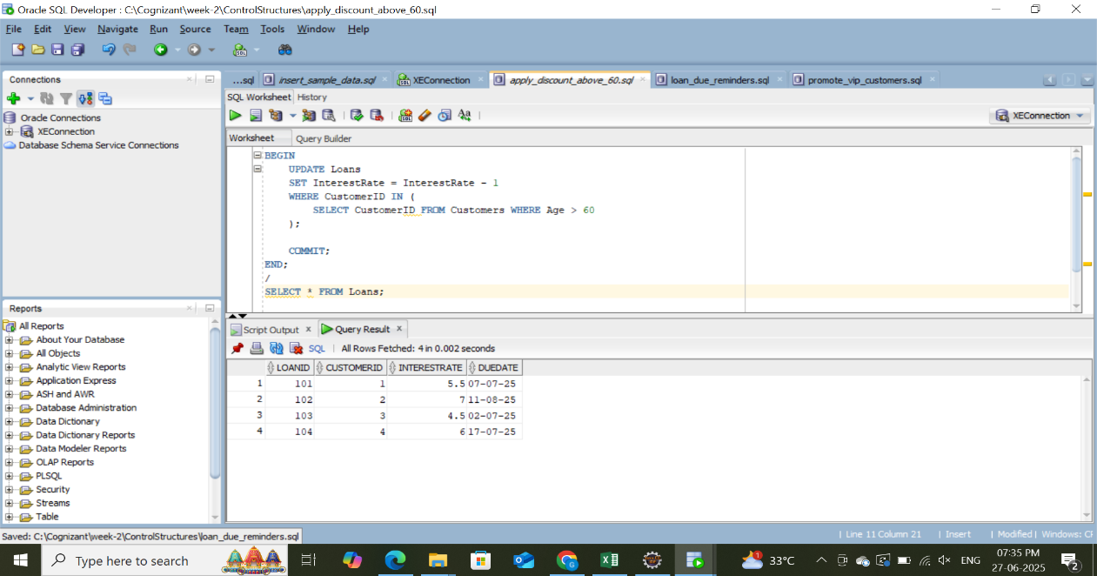

**Promote vip customers(Scenario 2) Output:**

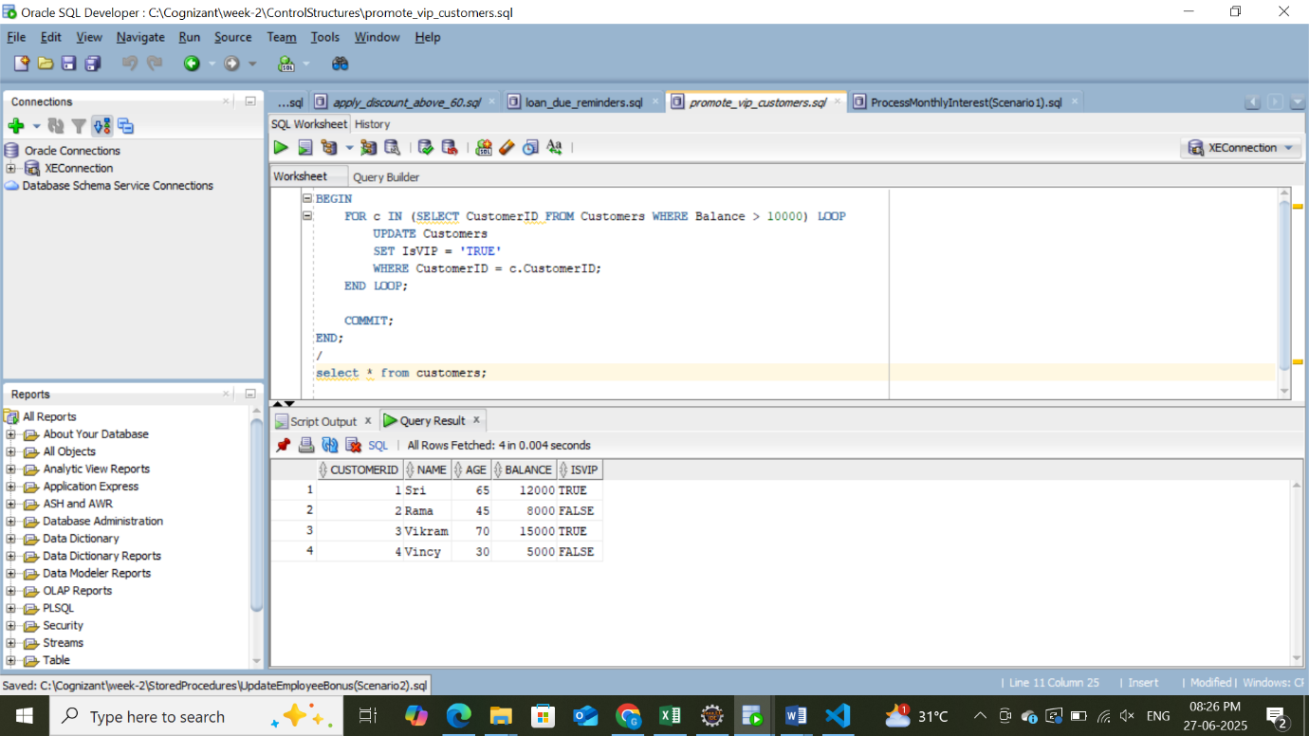

**Loan due reminders(Scenario 3) Output:**

