


A Course Project Work Report on

“ENTERPRISE SERVICE DESK & INCIDENT MANAGEMENT PLATFORM”
Submitted in partial fulfillment of the requirements of CCA Phase-2 for

BUILDING ENTERPRISE APPLICATIONS (BCS703B)
in

INFORMATION SCIENCE AND ENGINEERING

By

B. VEENA USN: 1BY23IS047
C. RACHANA USN: 1BY23IS055

Under the guidance of

Mrs. Malini M
Assistant Professor

2026-2027

ABSTRACT
This Phase-2 work turns the Phase-1 design of an Enterprise Service Desk & Incident Management Platform into a working full-stack application for the IT service-management domain. The implemented three-tier architecture uses a React 18 and Bootstrap 5 single-page client served by Nginx, a Spring Boot REST API secured with Spring Security, JSON Web Tokens and BCrypt with three roles (employee, support engineer, administrator), and Spring Data JPA/Hibernate persistence on MySQL 8.4, packaged as a Docker Compose stack. The repository separates frontend, controller, service, repository, model, DTO and security packages, with tests, deployment files, scripts and documentation in their own folders; the default backend runs on Spring Boot 3.5.16 and an identical hardened module runs on Spring Boot 4.1.1. Static analysis with SpotBugs 4.9.8 reported zero bugs, and therefore zero critical bugs, in the recorded build of 16 October 2026; Checkstyle (Google Java Style) warnings were reduced from 116 to 0 in both backend modules, and npm audit reports no known vulnerabilities after the frontend build toolchain was upgraded. Testing comprises two JUnit 5 unit tests of the dashboard metrics and six Spring MockMvc API tests covering input validation, authentication, authorization and the incident endpoints; all eight passed in the recorded run. A 20-step end-to-end smoke test and a single verification script were added to re-run the tests, analysers and image scans and to exercise the complete login, create, assign, resolve and report workflow against MySQL on the final source. The operational outcome is a role-based incident workflow with audit history, in-app notifications and administrator reporting, with the review findings on secrets, demo access, schema safety and report accuracy corrected in the source.

REPOSITORY SETUP & CODE STRUCTURE
1.1 Repository Details
• Repository Link: [insert the public GitHub URL here after pushing, e.g. https://github.com/<account>/enterprise-service-desk]
The Git repository is prepared locally with 89 tracked files on the main and dev branches (Figure 1.1). It has not been pushed yet, so no public URL is claimed. Publish it with:
git remote add origin https://github.com/<account>/enterprise-service-desk.git
git push -u origin main
git push -u origin dev

• Branching Practice: main holds stable, verified code; dev is the integration branch; each module or fix is developed on a feature/<name> branch and merged into dev through a pull request; dev is merged into main only after scripts/verify-all passes. .env files, database backups and tokens are never committed.
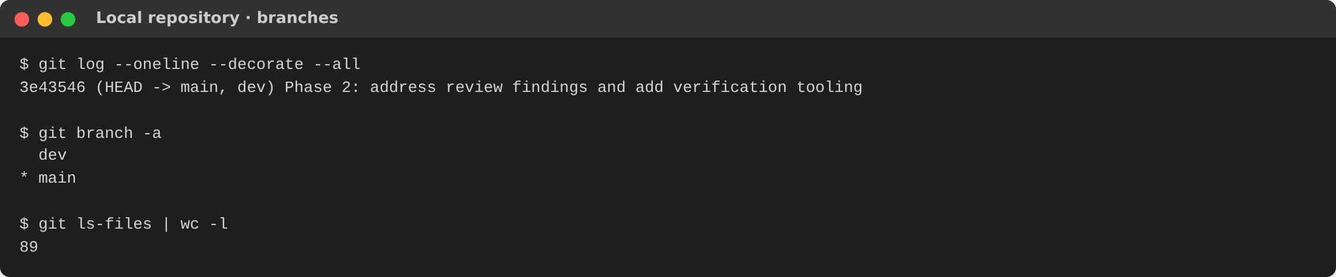
Figure 1.1: Local repository with main and dev branches
1.2 Technology Environment
Layer | Technology used
Presentation | React 18.3.1, Bootstrap 5.3.8, Vite 7.3.7 (build tool)
Web server / proxy | Nginx (alpine): serves the built SPA and forwards /api to the backend
REST API | Java 17; Spring Boot 3.5.16 (default backend) and 4.1.1 (hardened backend)
Security | Spring Security (stateless), JJWT 0.12.6 HMAC-SHA JWT valid 24 h, BCrypt, role and ownership checks
Persistence | Spring Data JPA, Hibernate ORM, MySQL 8.4 (H2 in MySQL mode for tests)
Testing | JUnit 5, Spring Boot Test + MockMvc, Maven Surefire; Node.js 22 end-to-end smoke test
Code quality | SpotBugs 4.9.8, Checkstyle 9.3 (Google Java Style), npm audit, Trivy image scan
Deployment | Docker Compose; multi-stage Dockerfiles; distroless and Chainguard JRE runtime images

1.3 Project Directory Structure
service-desk-phase2/
├── frontend/ # React UI: src/main.jsx, src/style.css, package.json
├── backend/ # Spring Boot 3.5 API (default deployment)
│ ├── src/main/java/com/bea/servicedesk/
│ │ ├── controller/ # REST endpoints (ApiController)
│ │ ├── service/ # Workflow, access rules, metrics
│ │ ├── repo/ # Spring Data JPA repositories
│ │ ├── model/ # JPA entities and enums
│ │ ├── dto/ # Validated request records
│ │ └── config/ # Security, JWT, optional demo seed
│ ├── src/test/java/... # JUnit unit + MockMvc API tests
│ ├── pom.xml, Dockerfile
├── backend-spring4-test/ # Same code on Spring Boot 4.1.1 (hardened)
├── scripts/ # verify-all, smoke-test, backup-db, pin-images
├── docs/ # Operations, test cases, review response
├── evidence/ # Archived and fresh analysis/test output
├── compose.yaml # MySQL + backend + frontend
├── compose.secure.yaml # Override: Spring Boot 4 backend, schema locked
├── Dockerfile, nginx.conf # Frontend image and /api reverse proxy
├── .env.example # Required variables, no values
└── README.md # Setup instructions and run commands

1.4 Execution & Setup Commands
With Docker (recommended):
cp .env.example .env # set DB_PASSWORD, MYSQL_ROOT_PASSWORD, JWT_SECRET
docker compose up --build -d # open http://localhost:8088
# optional Spring Boot 4 backend (back up the database first):
scripts/backup-db.sh
docker compose -f compose.yaml -f compose.secure.yaml up --build -d

Without Docker (Java 17, Maven 3.9, Node 20.19+, MySQL 8):
cd backend && mvn spring-boot:run # needs DB_URL, DB_USER, DB_PASSWORD, JWT_SECRET
cd frontend && npm ci && npm run dev # open http://localhost:5173
cd backend && mvn clean test # unit + API tests
scripts/verify-all.ps1 (or .sh) # all tests, analysis, scans, end-to-end check

STATIC CODE ANALYSIS
• Tools Used: SpotBugs 4.9.8 (bytecode bug-pattern analysis); Checkstyle 9.3 with google_checks.xml, the version used by maven-checkstyle-plugin 3.5.0; npm audit for frontend dependencies; Trivy for container images (run by scripts/verify-all).
• Quality Metrics Summary:
◦ Critical Bugs: 0 (SpotBugs total_bugs = 0)
◦ Vulnerabilities: 0 (npm audit, frontend dependencies)
◦ Code Warnings: 0 Checkstyle warnings after refactoring (116 before)
Metric | Result | Source and date
Bugs (all ranks, incl. critical) | 0 bug instances; 7 packages, 32 classes analysed | SpotBugs XML, Spring Boot 4 build of 16 Oct 2026 (before the 18 Oct refactoring); verify-all reruns it
Dependency vulnerabilities | 0 (previously 1 high, 1 moderate: esbuild/Vite 5.4) | npm audit, 18 Oct 2026
Style warnings | 116 → 0 in backend/ and backend-spring4-test/ | Checkstyle 9.3, 18 Oct 2026 (116 also in the 16 Oct XML)
Container image CVEs (HIGH/CRITICAL) | [fill in from verify-all trivy-*.log] | Trivy on rebuilt images; not run yet

• Code Issues Resolved:
Detected | File Name | Fix / Refactoring Applied
AvoidStarImport (21): wildcard imports such as model.* and repo.* | ApiController.java, IncidentService.java, model/*.java | Replaced with explicit imports in the required order
NeedBraces (20): if/for bodies without braces | ApiController.java, AccessService.java, IncidentService.java | Added braces; split IncidentService.update() into assign() and changeStatus() without behaviour change
MissingJavadocType/Method (52) | All public classes, records and methods | Added Javadoc describing purpose, parameters and access rules
Indentation (16): 4-space blocks | config/JwtService.java | Reformatted to Google style; extracted constants
npm audit: esbuild ≤ 0.24.2 via Vite 5.4 (GHSA-67mh-4wv8-2f99) | frontend/package.json | Upgraded to Vite 7.3.7, exact versions, package-lock.json, npm ci in the image build
Manual review: Spring Boot 4-only imports in Spring Boot 3 tests (compile failure) | backend/src/test/.../ApiIntegrationTest.java | Used the Spring Boot 3 Jackson and MockMvc packages
Manual review: 400/401 turned into 403 when forwarded to /error | config/SecurityConfig.java | Permitted /error and enabled RFC 9457 problem details

Verification Proof:
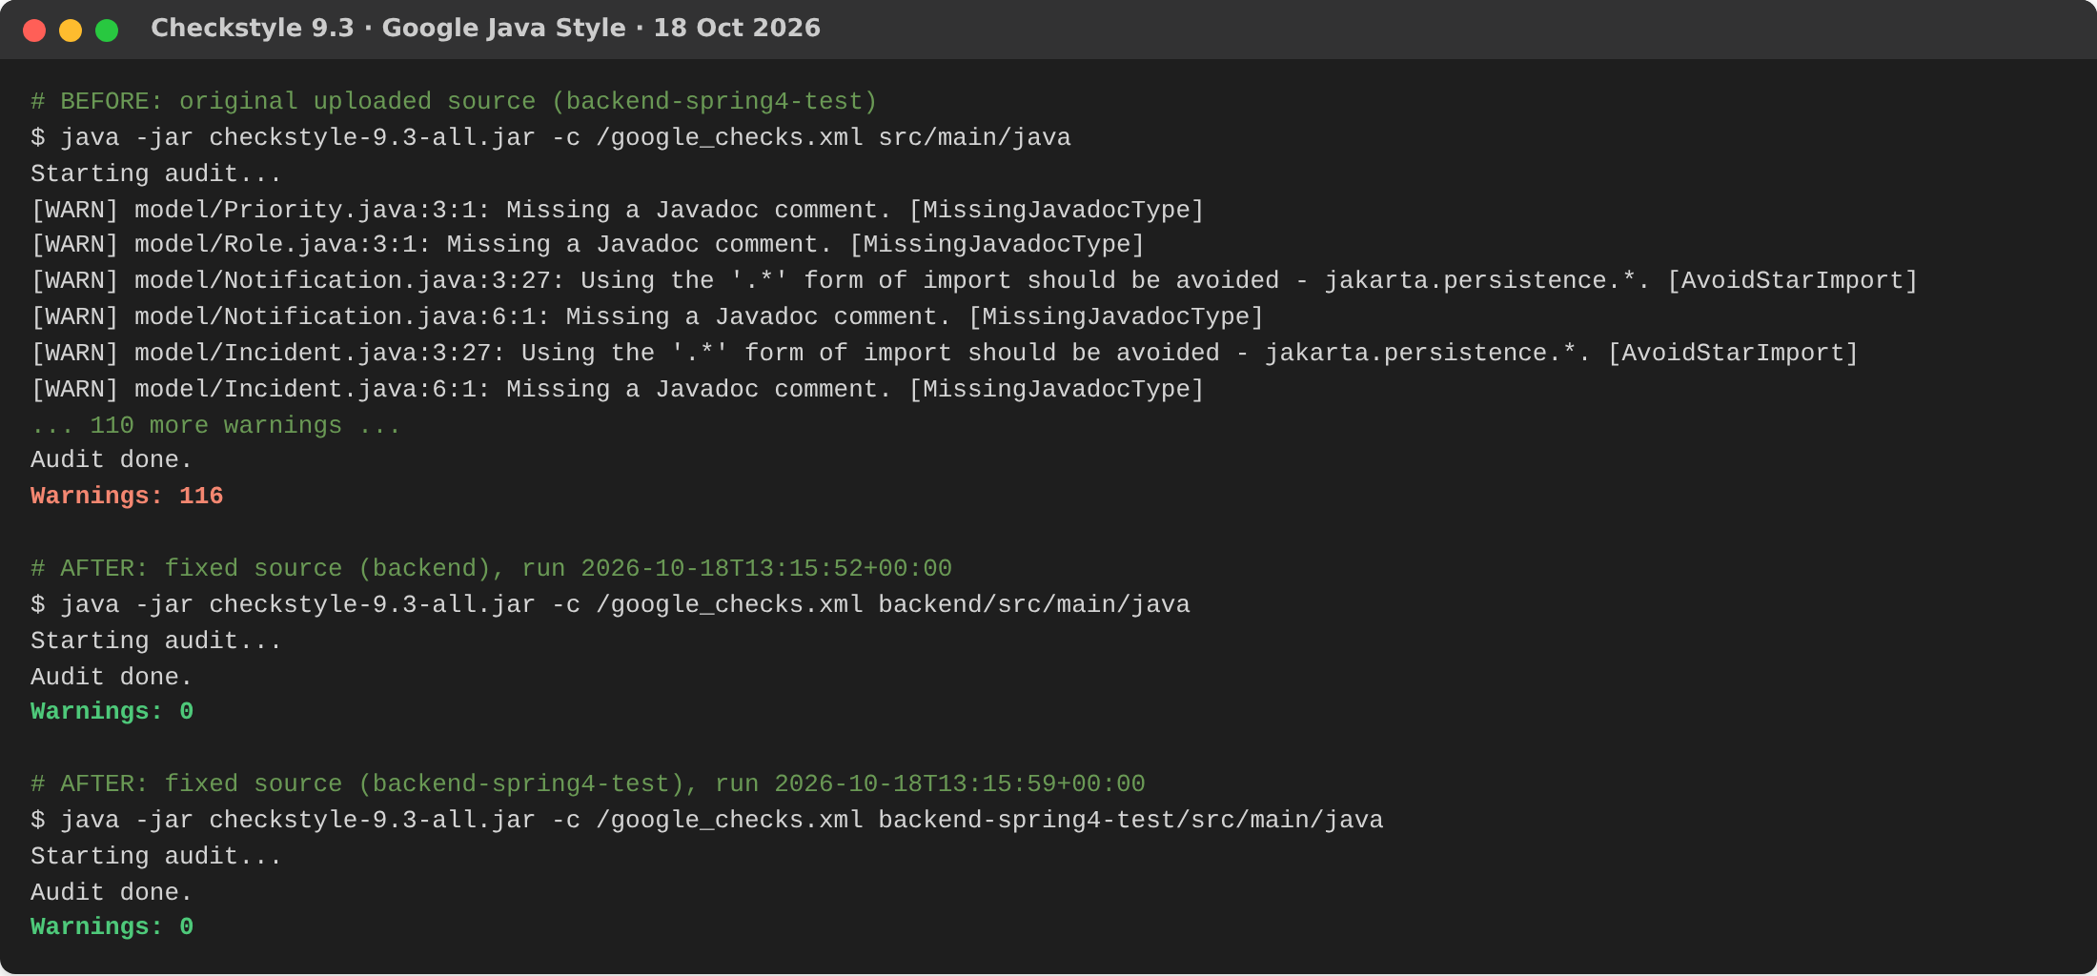
Figure 2.1: Checkstyle 9.3 — 116 warnings on the original source, 0 on the fixed backend modules (18 Oct 2026)
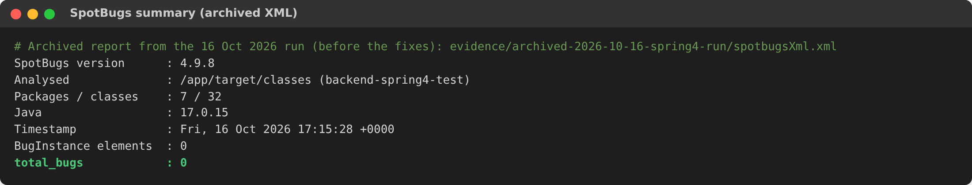
Figure 2.2: SpotBugs summary — 0 bugs (archived report, build of 16 Oct 2026)
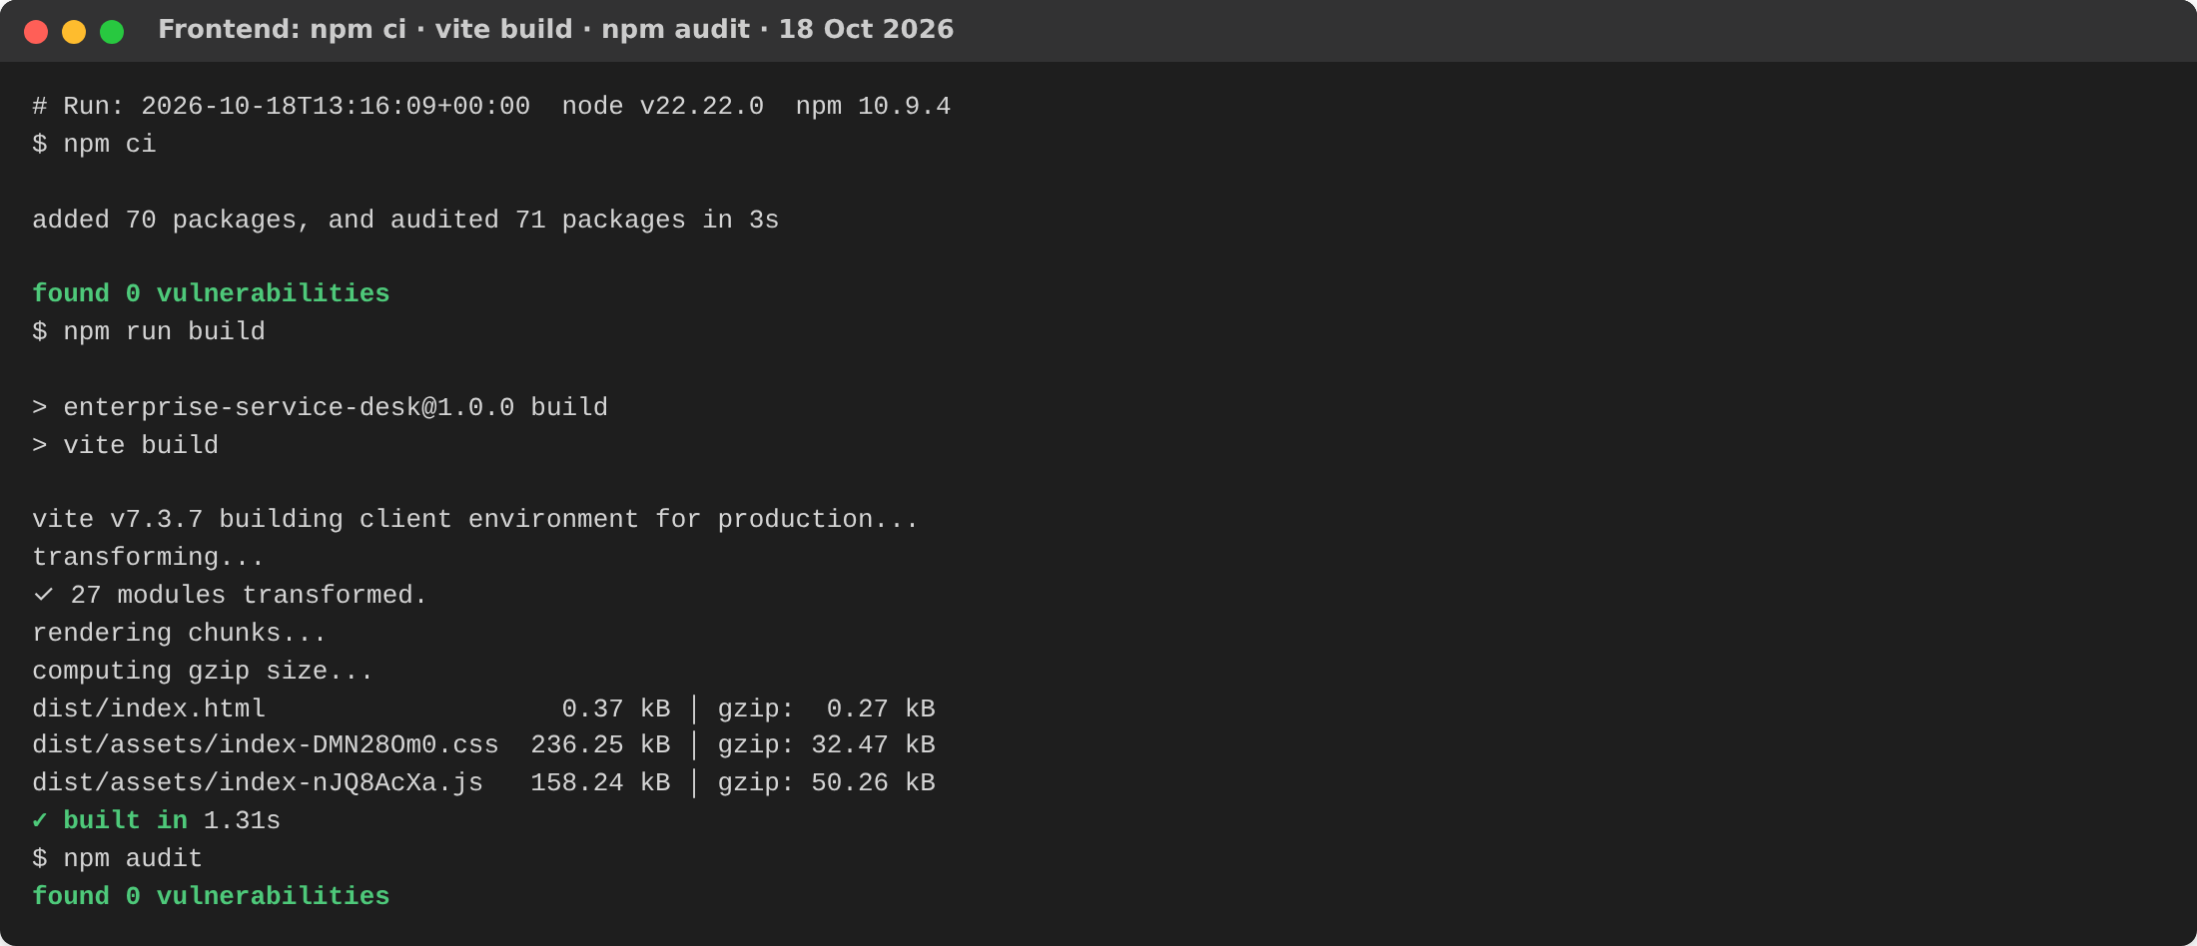
Figure 2.3: Frontend clean install, production build and npm audit — 0 vulnerabilities (18 Oct 2026)
SCREENSHOT TO INSERT — Figure 2.4
SpotBugs and Trivy results on the final source
Run scripts\verify-all.ps1, then screenshot backend-spring4-test-03-spotbugs.log (BUILD SUCCESS) and trivy-servicedesk-backend-sb4_local.log
Figure 2.4: SpotBugs and Trivy results on the final source
TESTING EXECUTION
• Test Framework Used: JUnit 5 (Jupiter) with Spring Boot Test and Spring MockMvc, run by Maven Surefire against an in-memory H2 database in MySQL mode. An end-to-end smoke test (Node.js 22, scripts/smoke-test.mjs) runs against the deployed Docker stack and MySQL.
• Test Cases Table: the eight automated test methods in the source, with the assertion each one makes.
Test ID | Test Level  (Unit / API) | Function / Endpoint Tested | Input / Action | Expected Result | Status  (Pass/  Fail)
TC-01 | Unit | IncidentMetrics.awaitingAction() | OPEN, ASSIGNED and RESOLVED incidents | Returns 2 (only OPEN/ASSIGNED counted) | Pass*
TC-02 | Unit | IncidentMetrics.completed() | OPEN, RESOLVED and CLOSED incidents | Returns 2 (RESOLVED/CLOSED counted) | Pass*
TC-03 | API | POST /api/auth/register | Email "invalid" | Status 400 Bad Request | Pass*
TC-04 | API | POST /api/incidents | Valid token and incident body | Status 201, status = OPEN | Pass*
TC-05 | API | POST /api/incidents | Blank title | Status 400 Bad Request | Pass*
TC-06 | API | GET /api/incidents | No token | Status 403 Forbidden | Pass*
TC-07 | API | GET /api/reports/summary | End-user token | Status 403 Forbidden | Pass*
TC-08 | API | GET /api/incidents | Valid end-user token | Status 200, JSON array | Pass*
* Status from the Maven Surefire reports of the 16 Oct 2026 run of the Spring Boot 4 module (8 run, 0 failures, 0 errors; Figure 3.1). The 18 Oct changes did not alter any assertion. Each API test first registers a new user (POST /api/auth/register, expects 201). Test method names are listed in docs/TEST_CASES_VERIFIED_FROM_SOURCE.md.
3.1 End-to-End Smoke Test
Login, assignment, status changes and notifications are not covered by separate unit tests, so scripts/smoke-test.mjs checks them against the running stack with real MySQL. It runs 20 checks: valid and invalid login (200/401), request without a token, incident creation (201, OPEN) and blank-title validation (400), role-scoped lists, admin assignment to an engineer, engineer progress with a comment, resolution refused without resolution text (400) and accepted with it, audit history (CREATED, ASSIGNED, STATUS_CHANGED, COMMENT, RESOLUTION), assignment and resolution notifications, the administrator dashboard counts, and denials for an employee updating a ticket, an employee opening the report, an unassigned engineer viewing a ticket and an engineer changing roles. verify-all runs it on the Spring Boot 3 backend and again after switching to the Spring Boot 4 backend on the same database, and checks that the schema is unchanged.
Execution Proof:
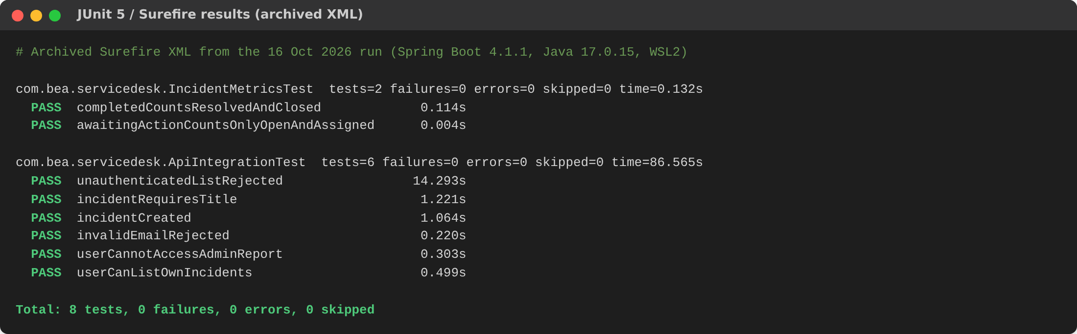
Figure 3.1: JUnit 5 results from the Surefire reports — 8 tests, 0 failures, 0 errors (run of 16 Oct 2026)
SCREENSHOT TO INSERT — Figure 3.2
Maven test run on the final source: "Tests run: 8, Failures: 0, Errors: 0 — BUILD SUCCESS"
From evidence\runs\<timestamp>\backend-01-mvn-test.log and backend-spring4-test-01-mvn-test.log
Figure 3.2: Maven test run on the final source: "Tests run: 8, Failures: 0, Errors: 0 — BUILD SUCCESS"
SCREENSHOT TO INSERT — Figure 3.3
End-to-end smoke test: "20/20 checks passed"
From evidence\runs\<timestamp>\stack-b-sb4-smoke-test.log (and stack-a-sb3-smoke-test.log)
Figure 3.3: End-to-end smoke test: "20/20 checks passed"
3.2 Evidence Status
Evidence | Status | Where
8 JUnit tests | Passed on 16 Oct 2026 (archived XML) | evidence/archived-2026-10-16-spring4-run/
Checkstyle 0 warnings | Run on the final source, 18 Oct 2026 | evidence/fresh-2026-10-18-this-environment/
npm build + audit | Run on the final source, 18 Oct 2026 | evidence/fresh-2026-10-18-this-environment/
Tests, SpotBugs, Trivy, smoke test on final source | To run: scripts/verify-all | evidence/runs/<timestamp>/summary.md

CORE IMPLEMENTATION
Summary of the working features developed:
• Module 1 (User Interface / Presentation): a React single-page application with role-aware navigation for employees, support engineers and administrators. Screens: sign-in and self-registration; an overview dashboard with total, awaiting-action, in-progress and resolved counts and the latest incidents; a searchable incident list; a new-incident form (title, description, category, priority); a ticket detail panel with the activity timeline and an update form (assign engineer, status, resolution, comment); notifications with an unread badge; user-role administration; and status and priority reporting. API errors are shown using the "detail" message returned by the backend.
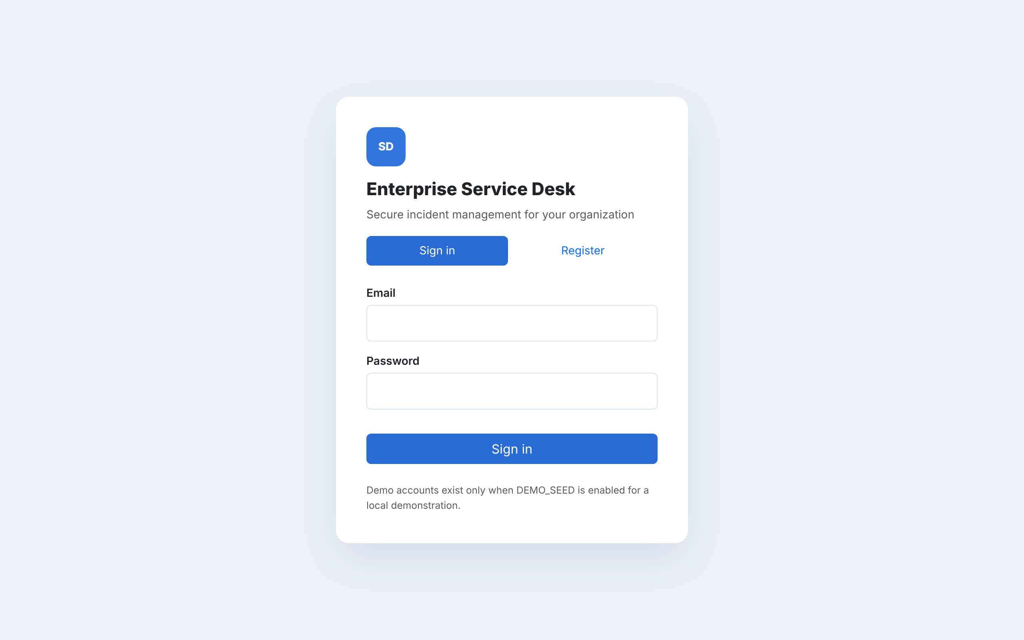
Figure 4.1: Sign-in screen (production build, 18 Oct 2026)
SCREENSHOT TO INSERT — Figure 4.2
Overview dashboard (administrator)
Run verify-all.ps1 -KeepRunning, open http://localhost:8089, sign in as admin@demo.local
Figure 4.2: Overview dashboard (administrator)
SCREENSHOT TO INSERT — Figure 4.3
Incident list with search (administrator or employee)
Incidents tab
Figure 4.3: Incident list with search (administrator or employee)
SCREENSHOT TO INSERT — Figure 4.4
New incident creation form (employee)
New incident tab, signed in as employee@demo.local
Figure 4.4: New incident creation form (employee)
SCREENSHOT TO INSERT — Figure 4.5
Ticket detail with activity timeline and update form (engineer)
Click a ticket, signed in as engineer@demo.local
Figure 4.5: Ticket detail with activity timeline and update form (engineer)
• Module 2 (Core Business Logic / Processing): incident workflow management in IncidentService and AccessService. An employee submits an incident; the request is validated and saved as OPEN with a CREATED audit event. An administrator assigns it to a user with the ENGINEER role (status ASSIGNED, assignment event, notification to the engineer). The assigned engineer moves it to IN_PROGRESS or ESCALATED, adds comments and records a resolution, then RESOLVED or CLOSED; each change notifies the requester. Rules enforced on the server:
◦ Employees see only their own incidents, engineers only those assigned to them, administrators all.
◦ Only employees and administrators create incidents; only engineers and administrators update them; only administrators assign.
◦ A ticket cannot be set back to OPEN or ASSIGNED, and RESOLVED/CLOSED require resolution text.
◦ Administrators manage roles but cannot change their own role; reports are administrator-only.
◦ Each change and its audit events and notifications are saved in one transaction (@Transactional).
• Module 3 (Data Persistence & Integration): Spring Data JPA repositories map four entities to MySQL 8.4 tables and use derived queries for role-scoped lists (for example findByAssigneeIdOrderByCreatedAtDesc). Integration is REST/JSON: the browser calls /api on Nginx, which forwards to Spring Boot; every request carries a Bearer JWT that the security filter verifies. No external email or SMS API is connected.
Table | Key columns | Purpose
users | id, name, email (unique), password_hash, role | Accounts with BCrypt hashes and one role
incidents | id, title, description, category, priority, status, requester_id, assignee_id, resolution, created_at, updated_at | Tickets
incident_events | id, incident_id, actor_id, action, detail, created_at | Audit timeline
notifications | id, recipient_id, message, read_flag, created_at | In-app notifications

Schema safety: Hibernate runs with JPA_DDL_AUTO=validate by default, so the application never alters an existing schema; update is used only once to create a new local database, and the Spring Boot 4 override forces validate. scripts/backup-db takes a mysqldump before any upgrade. Secrets come only from environment variables, the backend refuses a JWT secret shorter than 32 bytes, and demo accounts exist only when DEMO_SEED=true with a DEMO_PASSWORD supplied at run time.
SCREENSHOT TO INSERT — Figure 4.6
Database rows written by the workflow (incidents and incident_events)
From evidence\runs\<timestamp>\stack-b-sb4-db-rows.log
Figure 4.6: Database rows written by the workflow (incidents and incident_events)
4.1 Implementation Boundaries
Not implemented from the Phase-1 target architecture: email/SMS delivery, file attachments, category management, automatic SLA escalation, database replication, monitoring and cloud deployment. Versioned database migrations (Flyway) are the next planned step for production use.

EVALUATION RUBRICS

Construction Readiness, Testing and Implementation
(60 MARKS Scaled Down to 10 marks)
S.No | Evaluation Criteria | Excellent | Good | Needs Improvement | Max Marks | Marks Obtained
1. | Repo Setup &  Code Structure | Well-organized GitHub/GitLab repo setup with modular folder organization.  (9-10 marks) | Fairly organized repository with minor structural flaws.  (6-8 marks) | Disorganized repo; lacks clear modular structure.  (0-5 marks) | 10
2. | Static Code Analysis | Tool executed; zero critical bugs; report submitted.  (13-15 marks) | Tool executed; minor code bugs present.  (9-12 marks) | Static analysis not performed or results ignored.  (0-8 marks) | 15
3. | Testing Execution | Working Unit and API/Integration tests with passing logs  (17-20 marks) | Working unit tests, but limited integration test coverage.  (11-16 marks) | Missing unit/integration tests or execution errors.  (0-10 marks) | 20
4. | Implementation | Functional implementation of core modules matching architectural design.  (13-15 marks) | Partial implementation with minor functional bugs or gaps  (9-12 marks) | Incomplete or non-functional module implementation.  (0-8 marks) | 15
TOTAL MARKS

Signature of Course Co-Ordinator
REFERENCES/BIBLIOGRAPHY
[1] Spring, “Spring Boot Reference Documentation,” versions 3.5 and 4.1. [Online]. Available: https://docs.spring.io/spring-boot/
[2] Spring, “Spring Security Reference: Servlet Applications,” [Online]. Available: https://docs.spring.io/spring-security/reference/
[3] Spring, “Spring Data JPA Reference Documentation,” [Online]. Available: https://docs.spring.io/spring-data/jpa/reference/
[4] Hibernate, “Hibernate ORM User Guide,” [Online]. Available: https://hibernate.org/orm/documentation/
[5] Oracle, “MySQL 8.4 Reference Manual,” [Online]. Available: https://dev.mysql.com/doc/refman/8.4/en/
[6] M. Jones, J. Bradley and N. Sakimura, “JSON Web Token (JWT),” IETF RFC 7519, May 2015.
[7] M. Nottingham, E. Wilde and S. Dalal, “Problem Details for HTTP APIs,” IETF RFC 9457, Jul. 2023.
[8] Meta Open Source, “React Documentation,” [Online]. Available: https://react.dev/
[9] Bootstrap Team, “Bootstrap 5.3 Documentation,” [Online]. Available: https://getbootstrap.com/docs/5.3/
[10] JUnit Team, “JUnit 5 User Guide,” [Online]. Available: https://junit.org/junit5/docs/current/user-guide/
[11] SpotBugs Project, “SpotBugs Manual,” version 4.9. [Online]. Available: https://spotbugs.readthedocs.io/
[12] Checkstyle Project, “Checkstyle — Google Java Style Checks,” version 9.3. [Online]. Available: https://checkstyle.org/
[13] Google, “Google Java Style Guide,” [Online]. Available: https://google.github.io/styleguide/javaguide.html
[14] Aqua Security, “Trivy Documentation,” [Online]. Available: https://trivy.dev/
[15] Docker Inc., “Docker Compose Documentation,” [Online]. Available: https://docs.docker.com/compose/
[16] OWASP Foundation, “Application Security Verification Standard 4.0.3,” 2021. [Online]. Available: https://owasp.org/www-project-application-security-verification-standard/
All online sources accessed on 18 Oct. 2026.

