**To Start frontend**

Open Visual code if want to see frontend code.

1. Open cmder

2. cd G:\rachana\angular_springboot_udemy\application\frontend\todo

3. ng build

4. ng serve

5. Application will be available at http://localhost:4200/

**To Add new User for the Application (Java application is at location** G:\rachana\angular_springboot_udemy\application\backend)

1. Open Java class in Eclipse Project

com.rachana.rest.webservice.restful.web.service.BcryptEncoderTest

2. Add Whatever password you want to encode in the class. Run the class.

3. Copy last hash string printed on the console.

4. Go to JwtInMemoryUserDetailsService class. Add new user with your username and hashstring generated for password like below:

inMemoryUserList.add(new JwtUserDetails(2L, "rachana", "$2a$10$2L3Ti6KUohiKgwwNFRJc0uhNdrnuF1lYMvsgr8ooE/xGbPvck8rFG", "ROLE_USER_2"));

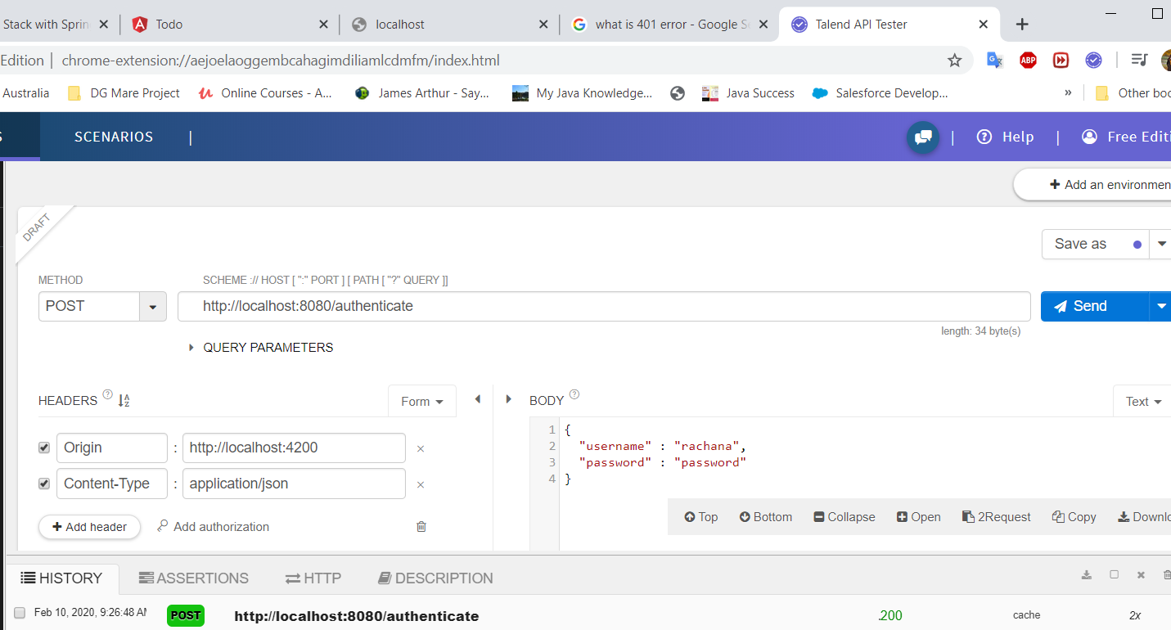

**To Start backend**

1. Go to Application.java

2. Start application

3. Make sure no errors in console.

4. login using Rachana/password