What this application is doing?

We have 3 microservices talking to each other

1. Movie-Info service : This service has information about movies. It has movie name and id of the movie

2. ratings - data service : This service has information about movies. This has movie ratings stored in it.

3. catalog-service : This service is a collector service. It finds out all the ratings provided by user by contacting ratings service. Then for each ratings received, it will contact movie info service to get name of the movie. And return the list by combining all the data

Also has discovery server- this is implemented using eureka framework. Purpose of this is to not hardcode microservice urls within application and use discovery server to discover other services.

Movie-catalog-service

Movie info service

Rating- data service

**Output generated by movie catalog service is:**

[{"name":"test movie","desc":"test","rating":4},

{"name":"test movie","desc":"test","rating":5}]

**Output generated by ratings service:**

[{"movieId":"1234","rating":4},

{"movieId":"2345","rating":5}]

**Output generated by movie-info service:**

{"movieId":"test","name":"test movie"}

**We have used Eureka framework to implement service for service discovery**

**Service discovery uses following model:**

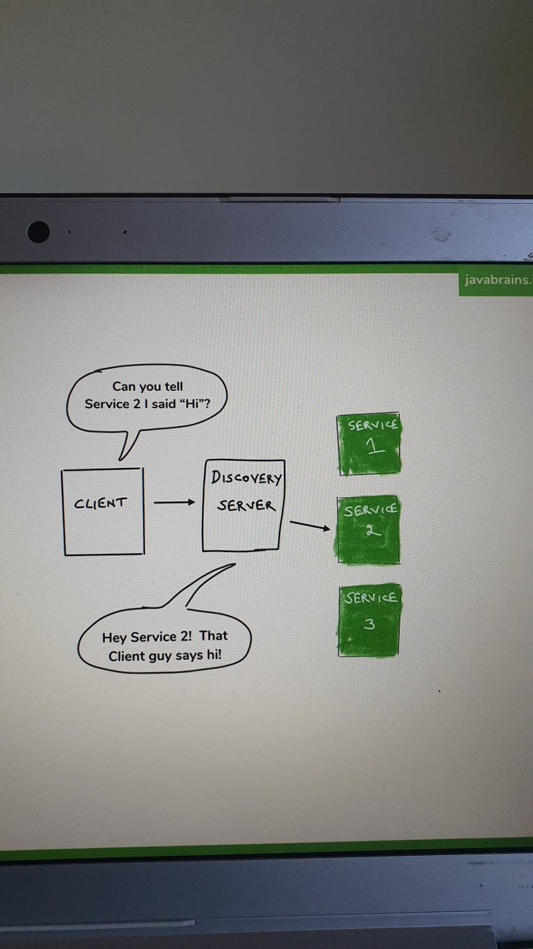

The way eureka works is,

You need to start spring boot application with eureka discovery server dependency. It will start as eureka server. Then you need to add eureka client dependency to all your microservices which you wish to register with discovery server. Then start discovery server and your microservices. Microservices will automatically register themselves with eureka server.

**IMP urls to access:**

Eureka discovery service - <http://localhost:8761/>

Catalog service : <http://localhost:8081/catalog/123>

Movie-info service : <http://localhost:8081/movies/test>

Ratings data service : <http://localhost:8083/ratingsdata/users/1>