### **Acknowledgment**

We are very thankful to Prof. Rushiraj Borisagar for their support and expert guidance. We express our heartfelt thanks and deep sense of gratitude under whose supervision and ceaseless encouragement, the present project was successfully accomplished.

We are thankful to Prof.Amit Purohit who also supported us in this innovative idea.

We also take this opportunity to thank all the other staff member of the information technology department for their valuable guidance and for completion of project.

We would like to thank the collage for providing the required material, books and to the internet for collection related to the project.

We are thankful to all those unseen people across the internet for maintaining those valuable resources on the net. Last but not least; we are also graceful to my friends for their valuable comments and suggestion and my family for their motivation.

**Abstract**

Our project is based on Ceramic Marketing and the purpose of our project is to adopt the best features of the industry to serve the customer.

The website allows one to log in /sign up and then they can order products and calculates Tile-Boxes according to the area as we have given facility of Tile-Calculator. This website also gives facility to download catalog and view picture application to select best tiles to your home or office. If the client has any query so, they will give the feedback about the product. Customer can locate the store from here only.

The administrator can manage tiles by updating, inserting and deleting the new products of tiles. They can also see feedbacks given by the customer and profiles of customers. The admin can also insert the new catalog in the website. This project is easy to manage by the admin. It is a user friendly website for internet user and comfortable interface between client and industry. One admin can also add another admin.

**Index**

**Ch. no Subject Pg. no**

1. **Introduction to industry** **4**
2. **Problem identification and analysis 6**

2.1 requirement of industry 7

2.2 requirement of analysis 7

2.3 feasibility study 8

* 1. risk identification and analysis 10

1. **Description of industrial process** **11**
2. **Outline of the solution 13**

4.1 project introduction 14

4.1.1 Roles and responsibility 15

4.1.2 Model 16

4.1.3 Hardware and software requirement 18

4.1.4 Development platform specification 19

4.1.5 Milestones and Gantt chart 24

4.2 functional and behavioral modeling 26

4.2.1 Data flow diagram 26

4.2.2 E-R diagram 30

4.2.3 use-case diagram 31

4.2.4 Databasedesign and snapshots of table 32

4.2.5 Activity diagram35

4.3 testing 36

4.4 snapshots of project 39

4.5 advantage of new system47

4.6 limitation and future enhancement 47

**5. Bi1bliography** **48**

**Chapter1**

**Introduction to Industry**

* **Introduction**

**Vardhman Marketing** is a versatile ceramic tile company with over six years of experience in this field. This is located in Jamnagar, Gujarat. Head address of this company is near Apsara Cinema, Behind Town Hall, - 361001.The **Vardhman Marketing** established in the year 2006 with the formation of a partnership firm at Jamnagar, Gujarat under the name of Vardhman Ceramics for delivering ceramic, vitrified tiles. The partners of this firm were Mr. Deepak Chag and Mr. Umeshjain.

The Company delivers a vast portfolio of tiles (floor and wall, Vitrified, Glossy). Ceramic tile was used almost everywhere on walls, floors, ceilings, fireplaces, in murals and as an exterior cladding on buildings.

Dealership of companies: NitcoTiles, AGX Tiles, Lorex Tiles

2008  
- Company name has been changed from Vardhman Ceramics to Vardhman Marketing.

**Chapter 2**

**Problem Identify and Analysis**

**2.1 Requirement of industry**

* The Vardhman marketing wants to give the facility to the customer to order tiles online so the customer can easily select the tiles design which gives the best look to the floor.
* They also want to add tile calculator which calculate the tiles-box as per the area of the floor so the large amount of tiles does not be taken by them.
* They also want to add catalog and Picture application so it will be easy for client to choose the best product for their home.
* They can give the facility to the customer to give the feedback. If any query occurs they can solve them and give their best another time.
* They also want to add store locator so it will be easy for customer to locate the store.

**2.2 Requirement Analysis**

* In requirement phase we gathered information, what is the requirement of user and what they actually want in their website.
* We can take information which can make us to solve the problem and provide better solution for by a system and their relationship within and outside of the system.
* In our project the basic aim is to design as, the web application in which the customer can view tiles online, download the catalog, and calculate the tiles-box as per area, give feedback, locate the store.
* To design a software essential component is the inputs, which is to feed in the software.

**2.3Feasibility study**

* Once scope has been identified (with the concurrence of the customer), it is reasonable to ask: “Can we build software to meet this scope? Is the project feasible?” All too often, software engineers rush past these questions only to become mired in a project that is doomed from the onset.
* When we are developing the system (software), we must know the proposed system will be feasible or i.e. practically implemented or not it may possible the proposed( candidate ) system may not implemented due to many reasons like it may take long time in development than the specified time limit ,cost may increase than proposed one etc.
* Therefore we must analyze the feasibility of the system.
* Feasibility is the analysis of risks, costs & benefits relating to economics, technology & user operation. There are several types of feasibility depending on the aspect they covers. Some important feasibility is as follows:-

1. Technical Feasibility

2. Operational Feasibility

3. Economic Feasibility

**1. Technical Feasibility**

* Necessary technology exists to do what is suggested and required by the organization.
* The proposed equipment’s have the technical capacity to hold the data required to use the new system.
* The proposed system will provide adequate response to inquiries regardless of the location if users.
* The hardware needed to develop and implement the system is adequate.

**2. Operational feasibility**

* Operational Feasibility is a measure of how people are able to work with system. This type of feasibility demands if the system will work when developed and installed.
* Since website is very user friendly so users will find it comfortable to work on this site.

**3. Economic feasibility**

A system that can be developed and that will be used if installed must still be a good investment for the organization. Financial benefits must equal or exceed the costs.

The financial and economic issues raised are as under:

* No extra cost is incurred for developing the system. As required software are already used by the department.
* No extra cost for the modification or addition of software and hardware will require in case of future expansion of the current system.

**2.4Risk Identification and Analysis**

###### **Risk Identification**

* Some roughly predicted risks which may arise in our project development are

###### **Project Risk:**

* Save electricity system is a scientific application. Developers & user must have basic knowledge of functional & technical areas of save electricity system.

###### **Technical Risk:**

* Highly functioned module is used so if minimum hardware requirements are only fulfilled then software may be affected by low execution speed.
* As the software is been made for scientific purpose I may not get popular in regular market. The user/operator must have some basic knowledge of advance technology.

**Risk Analysis:**

* It is employed in the broadest sense to include:

###### **Risk Communication:**

* It involves an interactive dialog between stack holders & risk assess and risk managers which actively informs the other process

**Risk analysis = risk assessment + risk management + risk communication.**

###### **Risk Assessment:**

* It involves identifying source of potential harm, accessing the likelihood that harm will occur and the consequences if harm does occur.

**Risk Planning:**

* Interviewing: more number of items the requirements were gathered & filtered so more refined data was collected so the chances of changes in software would be minimal & risk of the in-regular communication could be avoided.

**Chapter 3**

**Description of Industrial Process**

* **Description of Industrial Process**
* If the customer wants to buy or purchase the tiles they have to go to the company but they will get confuse in selecting best tiles for their home or office.
* So this company wants to give the facility to their client to view the tiles online with the help of shopping cart and the customer should select design, color, size etc. than they can give the order online in the website.
* The facility picture application is given.
* So it will be easy for the customer and will save their valuable time.
* This website also gives the facility of tile calculator so customer can order tiles-box as per the area.

**Chapter 4**

**Outline of the Solution**

**4.1 Project Introduction**

* Vardhman Marketing is a web application that provides services like view tiles, Order tiles, download catalog, calculate tiles-box and view picture application.
* Anyone can search the tiles by search engine.
* Vardhman Marketing is a free website where you can see products and many more.
* Customer can view their favorite product for their home, office in Jamnagar.
* Find items from shopping cart, calculate tiles-box as per area, view picture application and order the best suitable tiles for your home to décor.
* Customer can filter your search by size, application, rooms and finish.
* Customer can contact the industry anytime and from anywhere.
* **LIST OF MODULES.**
  + **Client side**
* Search
* Product
* Clint Registration
* Client login
* Contact Us
* About Us
* Store Locator
* Change password
* Contact(feedback)
* Calculator
* Forgot Password
* Add to Cart
* Your Cart
* **Admin side**
* login
* Manage Tiles
* Insert Catalog
* View profile
* View feedback
* Show product
* Remove admin
* Change password
* Add admin(registration)
* Forgot Password

**4.1.1 Roles and responsibility**

* **System Analysis: - Rachana Chag**

**Priya Mulani**

* **System Design: - Rachana Chag**

**Priya Mulani**

* **Database Design: - Rachana Chag**

**Priya Mulani**

* **Form Designing: - Rachana Chag**

**Priya Mulani**

* **Coding: - Rachana Chag**

**Priya Mulani**

* **Testing: - Priya Mulani**

**Rachana Chag**

**4.1.2 Model**

* **Incremental Model**
* In incremental model the whole requirement is divided into various builds. Multiple development cycles take place here, making the life cycle a [“multi-waterfall” cycle](http://istqbexamcertification.com/what-is-waterfall-model-advantages-disadvantages-and-when-to-use-it/).
* Cycles are divided up into smaller, more easily managed modules. Each module passes through the requirements, design, implementation and [testing](http://istqbexamcertification.com/what-is-a-software-testing/) phases.
* A working version of software is produced during the first module, so you have working software early on during the [software life cycle](http://istqbexamcertification.com/what-are-the-software-development-life-cycle-phases/).
* Each subsequent release of the module adds function to the previous release. The process continues till the complete system is achieved.

For example:

* In the diagram above when we work incrementally we are adding piece by piece but expect that each piece is fully finished. Thus keep on adding the pieces until it’s complete.
* **Diagram of Incremental model**:

[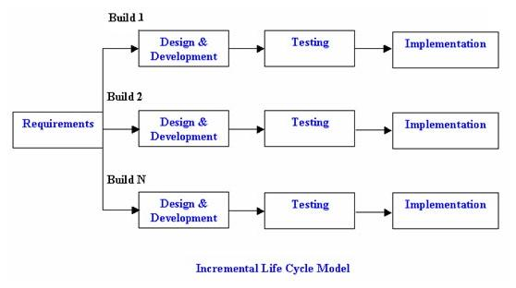](http://istqbexamcertification.com/wp-content/uploads/2012/01/Incremental_model.jpg)

* **Advantages of Incremental model:**
* Generates working software quickly and early during the software life cycle.
* More flexible – less costly to change scope and requirements.
* Easier to test and debug during a smaller iteration.
* Customer can respond to each built.
* Lowers initial delivery cost.
* Easier to manage risk because risky pieces are identified and handled during it’d iteration.
* **Disadvantages of Incremental model**:
* Needs good planning and design.
* Needs a clear and complete definition of the whole system before it can be broken down and built incrementally.
* Total cost is higher than [waterfall](http://istqbexamcertification.com/what-is-waterfall-model-advantages-disadvantages-and-when-to-use-it/).
* **When to use the Incremental model:**
* Requirements of the complete system are clearly defined and understood.
* Major requirements must be defined; however, some details can evolve with time.
* There is a need to get a product to the market early.
* A new technology is being used
* Resources with needed skill set are not available
* There are some high risk features and goals.

**4.1.3 Hardware and software requirement**

**Hardware**

* Minimum 128MB RAM
* Dual core /p4 processor
* Minimum 80GB Hard disk
* Windows 95/98/XP/7/8 or later

**Software**

* IIS configured server.
* Unlimited/limited bandwidth.
* .net framework 4.0 supported.
* Unlimited/limited storage.

**4.1.4 Development Platform specification**

* **Specification: -**

Hard Disk 298GB,

Main memory 2GB RAM,

Operating system: - windows 8

* **Front End Tool: -** Microsoft Visual studio 2010
* **Back End Tool: -** Microsoft visual SQL client
* **Processor: -** Intel i3-2370M CPU @ 2.40 GHz
* **System Type: -** 32 bit - OS, x-64 based processor
* **Programming Language : -** Vb.net and Asp.net

.

**Technology review**

* **ASP.NET**:
* ASP.NET is a set of Web development tools offered by Microsoft.
* Programs like Visual Studio .NET and Visual Web Developer allow Web developers to create dynamic websites using a visual interface Of course, programmers can write their own code and scripts and incorporate it into ASP.NET websites as well.
* Though it often seen as a successor to Microsoft's ASP programming technology, ASP.NET also supports Visual Basic.NET, Script .NET and open-source languages like Python and Perl.
* ASP.NET is built on the .NET framework, which provides an application program interface (API) for software programmers.
* The .NET development tools can be used to create applications for both the Windows operating system and the Web.
* Programs like Visual Studio .NET provide a visual interface for developers to create their applications, which makes .NET a reasonable choice for designing Web-based interfaces as well.
* In order for an ASP.NET website to function correctly, it must be published to a Web server that supports ASP.NET applications. Microsoft's Internet Information Services (IIS) Web server is by far the most common platform for ASP.NET websites.
* While there are some open-source options available for Linux-based systems, these alternatives often provide less than full support for ASP.NET applications.

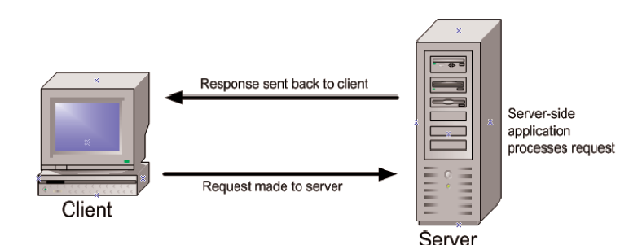

* ASP.NET is much more robust and reliable and deals with memory leaks and freezes efficiently, it automatically handles memory leaks, when a memory leak is detected a new copy of the script is made and execution starts on that copy, the older copy along with the memory leak is deleted once it finishes executing all the takes that were assigned to it previously.
* Previously ASP supported only a few .NET languages which in a way was a big problem for many developers, however ASP.NET now has in-built support for languages like C#, VB, J Script etc.. Best of all ASP.NET code is compatible with all the major browsers i.e. it works on almost all the browsers.
* ASP.NET makes sure that your applications stay secure by its inbuilt windows authentication and per-application configuration.
* **VB Programming Language:**
* VB is an elegant and type-safe object-oriented language that enables developers to build a variety of secure and robust applications that run on the .NET Framework.
* You can use VB to create Windows client applications, XML Web services, distributed components, client-server applications, database applications, and much, much more.
* VB provides an advanced code editor, convenient user interface designers, integrated debugger, and many other tools to make it easier to develop applications based on the VB language and the .NET Framework.
* VB syntax is highly expressive, yet it is also simple and easy to learn.
* VB provides powerful features such as null able value types, enumerations, delegates, lambda expressions and direct memory access, which are not found in Java.
* VB supports generic methods and types, which provide increased type safety and performance, and integrators, which enable implementers of collection classes to define custom iteration behaviors that are simple to use by client code.
* As an object-oriented language, VB supports the concepts of encapsulation, inheritance, and polymorphism.
* All variables and methods, including the Main method, the application's entry point, are encapsulated within class definitions.

.

* **MICROSOFT SQL SERVER**
* Microsoft SQL Server is a relational database management system developed by Microsoft. As a database, it is a software product whose primary function is to store and retrieve data as requested by other software applications, be it those on the same computer or those running on another computer across a network.
* There are at least a dozen different editions of Microsoft SQL Server aimed at different audiences and for different workloads (ranging from small applications that store and retrieve data on the same computer, to millions of users and computers that access huge amounts of data from the Internet at the same time).
* Its primary query languages are T-SQL and ANSI SQL.
* SQL CE databases can support [ACID](http://en.wikipedia.org/wiki/ACID)-compliance, but do not meet the durability requirement by default because Auto Flush buffers changes in memory therefore committed transaction changes can be lost. To meet the durability.
* Requirement the commit call on the transaction must specify the immediate flag.
* Like [Microsoft SQL Server](http://en.wikipedia.org/wiki/Microsoft_SQL_Server), SQL CE supports transactions, referential integrity constraints, locking as well as multiple connections to the database store.
* However, [nested transactions](http://en.wikipedia.org/wiki/Nested_transaction) are not supported, even though parallel transactions (on different tables) are.
* The current release does not support [stored procedures](http://en.wikipedia.org/wiki/Stored_procedures)  or native [XML](http://en.wikipedia.org/wiki/XML) data type either. It uses a subset of [T-SQL](http://en.wikipedia.org/wiki/T-SQL)  for querying and due to lack of XML support, [Query](http://en.wikipedia.org/wiki/XQuery) is not supported either.
  + 1. **Milestones**
* Sometimes there are events externals to your project that you want to track. If you cannot link to them because they are not in project plan you can create a milestone to represent them in your own project.
* Some milestones may need duration. For example, your project has an approval milestone at the end of a phase and you know that the approval process will take time nr. About a week.
* **WEEK 1:** Introduction to project.
* **WEEK 2:** Requirement gathering.
* **WEEK 3:** Roles & Responsibility Analysis.
* **WEEK 4:** Detailed study of Project.
* **WEEK 5:** Database analysis & design.
* **WEEK 6:** Creation of DFD diagram, design phase.
* **WEEK 7:** Development of basic application using ASP.NET.
* **WEEK 8:** Start with analysis & decide the flow of the project**.**
* **WEEK 9:** Testing of Project.
* **WEEK 10:** Documentation of project.

**4.2.5 Activity Gantt chart:**

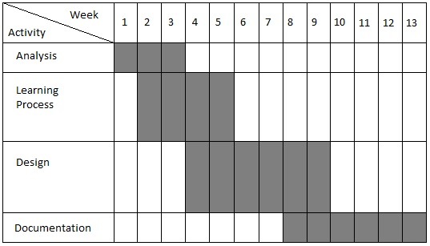

**4.2 Functional and Behavioral Modeling**

**4.2.1 Data flow diagram:**

As information moves through software, it is modified by a series of transformations. A Data Flow Diagram (DFD) is a graphical technique that depicts information flow and the transformations that are applied as data move from input to output. The data flow diagram is known as a data flow graph or a bubble chart.

The Data Flow Diagram may be used to representation a system or software at any level of abstraction. In fact, DFDs may be used partitioned into levels that represent increasing information flow and functional detail.

**The Data Flow Diagram (DFD) serves two purposes:**

1). to provide an indication of how data are transformed as move through the system

2). to depict the functions that transform the data flow. The DFD provides additional information that is used during the analysis of the information domain and serves as a basis for the modeling of function.

A Level 0 DFD also called as fundamental system model or a context model represents the entire software element as a single bubble with input and output data indicated by incoming and outgoing arrows respectively. Additional processes and information flow paths are represented as the level 0 is partitioned to reveal details. Each of the proof represents at level 1 is sub function of the overall system depicted in the context model. Each of the process may be refined are layered to depict more detail. Information continuity must be maintained in every layer, that is input and output to each refinement must remain the same**.**

Convention used in drawing the data flow diagram is as follows:-

* **Process**
* **Data Store**
* **Entity**
* **Data Flow**
* A DFD also known as ‘bubble chart’ has the purpose of clarifying system requirements and identifying major transformations. It shows the flow of data through a system.
* It is a graphical tool because it presents a picture. The DFD may be partitioned into levels that represent increasing information flow and functional detail.
* Four simpl111e notations are used to complete a DFD. These notations are given below:-

**Data flow: -**

* The data flow is used to describe the movement of information from one part of the system to another part. Flows represent data in motion. It is a pipe line through which information flows. Data flow is represented by an arrow.

**Process:** -

* A circle or bubble represents a process that transforms incoming data to outgoing data. Process shows a part of the system that transforms inputs to outputs.

**External entity**: -

* A square defines a source or destination of system data. External entities represent any entity that supplies or receive information from the system but is not a part of the system.

**Data store**: -

* The data store represents a logical file. A logical file can represent either a data store symbol which can represent either a data structure or a physical file on disk.
* The data store is used to collect data at rest or a temporary repository of data.
* It is represented by open rectangle.

**Output**:-

* The output symbol is used when a hard copy is produced and the user of the copies cannot
* Be clearly specified or there are several users of the output.
* **Context level DFD**

Add admin

Remove admin

Change password

Show product calculator

**Admin**

**Client**

View profile store locator

Forgot Password See product

Login Search

Insert tiles registration

Delete tiles Login

View feedback

Insert catalog Order Product

Forgot Password

Feedback

Change password

* **0 Level DFD**

**Insert data**

**Client**

**Sign _in**

Order

Search

Enters feedback **description prod**

**Feedback**

View

Insert/update/delete /Show

View

Insert

**Admin**

**Ad _signup Ad _signup**

Insert view profile

**Catalog**

**4.2.2E-R diagram**

* Also called an **entity-relationship** (**ER**) **diagram**, a graphical representation of entities and their relationships to each other, typically used in computing in regard to the organization of data within databases or information systems. An entity is a piece of data-an object or concept about which data is stored.

.

* The ER model would say that you are an entity, and each phone number is an entity, and the relationship between you and the phone numbers is 'has a phone number'.
* Diagrams created to design these entities and relationships are called entity–relationship diagrams or ER diagrams.
* ER diagrams often use symbols to represent three different types of information. Boxes are commonly used to represent entities.
* Diamonds are normally used to represent relationships and ovals are used to represent attributes.

## 

## **ER Diagram**

Checks

**Ad_signup**

Insert

**Feedback**

Gives

**Catalog**

**Signin**

Watch

**Description**

**4.2.3 Use Case Diagram**

* **Client:**

Client

* **Admin:**

Admin

**4.2.4 Data base Design and Table Snap Shot:**

**1. Sign in**

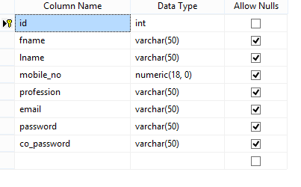

**2. Catalog**

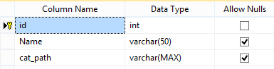

**3. Product:**

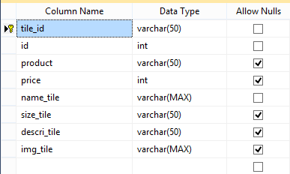

**4. Feedback:**

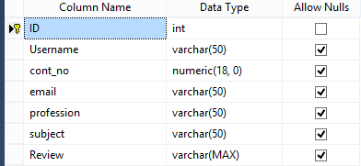

**5. Ad_signup**

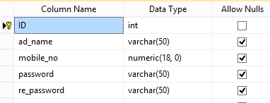

**4.2.5 ACTIVITY DIAGRAM**

Validity

Login

Invalid password valid password

Go to User Account

Locate store

View catalog

Calculate tiles

View product

Feedback

**4.3 Testing**

* Software testing is the process of evaluation a software item to detect differences between given input and expected output. Also to assess the feature of a software item. Testing assesses the quality of the product. Software testing is a process that should be done during the development process. In other words software testing is a verification and validation process.
* Generally, no system is perfect due to communication problems between user and developer, time constraints, or conceptual mistakes by developer.
* To purpose of system testing is to check and find out these errors or faults as early as possible so losses due to it can be saved.
* Testing is the fundamental process of software success. Testing is not a distinct phase in system development life cycle but should be applicable throughout all phases i.e. design development and maintenance phase.
* Testing is used to show incorrectness and considered to success when an error is detected.
* **OBJECTIVES OF SOFTWARE TESTING**
* The software testing is usually performed for the following objectives:-
* **SOFTWARE QUALITY IMPROVEMENT**:-
* The computer and the software are mainly used for complex and critical applications and a bug or fault in software causes severe losses.
* So a great consideration is required for checking for quality of software.
* VERIFICATION AND VALIDATION Verification means to test that we are building the product in right way .i.e. are we using the correct procedure for the development of software so that it can meet the user requirements.
* **SOFTWARE RELIABILTY ESTIMATION**:-
* The objective is to discover the residual designing errors before delivery to the customer.
* The failure data during process are taken down in order to estimate the software reliability.
* **PRINCIPLES OF SOFTWARE TESTING: -**
* Testing is an extremely creative and challenging task.
* Some important principles of software testing are as given: - All tests should be traceable to customer requirements.
* Testing time and resources should be limited i.e. avoid redundant testing. It is impossible to test everything.
* Use effective resources to test. Test should be planned long before testing begins i.e. after requirement phase.
* Test for invalid and unexpected input conditions as well as valid conditions. Testing should begin in “in the small” and progress towards testing “in the large”.

.

* **STRATEGY FOR SOFTWARE TESTING**
* Different levels of testing are used in the test process; each level of testing aims to test different aspects of the system.
* The first level is unit testing. In this testing, individual components are tested to ensure that they operate correctly.
* It focuses on verification efforts. The second level is integration testing. It is a systematic technique for constructing the program structure.
* In this testing, many tested modules are combined into the subsystem which is then tested.
* The good here is to see if the modules can be integrated properly. Third level is integration testing
* System testing is actually a series of different tests whose primary purpose is to fully exercise computer based system.
* These tests fall outside scope of software process and are not conducted solely by software engineers.
* **White Box Testing**
* White box testing is the detailed investigation of internal logic and structure of the code. White box testing is also called glass testing or open box testing. In order to perform white box testing on an application, the tester needs to possess knowledge of the internal working of the code
* White box testing sometimes-called glass box testing is a test case design method that uses the control structure of the procedural design to derive test cases.
* Using white box testing Methods, the software engineer can derive test cases that:

1. Guarantee that all independent paths within a module have been exercise at least once.
2. Exercise all logical decisions on their true and false sides.
3. Execute all loops at their boundaries and within their operational bounds.
4. Exercise internal data structure to assure their validity.

* **Black Box Testing**
* The technique of testing without having any knowledge of the interior workings of the application is Black Box testing. The tester is oblivious to the system architecture and does not have access to the source code. Typically, when performing a black box test, a tester will interact with the system's user interface by providing inputs and examining outputs without knowing how and where the inputs are worked upon.
* Black box testing is not an alternative to white box techniques.
* Rather it is a complimentary approach that is likely to uncover a different class of errors than white box method. Black box testing attempts to find errors in their following categories:

1. Incorrect on missing functions.
2. Interface errors.
3. Performance errors.
4. Errors in data structures or external data based access.
5. Initialization and termination Errors.

**4. Screen shot of project**

**Client Side**

**1. User Registration:**

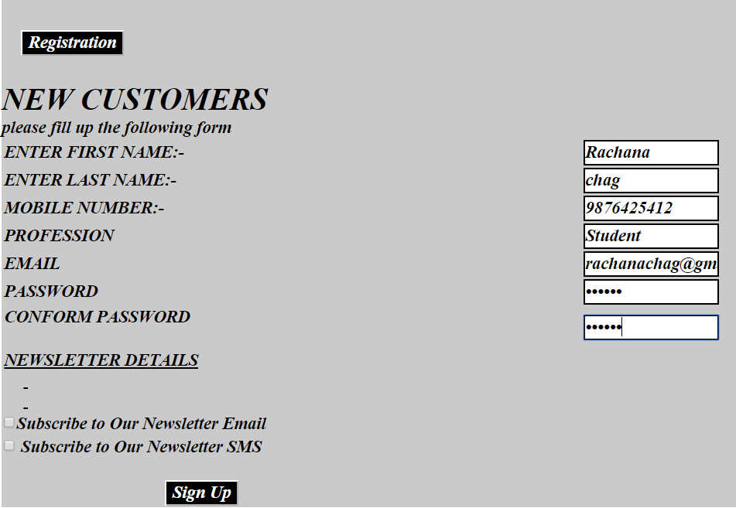

* **Registration, it’s for those Clients who haven’t registered yet.**

**2. Login:**

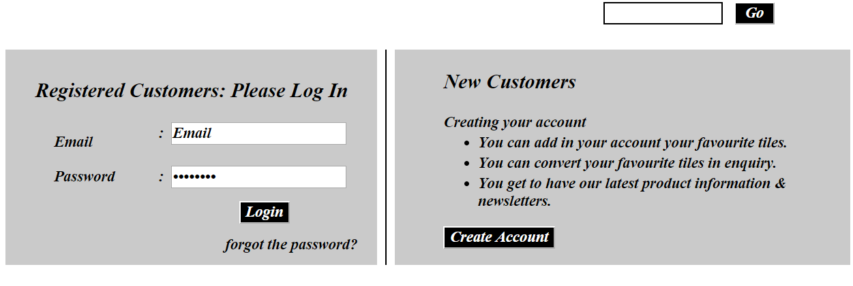

* **The User Login Page, User can login in the site.**
* **Before Login, Client can find Products, Categories, Login, sign-up and Home Page:**

**3. Store Locator:**

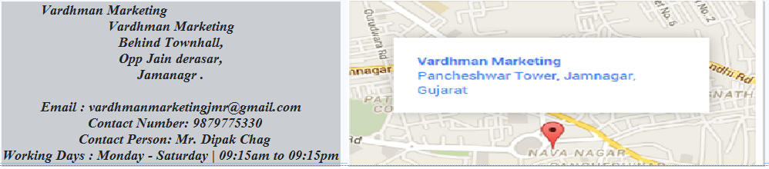

* **By this module client can find proper way and location through map.**

**4Home**:

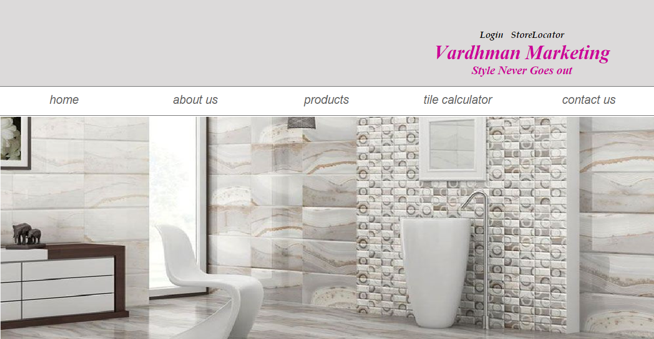

* **When customer visit the web site they will open home page Before Login, Client can only find Products, Categories, view picture application, download catalog, Login, sign-up and Home Page:**

**5. about Us:**

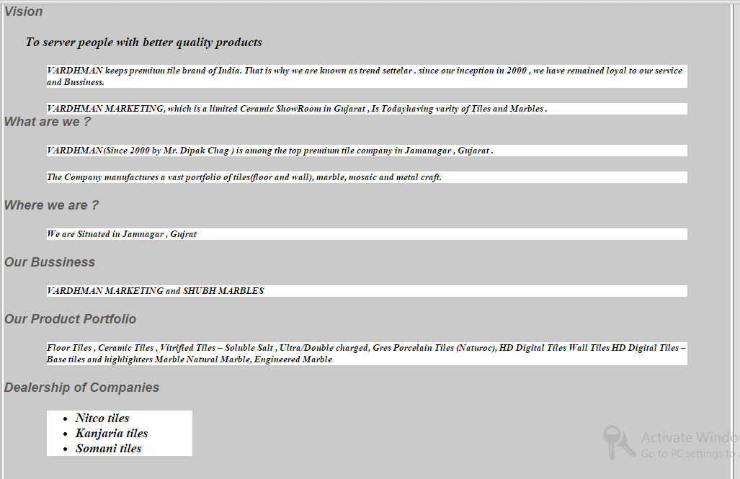

* **The about us page; User can view information about the company.**

**6. Contact Us:**

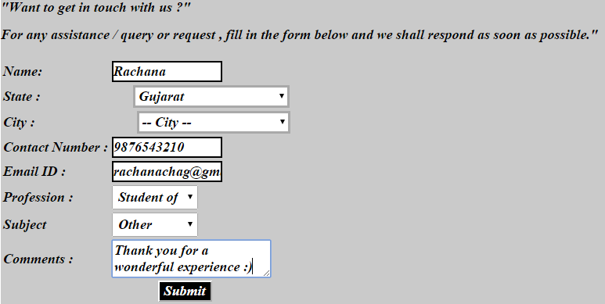

* **Customer can contact the company and give their valuable feedback**

**8: Products**

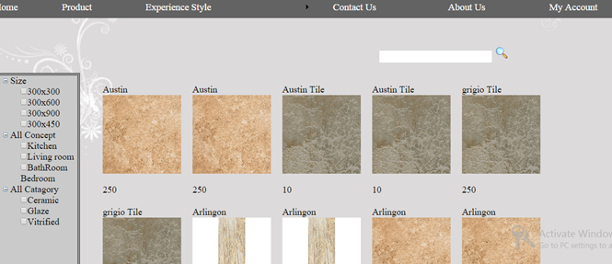

* **Product page, Customer can see, Order their favorite tiles.**
* **They can also search for the tiles.**

**9. Product details:**

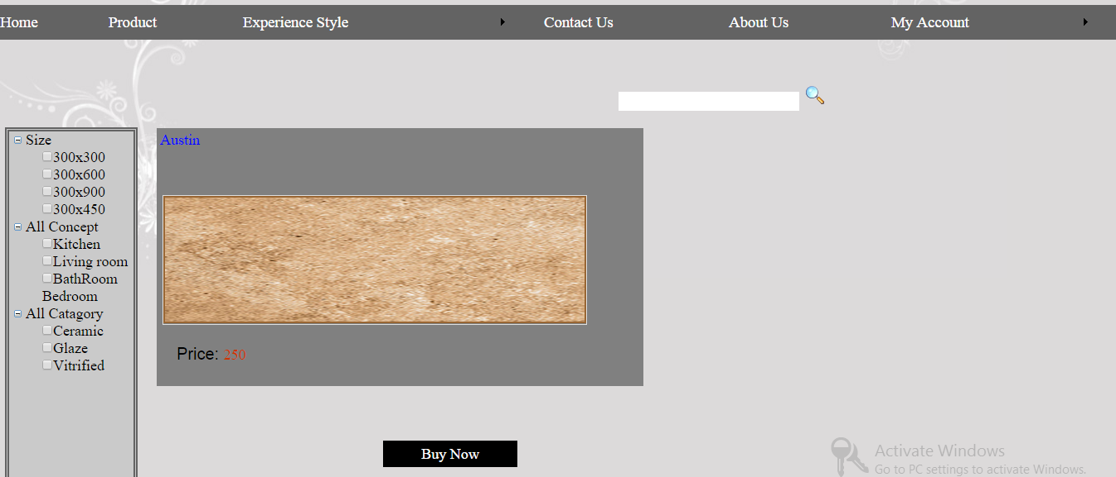

* **Details of the product and if customer wants to buy any product then this page allows one to purchase the tile.**

**10. Order product:**

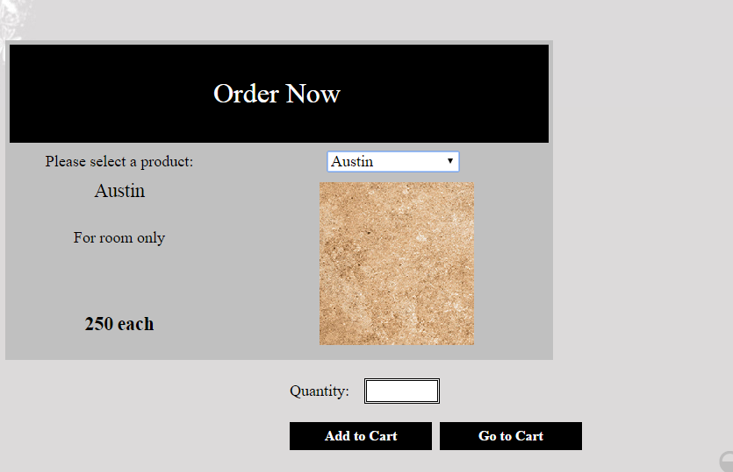

* **Here Customer can place his or her order and quantity of ties, it will be added to their cart.**

**11. Your Cart:**

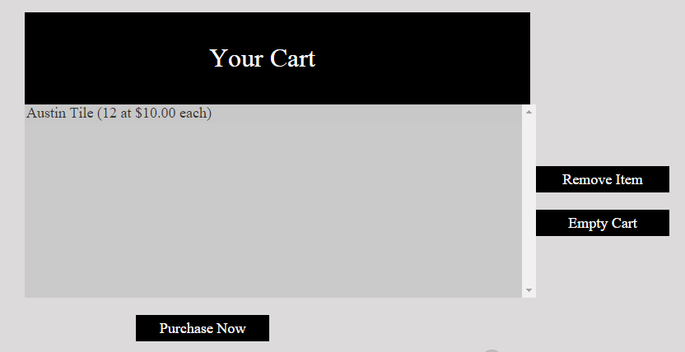

* **Cart will display your chosen tiles, which customer has choose to buy , they can delete cart items.**

**11. Purchase:**

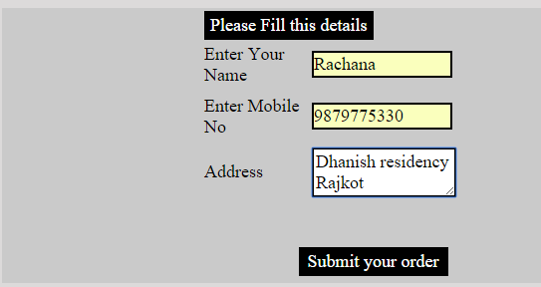

* **If customer wants to purchase the tile online then they have to fill this form and this will redirect to a gateway or a bank website.**

**12. Tile calculator:**

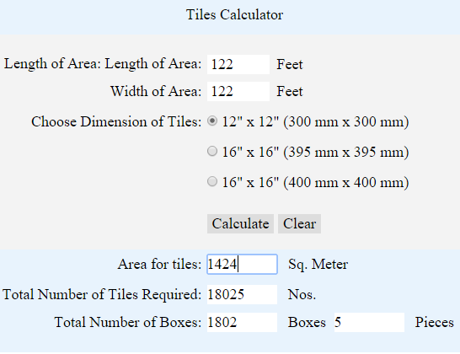

* **Tile calculator which calculate the tiles-box as per the area of the floor so the large amount of tiles does not be taken by them.**

**13. Catalog:**

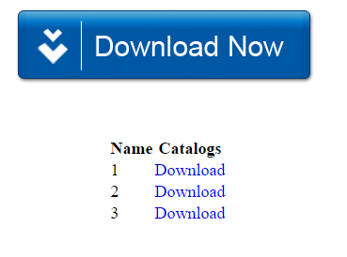

* **It allows customer to download catalog, Catalog displays all tiles and picture application together.**

**13. Search:**

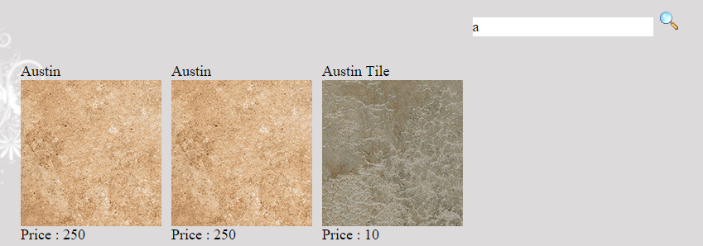

* **Search engine allows customer to find their favorite tile with just one click.**

**14. Change Password:**

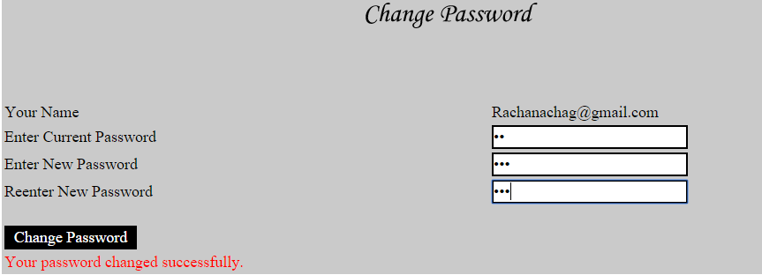

* **It allows customer to change their password after log in.**

**15. Forgot Password:**

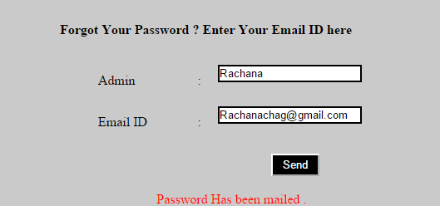

* **If customer forgot the password then this website will send their password to their Mail Id.**

**Admin Side**

**1. Admin Login:**

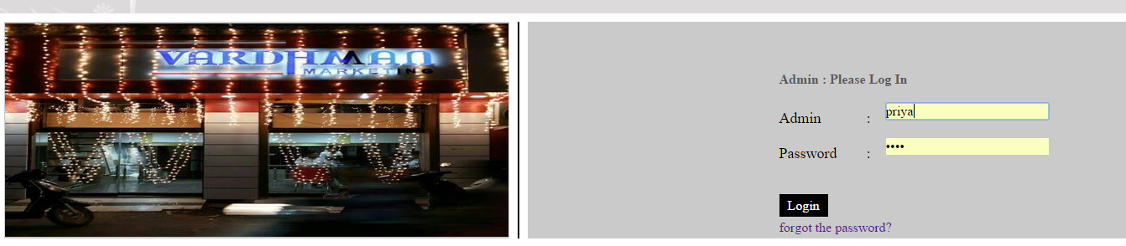

* **The Admin Login Page; Administrator can login into website and Update information.**
* **Admin can insert tiles, update and delete tiles.**
* **Admin can see contact details and feedbacks and can response them**.

**2. AdminHome:**

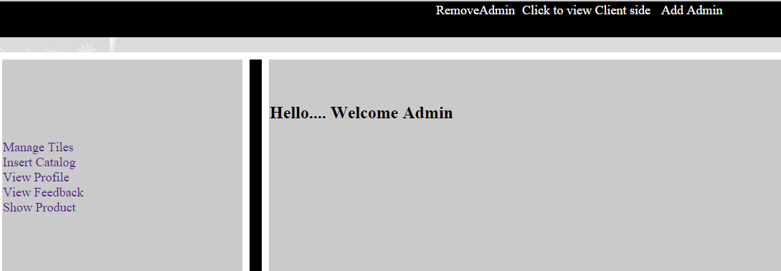

* **After login Admin will redirect to this page.**

**3. AddAdmin:**

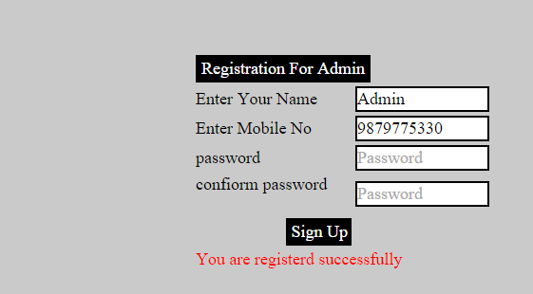

* **An Admin can add a new admin to make their work easy.**

**4. RemoveAdmin:**

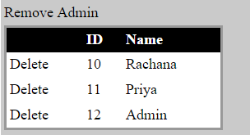

* **A main admin can remove any admin.**

**4. Change Password:**

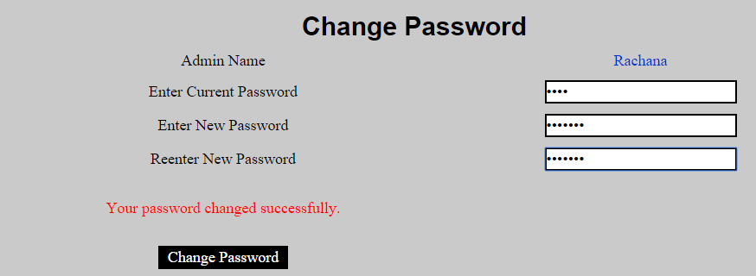

* **Change password module allows user to change their password after log in.**

**5. Insert Tiles:**

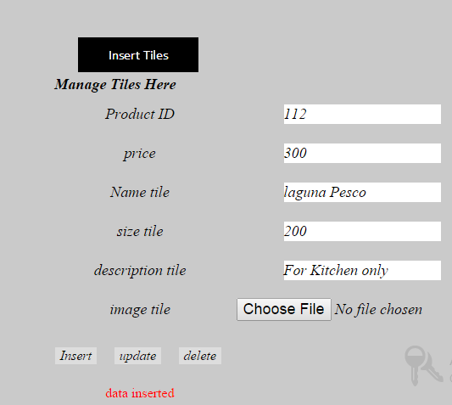

* **By this module admin can insert any Item, Even they can edit and delete the product.**

**6. Insert Catalog:**

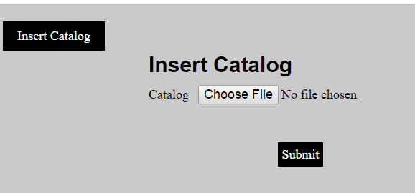

**By This module admin can insert catalog, Thus with the help of this catalog**

**7. Profile of Customer:**

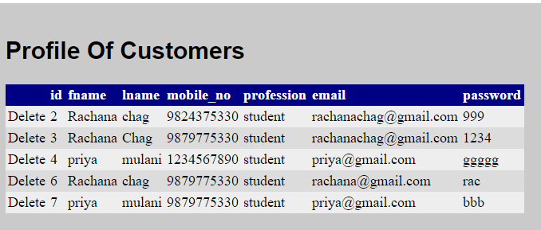

* **An Admin can view profiles of customer and even can delete their account.**
* **8. Feedbacks from customer:**

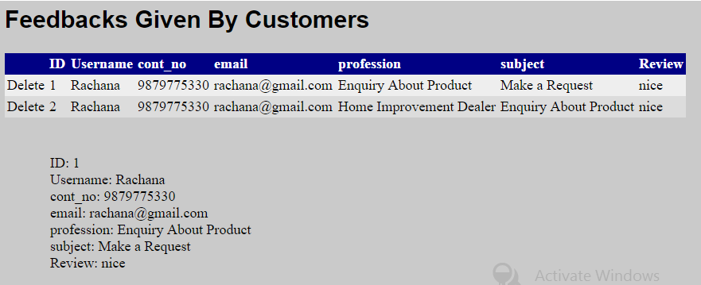

* **An Admin can view feedbacks given by customer and even can delete their feedbacks.**

**9. Products Added by admin:**

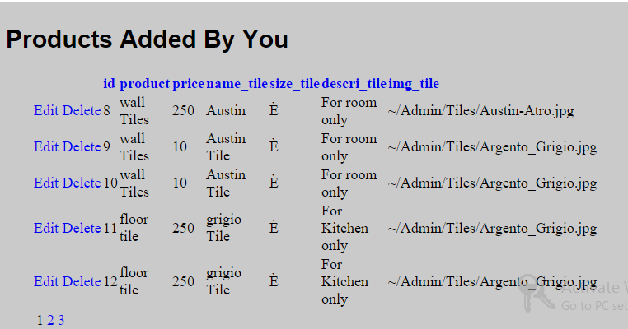

* **An Admin can view products they have added.**

**10. Forgot Password**



* **If an admin forgot the password, with the help of database they can get their password and log in.**
  1. **Advantage of New System:**
* Customer can find appropriate product and its details.
* Customer can see the tiles without Registration.
* They can calculate tiles-box as per area, download catalog, view picture application and give the order of the products online.
* Any People can search and buy any kind of product.
* Easy to use and find any product through search engine.

## **4.6 Limitations and Future Enhancement:**

* **LIMITATIONS:**
* Due to short period of time we could not provide security to the website.
* Digital Media like Internet is required.
* Only Internet User Can Find or see this website.
* This site do not Provide protection against hackers, viruses, and some more external threats.
* **FUTURE ENHANCEMENT:**
* Right now we have just kept this project narrowed down due to short period of time i.e. customer can log in/sign up and see the products and give the feedback and can contact the industry and they can also get information of the industry, download catalog and view picture application.
* But if given a chance we would like to enhance it to all modules like online payment of tiles.

**Chapter 5**

**Bibliography**

**www.nitcotiles.com**

<https://www.somanyceramics.com>

[**www.google.com**](http://www.google.com)

**And the required guidance, suggestions to develop website was given by faculty, staff members, family and friends.**