Author Database:

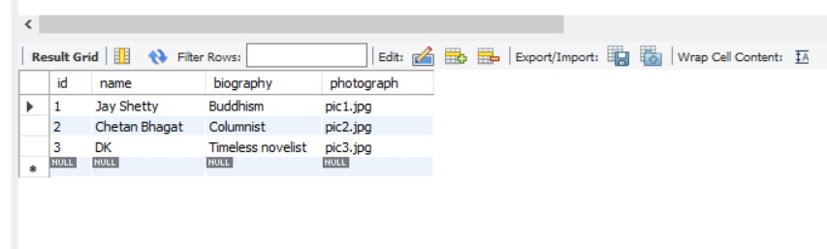

Book Database:

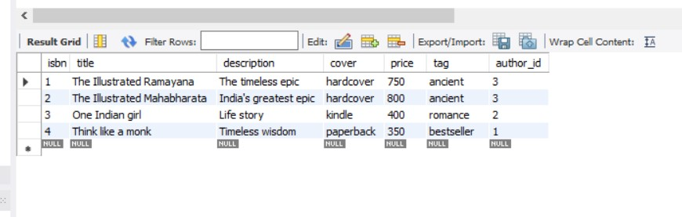

Review Database:

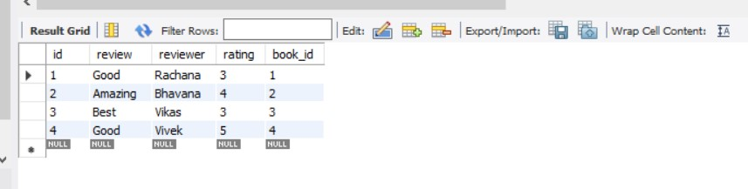

Output Snapshots:

* Author related endpoints:

1. Creating an author

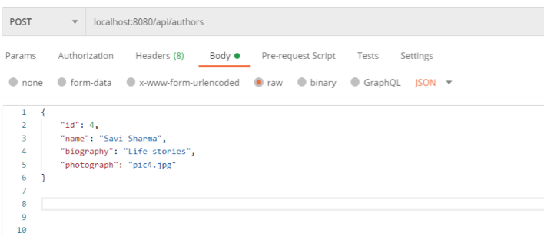

Updated in author database:

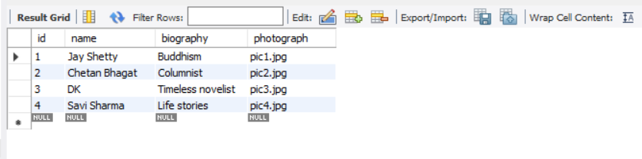

1. List of all authors

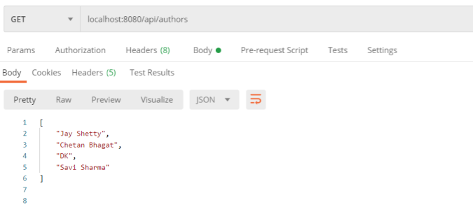

1. Author by Id

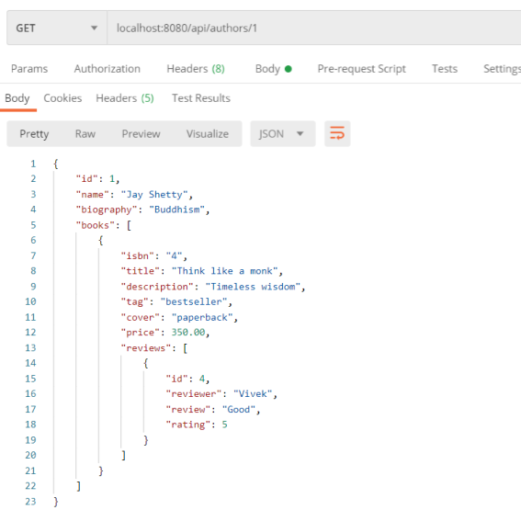

1. All books by current author

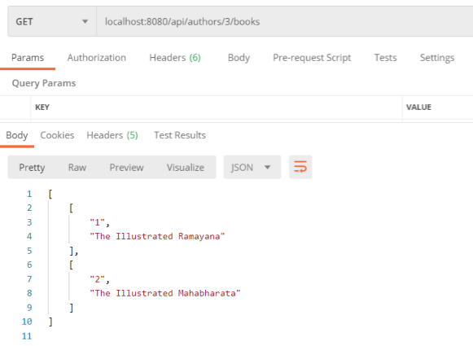

1. Update Author

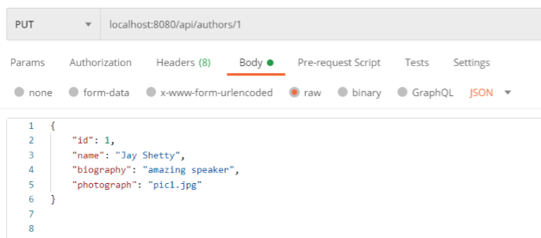

Author database updated

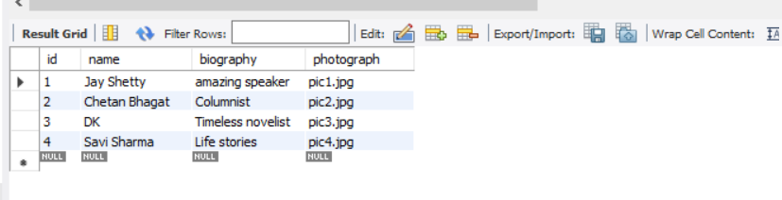

1. Delete Author

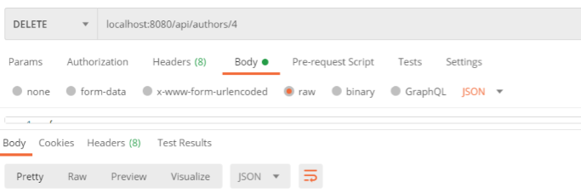

Id 4 got deleted from author database

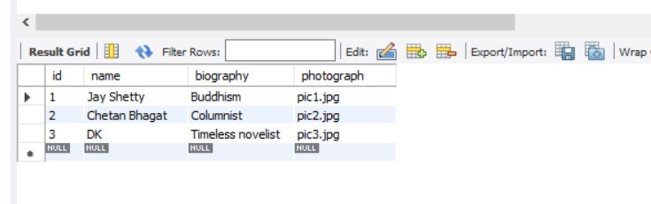

* Book related endpoints:

1. Create new book

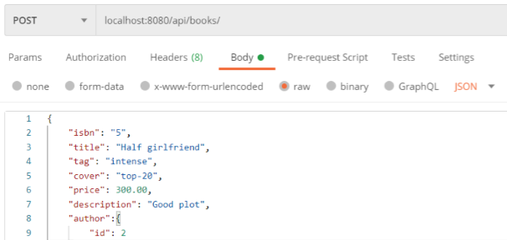

New book in book database

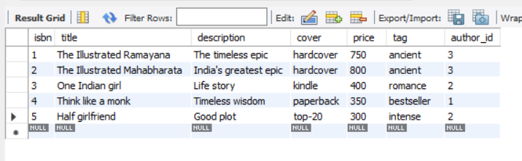

1. Get all books

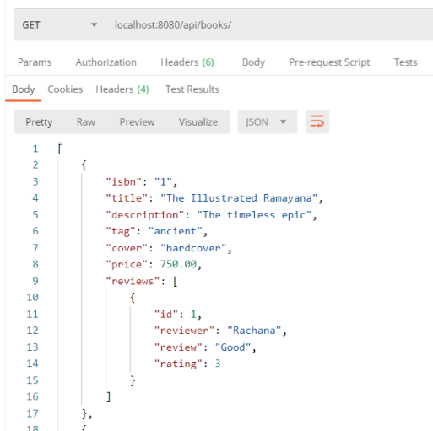

1. Get book by Isbn

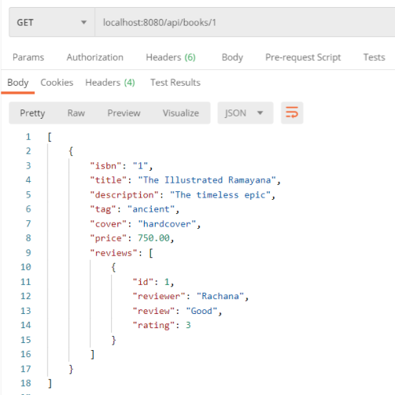

1. Update a Book

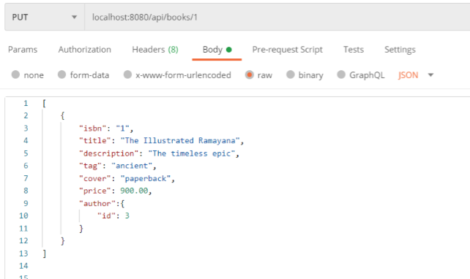

Book database has been updated

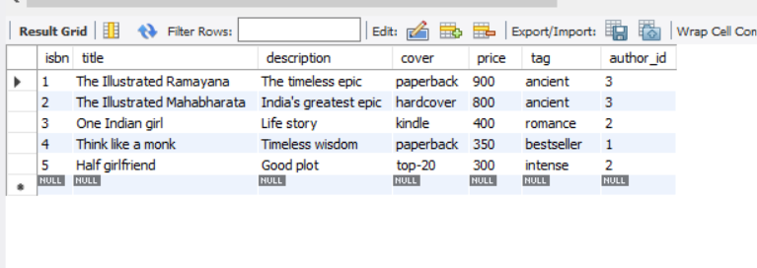

1. Delete a book

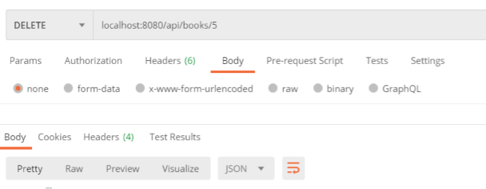

Last book has been deleted from book database

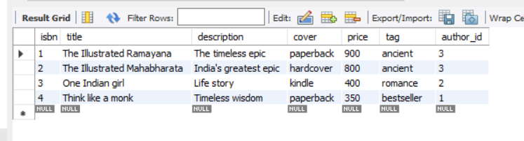

1. Get book by matching author name part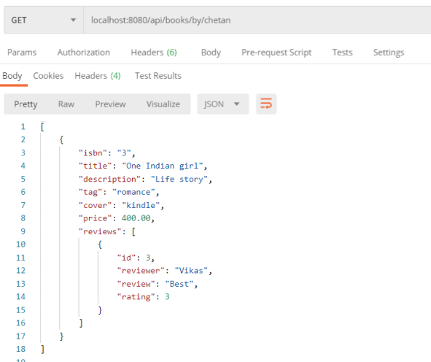
2. Get book in price range

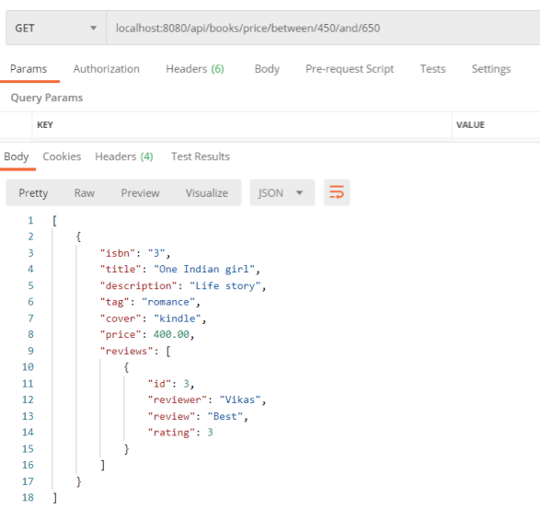

1. Get all reviews for the given Isbn

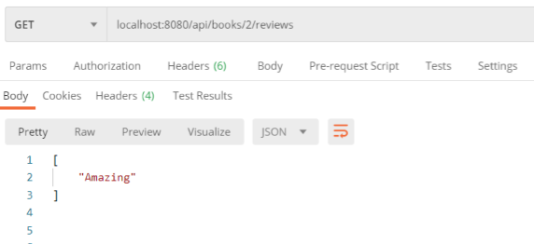

* Review related endpoints:

1. Create a review

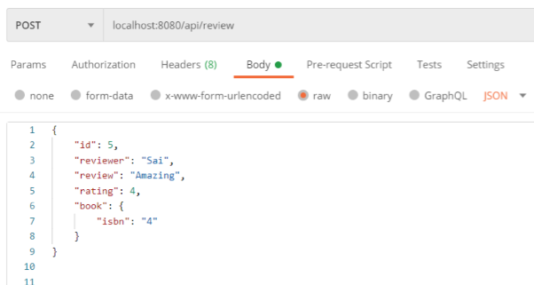

Review has been added to database

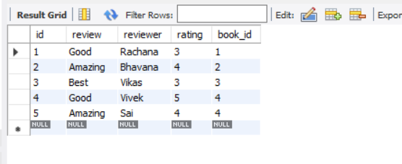

1. Get all reviews

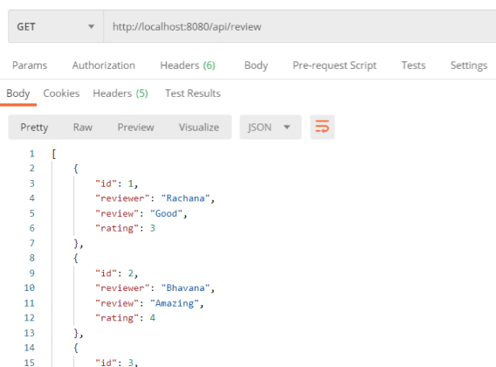

1. Get all reviews for given Isbn

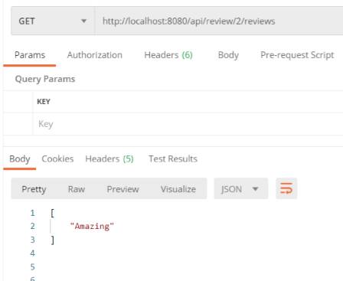

1. Get all reviews in min-max range

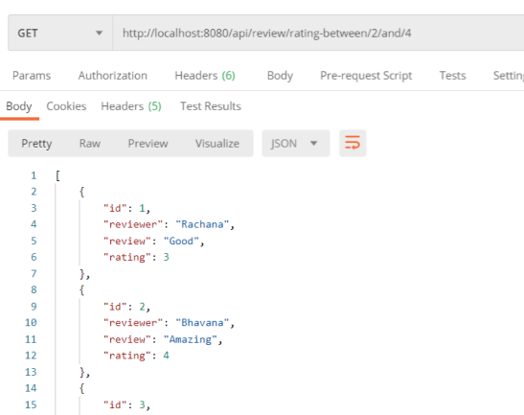

1. Return average rating

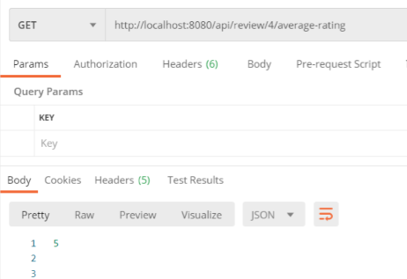

1. Get all reviews containing text

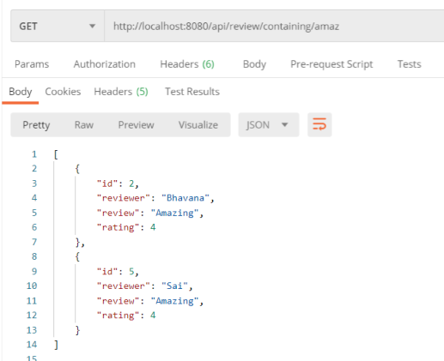

----------------------------END----------------------------