**WEEK-4**

**Hands on 1**

**Create a Spring Web Project using Maven**

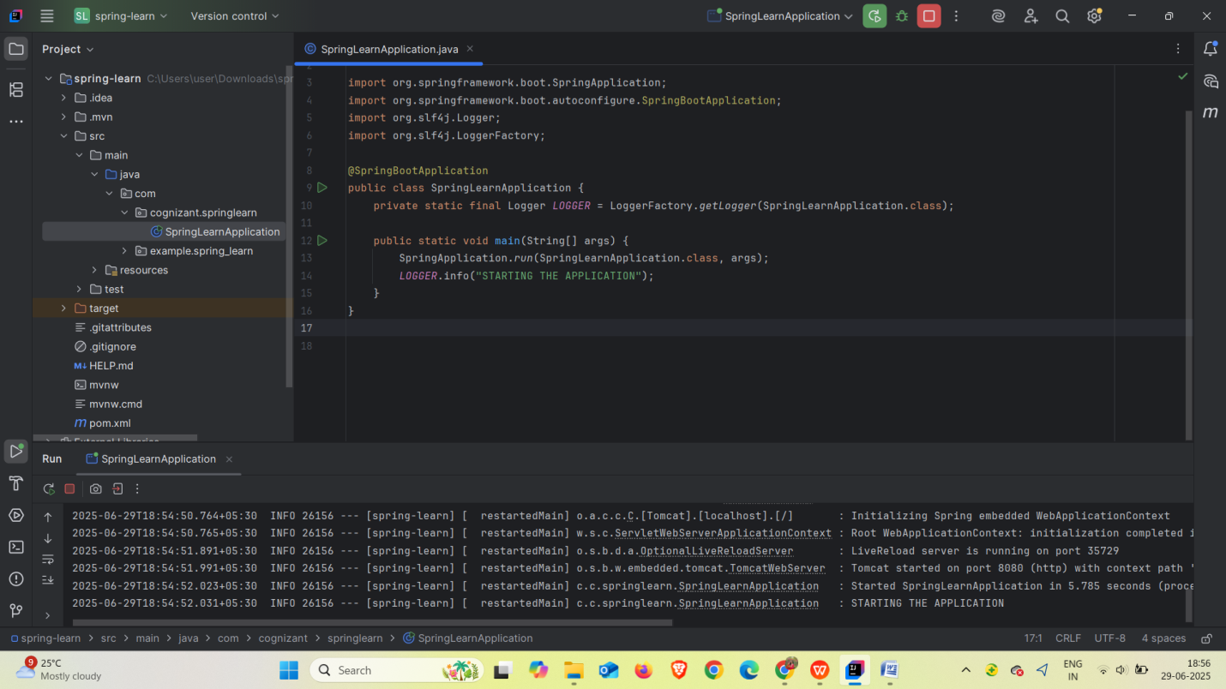

SME Walkthrough Points

1. `src/main/java`  
*Java application code lives here

*Follows base package structure:

`com.cognizant.springlearn`

Contains:

* Main class

* Future controllers, services, models

2. `src/main/resources`

For configuration files

* `application.properties` goes here

* Static resources and templates

* Spring reads this for boot-time setup

3. `src/test/java`

For unit testing

* IntelliJ supports running tests easily

4. `SpringLearnApplication.java`

* This is the main class

* Contains the `main()` method which bootstraps the Spring Boot app

* Uses: SpringApplication.run(SpringLearnApplication.class, args);

5.Purpose of `@SpringBootApplication`

This is a meta-annotation that includes:

|  |  |
| --- | --- |
| ANNOTATION | PURPOSE |
| |  | | --- | | @Configuration |  |  | | --- | |  | | |  | | --- | | Marks this class as Spring config class |  |  | | --- | |  | |
| |  | | --- | | @EnableAutoConfiguration |  |  | | --- | |  | | |  | | --- | | Enables Spring Boot's auto setup |  |  | | --- | |  | |
| |  | | --- | | @ComponentScan |  |  | | --- | |  | | Enables scanning for beans and components |

6. `pom.xml` – Walkthrough

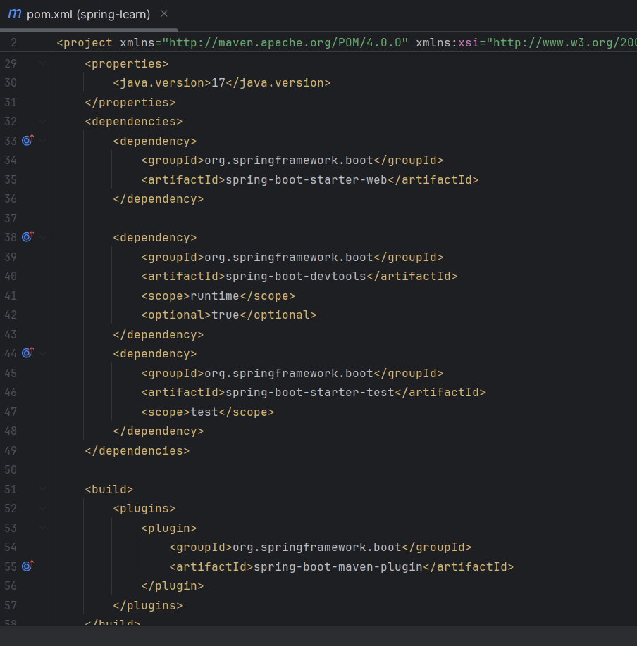

7. Dependency Hierarchy in IntelliJ

1. Open the `pom.xml`

2. At the bottom, click the or "Maven" tab

3. Expand `spring-boot-starter-web` → See all sub-dependencies like:

* `spring-web`

* `spring-core`

* `jackson`

* `spring-context`, etc.

**Hands on 2**

**Spring Core – Load SimpleDateFormat from Spring Configuration XML**

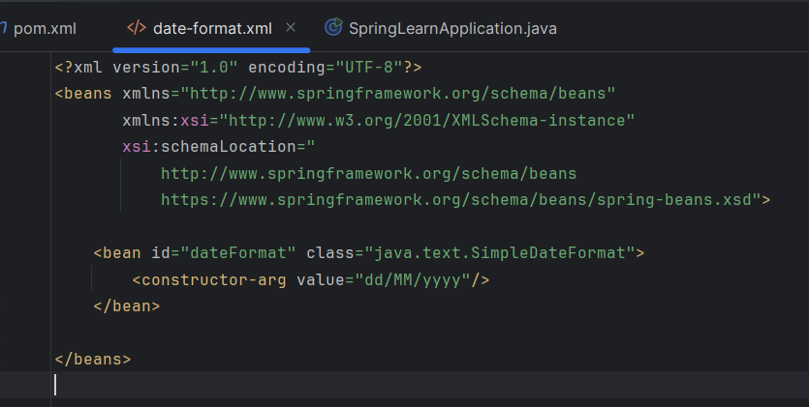

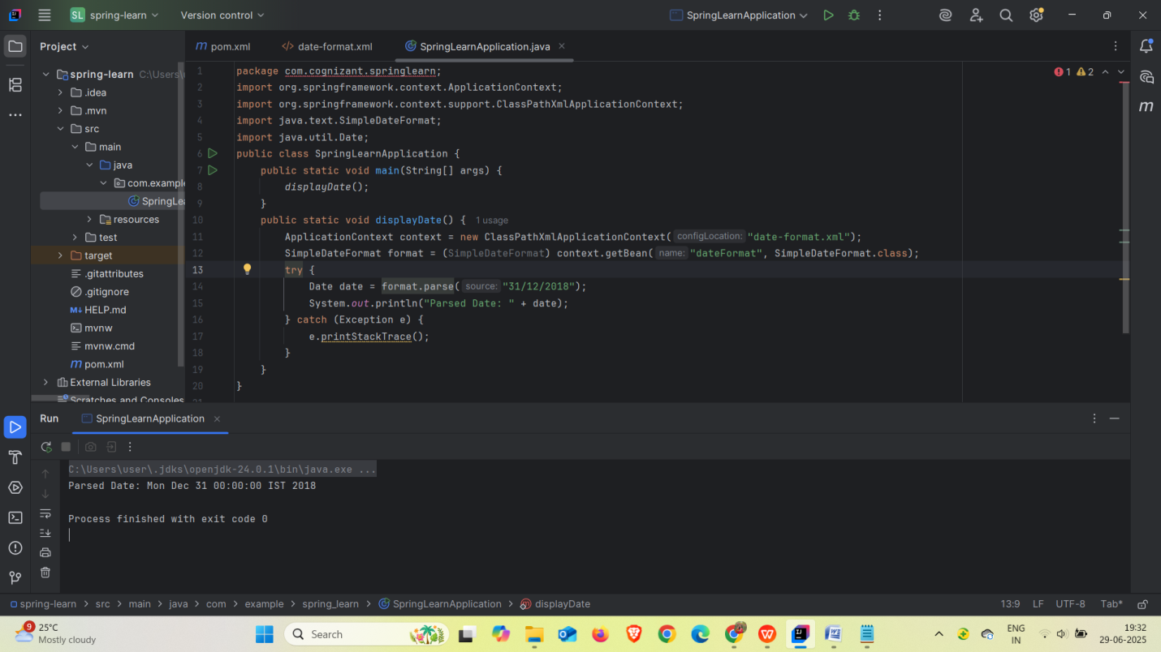

**Hands on 4**

**Spring Core – Load Country from Spring Configuration XML**

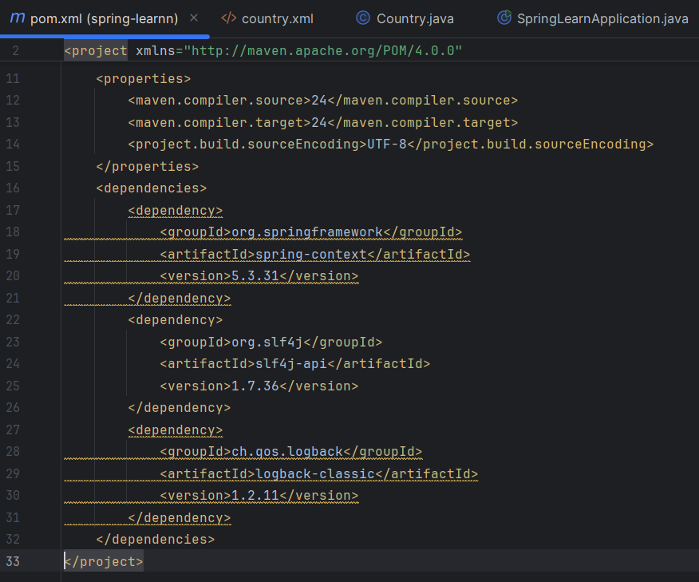

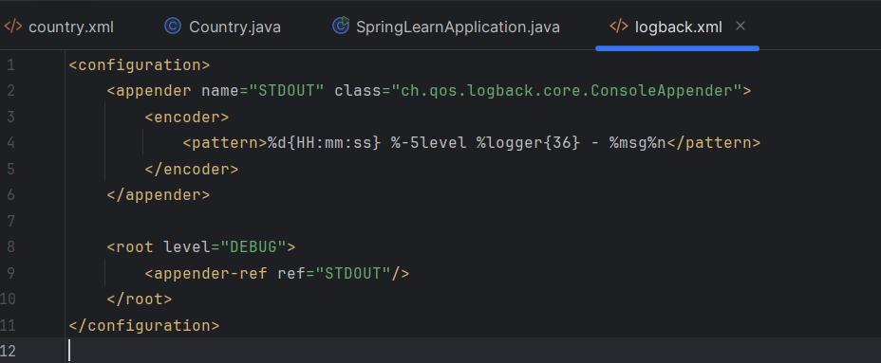

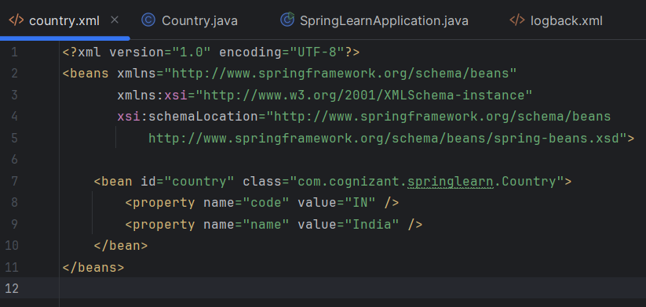

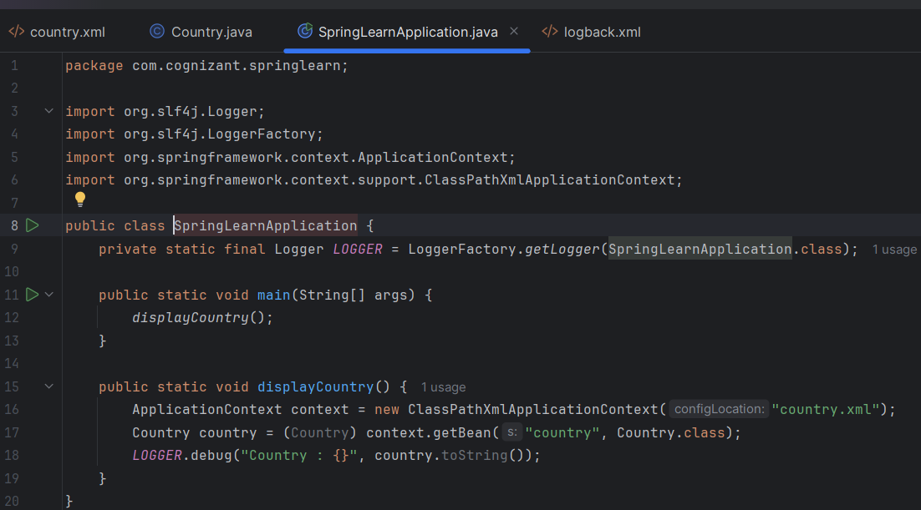

**OUTPUT**

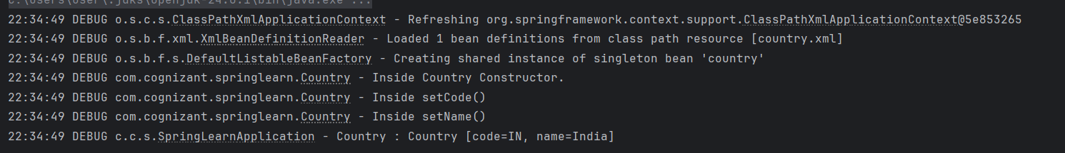

**Hello World RESTful Web Service**

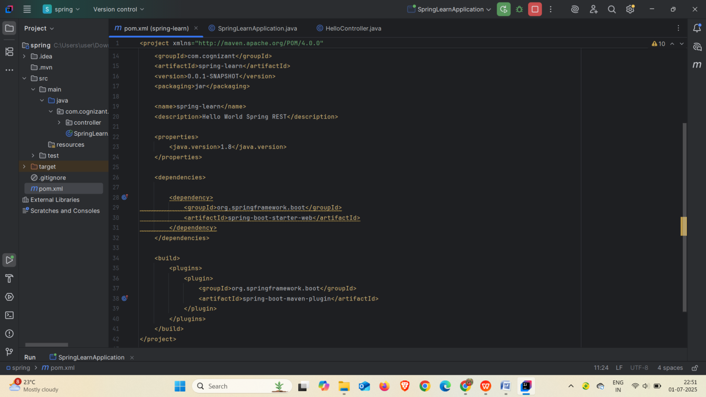

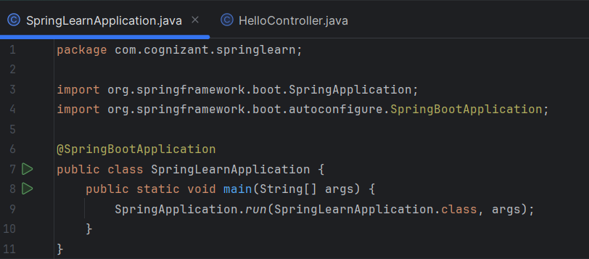

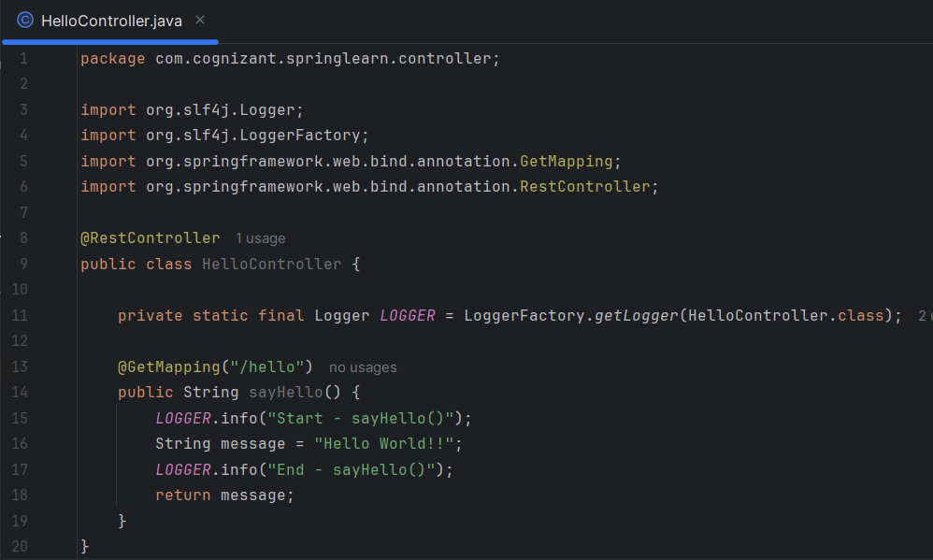

**OUTPUT**



**REST - Country Web Service**

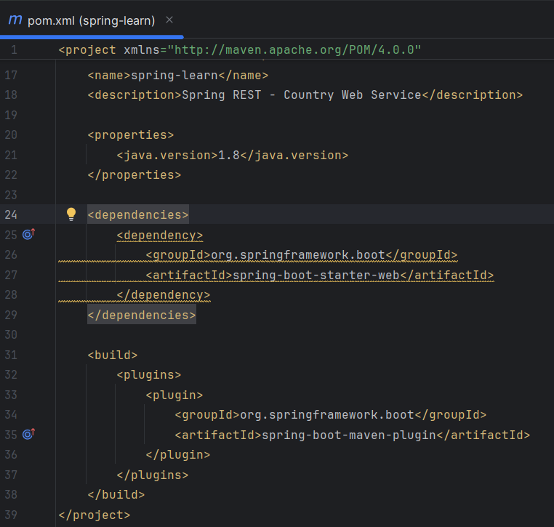

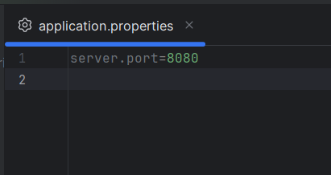

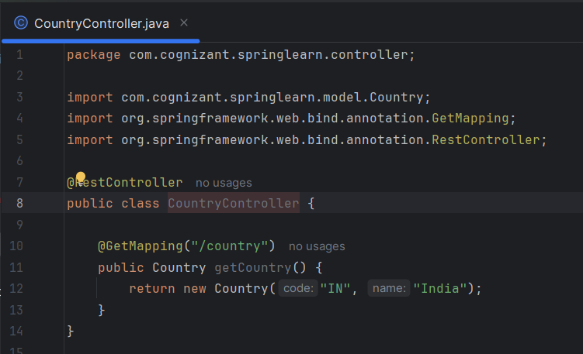

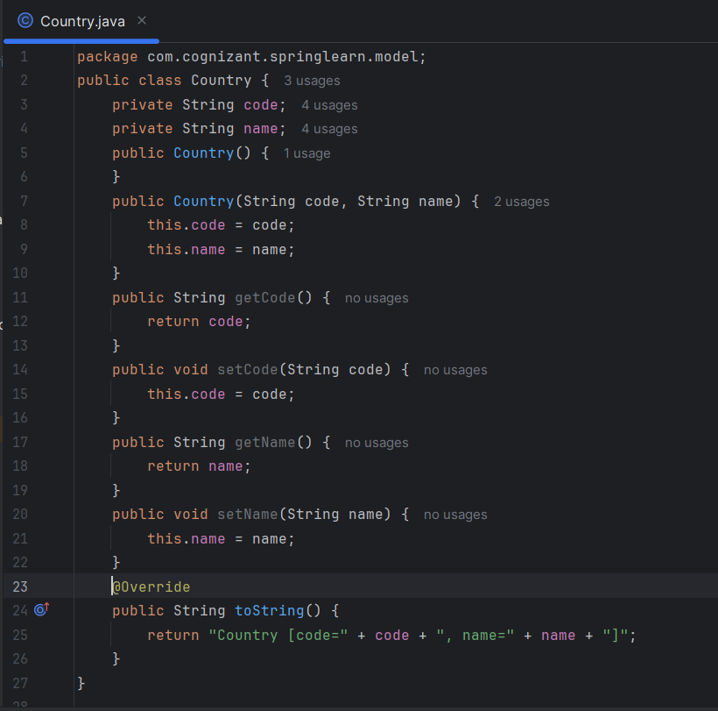

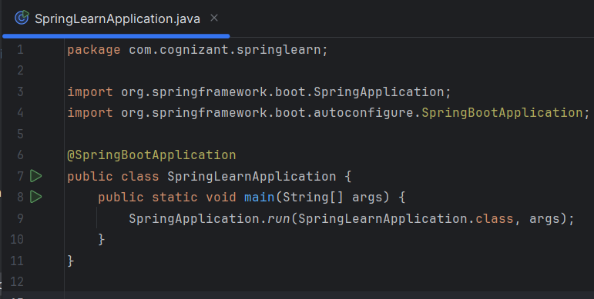

**OUTPUT**

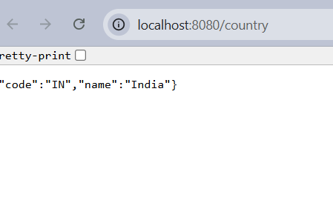

**REST - Get country based on country code**





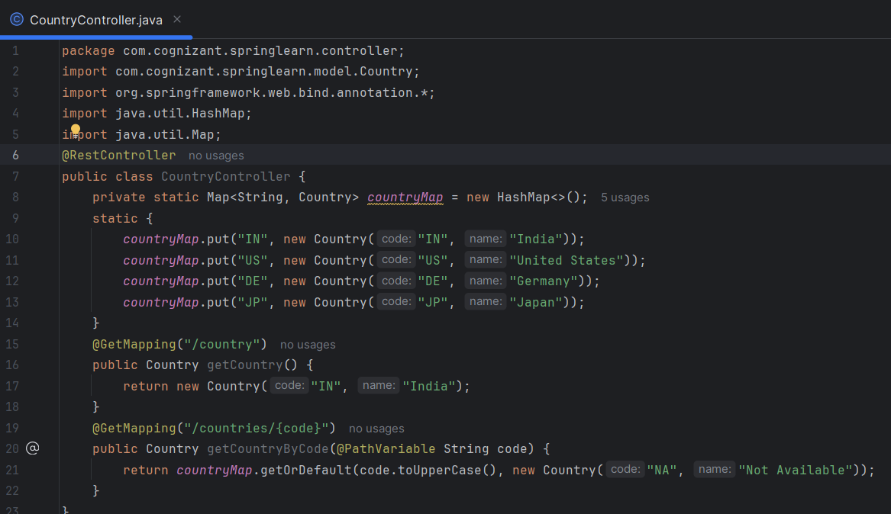





**OUTPUT**

