1. Not had any tests for min or max field value for Email field while Reset Your Password, because all we have to check here is a registered or not as the actual field length validation will be filtered while registration.

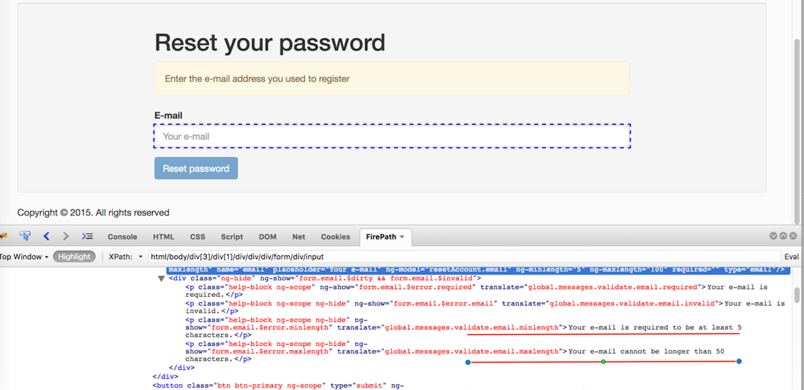

1. I think there is some mismatch with the min and max length defined verses the field pattern defined.

Field pattern says *ng-pattern="^(?=[^\d_].*?\d)\w(\w|[!@#$%]){7,20}"* , which should be min 7 characters and max 20 characters, and should start with alphabet and should contain number and may contain special characters.

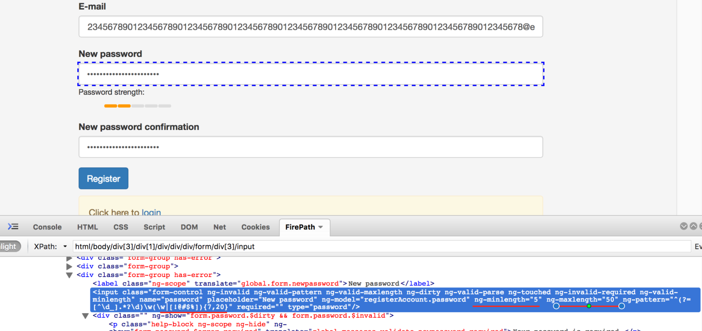

1. Pagination button should be disabled when there are not records to display

