Customer Validation

## What we thought our product would be

From the very beginning, we thought our product was an excellent answer to a prevalent pain. Having the convenience of ordering food from your stadium seat through your smartphone just seemed too good to be true. Those who would use the product wouldn’t have to miss any part of the game in order to satisfy their appetite. Additionally, it appeared to us that with how huge of an industry concessions actually is, owning just a tiny section of that market through Stadium Order would create large revenues. It also made sense as a product since we assumed that anybody who goes to a sporting event and orders overpriced food doesn’t typically care too much about paying extra money for a convenience.

We also thought that including in game promotions through the app would be a very appealing idea to customers. This additional feature for the app would make them feel more involved by getting special deals when their team was winning. We also thought it would create situations where somebody that normally wouldn’t buy food would actually buy it. People like getting deals and discounts. Customers also have a tendency to spend more money when they feel good and getting their discount when their preferred team is winning would only increase the likelihood of putting them in a good mood.

## What we wanted to validate

There were multiple questions that we had for our potential customers to validate for Stadium Order. First off, we needed to make sure that people were actually willing to even pay for the convenience of staying in their seat and having food and drink bought through their cell phone. We also wanted to assess if customers would prefer just paying from their seat and going to get their food or if there was actual value in having the food brought to them through delivery workers. Additionally, we needed to make sure the approximate price range customers would pay for the extra convenience. If the extra money they were willing to pay wasn’t sufficient, then it might be difficult to make significant profits with the product.

Another validation we wanted to investigate was whether or not the idea of in game promotions would interest the customer. If in game promotions was an interesting and desired feature to customers, it would evolve the original idea for the app significantly. It would also help the app reach a whole new market share of customers who aren’t normally interested in buying food because it is too expensive in the first place. If the idea wasn’t that interesting to the customer, then it would help us to know to not focus on that aspect for the app.

## What we found out

A lot of the things that we learned were based on the attitudes of fans on spending money on concessions at games. Most people we interviewed were not willing to spend that much more concessions than they currently do, even if they didn’t have to wait in a line. However, most people were willing to spend additional fees to have their food delivered to them. Additionally, it was interesting to note the reasons more people said they would or would not use our app. Almost everyone that buys concessions frequently at games said they would use our app. Many who do not buy concessions also said they would use our app because they would no longer have to miss the game to get them. The people who said they would not use our app were those who don’t buy concessions because of their price. They know that we couldn’t lower the price of the food they would buy so they knew they would never use it because our app does not fix the reason they don’t buy concessions. However, it seemed that those who were willing to spend money on concessions all said they would use our app.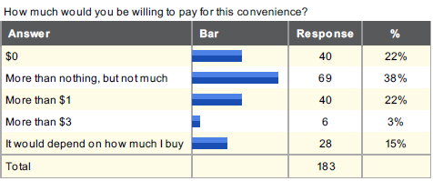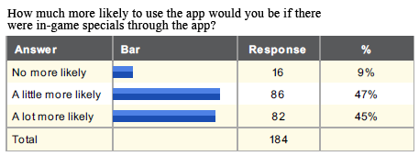

We also learned the influence of adding the ability to do promotions through our app. Almost everyone surveyed said they would be more likely to use our app if there were promotions. Some even said they would probably end up spending more money overall because of the promotions. Of those we interviewed in person, most enthusiastically said they would be more likely to use our app under those circumstances. If we could provide this functionality, most people seem to be willing to buy concessions through our app at a time like that.

## What we are going to do now

Based on the response of those we interviewed, we are going to change the emphasis of the app from convenience to promotions and discounts. Our in-game promotions will set us apart from all of our competitors and will increase the number of people buying concessions. Promotions will attract new customers to the concessions market space that normally would have never bought concessions. Our next step is to coordinate with vendors to find out what delivery system would work best for them and how much they would pay in order to use our services.