**NYC Water Charges**

**Dev/Building User Manual**

Table of Contents

* Create an account 3
* Log In 2
* View Buildings 6
* View Charges 7
* List of Developments and Development IDs 3

Log In

For demonstration purposes, I created some development accounts. Feel free to skip the Sign Up section and log in with one of the following accounts:

Username: lefferts25

Password: lefferts25

Username: belmont5

Password: belmont5

Username: berry6

Password: berry6

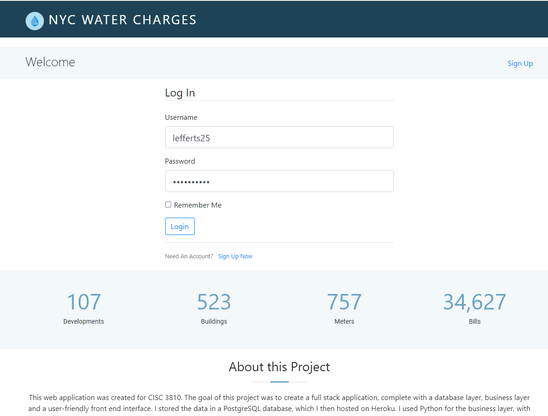

Sign Up

Note that there is only one admin account, which has already been created. Any user signing up will be signing up as a Development/Building user and will have to use the associated Development ID.

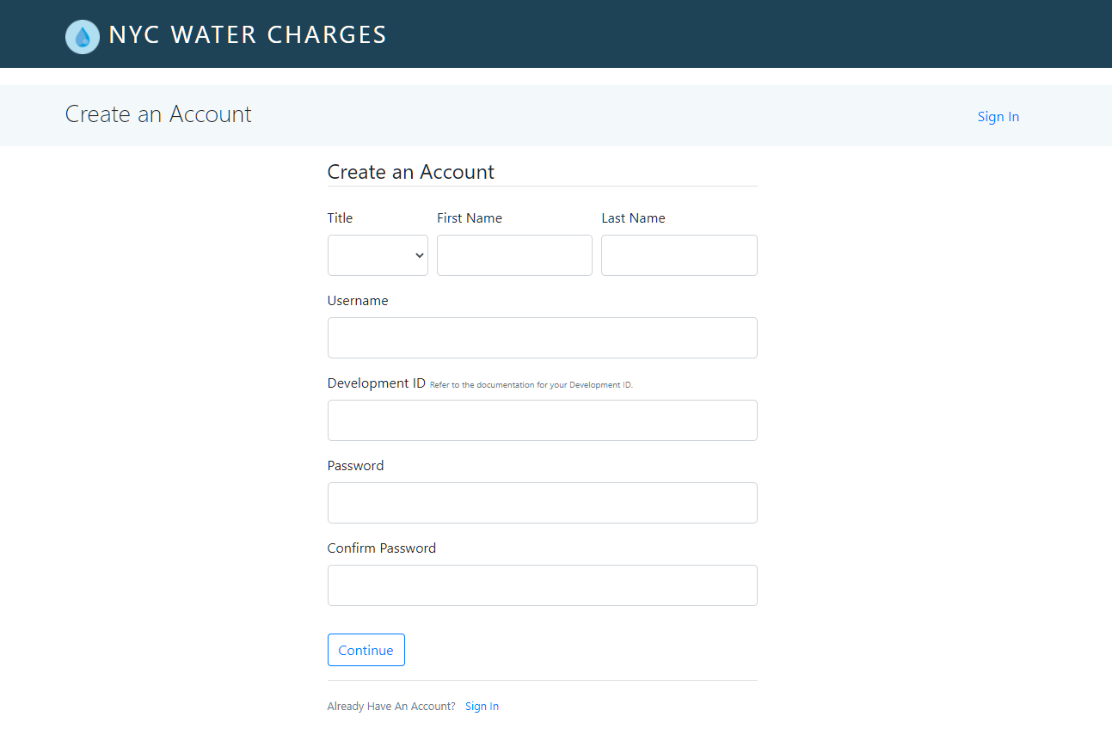  
  
To create an account for a specific development, create a username and password and choose the associated Development ID. Only numbers 1-127 can be used. Refer to list of developments and Development IDs below. *(Note: Please create accounts for* ***Brooklyn developments only*** *, since I deleted the data for all other boroughs due to space constraints on Heroku.)*

List of Developments and Development IDs

|  |  |  |
| --- | --- | --- |
| Dev_id | Name | Borough |
| 1 | 154 WEST 84TH STREET | MANHATTAN |
| 2 | ARMSTRONG I | BROOKLYN |
| 3 | BAISLEY PARK | QUEENS |
| 4 | BAY VIEW | BROOKLYN |
| 5 | BELMONT-SUTTER AREA | BROOKLYN |
| 6 | BERRY STREET-SOUTH 9TH STREET | BROOKLYN |
| 7 | BETANCES III, 9A | BRONX |
| 8 | BETANCES VI | BRONX |
| 9 | BOULEVARD | BROOKLYN |
| 10 | BOYNTON AVENUE REHAB | BRONX |
| 11 | BRYANT AVENUE-EAST 174TH STREET | BRONX |
| 12 | BUSHWICK II (GROUPS A & C) | BROOKLYN |
| 13 | BUSHWICK II (GROUPS B & D) | BROOKLYN |
| 14 | BUSHWICK II CDA (GROUP E) | BROOKLYN |
| 15 | CLAREMONT REHAB (GROUP 2) | BRONX |
| 16 | CLAREMONT REHAB (GROUP 4) | BRONX |
| 17 | CLINTON | MANHATTAN |
| 18 | CONLON LIHFE TOWER | QUEENS |
| 19 | CROWN HEIGHTS | BROOKLYN |
| 20 | EAST 004TH STREET REHAB | MANHATTAN |
| 21 | EAST 152ND STREET-COURTLANDT AVENUE | BRONX |
| 22 | EAST 165TH STREET-BRYANT AVENUE | BRONX |
| 23 | EAST 173RD STREET-VYSE AVENUE | BRONX |
| 24 | EAST NEW YORK CITY LINE | BROOKLYN |
| 25 | FENIMORE-LEFFERTS | BROOKLYN |
| 26 | FHA REPOSSESSED HOUSES (GROUP I) | FHA |
| 27 | FHA REPOSSESSED HOUSES (GROUP II) | FHA |
| 28 | FHA REPOSSESSED HOUSES (GROUP III) | FHA |
| 29 | FHA REPOSSESSED HOUSES (GROUP IV) | FHA |
| 30 | FHA REPOSSESSED HOUSES (GROUP IX) | FHA |
| 31 | FHA REPOSSESSED HOUSES (GROUP V) | FHA |
| 32 | FHA REPOSSESSED HOUSES (GROUP V) | FHA |
| 33 | FHA REPOSSESSED HOUSES (GROUP VI) | FHA |
| 34 | FHA REPOSSESSED HOUSES (GROUP VII) | FHA |
| 35 | FHA REPOSSESSED HOUSES (GROUP VII) | FHA |
| 36 | FHA REPOSSESSED HOUSES (GROUP VIII) | FHA |
| 37 | FHA REPOSSESSED HOUSES (GROUP X) | FHA |
| 38 | FHA REPOSSESSED HOUSES (GROUP X) | FHA |
| 39 | FIRST HOUSES | MANHATTAN |
| 40 | FORT WASHINGTON AVENUE REHAB | MANHATTAN |
| 41 | FRANKLIN AVENUE I CONVENTIONAL | BRONX |
| 42 | FRANKLIN AVENUE II CONVENTIONAL | BRONX |
| 43 | FRANKLIN AVENUE III CONVENTIONAL | BRONX |
| 44 | GOMPERS | MANHATTAN |
| 45 | HARRISON AVENUE REHAB (GROUP B) | BRONX |
| 46 | HIGHBRIDGE REHABS (ANDERSON AVENUE) | BRONX |
| 47 | HOWARD AVENUE | BROOKLYN |
| 48 | HOWARD AVENUE-PARK PLACE | BROOKLYN |
| 49 | HUNTS POINT AVENUE REHAB | BRONX |
| 50 | INGERSOLL | BROOKLYN |
| 51 | INGERSOLL | BROOKLYN |
| 52 | INTERNATIONAL TOWER | QUEENS |
| 53 | LONGFELLOW AVENUE REHAB | BRONX |
| 54 | LOWER EAST SIDE I INFILL | MANHATTAN |
| 55 | LOWER EAST SIDE II | MANHATTAN |
| 56 | LOWER EAST SIDE III | MANHATTAN |
| 57 | LOWER EAST SIDE REHAB (GROUP 5) | MANHATTAN |
| 58 | MANHATTANVILLE REHAB (GROUP 2) | MANHATTAN |
| 59 | MARCY AVENUE-GREENE AVENUE SITE B | BROOKLYN |
| 60 | MARLBORO | BROOKLYN |
| 61 | MELROSE | BRONX |
| 62 | MORRISANIA AIR RIGHTS | BRONX |
| 63 | NDF - CENTRAL MAINTENANCE SHOP, 23 ASH ST | NON DEVELOPMENT FACILITY |
| 64 | NOSTRAND | BROOKLYN |
| 65 | OCEAN BAY APARTMENTS (OCEANSIDE) | QUEENS |
| 66 | OCEAN HILL-BROWNSVILLE | BROOKLYN |
| 67 | PARK ROCK REHAB | BROOKLYN |
| 68 | POLO GROUNDS TOWERS | MANHATTAN |
| 69 | QUEENSBRIDGE NORTH | QUEENS |
| 70 | QUEENSBRIDGE SOUTH | QUEENS |
| 71 | RALPH AVENUE REHAB | BROOKLYN |
| 72 | RANGEL | MANHATTAN |
| 73 | RED HOOK EAST | BROOKLYN |
| 74 | REHAB PROGRAM (COLLEGE POINT) | QUEENS |
| 75 | REHAB PROGRAM (TAFT REHABS) | MANHATTAN |
| 76 | REID APARTMENTS | BROOKLYN |
| 77 | SAMUEL (CITY) | MANHATTAN |
| 78 | SAMUEL (MHOP) I | MANHATTAN |
| 79 | SAMUEL (MHOP) II | MANHATTAN |
| 80 | SHELTON HOUSE | QUEENS |
| 81 | SMITH | MANHATTAN |
| 82 | SOTOMAYOR HOUSES | BRONX |
| 83 | SOUTH BRONX AREA (SITE 402) | BRONX |
| 84 | SOUTH JAMAICA I | QUEENS |
| 85 | SOUTH JAMAICA II | QUEENS |
| 86 | STANTON STREET | MANHATTAN |
| 87 | STAPLETON | STATEN ISLAND |
| 88 | STEBBINS AVENUE-HEWITT PLACE | BRONX |
| 89 | STERLING PLACE REHABS (SAINT JOHNS-STERLING) | BROOKLYN |
| 90 | STERLING PLACE REHABS (STERLING-BUFFALO) | BROOKLYN |
| 91 | STUYVESANT GARDENS II | BROOKLYN |
| 92 | TAFT | MANHATTAN |
| 93 | TAPSCOTT STREET REHAB | BROOKLYN |
| 94 | TAPSCOTT STREET REHAB | FHA |
| 95 | THOMAS APARTMENTS | MANHATTAN |
| 96 | UNION AVENUE-EAST 166TH STREET | BRONX |
| 97 | UPACA (SITE 5) | MANHATTAN |
| 98 | UPACA (SITE 6) | MANHATTAN |
| 99 | VAN DYKE I | BROOKLYN |
| 100 | WASHINGTON HEIGHTS REHAB (GROUPS 1&2) | MANHATTAN |
| 101 | WASHINGTON HEIGHTS REHAB PHASE III | MANHATTAN |
| 102 | WASHINGTON HEIGHTS REHAB PHASE IV (C) | MANHATTAN |
| 103 | WASHINGTON HEIGHTS REHAB PHASE IV (D) | MANHATTAN |
| 104 | WEST FARMS ROAD REHAB | BRONX |
| 105 | WEST FARMS SQUARE CONVENTIONAL | BRONX |
| 106 | WHITMAN | BROOKLYN |
| 107 | WILLIAMSBURG | BROOKLYN |

View Your Buildings

After you log in, you will automatically be redirected to your list of buildings. Note that as a Dev/Building user, you do not have the option to view other developments or other buildings.

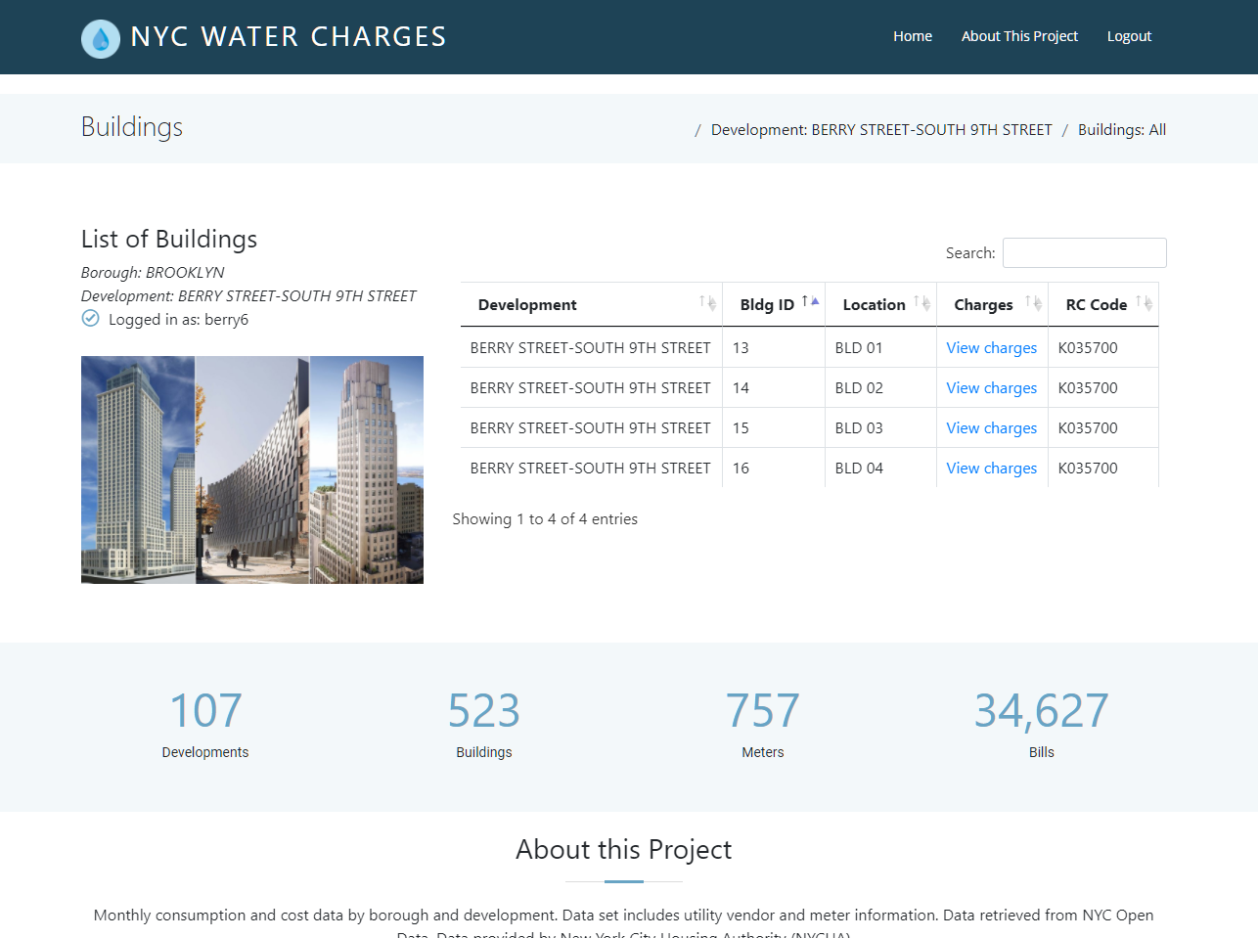

View Your Bills

1. To view the charges associated with that building, click on **View charges**. Note that as a user, you do NOT have the option to delete or edit a bill.

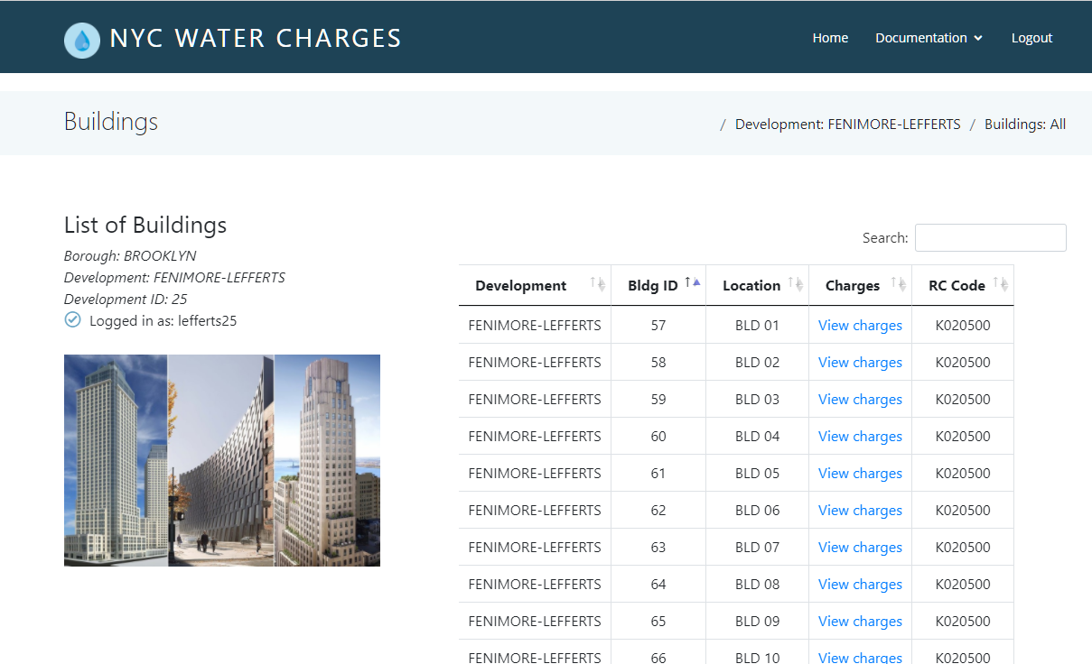

1. You will be presented with a list of bills associated with that building.

