**ECE 302: Probability, Statistics, and Random Processes for EE**

Fall 2022

Assignment 6: Extra Credit

Rachel Gottschalk (ID: 313094)

Electrical and Computer Engineering Department

Caterpillar College of Engineering and Technology

[Bradley University](http://www.bradley.edu/)

# Problem 7.1

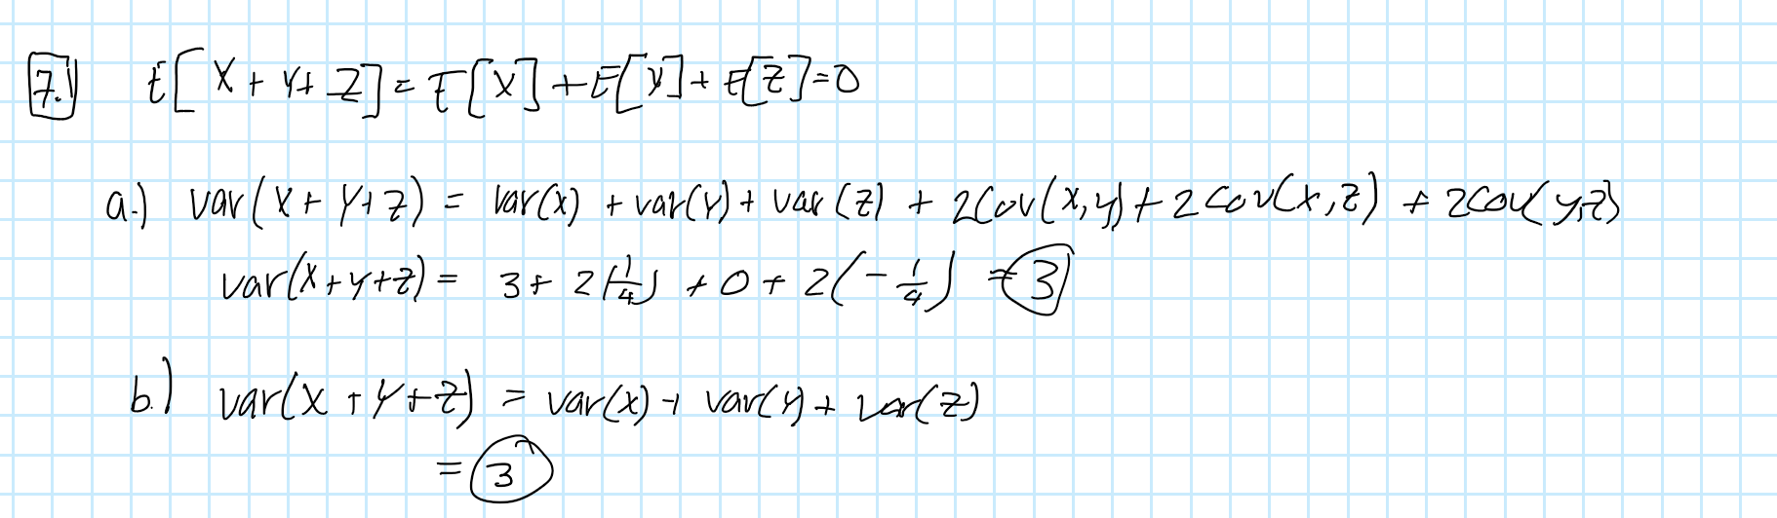

# Problem 7.2

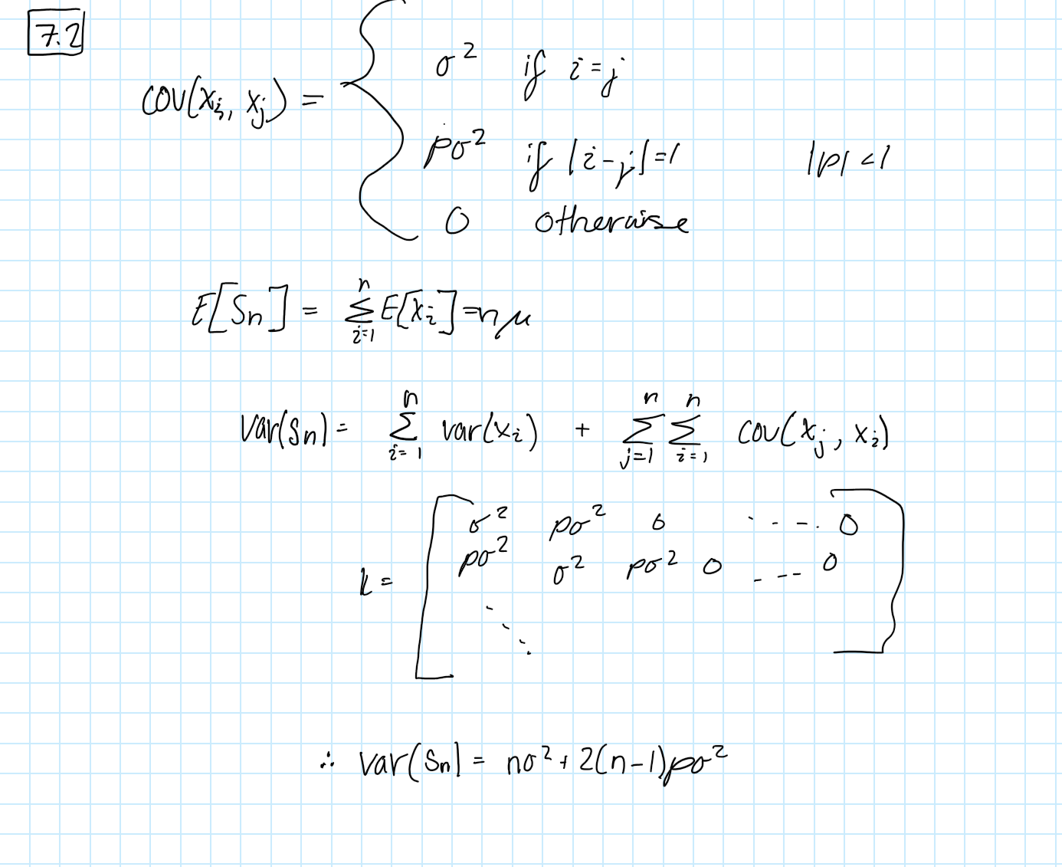

# Problem 7.22

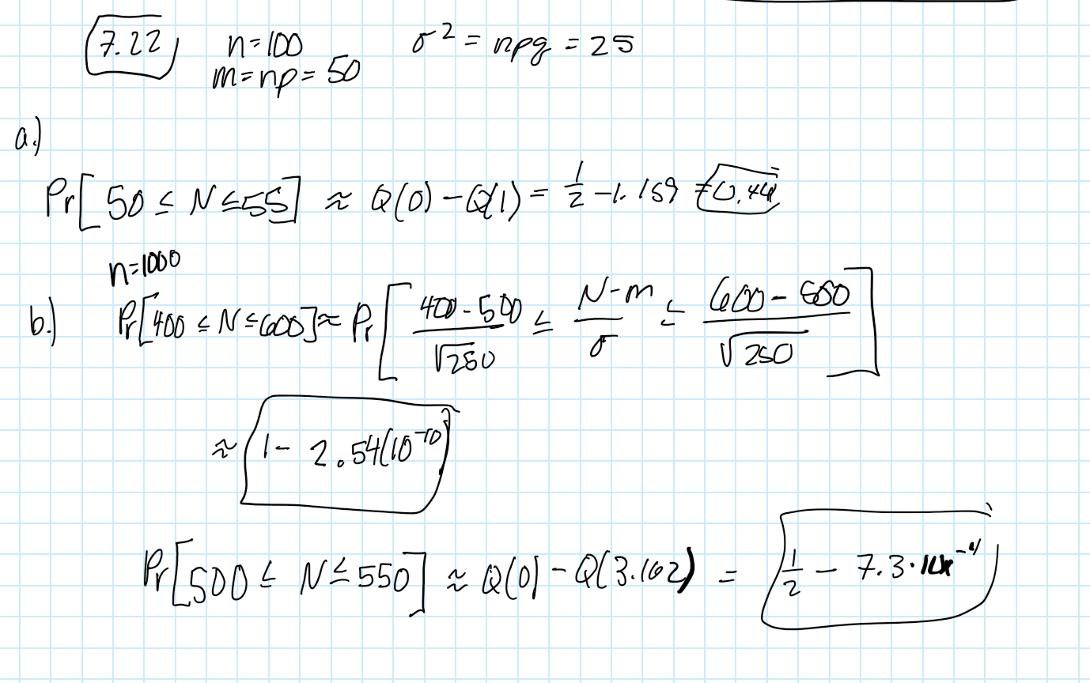

# Problem 7.24

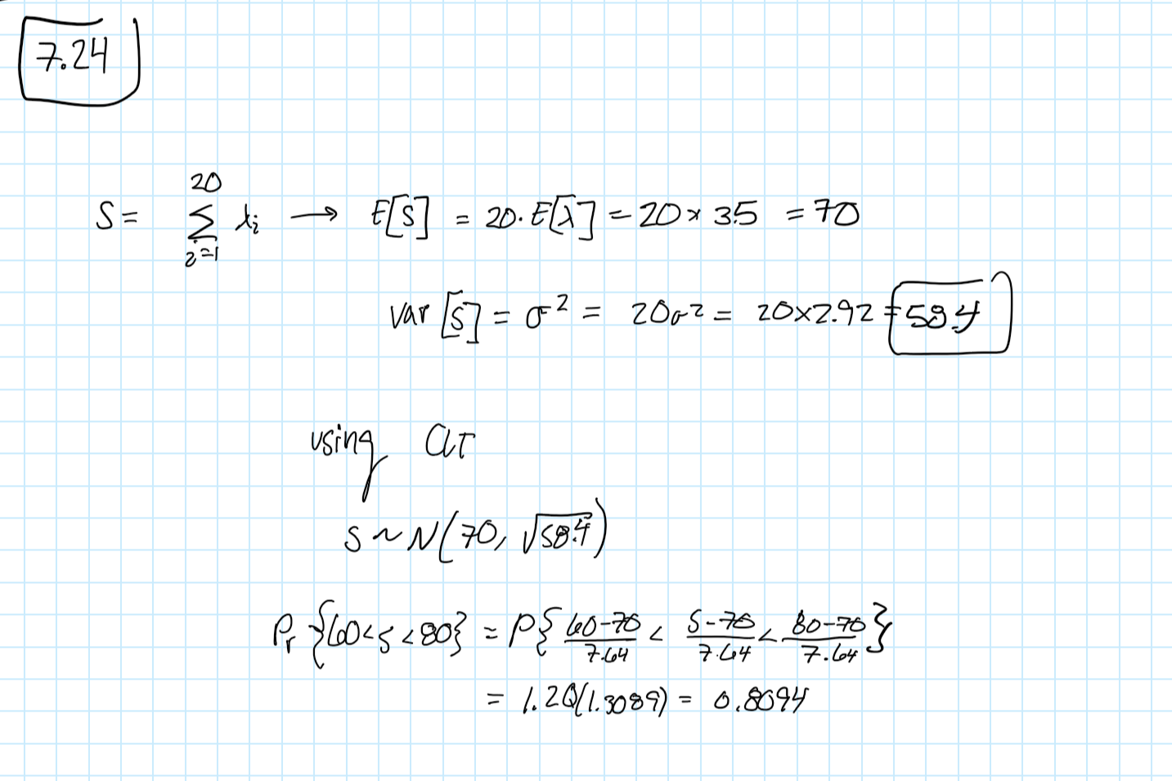

# Problem 7.25

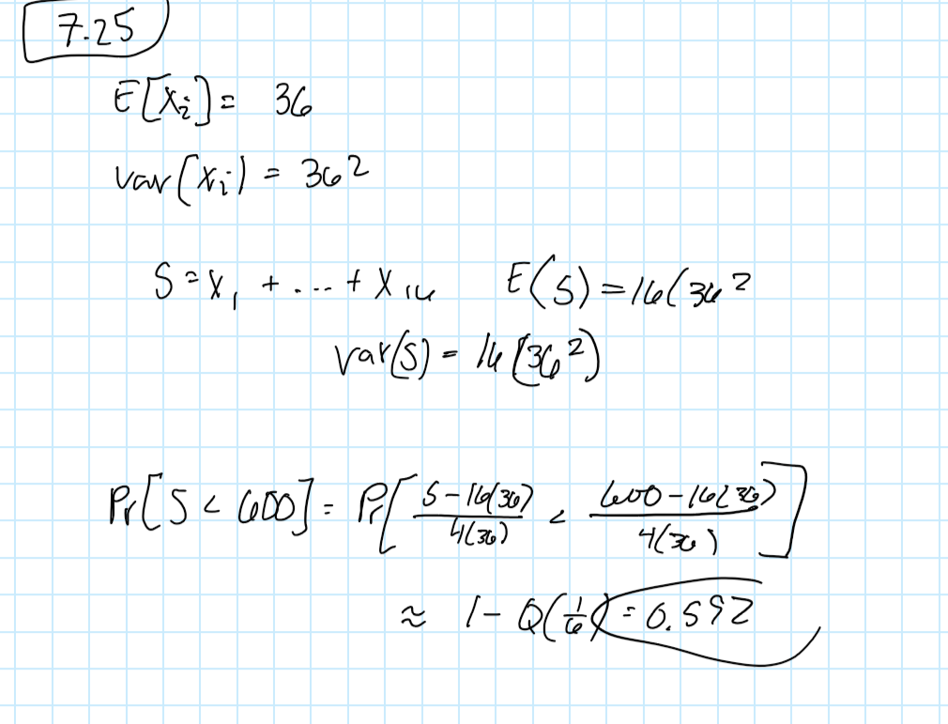

# Problem 8.39

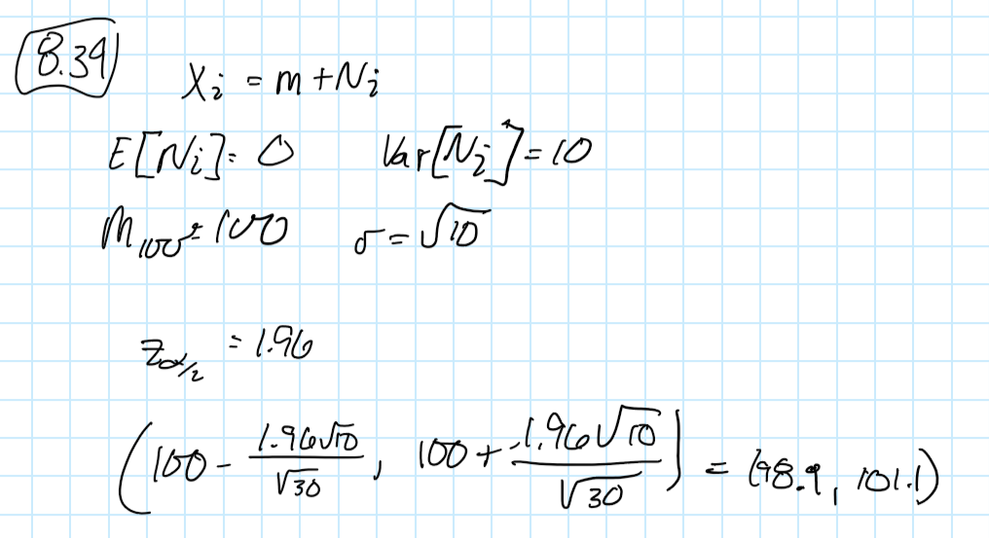

# Problem 8.40

# 

# Computer Experiments

1.



2.



MATLAB Solutions

%Gottschalk, Rachel ECE 302: Assignment #6

close all;

clear all;

clc;

%%%%%%%% Part 1 %%%%%%%%%%

n=1;

[k1,y1]=pmf(n); % send to pmf function

[s1,f1]=pdf(n); % send to pdf function

n=3;

[k2,y2]=pmf(n); % send to pmf function

[s2,f2]=pdf(n); % send to pdf function

n=10;

[k3,y3]=pmf(n); % send to pmf function

[s3,f3]=pdf(n); % send to pdf function

n=30;

[k4,y4]=pmf(n); % send to pmf function

[s4,f4]=pdf(n); % send to pdf function

n=40;

[k5,y5]=pmf(n); % send to pmf function

[s5,f5]=pdf(n); % send to pdf function

n=50;

[k6,y6]=pmf(n); % send to pmf function

[s6,f6]=pdf(n); % send to pdf function

% plot all PMF and PDF for different n values

figure(1)

subplot(3,3,1)

stem(k1,y1, "Linewidth", 1.3)

hold on;

plot(s1,f1, "Linewidth", 1.3)

legend('PMF', 'PDF')

grid on;

xlabel('k value')

ylabel('Sn')

title('N=1')

subplot(3,3,2)

stem(k2,y2, "Linewidth", 1.3)

hold on;

plot(s2,f2, "Linewidth", 1.3)

legend('PMF', 'PDF')

grid on;

xlabel('k value')

ylabel('Sn')

title('N=3')

subplot(3,3,3)

stem(k3,y3, "Linewidth", 1.3)

hold on;

plot(s3,f3, "Linewidth", 1.3)

legend('PMF', 'PDF')

grid on;

xlabel('k value')

ylabel('Sn')

title('N=10')

subplot(3,3,4)

stem(k4,y4, "Linewidth", 1.3)

hold on;

plot(s4,f4, "Linewidth", 1.3)

legend('PMF', 'PDF')

grid on;

xlabel('k value')

ylabel('Sn')

title('N=30')

subplot(3,3,5)

stem(k5,y5, "Linewidth", 1.3)

hold on;

plot(s5,f5, "Linewidth", 1.3)

legend('PMF', 'PDF')

grid on;

xlabel('k value')

ylabel('Sn')

title('N=40')

subplot(3,3,6)

stem(k6,y6, "Linewidth", 1.3)

hold on;

plot(s6,f6, "Linewidth", 1.3)

legend('PMF', 'PDF')

grid on;

xlabel('k value')

ylabel('Sn')

title('N=50')

%%%%%%%% Part 2 %%%%%%%%%%

n = 100;

var = 1; % variance

r = 330; % resistance

i = 1:1:n;

X = zeros(1,length(i));

for j = 1:length(i) % calculating X values

X(j) = r + normrnd(0,var);

end

smean = (1/n)*sum(X); % calculate sample mean

% calculating upper and lower bounds

lbound = smean - ((1.96*sqrt(var))/(sqrt(n)));

ubound = smean + ((1.96*sqrt(var))/(sqrt(n)));

% plot the X values, resistance, sample mean, and convidence interval

figure(2)

scatter(i,X, "black")

hold on;

yline(r,'r','LineWidth',1.2)

hold on;

yline(smean, "b", "LineWidth",1.2)

hold on;

yline(lbound, "LineWidth",1)

hold on;

yline(ubound,"LineWidth",1)

grid on;

xlabel('i value')

title("Estimating Resistance from Nosiy Measurement")

legend('Sample Resistance','True Resitance', "Sample Mean", "Convidence Interval")

%%%%%%%%%%%%%%%%%%% Functions %%%%%%%%%%%%%%%%%%%%%%

function [k,y] = pmf(n) %PMF Calulation

p = 0.5;

k = 0:1:n;

y = zeros(1,length(k));

b = zeros(1,length(k)+1);

for i = 1:n

b(i) = nchoosek(n, k(i));

y(i) = b(i)*(p^k(i))*((1-p)^(n-k(i)));

end

end

function [s,f] = pdf(n) %PDF Calculation

p = 0.5;

s = 0:n/100:n;

f = normpdf(s,n*p,sqrt(n*(p*(1-p))));

end