“Hollycrest”, originally named “Garran Hill”, is one of the distinctly historical homes in southern Moore County.
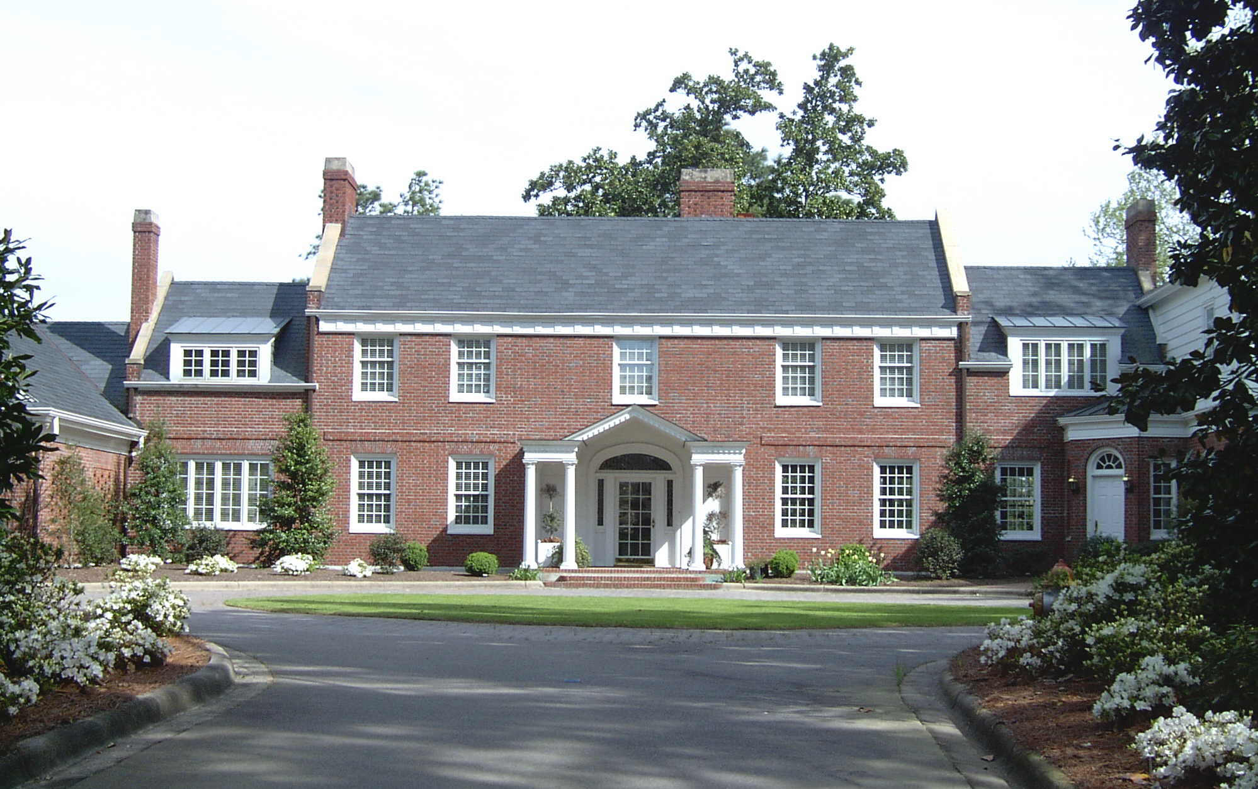
Hollycrest House, after initial installation of landscaping at the front of the home (2002).
It was built in 1915-16 for Walter Hines Page, to be his home in his native Moore County, after he returned from London, where he had served as the U.S. Ambassador to the Court of St. James throughout the First World War. Page had been a prominent newspaper editor and author, and he was a co-founder of Doubleday, Page, and Co., a large publishing firm. He had nominated Woodrow Wilson for the presidency at the convention in 1912 and hoped to be appointed Secretary of Agriculture in the Wilson administration. This was not to be, and he was appointed Ambassador to England before the outbreak of the war.
Anticipating Page’s return when the war ended, construction of his home was supervised by his son, Ralph, according to plans provided by a Boston architectural firm, and supported by experienced builders working with Leonard Tufts in Pinehurst. The structure was designed in Neo-Georgian style and situated upon a hundred-acre tract that his family owned and which had been clear-cut for the valuable long-leaf pine timber.
W.H. Page returned to Moore County in 1918, suffering from hypertension and apparent renal failure. He died only a few weeks after his return and was never able to enjoy the home his son had built for him. Ralph Page moved his family into Garran Hill after his father’s death, and the home remained in the Page family at least through World War II.
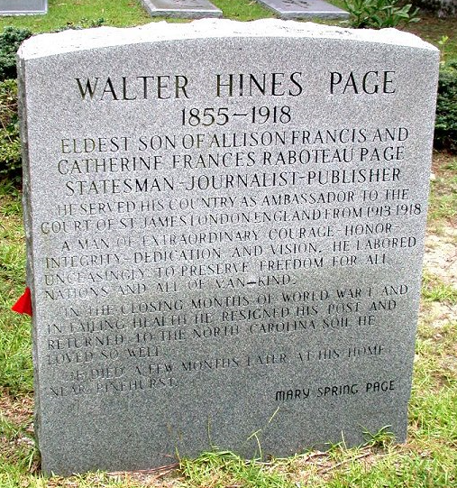

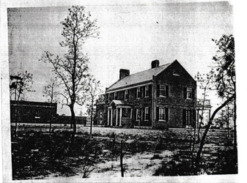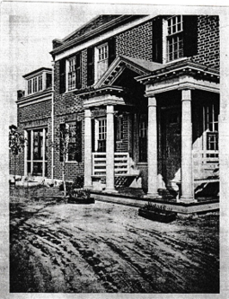
Front views of Garran Hill in 1916.
A report in the local newspaper at this time noted that one could see the Carolina Hotel from the front porch of Page’s home, because the extensive timbering left the area devoid of trees. Page returned to Moore County in 1918, after the war ended, but suffering from hypertension and kidney failure, he lived only a few months and was never able to enjoy the home his son had built for him. Ralph Page moved his family into Garran Hill after his father’s death, and the home remained in the Page family for a number of years.
A prominent Bostonian, Ellizabeth Dumaine, purchased the home and the surrounding acreage in 1959, permitting her to pursue her fondness for horses and hounds. She re-named the property “Hollycrest” for the large native holly trees at the front of the home. “Betty” Dumaine was well known in the small Pinehurst community, both for her community activism, in opposing destruction of the trees in the median of Midland Road, and for her practice of holding annual birthday parties for her horses, to which the children of the community were invited. She had shared a room while at Vassar with a girl who became the Queen of Thailand, and Hollycrest hosted the royal personage on several occasions.

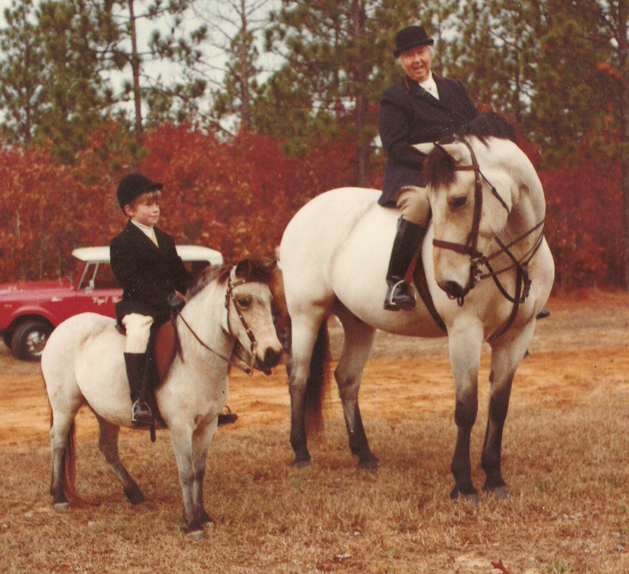

She kept her horses in stables just east of her home and had kennels for her hounds and a collection of peacocks on the property. When her favorite jumper, “Blue Fox”, died in 1969, she buried him in a 10X16 foot grave, covered with slate, and adorned with a brass marker, at the back of the yard. Beside the grave was a four-foot tall statue of a blue fox, but this was lost after her death in 1980.

When Miss Dumaine died in 1980, she left her property to Duke University, which was unable to find a buyer notwithstanding advertising in Atlanta and New York. An attempt to build a subdivision around the home was begun, to great fanfare, in 1985, but was unsuccessful due to a downturn in the economy.. At this time, in preparation for the expected subdivision, tennis courts with professional-grade fencing and lighting were built on the northeastern side of the property, and a large, in-ground swimming pool installed to the southwest. In 1990, a real estate developer, Robert Kramer, purchased the property, but died before any further development could be initiated.
The home was unoccupied following Miss Dumaine’s death and the grounds minimally maintained. The house and the surrounding 4.5 acres were purchased by Dr. and Mrs. Russell McAllister from Mrs. Kramer in 1998, at which time an architect from Durham, Thomas O’Shea, was asked to re-create architectural drawings for the house as it existed, and work with Ann McAllister to design modifications consistent with the home’s historical panache and appropriate for 21st century living.
In 1999, the general contractor, Dennis Dunagan, began a 3-year project to renovate and restore Hollycrest House, before the McAllisters could take up residence in late 2001. The interior was completely gutted, all plumbing and electrical lines replaced, low-voltage lines for cable TV and a security system installed, new joists added beneath the floors, new windows and doors installed, and new heart-pine flooring added in the expanded new kitchen area. Careful cleaning of the chimneys and installation of new dampers for the seven interior fireplaces were completed, and propane gas logs installed in six of them. The propane was held in a 250-gallon underground tank installed at the back of the property.
The all-new interior woodwork was patterned in the Georgian style found in many significant historic homes, particularly in England. The NE/SW orientation of the house permitted the back of the house to be filled with windows and glass doors, designed to let as much light into the home as possible. Master carpenter David Prest supervised custom construction of the various wood panelings, crown moldings, chair rails, and floor moldings around the house. A handful of items remain from the original Garran Hill: the frontspiece in the dining room, leaded glass sidelights and an over-door fan at the front entry, the mantels for each of the seven interior fireplaces, and the oak flooring. The many solid-wood interior doors with brass key plates (and their keys) were also original to the house. All the windows in the home were replaced and custom-made,by Marvin windows, to ensure effective climate control.
Garran Hill/Hollycrest consists of about 6700 sq ft of heated/cooled interior space on the first and second floors. There is a sizeable attic/storage space over the two-car garage on the northeastern side of the house, and a large attic, now containing a large air-handler unit and its duct work,, on the third floor. The home has a stone-walled four-room basement under about half of the house; this area has been partially developed and climate-controlled and it provides extensive storage space, including storage cabinets, shelving, a refrigerator, an upright freezer, and a large wine rack. The basement area has access from inside the home and from an exterior door.

The grounds contain a wide variety of mature plantings, including many long-leaf pines and three American Plain trees (sycamores) planted by Miss Dumaine in 1959. She also oversaw installation of a camellia garden beside the front entry circle, as well as Grandiflora magnolias and dogwoods.. The McAllisters have installed a variety of holly trees across the property, as well as azaleas, dwarf nandinas, a “signature” autumnalis tree, and a number of different iris specimens around the home in defined planting beds. There is a children’s playhouse (called “The Wee Cottage”) in the rear yard, sitting beside a smaller well house which shelters the in-ground well and storage tank, which supplies an extensive irrigation system through the yard areas and planting beds, as well as providing water for the swimming pool. The home has county water and sewer lines.
A brick terrace behind the house, accessed from both the dining room and the living room, will seat a large number of people for al fresco dining, and a balcony off two of the second-floor bedrooms provides a venue for early-morning coffee, as well as a viewing site for the tennis courts and the rear of the property, often populated by the local deer herd.
Over the past 25 years, Hollycrest House, designed as it was for entertaining, has served as a venue for a large number of social events, including regional and local meetings of the English Speaking Union, gatherings of the local Pi Beta Phi Alumnae chapter, the Pinehurst chapter of Phi Beta Kappa, the Temperance Smith Alston chapter of the DAR, the Folio Club of Durham, a large wedding engagement celebration, as well as offering a comfortable site for many family gatherings and meeting with friends and associates.

