ECEN 758 DMA – Assignment 1

Rachel Hsingtze Yeh

[hsingtze1007@tamu.edu](mailto:hsingtze1007@tamu.edu)

**Problem 1**

1. False. Mean is not robust.
2. True. Median is robust.
3. False. Standard deviation is not robust.

**Problem 2**

1. Mean (X) = 71.45

Median (X) = 71.5

Mode (X) = 74

1. Sample Variance (Y) = 1369.21
2. Mean (X) = 71.45

Variance (X) = 13.8475

Probability density function:

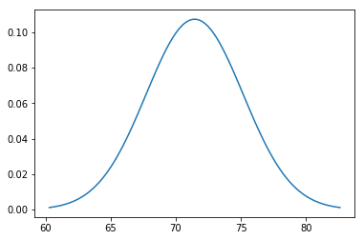

1. Freq (X > 80) = 0
2. Mean (XY) = [71.45, 164.7]

|  |  |
| --- | --- |
| 13.8475 | 122.435 |
| 122.435 | 1369.21 |

Covariance matrix (XY) =

1. Correlation (X Y) = 0.88917
2. Age vs. weight:

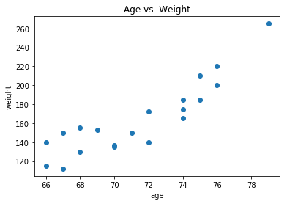

**Code for problem 2:**

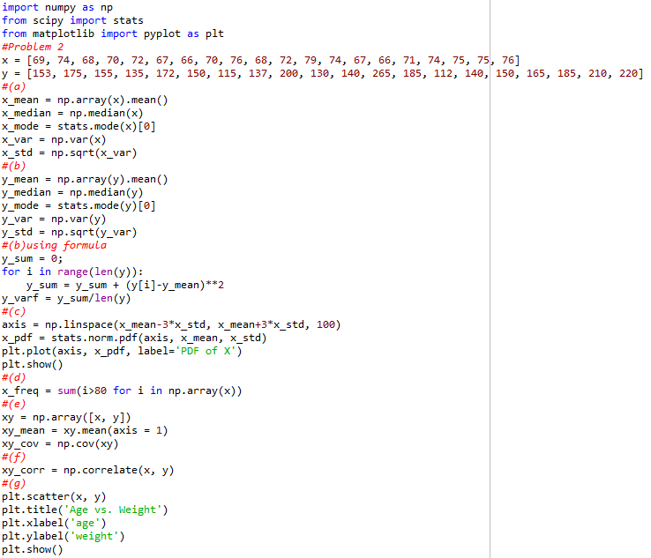

**Problem 3**

1. Mean = [6, -12]

|  |  |
| --- | --- |
| 17.6 | -38.0 |
| -38.0 | 88.4 |

Covariance matrix =

1. Eigenvalues = [1.0658, 104.9342]
2. Dimension = 1
3. First principal component: [-0.39897876, 0.91696017]

|  |
| --- |
| -8.13364 |
| 12.4804 |
| -8.01464 |
| -8.9316 |
| 12.5994 |

1. Projected coordinate:

**Code for problem 3:**

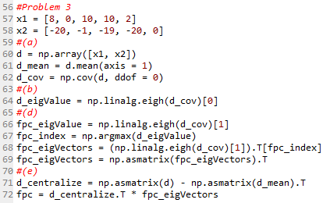

**Problem 4**

$$ρ_{12}=\frac{σ_{12}}{σ_{1}σ_{2}}=0$$

$$σ_{12}=0=\frac{1}{n}\sum_{i=1}^{n}{(X_{i1}-μ_{1})(X_{i2}-μ_{2})}$$

$$μ_{1}=\frac{1+0+1+0+0}{5}=\frac{2}{5} μ_{2}=\frac{a+b+c+a+c}{5}=\frac{2a+b+2c}{5}$$

$$0=\left(1-\frac{2}{5}\right)\left(a-\frac{2a+b+2c}{5}\right)+\left(0-\frac{2}{5}\right)\left(b-\frac{2a+b+2c}{5}\right)+\left(1-\frac{2}{5}\right)\left(c-\frac{2a+b+2c}{5}\right)+\left(0-\frac{2}{5}\right)\left(a-\frac{2a+b+2c}{5}\right)+(0-\frac{2}{5})(c-\frac{2a+b+2c}{5})$$

$$0=\frac{3}{5}\left(\frac{3a-b-2c}{5}\right)-\frac{2}{5}\left(\frac{-2a+4b-2c}{5}\right)+\frac{3}{5}\left(\frac{-2a-b+3c}{5}\right)-\frac{2}{5}\left(\frac{3a-b-2c}{5}\right)-\frac{2}{5}(\frac{-2a-b+3c}{5})$$

$$0=9a-3b-6b+4a-8b+4c-6a-3b+9c-6a+2b+4c+4a+2b-6c$$

$$0=5a-10b+5c$$

$$0=a-2b+c$$