ECEN758 – Assignment 3

Rachel Hsingtze Yeh

hsingtze1007@tamu.edu

**Problem 1: K-means**

Using the K-means algorithm and Euclidean distance, the results are:

* Iterations till convergence: t = 2
* C1 = {x1, x2, x3}
* C2 = {x4, x5}
* Mean(C1): [0.5, 0.66667]
* Mean(C2): [5, 1]

**Codes:**

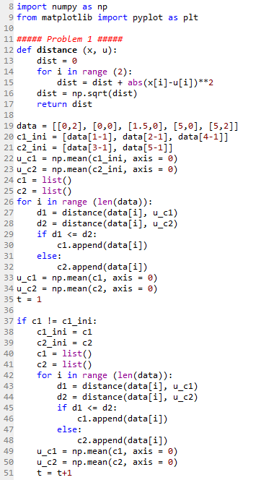

**Problem 2: Gaussian Mixture Models**

1. **Compute the first EM iterated of the cluster means.**
$$μ_{1}=\frac{\sum_{j=1}^{10}{w_{1j}*x_{j}}}{\sum_{j=1}^{10}{W_{1j}}}={(0.5504, 4.0402)}^{T}$$

$$μ_{2}=\frac{\sum_{j=1}^{10}{w_{2j}*x_{j}}}{\sum_{j=1}^{10}{W_{2j}}}={(2.3031, 1.7433)}^{T}$$

$$μ_{3}=\frac{\sum_{j=1}^{10}{w_{3j}*x_{j}}}{\sum_{j=1}^{10}{W_{3j}}}={(2.8712, 3.4431)}^{T}$$

2. **Show the data on a scatter plots, together with the initial and iterated means.**

The scatter plots are showing below. The first iterated means are updated and adjusted to move closer to the center of the points for each cluster. And if more iterations are computed the iterated means will be more accurate for the mean of points.

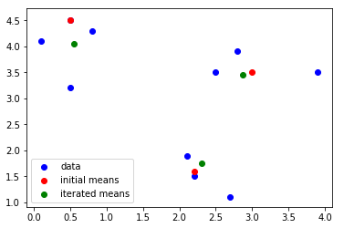

1. **Compute the first EM iterates of the mixture probabilities.**
$$P\left(C_{1}\right)=\frac{\sum_{j=1}^{10}{w_{1j}}}{10}=0.3822$$

$$P\left(C_{2}\right)=\frac{\sum_{j=1}^{10}{w_{2j}}}{10}=0.3067$$

$$P\left(C_{3}\right)=\frac{\sum_{j=1}^{10}{w_{3j}}}{10}=0.3111$$

2. **Compute the first iterates of the covariance matrices for the three clusters.**

$$Σ_{1}=\frac{\sum_{j=1}^{10}{w_{1j}(x_{j}-μ_{1})({\left(x_{j}-μ_{1}\right)}^{T}}}{\sum_{j=1}^{10}{w_{1j}}}=\{\left(0.2329, -0.0247\right), \left(-0.0247, 0.2395\right)\}$$

$$Σ_{2}=\frac{\sum_{j=1}^{10}{w_{2j}(x_{j}-μ_{2})({\left(x_{j}-μ_{2}\right)}^{T}}}{\sum_{j=1}^{10}{w_{2j}}}=\{\left(0.2633, -0.1245\right), \left(-0.1245, 0.5581\right)\}$$

$$Σ_{2}=\frac{\sum_{j=1}^{10}{w_{3j}(x_{j}-μ_{3})({\left(x_{j}-μ_{3}\right)}^{T}}}{\sum_{j=1}^{10}{w_{3j}}}=\{\left(0.7129, 0.0598\right), \left(0.0598, 0.4353\right)\}$$

**Code:**

