ECEN758 – Assignment 4

Rachel Hsingtze Yeh

hsingtze1007@tamu.edu

**Exercise 14.4 Q3:**

Using the average Link, we have the question to find the distance:

$$δ\left(C_{i}, C_{j}\right)= \frac{\sum_{x∈C_{i}}{\sum_{y∈C_{j}}{δ\left(x, y\right)}}}{n_{i}n_{j}}$$

Below are tables to generate the cluster which the red number is the smallest distance chosen for next step.

|  |  |  |  |  |  |  |  |  |  |  |  |  |  |  |  |  |  |  |  |
| --- | --- | --- | --- | --- | --- | --- | --- | --- | --- | --- | --- | --- | --- | --- | --- | --- | --- | --- | --- |
|  | A | B | C | D | E |  |  | AB | C | D | E |  |  | AB | CD | E |  |  | E |
| A | 0 | 1 | 3 | 2 | 4 |  | AB | 0 | 3 | 2 | 3.5 |  | AB | 0 | 2.5 | 3.5 |  | ABCD | 3.75 |
| B |  | 0 | 3 | 2 | 3 |  | C |  | 0 | 1 | 3 |  | CD |  | 0 | 4 |  |  |  |
| C |  |  | 0 | 1 | 3 |  | D |  |  | 0 | 5 |  | E |  |  | 0 |  |  |  |
| D |  |  |  | 0 | 5 |  | E |  |  |  | 0 |  |  |  |  |  |  |  |  |
| E |  |  |  |  | 0 |  |  |  |  |  |  |  |  |  |  |  |  |  |  |

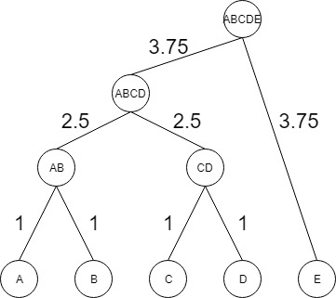

**Exercise 15.5 Q1:**

1. **List all the core points.**

Using the Euclidean distance and $ε=2 and minpts=3,$ we know that if the point has at least 3 points (include itself) in the circle with radius of 2 we can say it is a core point. So the core points are finding from the table below and we have**: {a, b, c, d, e, f, g, h, i, j, k, n, o, p, q, r, s, t, v, w}**

1. **Is *a* directly density reachable from *d*?**

Yes. From the table we can see that $aϵN_{ε}\left(d\right)$ and d is a core point.

1. **Is *o* density reachable from *i*?**

Yes. From the table we can find a path: *o 🡪 n 🡪j 🡪f 🡪e 🡪 i* where those passing points are all core points from part (a).

1. **Is density reachable a symmetric relationship?**

No. Since one node can be a core point but the other is not, leads that one node is reachable to another but another cannot reachable back.

1. **Is *l* density connected to *x*?**

Yes. For the core point *t*, we can find the path from *l🡪*t and also from *x🡪 w🡪t*, so *l* and x are density connected.

1. **Is density connected a symmetric relationship?**

Yes.

1. **Show the density-based clusters and the noise points.**

Cluster 1: **{a, d, h, k, p, q, r, s, t, l, v, w, x}**

Cluster 2: **{b, c, e, f, g, i, j, n, m, o, u}**

There is no noise points.

|  |  |  |  |  |  |  |
| --- | --- | --- | --- | --- | --- | --- |
| Point | $$N_{ε}\left(pt\right)$$ | # |  | Point | $$N_{ε}\left(pt\right)$$ | # |
| a | {a, d, h} | 3 |  | m | {i, m} | 2 |
| b | {b, c, e, i} | 4 |  | n | {g, j, n, o} | 4 |
| c | {b, c, e, f} | 4 |  | o | {n, o, u} | 3 |
| d | {a, d, h, k} | 4 |  | p | {p, q, v} | 3 |
| e | {b, c, e, f, i} | 5 |  | q | {p, q, r, v} | 4 |
| f | {c, e, f, g, j} | 5 |  | r | {h, k, r, s, t, q} | 6 |
| g | {f, g, n, j} | 4 |  | s | {k, s, t, w, r} | 5 |
| h | {a, d, h, k ,r} | 5 |  | t | {r, s, t, k, l ,w} | 6 |
| i | {b, e, i, m} | 4 |  | u | {o, u} | 2 |
| j | {e, g, j, n} | 4 |  | v | {p, q, v} | 3 |
| k | {d, h, k, r, s, t} | 6 |  | w | {s, t, w, x} | 4 |
| l | {l,t} | 2 |  | x | {w, x} | 2 |

**Problem 3:**

**Using the 1-dimensional discrete kernel from [ZM] eq. (15.2), with width h = 3, draw the kernel density estimate based on the points { 1, 5, 6, 9, 15}.**

Using the equation for the discrete kernel, we generate the kernel density estimation for the continuous random variables from 0 to 20 with increments of 0.1. The plot and code are attaching below.

$$f\left(x\right)=\frac{1}{nh}\sum_{i=1}^{n}{K\left(\frac{x-x_{i}}{h}\right)} where n=5, h=3, K\left(\frac{x-x_{i}}{h}\right)=\left\{\begin{aligned}1 if \left|\frac{x-x_{i}}{h}\right|≤\frac{1}{2} \\ 0 otherwise\end{aligned}\right.$$

**Kernel Density Estimate Plot:**

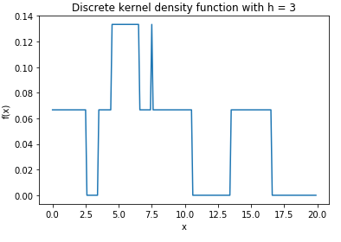

**Code:**

