ECEN758 – Assignment 5

Rachel Hsingtze Yeh

hsingtze1007@tamu.edu

**Exercise 18.5 Q2:**

Using the Naïve Bayes Classifier theorem, one can find out the prior probability and mean for each cluster as:

$$P\left(C_{i}\right)=\frac{n_{i}}{n} μ_{i}=\frac{1}{n_{i}}\sum_{x_{j}∈D}{x_{i}}$$

And using calculated mean to centralize the data for each cluster:

$$Z_{i}=D_{i}-1*μ_{i}^{T}$$

Then for each cluster, the centralized data can calculate the variance for each dimension.

$$σ_{ij}^{2}=\frac{1}{n_{i}}Z_{ij}^{T}Z_{ij} σ_{i}={\left(σ_{i1}^{2},σ_{i2}^{2},σ_{i3}^{2}\right)}^{T}$$

Then for the testing point (T, F, 1.0) , choosing the largest probability to determine the cluster by applying the equation each cluster’s prior probability, mean, and variance:

$$y←arg\max_{Ci}{ \{P\left(C_{i}\right)\prod_{j=1}^{d=3}{f\left(x_{j} | μ_{ij},σ_{ij}^{2}\right)}\}}$$

$$f\left(x_{j} | μ_{ij},σ_{ij}^{2}\right)=\frac{1}{\sqrt{2π}σ_{ij}}exp⁡\{-\frac{{\left(x_{j}-μ_{ij}\right)}^{2}}{2σ_{ij}^{2}}\}$$

**Results:**

Setting the T = 1.0 and F = 0.0, use the python code the result can be concluded as:

|  |  |  |
| --- | --- | --- |
|  | Class 1 (Y) | Class 2 (N) |
| P(Ci) | 0.4444 | 0.5556 |
| Mean | [0.75, 0.5, 5.25] | [0.2, 0.6, 5.0] |
| Variance | [0.1875, 0.25, 2.1875] | [0.16, 0.24, 6.0] |
| **P (Test Point)** | **0.0007287** | **0.00123** |

From the above table, one can see that the probability of test point in N is larger than probability of test point in Y, then the test point is be placed to **Class N**.

**Code:**

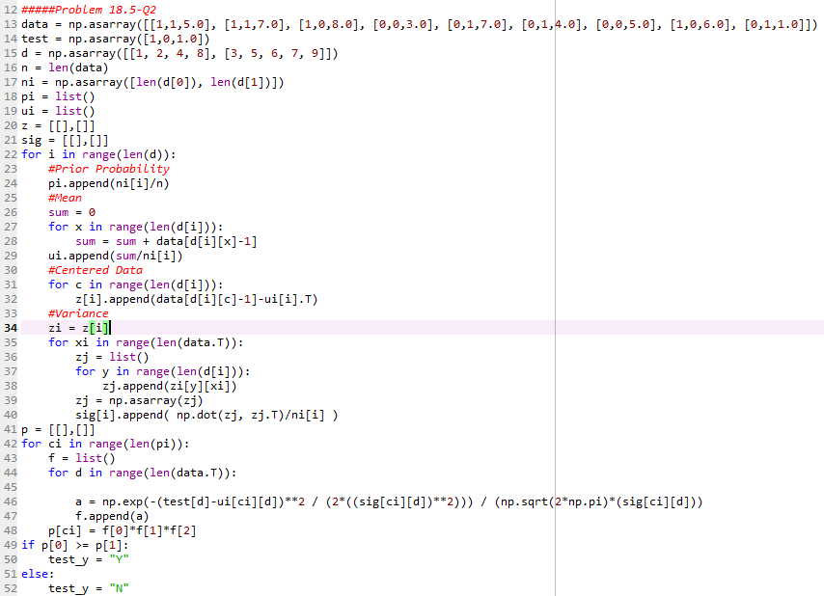

**Exercise 18.5 Q3:**

Using the full Bayes Classifier theorem, the probability of predict class is given as:

$$y←arg\max_{Ci}{f_{i}\left(x\right)P\left(C_{i}\right)}$$

$$f_{i}=f\left(x_{j} | μ_{i},Σ_{i}\right)=\frac{1}{{\left(\sqrt{2π}\right)}^{d}\sqrt{\left|Σ_{i}\right|}}exp⁡\{-\frac{{\left(x-μ_{i}\right)}^{T}Σ_{i}\left(x-μ_{i}\right)}{2}\}$$

So the results of the probability with the given mean, covariance, and prior probability is conclude as:

|  |  |  |
| --- | --- | --- |
|  | Class 1 | Class 2 |
| P(Ci) | 0.5 | 0.5 |
| Mean | (1, 3) | (5, 5) |
| Covariance | $$(\begin{matrix}5 & 3 \\ 3 & 5\end{matrix})$$ | $$(\begin{matrix}2 & 0 \\ 0 & 1\end{matrix})$$ |
| **P (Test point)** | **0.048266** | **0.012555** |

It’s clearly see that the probability of class 1 is larger than class 2 for the test point, so test point is predicted to the **Class 1**.

**Code:**

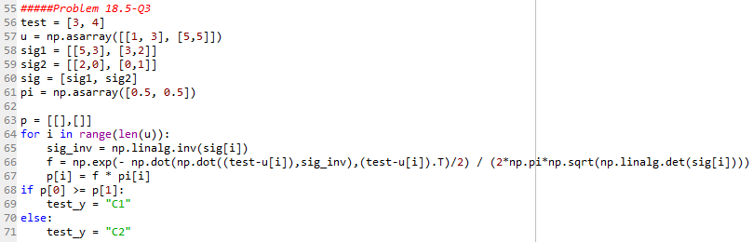

**Exercise 19.4 Q2:**

For the Decision Tree Classifier, we have the equation for entropy, split entropy, information gain as:

$$H\left(D\right)=-\sum_{i=1}^{k}{P\left(C_{i} | D\right)\log_{2}{P(C_{i}|D)}}$$

$$H\left(D_{Y},D_{N}\right)=\frac{n_{Y}}{n}H\left(D_{Y}\right)+\frac{n_{N}}{n}H(D_{N})$$

$$Gain\left(D,D_{Y},D_{N}\right)=H\left(D\right)-H\left(D_{Y}, D_{N}\right)$$

**Fist Split Point**: find out the maximum gain for each split point is:

|  |  |  |  |  |  |  |
| --- | --- | --- | --- | --- | --- | --- |
|  |  |  |  |  |  |  |
|  |  |  | 0 | 1 | 0.6667 | 0.2516 |
|  |  |  | 0.97095 | 0 | 0.80913 | 0.10917 |
| Car = Sport |  |  | 0.91829 | 0 | 0.45915 | 0.459145 |
| Car = Vintage |  |  | 0 | 0.97095 | 0.80913 | 0.10917 |
| Car = SUV |  |  | 0 | 1 | 0.6667 | 0.2516 |

Compare with all the gain, the maximum gain is Car = Sport, which become the first split point.

* Looking for the side of $Car≠Sport$ can conclude that L = {} and H = {x2, x4, x6} where the purity is 100% and no more split can provide.
* Looking for the side of $Car=Sport$ can find that L = {x1, x3} and H = {x5} where the purity is not 100% and need to split again.

**Second split point**: we only have set $Car=Sport=\{x1, x3, x5\}$ and do the same procedure for finding out the maximum gain:

|  |  |  |  |  |  |  |
| --- | --- | --- | --- | --- | --- | --- |
|  |  |  |  |  |  |  |
|  |  |  | 0 | 0 | 0 | 0.9183 |

Since we only have one split point which is also the maximum gain, we can have:

* Looking for $Age≤22.5$ can conclude L = {}, H = {x5} where the purity is 100% and no more split.
* Looking for $Age>22.5$ can conclude L = {x1, x3} and H = {} where the purity is 100% and no more split.

**Decision Tree:**

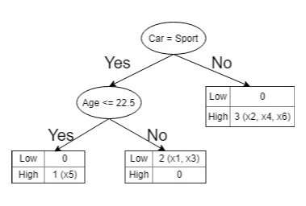

**Test Point: (Age = 17, Car = Vintage)**

Fellow by decision tree, we have $Car≠Sport$ so we get the class of **High**.