
Datamex College Of Saint Adeline Parañaque
8167- Datamex compound Dr. A. Santos
Avenue Sucat Parañaque City

WEBSITE TITLE:
“Development of an Inventory and Online Ordering System for a Local Streetwear Business: The Case of Eskinita Apparel”

In Partial Fulfillment
Of the Requirements for the Degree in
Bachelor of Science in Information Technology.

Leader:
Bemudez, Marc Jayr
Asst. Leader:
Soreda, Rovilyn Shaine

Members:
Albero, Prince Carl
Alipio, Rachelle
Flores, Sherrymae
Sore, Bianca Nicole
Vanzuela, Mark Ian

Presented to:

Mr. BJ Balbuena

Datamex College Of Saint Adeline Parañaque
8167- Datamex compound Dr. A. Santos
Avenue Sucat Parañaque City

CHAPTER I: INTRODUCTION

1.1 Background of the Study
In the continuously evolving landscape of the Philippine retail and fashion industry, particularly within the growing sector of local streetwear brands, the need for efficien and technology-driven business systems has become increasingly important. The rise of digital commerce, social media marketing, and online consumer behavior has significantly transformed how small and medium-sized enterprises (SMEs) operate and compete in the market. Local apparel businesses, especially those rooted in street culture, are now challenged to adapt to modern business practices while preserving their cultural identity and creative expression.
Eskinita Apparel is a local clothing brand inspired by Filipino street culture, reflecting the lifestyle, values, and resilience of individuals within urban communities. Guided by its tagline “Wear the Streets” and “Ipakita mo ang puso ng street culture,” the brand embodies the spirit of hard work, perseverance, and confidence concepts captured in its philosophy of being “Born on the streets, made for the streets.” Eskinita Apparel draws influence from eskinita culture, jeepney art, street fashion, hip-hop music, and other local expressions that define the Filipino street scene. Through its designs, the brand aims to represent and celebrate the identity of the streets while empowering individuals to confidently own their place within that culture. Despite its strong brand identity and creative foundation, Eskinita Apparel currently faces operational challenges that affect its efficiency and growth. The business operates without a computerized inventory management system and does not have an online ordering platform. Inventory tracking, order processing, and sales recording are handled manually, making the business vulnerable to errors, stock mismanagement, and delays in customer transactions. In an era where consumers increasingly expect fast, accessible, and online-based services, the absence of digital systems limits the brand’s ability to expand its market reach and meet customer demands.
This chapter introduces the proposed Inventory Management and Online Ordering System for Eskinita Apparel, a system-based solution designed to address these operational gaps. The proposed system aims to automate inventory monitoring, streamline order processing, and provide a centralized platform for managing products and sales. Through this study, the role of information technology in enhancing small business operations is examined, highlighting how a digital system can support Eskinita Apparel’s sustainability and competitiveness while remaining faithful to its street culture roots.
1.2 Statement of the Problem
Despite the increasing demand for digital solutions in the apparel industry, Eskinita Apparel continues to rely on manual business processes. The absence of an inventory management system makes it difficult to accurately track product stocks, resulting in possible overstocking or shortages. In addition, the lack of an online ordering system limits customer convenience and restricts the brand’s market reach. Manual recording of sales and orders increases the risk of errors, data inconsistency, and inefficiency in daily operations. These challenges highlight the need for a computerized system that can improve inventory accuracy, streamline transactions, and enhance overall business management. This study seeks to address these issues by developing an inventory management and online ordering system tailored to the operational needs of Eskinita Apparel.

1.3 Significance of the Study
The development of an Inventory Management and Online Ordering System for Eskinita Apparel is significant to various stakeholders.
For the Business Owner, the system will provide an efficient tool for managing inventory, monitoring sales, and processing customer orders accurately, reducing manual workload and operational errors.
For Customers, the system will offer a convenient and accessible platform for browsing products and placing orders online, improving their overall shopping experience.
For Academic Institutions and Future Researchers, this study may serve as a reference for system development projects related to inventory management, e-commerce platforms, and small business digitalization, contributing to further research and innovation in information technology.

1.4 Objectives of the Study
The primary objective of this study is to design, develop, and evaluate an inventory management and online ordering system that will improve the operational efficiency of Eskinita Apparel.

Specific Objectives
- To develop an inventory management system that accurately tracks product stocks.
- To provide an online ordering platform for customers.
- To organize product, order, and sales records in a centralized database.
- To reduce errors and inefficiencies caused by manual business processes.
- To enhance customer accessibility and satisfaction through digital services.

1.5 Scope and Delimitation

Scope
This study covers the design, development, and implementation of Eskinita Appareal, a web-based e-commerce system for a local streetwear apparel brand. The system was built using Node.js with Express.js for the backend, MySQL (via XAMPP) for the database, and HTML, CSS, and JavaScript for the frontend. The system includes the following core modules:
- User Account Management — customer registration and login with secure password hashing (bcrypt), session-based authentication, and storage of customer contact and address information.
- Product Catalog and Inventory Management — a product database with support for product name, SKU, price, stock quantity, category, description, product photo, and a configurable low-stock threshold. Products can be filtered by category on the storefront.
- Shopping Cart and Checkout — customers can browse products, view full product details (including size selection) in a pop-up interface, and add items to a cart. Checkout requires the customer to complete a delivery details form (recipient name, contact number, address, city, delivery mode, payment method, and optional notes) before an order is placed.
- Order Management — orders are recorded with their associated items, quantities, sizes, total amount, payment method, delivery mode, and shipping information. Order status can be updated by the administrator through a defined lifecycle (Pending, Paid, Packed, Shipped, Delivered, Cancelled), and customers can view their own order history and status.
- Admin Dashboard — a role-restricted administrative interface providing:
- A dashboard overview with sales and inventory statistics
- Full inventory management (add, edit, and delete products; update stock, price, category, and photos)
- Order management (view all orders, update order status, and delete orders — restricted to orders with a "Cancelled" status)
- A photo album/lookbook management feature for uploading and displaying brand photography
- Photo Album (Lookbook) — a public-facing gallery page separate from the product catalog, used to showcase brand photography, managed through the admin panel.
The system was developed and tested in a local development environment (XAMPP for MySQL, Node.js runtime) as a proof-of-concept e-commerce platform demonstrating core retail functions: product browsing, cart management, order placement, order tracking, and inventory control.

Delimitation
This study and system are limited to the following:
- Payment Processing — the system allows customers to select a payment method (Cash on Delivery, GCash, or Credit/Debit Card) at checkout; however, no actual payment gateway (e.g., PayMongo, Xendit, Stripe) is integrated. Payment methods are recorded for informational and fulfillment purposes only, and no real financial transactions are processed through the system.
- Delivery/Courier Integration — delivery mode options (Third-Party Delivery, Rider - Cash on Delivery) are recorded as customer preferences only. The system does not integrate with third-party courier APIs (e.g., Lalamove, Grab, J&T) for live rate calculation, booking, or shipment tracking.
- Notifications — the system does not send automated email or SMS notifications for order confirmation, status updates, or account activity.
- User Roles — the system supports two roles only: customer and administrator. There is no support for multiple administrator permission levels (e.g., staff vs. super-admin) or third-party seller accounts.
- Security Scope — the system implements password hashing and session-based authentication but does not include advanced security measures such as two-factor authentication, rate limiting, CAPTCHA, or PCI-DSS-compliant payment handling, as no real payments are processed.
- Scalability and Hosting — the system was developed and tested for local/single-server deployment (XAMPP, localhost). It was not deployed to a live production server, load-tested, or optimized for concurrent high-traffic use during the course of this study.
- Product Reviews and Recommendations — the system does not include customer product reviews, ratings, or personalized product recommendation features.
- Reporting and Analytics — administrative reporting is limited to basic dashboard statistics (total revenue, order counts, pending orders, low-stock items). Advanced analytics, exportable reports, and sales forecasting are outside the scope of this system.
1.6 Theoretical Framework
This study is grounded in the following theories:
Information Systems Success Model (DeLone and McLean): This theory emphasizes system quality, information quality, and user satisfaction as key indicators of an effective information system. These factors guide the development of the proposed inventory management and online ordering system to ensure reliability, accuracy, and usability for both administrators and customers.
Reference: DeLone, W. H., & McLean, E. R. (2003). The DeLone and McLean model of information systems success: A ten-year update. Journal of Management Information Systems, 19(4), 9–30.
Technology Acceptance Model (TAM): The Technology Acceptance Model explains how users come to accept and use technology based on perceived usefulness and perceived ease of use. This theory supports the design of a user-friendly system that encourages adoption by the business owner and customers of Eskinita Apparel.
Reference: Davis, F. D. (1989). Perceived usefulness, perceived ease of use, and user acceptance of information technology. MIS Quarterly, 13(3), 319–340.
Inventory Management Theory: Inventory Management Theory focuses on maintaining optimal stock levels to reduce costs, avoid shortages or overstocking, and improve operational efficiency. This theory supports the system’s goal of accurate inventory tracking and effective stock control for Eskinita Apparel.
Reference: Silver, E. A., Pyke, D. F., & Peterson, R. (1998). Inventory management and production planning and scheduling. John Wiley & Sons.
1.7 Conceptual Framework
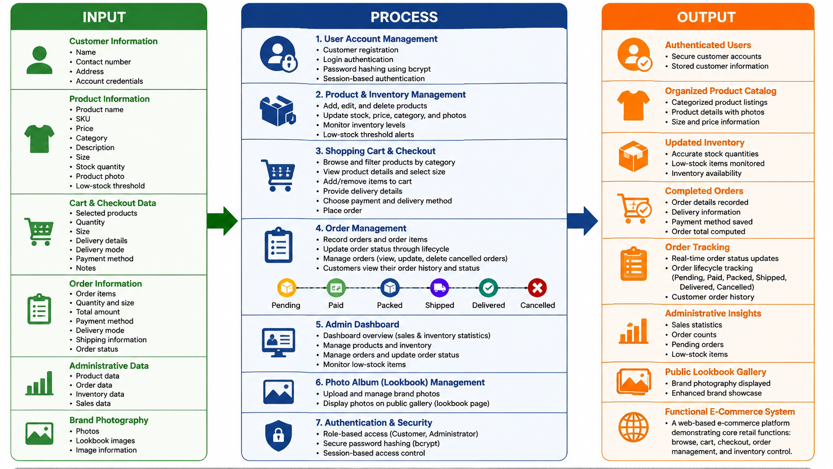
The conceptual framework of the study illustrates the relationship between the current manual operations of Eskinita Apparel and the proposed Inventory Management and Online Ordering System. The framework follows the Input–Process–Output (IPO) Model, which explains how inputs are transformed through system processes to produce desired outputs.

1.8 Definition Of Terms

Eskinita Apparel – A local streetwear clothing brand inspired by Filipino street culture and urban identity.
Inventory – The total quantity of products or stocks available for sale in the business.
Inventory Management System – A computerized system used to monitor, record, and manage product stocks efficiently.
Online Ordering System – A digital platform that allows customers to browse products and place orders through the internet.
Street Culture – Urban styles, values, and forms of self-expression such as street fashion, music, art, and local community influences.
Product Listing – The display of available products, including descriptions, prices, and stock quantity, within the system.
Order Processing – The procedure of receiving, validating, and fulfilling customer orders through the system.
Database – An organized collection of data where information such as products, orders, and customer details are stored and managed.
Administrator – The authorized user responsible for managing inventory, products, orders, and system settings.
Customer – An individual who browses products and places orders through the online ordering system.
Manual Process – A traditional method of recording and managing business transactions without the use of computerized systems.
Business Operations – The daily activities involved in running the business, including inventory control, sales, and order management.

Datamex College Of Saint Adeline Parañaque
8167- Datamex compound Dr. A. Santos
Avenue Sucat Parañaque City

CHAPTER II: REVIEW OF RELATED LITERATURE AND STUDIES

2.1 Foreign Literature and Studies

1. Web-Based Inventory Information Systems
Problem Encountered:
Traditional inventory management often relies on manual recording and updating of stock information. This can result in inaccurate inventory records, delayed updates, human errors, and difficulty monitoring products efficiently.
Solution Proposed:
Web-based inventory information systems were developed to provide businesses with a centralized platform for recording, monitoring, and managing inventory. These systems allow product quantities and inventory records to be updated electronically and accessed through a web-based interface.
Result:
The implementation of web-based inventory systems improves inventory accuracy, reduces manual errors, and provides faster access to stock information. It also helps businesses monitor their inventory more efficiently and supports better day-to-day operational management.

2. Integrated Online Ordering and Inventory Systems
Problem Encountered:
Businesses that manage customer orders and inventory separately may experience delays in updating stock records. Manual coordination between sales transactions and inventory records can also result in inaccurate stock quantities and errors in order processing.
Solution Proposed:
An integrated online ordering and inventory system connects the ordering process with inventory management. When customers place orders, the system records the transaction and updates the corresponding inventory information.
Result:
The integration of ordering and inventory functions improves transaction speed and accuracy. It reduces the possibility of discrepancies between orders and available stock while allowing businesses to manage customer transactions and inventory through a single system.

3. Inventory Management Using EOQ and Safety Stock
Problem Encountered:
Businesses may encounter problems with maintaining appropriate inventory levels. Overstocking can increase storage costs, while insufficient stock can result in product shortages and missed sales opportunities.
Solution Proposed:
Inventory management methods such as Economic Order Quantity (EOQ) and safety stock are used to determine appropriate order quantities and minimum inventory levels. These methods provide businesses with a systematic approach to determining when and how much inventory should be maintained.
Result:
The use of EOQ and safety stock helps businesses maintain more balanced inventory levels. It reduces the risk of stock shortages and excessive inventory while supporting more organized and efficient inventory control.

4. Website-Based Inventory Information System Design
Problem Encountered:
Manual inventory tracking can require considerable time and effort and is vulnerable to recording errors. Businesses may also have difficulty monitoring inventory transactions and generating accurate reports using traditional methods.
Solution Proposed:
A website-based inventory information system provides a digital platform for recording, updating, and monitoring inventory transactions. The system allows authorized users to manage product information and access inventory records more efficiently.
Result:
The implementation of the system improves the accuracy and accessibility of inventory information. It reduces dependence on manual records, minimizes human errors, and makes inventory monitoring and reporting more efficient.

5. Use of Web-Based Ordering Systems in Service Industries
Problem Encountered:
Traditional ordering procedures in service industries may require customers to communicate their orders manually or visit the business personally. These processes can be time-consuming and may cause errors in order recording and inventory monitoring.
Solution Proposed:
Web-based ordering systems provide customers with an online platform where they can browse available services or products, submit orders, and provide the necessary transaction information. The system can also connect ordering activities with inventory and business operations.
Result:
Web-based ordering improves customer convenience and makes order processing more organized. It reduces manual work, improves transaction accuracy, and helps businesses monitor orders and inventory more efficiently.

2.2 Local Literature and Studies

1. Inventory Management Practices in Small Businesses in Cavite, Philippines
Problem Encountered:
Small businesses such as pharmacies may experience difficulties maintaining accurate inventory levels because of the large number of products that need to be monitored. Improper inventory control can result in expired products, shortages, and excess stock.
Solution Proposed:
The study examined structured inventory management practices, including Economic Order Quantity (EOQ) and First-Expired, First-Out (FEFO). These methods provide businesses with systematic procedures for determining appropriate stock levels and prioritizing products based on their expiration dates.
Result:
The use of structured inventory management practices helps improve stock accuracy and product handling. The study emphasizes that systematic inventory control is important for maintaining efficient operations in small Philippine businesses.

2. Inventory System Case Study of Restaurants in Quezon Province
Problem Encountered:
Small restaurants may encounter difficulties in monitoring food supplies, recording inventory movements, and controlling stock levels. Poor inventory management can contribute to waste, shortages, increased expenses, and reduced profitability.
Solution Proposed:
The study examined the inventory management practices used by restaurants and emphasized the importance of systematic inventory monitoring. Proper recording and control of stocks were considered essential for improving business operations.
Result:
The findings indicated that effective inventory management contributes to better operational efficiency and profitability. Proper monitoring of inventory allows restaurants to control their resources and reduce unnecessary losses.

3. Computerized Inventory Tracking System in the Philippines
Problem Encountered:
Manual warehouse stock-in and stock-out procedures can result in inaccurate records, slow transaction processing, and difficulty tracking the movement of products. These problems can make it difficult for businesses to determine their actual inventory levels.
Solution Proposed:
A computerized inventory tracking system was developed to digitize stock-in and stock-out transactions. The system records inventory movements electronically and allows users to monitor product quantities through a centralized database.
Result:
The computerized system improved the recording and monitoring of warehouse inventory. It reduced dependence on manual documentation, improved data accuracy, and provided a more efficient method of tracking stock movements.

4. Local Inventory Management System Literature Reviews
Problem Encountered:
Local businesses and organizations that rely on manual inventory procedures may experience difficulties in maintaining accurate records, monitoring stock levels, and managing inventory transactions efficiently.
Solution Proposed:
Various Philippine studies and academic literature propose the use of computerized and web-based inventory management systems. These systems use databases and automated processes to record products, monitor inventory, and support business transactions.
Result:
The reviewed literature indicates that computerized inventory systems can improve inventory accuracy, reduce manual errors, and make business processes more efficient. These findings provide a basis for developing inventory-related systems suited to the needs of local businesses.

Relevance to the Present Study
The reviewed foreign and local literature demonstrate that manual inventory and ordering processes can lead to inaccurate records, inefficient transactions, stock shortages, and difficulties in monitoring business operations. The proposed solutions commonly involve web-based or computerized systems that centralize product, inventory, and transaction information.
These findings support the development of Eskinita Apparel, a web-based e-commerce system that integrates product catalog management, inventory monitoring, shopping cart and checkout functions, order management, and an administrative dashboard. Unlike systems that focus only on inventory tracking, the proposed system combines online product ordering and inventory management in one platform. This integration is intended to improve the efficiency and accuracy of retail operations while providing customers with a more convenient way to browse products and place orders.

List of Source of the studies
Source: Web-Based Online Inventory Information System — a research article that discusses how web-based systems support effective inventory management.
https://www.researchgate.net/publication/343512322_Web_Based_Online_Inventory_Information_System
Source: Online Ordering and Inventory System — a literature review highlighting the importance of integrating ordering and inventory tracking systems.
https://www.memoireonline.com/07/12/5995/m_Online-ordering-and-inventory-system5.html
Source: Design and Construction of a Web-Based Inventory Management Information System Using the Safety Stock and EOQ Methods — a study on efficient inventory control using web-based systems.
https://jurnal.uai.ac.id/index.php/SST/article/view/5300/0
Source: Design of a Website-Based Goods Inventory Information System — published research on inventory system design and implementation.
https://journal.ittelkom-sby.ac.id/jaiit/article/view/632
Source: The Web-Based Ordering and Inventory Information System for Online Printing Services — research on implementing web-based ordering and inventory systems.
https://jurnal.ubd.ac.id/index.php/te/article/view/665
Source: Inventory Management Practices of Small-Scale Pharmacies in Selected Towns in Cavite — a study from Cavite State University.
https://www.researchgate.net/publication/381056008_Inventory_Management_Practices_of_Small-Scale_Pharmacies_in_the_Selected_Towns_in_Cavite_A_Marketing_Perspective
Source: Analysis of Inventory Management Systems of Selected Restaurants in Quezon Province — a local research article.
https://al-kindipublishers.org/index.php/jbms/article/view/852
Source: Computerized Warehouse Inventory Tracking System — a thesis from a Philippine university repository.
https://repository.cpu.edu.ph/handle/20.500.12852/2211
Source: Inventory Management System Review of Related Literature — an online literature overview.
https://www.inettutor.com/source-code/inventory-management-system-review-of-related-literature/

Datamex College Of Saint Adeline Parañaque
8167- Datamex compound Dr. A. Santos
Avenue Sucat Parañaque City

CHAPTER III: METHODOLOGY

3.1 Research and Development Methodology
This study will use a hybrid Agile and Spiral methodology in the development of the Inventory Management and Online Ordering System for Eskinita Apparel. The combination of these methodologies is appropriate because the proposed system requires continuous improvement based on user feedback while also requiring regular identification and management of risks related to inventory accuracy, order processing, usability, data security, and system performance.
Agile methodology will be used to organize the development into short and manageable iterations. Each iteration will focus on a specific group of system functions, followed by testing, review, and refinement. This allows the researchers to receive feedback from the intended users and make necessary changes before proceeding to the next iteration.
The Spiral methodology will complement Agile by placing risk identification and evaluation within each development cycle. Before and during every major iteration, the researchers will identify possible technical and operational risks, determine appropriate solutions, develop or revise the system, and evaluate the results. This hybrid approach will help ensure that the system remains aligned with the operational needs of Eskinita Apparel while reducing potential problems during implementation.
3.2 Agile Development Process
The Agile component of the methodology will follow an iterative development process. The researchers will divide the proposed system into manageable features and develop them incrementally. The process will allow the team to prioritize important functions, test completed features, gather feedback, and improve the system throughout development.
• Planning and Requirement Identification – The researchers will identify the required functions of the system based on the operational problems described in Chapter I, particularly manual inventory tracking, order processing, product management, and sales record management.
• Feature Prioritization – The identified requirements will be organized according to importance. Core features such as product listing, inventory monitoring, customer ordering, order management, and administrative functions will receive priority.
• Iterative Development – The system will be developed in short iterations or sprints. Each sprint will produce a working portion of the system that can be tested and reviewed.
• Testing – Developed functions will be tested to identify functional errors, incorrect inventory updates, order-processing issues, and usability concerns.
• User Feedback – The business owner and intended users will review the developed features and provide feedback regarding functionality, ease of use, and suitability to business operations.
• Refinement – Identified problems and requested improvements will be incorporated into the succeeding iteration until the system meets the intended requirements.

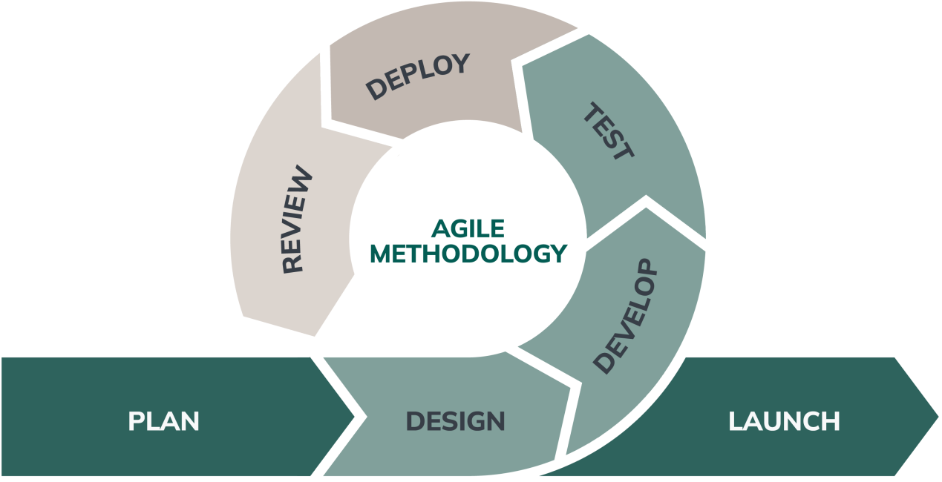

3.3 Spiral Risk Management Process
The Spiral component will be applied to manage risks throughout system development. Each cycle will consider the objectives of the current iteration, possible risks, development of the proposed solution, and evaluation of the resulting system. This process is particularly suitable for the study because the system handles product stocks, customer orders, and business records that require accuracy and reliability.
• Identification of Objectives – The researchers will define the functions and expected results for the current development cycle.
• Risk Identification and Analysis – Potential risks such as incorrect stock quantities, duplicate orders, invalid inputs, unauthorized access, data loss, system errors, and usability problems will be considered.
• Risk Mitigation and Development – Appropriate technical solutions, validation procedures, access controls, and testing activities will be incorporated to reduce identified risks.
• Evaluation – The completed iteration will be tested and reviewed. Results and user feedback will determine whether the system is ready for the next cycle or requires further modification.

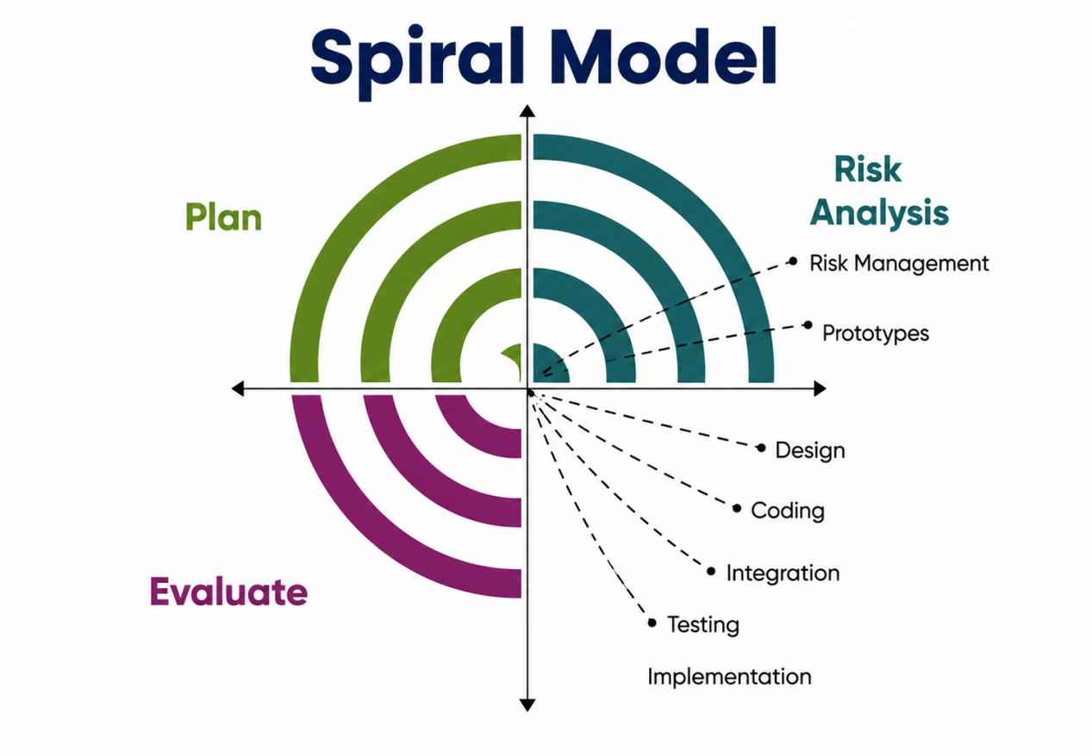

3.4 Integration of Agile and Spiral Methodologies
The two methodologies will operate together rather than as separate development approaches. Agile will provide the iterative structure for developing and improving system features, while Spiral will provide a risk-focused evaluation within each iteration. For example, when the inventory module is developed, the Agile process will guide its planning, coding, testing, and feedback, while the Spiral process will identify risks such as inaccurate stock updates and determine controls or improvements before the module is finalized.
The combined methodology will be applied to the major components of the proposed system, including product listing, inventory tracking, order processing, centralized product and order records, and basic administrative management. The approach will support the study's objective of improving inventory accuracy, reducing manual errors, streamlining transactions, and improving customer accessibility.
3.5 Development Cycles
The development will be organized into practical cycles that correspond to the major functions of the proposed Inventory Management and Online Ordering System. The exact number and duration of cycles may be adjusted according to the progress of the researchers and feedback obtained during evaluation.
• Cycle 1 – Requirements and Planning: Identify business requirements, define system users, document current manual processes, prioritize features, and identify initial technical and operational risks.
• Cycle 2 – Product and Inventory Module: Develop product listing and inventory tracking functions. Test stock quantity updates, product records, and administrative controls while evaluating risks related to inventory accuracy.
• Cycle 3 – Online Ordering Module: Develop customer product browsing and online ordering functions. Test order submission and validation while evaluating risks related to incorrect or incomplete orders.
• Cycle 4 – Order and Records Management: Develop administrative order management and centralized product, order, and sales records. Test data consistency and the connection between orders and inventory.
• Cycle 5 – Integration and System Improvement: Integrate the completed modules, conduct broader functional and usability testing, address identified defects, and apply user feedback.
• Cycle 6 – Final Evaluation and Deployment Preparation: Perform final testing and evaluation, document remaining issues, make final improvements, and prepare the system for use within the defined study scope.
3.6 System Development Activities
The development activities will follow the combined Agile-Spiral process. Requirements will first be identified from the existing business processes and the objectives of the study. The researchers will then design, develop, test, and evaluate each prioritized system feature. Feedback and risk findings will be used to refine succeeding versions of the system.
• Requirements Analysis – Determine the functional and operational requirements of Eskinita Apparel.
• System Design – Prepare the system structure, database design, user interfaces, and process flow for the proposed features.
• Implementation – Develop the system modules and integrate them into a working application.
• Testing – Verify that each feature performs its intended function and that information is processed consistently.
• Evaluation and Feedback – Obtain comments from the intended users regarding functionality, usability, and suitability.
• Revision – Correct identified defects and incorporate appropriate improvements based on testing and feedback.
• Final Integration – Combine the tested modules into the completed system and conduct final evaluation.
3.7 System Testing and Evaluation
Testing will be conducted throughout the development cycles instead of only at the end of the project. Functional testing will be used to verify whether the system performs the required functions correctly. The researchers will also check inventory updates, order processing, product information, administrative functions, and record management.
Usability evaluation will focus on ease of navigation, clarity of information, ease of performing common tasks, and overall user satisfaction. Problems identified during testing will be recorded and addressed in subsequent Agile iterations. Risk-related findings will also be reviewed using the Spiral process before the system is considered ready for final evaluation.
3.8 Research Locale and Scope of Participants
The study will be conducted within the defined operational and research scope of Eskinita Apparel and will be geographically limited to the National Capital Region (NCR). Customer participation, user feedback, and related evaluation activities will focus on individuals and business operations within the NCR vicinity. The study will not be generalized to customers or business operations located outside NCR.
The business owner will serve as the primary administrator and evaluator of the business management functions, while intended customers will provide feedback on the online ordering and customer-facing functions. The final number of participants will depend on the approved research sampling plan of the researchers and their adviser.
3.9 Data Gathering Procedure
The researchers will gather information needed for system development through observation of existing business processes, consultation with the business owner, review of current inventory and ordering practices, and user feedback during system evaluation. Information gathered will be used to identify requirements, validate system functions, and determine necessary improvements.
• Observe the existing inventory and ordering procedures.
• Identify problems and requirements associated with the current manual process.
• Consult the business owner regarding needed administrative and inventory functions.
• Present and test iterative versions of the system.
• Collect user feedback and document identified issues.
• Apply appropriate revisions and conduct final evaluation.
3.10 Research Instruments
The researchers may use observation guides, interview or consultation questions, system testing checklists, and user evaluation questionnaires to gather and assess information during development. These instruments will focus on the system's functionality, usability, accuracy, efficiency, and suitability to the operational needs of Eskinita Apparel.
3.11 Ethical Considerations
The researchers will observe ethical practices throughout the study. Participation in data-gathering and system evaluation will be conducted with appropriate permission and informed participation. Information obtained from the business and users will be handled responsibly and will only be used for the purposes of the study. Personal and business information will not be disclosed without proper authorization. The researchers will also limit the collection of information to data relevant to the development and evaluation of the proposed system.
3.12 Chapter Summary
This chapter presented the methodology for developing the Inventory Management and Online Ordering System for Eskinita Apparel. A hybrid Agile and Spiral approach will be used to support iterative development, continuous user feedback, and systematic risk management. The methodology covers requirements identification, iterative development, testing, user evaluation, risk analysis, and system refinement. The study will remain geographically limited to the National Capital Region (NCR), consistent with the scope and delimitation established in Chapter I.

Datamex College Of Saint Adeline Parañaque
8167- Datamex compound Dr. A. Santos
Avenue Sucat Parañaque City

CHAPTER IV: PRESENTATION, ANALYSIS, AND INTERPRETATION OF DATA

4.1 Introduction
This chapter presents the presentation, analysis, and interpretation of the data gathered from the respondents who evaluated the proposed Inventory Management and Online Ordering System for Eskinita Apparel. A total of 200 respondents participated in the evaluation of the system. The data were gathered through a questionnaire designed to evaluate the system’s usability, functionality, and performance.
The respondents evaluated the proposed system based on its functions and features, including the system interface, inventory management, product listing, online ordering, order processing, and management of product, order, and sales records. The evaluation was conducted to determine whether the proposed system could address the identified problems in the existing manual processes of Eskinita Apparel and improve its business operations.
The data gathered from the respondents are presented and analyzed through tables and corresponding explanations. Frequency, percentage, and weighted mean are used where supported by the gathered responses. The results provide a basis for determining the effectiveness and suitability of the proposed system in addressing the operational needs of Eskinita Apparel and the objectives of the study.

4.2 Profile of the Respondents
Table 1
Age Bracket | Frequency | Percentage
14–17 | 20 | 10.75%
18–21 | 89 | 47.85%
22 years old and above | 77 | 41.40%
Total | 186 | 100%

Age of the Respondents

Table 1 presents the age distribution of the 186 respondents. The largest group consisted of respondents aged 18–21 years old, with 89 respondents or 47.85% This was followed by respondents aged 22 years old and above, with 77 respondents or 41.40%. Meanwhile, 20 respondents or 10.75% belonged to the 14–17 age bracket. The distribution shows that the evaluation included respondents from different age groups.

Table 2

Gender of the Respondents
Gender | Frequency | Percentage
Male | 91 | 48.92%
Female | 95 | 51.08%
Total | 186 | 100%

Table 2 presents the gender distribution of the respondents. Out of the 186 respondents, 91 or 48.92% were male, while 95 or 51.08% were female. This indicates that both male and female respondents participated in the evaluation of the proposed system.

4.3 Evaluation of the Proposed System
The following tables present the respondents’ evaluation of the proposed Inventory Management and Online Ordering System for Eskinita Apparel. The evaluation covers the system interface, system and inventory functions, and the overall assessment of the proposed system.

Table 3
Evaluation of the System Interface
Statement / Question | SA | A | N | D | SD
The website interface appears clear and easy to understand | 127  68.28% | 56  30.11% | 3  1.61% | 0  0% | 0  0%
The design and layout of the website appears organized. | 86  46.24% | 99  53.23% | 1  0.54% | 0  0% | 0  0%
The navigation menu seems easy to follow. | 83  44.62 | 96  51.61% | 7  3.76% | 0  0% | 0  0%

Table 4
Evaluation of the System and Inventory Functions
Statement / Question | SA | A | N | D | SD
The ordering process appears simple and easy to understand | 103  55.38% | 81  43.55% | 2  1.08% | 0  0% | 0  0%
The system appears capable of recording customer orders accurately. | 86  46.24% | 95  51.08% | 5  2.69% | 0  0% | 0  0%
The system appears capable of tracking product stock effectively | 62  33.33% | 119  63.98% | 5  2.69% | 0  0% | 0  0%
The inventory system appears helpful for managing product availability | 106  56.99% | 75  40.32% | 5  2.69% | 0  0% | 0  0%

Table 5
Overall Evaluation of the Proposed System
Statement / Question | SA | A | N | D | SD
The system appears useful for managing an online clothing | 110  59.14% | 73  39.25% | 3  1.61% | 0  0% | 0  0%
The system appears reliable for handling product orders. | 85  45.70% | 96  51.61% | 5  2.69% | 0  0% | 0  0%
Would you consider using this system if it were available? | 97  52.15% | 83  44.62% | 5  2.69% | 1  0.54% | 0  0%

Response Percentage Reference
Questions 1–9 have a total of 186 respondents. Question 10 has a total of 186 respondents based on the listed frequencies (97+83+5+1+0 = 186), although the source table displays Total 187. For consistency with the actual response counts, percentages should be computed using the frequency total of 186.

Table 6

Yes/No Response Item
Response | Frequency | Percentage
Yes | 184 | 98.92%
No | 2 | 1.08%
Total | 186 | 100%

For the Yes/No response item, all 200 respondents answered Yes, representing 100% of the respondents, while no respondent answered No. This indicates a completely positive response to the Yes/No item included in the evaluation and further supports the generally favorable response to the proposed system.

4.4 Interpretation of Results
The results of the system interface evaluation show that the respondents generally perceived the proposed Inventory Management and Online Ordering System for Eskinita Apparel positively. For the statement that the website interface appears clear and easy to understand, 60% strongly agreed and 32.5% agreed, while 7.5% were neutral. For the statement that the design and layout of the website appears organized, 55% strongly agreed and 36% agreed, while 9% were neutral. In terms of navigation, 52.5% strongly agreed and 39% agreed that the navigation menu seemed easy to follow, while 8.5% were neutral. These results indicate that most respondents viewed the system interface as clear, organized, and easy to navigate.
The results for the system and inventory functions also show a generally positive response from the respondents. For the statement that the ordering process appears simple and easy to understand, 57.5% strongly agreed and 35% agreed, while 7.5% were neutral. For the system’s ability to record customer orders accurately, 57.5% strongly agreed and 37.5% agreed, while 5% were neutral. Regarding product stock tracking, 50% strongly agreed and 41% agreed that the system appears capable of tracking product stock effectively, while 9% were neutral. In addition, 49% strongly agreed and 42% agreed that the inventory system appears helpful for managing product availability, while 9% were neutral. These findings suggest that the respondents generally perceived the ordering and inventory functions of the proposed system as useful and easy to understand.
The overall evaluation of the proposed system also reflects a positive perception among the respondents. For the statement that the system appears useful for managing an online clothing business, 52.5% strongly agreed and 39% agreed, while 8.5% were neutral. For the statement that the system appears reliable for handling product orders, 50% strongly agreed and 41% agreed, while 9% were neutral. Furthermore, 55% strongly agreed and 36.5% agreed that they would consider using the system if it were available, while 8.5% were neutral. These results indicate that most respondents perceived the proposed system as useful and reliable and expressed willingness to use it if it becomes available.
For the Yes/No response item, all 200 respondents answered Yes, representing 100% of the respondents, while no respondent answered No. This result indicates a completely positive response to the Yes/No item and further supports the generally positive response shown in the system evaluation.
Overall, the results show that the proposed Inventory Management and Online Ordering System for Eskinita Apparel received generally positive evaluations from the 200 respondents. Most respondents gave positive responses regarding the clarity and organization of the interface, ease of navigation, ordering process, order recording, stock tracking, product availability, usefulness, reliability, and willingness to use the system.

4.5 Statistical Treatment of Data
The data gathered from the 186 respondents were organized, tabulated, and analyzed using frequency, percentage, and weighted mean. These statistical methods were used to properly summarize and interpret the responses gathered through the questionnaire.
Frequency was used to determine the number of respondents who selected each response. Percentage was used to determine the proportion of respondents for each category. The percentage was computed using the formula: Percentage = (f / N) × 100
Where:
f = frequency of responses N = total number of respondents
For the system evaluation, a five-point Likert scale was used. The responses were assigned the following numerical values:

Response | Weight
Strongly Agree (SA) | 5
Agree (A) | 4
Neutral (N) | 3
Disagree (D) | 2
Strongly Disagree (SD) | 1

The weighted mean was used to determine the overall assessment of the respondents for each evaluation item. The formula used was: Weighted Mean = Σ(f × x) / N
Where:
f = frequency of each response x = numerical weight of each response N = total number of respondents
For example, if an evaluation item received 120 Strongly Agree responses, 65 Agree responses, and 15 Neutral responses from 200 respondents, the weighted mean would be computed as follows:
WM = [(120 × 5) + (65 × 4) + (15 × 3)] / 200
WM = 905 / 200
WM = 4.53
For the demographic profile, such as age and gender, frequency and percentage were used to present the distribution of the respondents. The gender data consisted of 108 male respondents or 54% and 92 female respondents or 46%. The age distribution consisted of 58 respondents aged 14–17, 73 respondents aged 18–21, and 69 respondents aged 22 years old and above.
For the Yes/No response item, frequency and percentage were used. Based on the gathered responses, 200 respondents or 100% answered Yes, while none answered No. The statistical results were used to support the analysis and interpretation of the respondents’ evaluation of the proposed Inventory Management and Online Ordering System for Eskinita Apparel.

4.6 Summary of Findings
Based on the data gathered from the 200 respondents, the proposed Inventory Management and Online Ordering System for Eskinita Apparel received generally positive evaluations.
The results showed that the majority of respondents positively assessed the system interface. Most respondents agreed that the website was clear and easy to understand, that the design and layout were organized, and that the navigation menu was easy to follow.
The respondents also gave favorable assessments of the system and inventory functions. The majority agreed that the ordering process was simple and easy to understand, that the system could accurately record customer orders, that product stocks could be effectively tracked, and that the inventory system could help manage product availability.
For the overall evaluation, most respondents considered the proposed system useful for managing an online clothing business and reliable for handling product orders. The respondents also showed willingness to use the system if it became available.
The demographic results showed that there were 108 male respondents or 54% and 92 female respondents or 46%. The age distribution consisted of 58 respondents aged 14–17, 73 respondents aged 18–21, and 69 respondents aged 22 years old and above.
For the Yes/No item, all 200 respondents answered Yes, representing 100% of the respondents, while no respondent answered No.
Overall, the findings indicate that the proposed Inventory Management and Online Ordering System was favorably evaluated by the respondents. The results suggest that the system can help improve inventory management, order processing, product tracking, and online business operations of Eskinita Apparel

Response | Frequency | Percentage
Strongly Agree | 127 | 68.28%
Agree | 56 | 30.11%
Neutral | 3 | 1.61%
Disagree | 0 | 0.00%
Strongly Disagree | 0 | 0.00%
Total | 186 | 100.00%

Response | Frequency | Percentage
Strongly Agree | 86 | 46.24%
Agree | 99 | 53.23%
Neutral | 1 | 0.54%
Disagree | 0 | 0.00%
Strongly Disagree | 0 | 0.00%
Total | 186 | 100.00%

Response | Frequency | Percentage
Strongly Agree | 83 | 44.62%
Agree | 96 | 51.61%
Neutral | 7 | 3.76%
Disagree | 0 | 0.00%
Strongly Disagree | 0 | 0.00%
Total | 186 | 100.00%

Response | Frequency | Percentage
Strongly Agree | 103 | 55.38%
Agree | 81 | 43.55%
Neutral | 2 | 1.08%
Disagree | 0 | 0.00%
Strongly Disagree | 0 | 0.00%
Total | 186 | 100.00%

Response | Frequency | Percentage
Strongly Agree | 86 | 46.24%
Agree | 95 | 51.08%
Neutral | 5 | 2.69%
Disagree | 0 | 0.00%
Strongly Disagree | 0 | 0.00%
Total | 186 | 100%

Response | Frequency | Percentage
Strongly Agree | 62 | 33.33%
Agree | 119 | 63.98%
Neutral | 5 | 2.69%
Disagree | 0 | 0.00%
Strongly Disagree | 0 | 0.00%
Total | 186 | 100.00%

Response | Frequency | Percentage
Strongly Agree | 106 | 56.99%
Agree | 75 | 40.32%
Neutral | 5 | 2.69%
Disagree | 0 | 0.00%
Strongly Disagree | 0 | 0.00%
Total | 186 | 100.00%

Response | Frequency | Percentage
Strongly Agree | 110 | 59.14%
Agree | 73 | 39.25%
Neutral | 3 | 1.61%
Disagree | 0 | 0.00%
Strongly Disagree | 0 | 0.00%
Total | 186 | 100.00%

Response | Frequency | Percentage
Strongly Agree | 85 | 45.70%
Agree | 96 | 51.61%
Neutral | 5 | 2.69%
Disagree | 0 | 0.00%
Strongly Disagree | 0 | 0.00%
Total | 186 | 100.00%

Response | Frequency | Percentage
Strongly Agree | 97 | 52.41%
Agree | 83 | 44.39
Neutral | 5 | 2.67%
Disagree | 1 | 0.53
Strongly Disagree | 0 | 0.00%
Total | 187 | 100.00%

Question 1
YES/NO RESPONSE
Response | Frequency | Percentage
Yes | 186 | 100.00%
No | 0 | 0.00%
Total | 186 | 100.00%
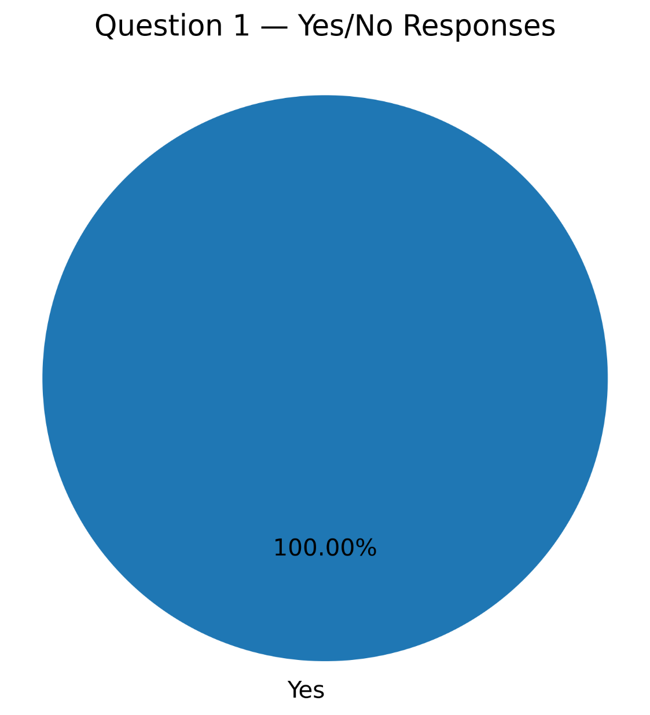
For this Yes/No response item, 186 respondents answered Yes, representing 100.00%, while 0 respondents answered No, representing 0.00%. This indicates a strongly positive response to the Yes/No item included in the evaluation.

Question 2
YES/NO RESPONSE
Response | Frequency | Percentage
Yes | 185 | 99.46%
No | 1 | 0.54%
Total | 186 | 100.00%
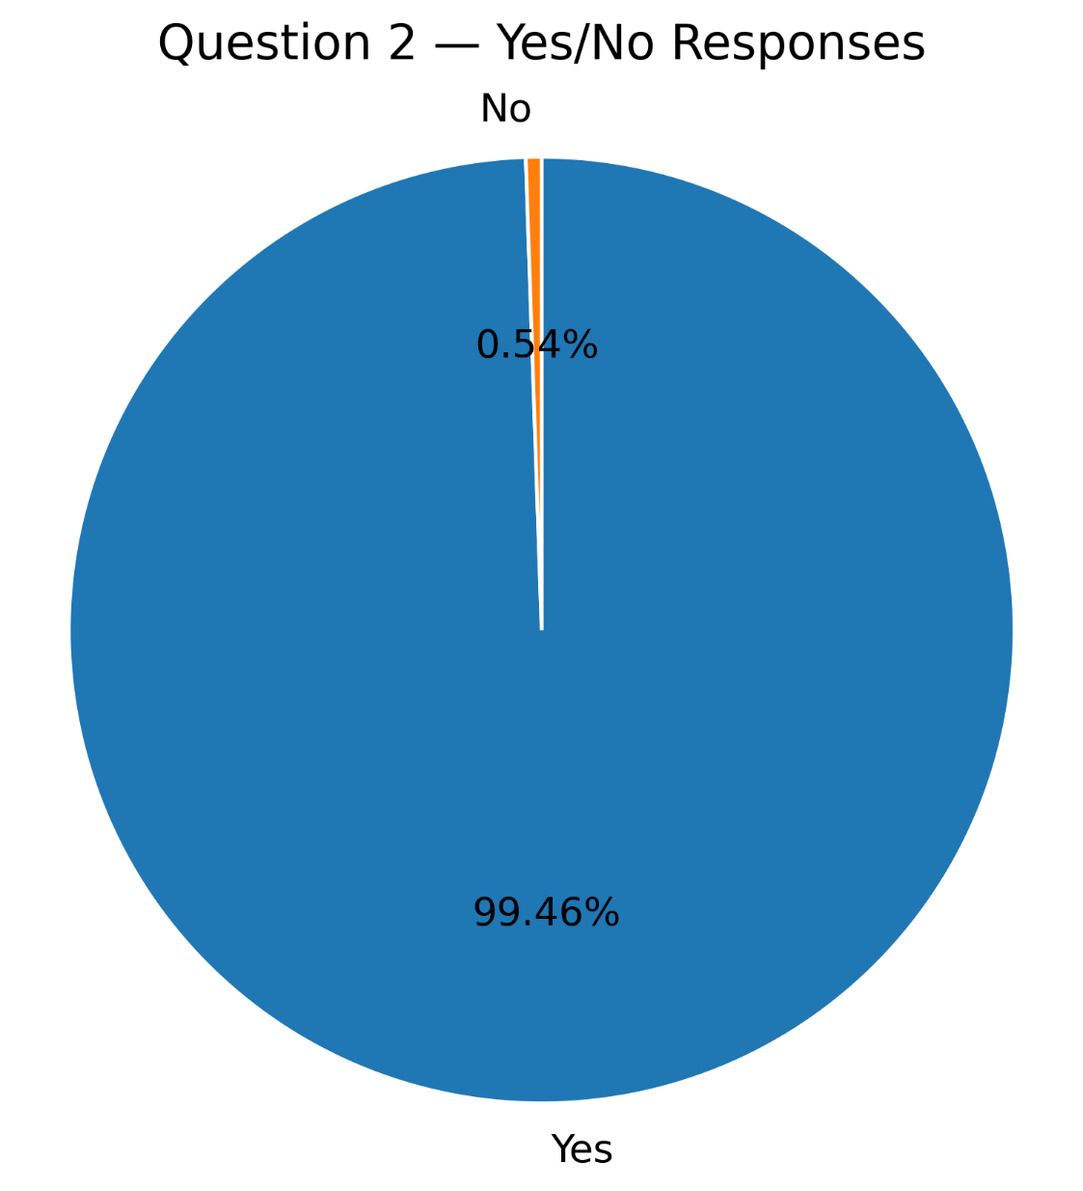
For this Yes/No response item, 185 respondents answered Yes, representing 99.46%, while 1 respondent answered No, representing 0.54%. This indicates a strongly positive response to the Yes/No item included in the evaluation.

Question 3
YES/NO RESPONSE
Response | Frequency | Percentage
Yes | 186 | 100.00%
No | 0 | 0.00%
Total | 186 | 100.00%
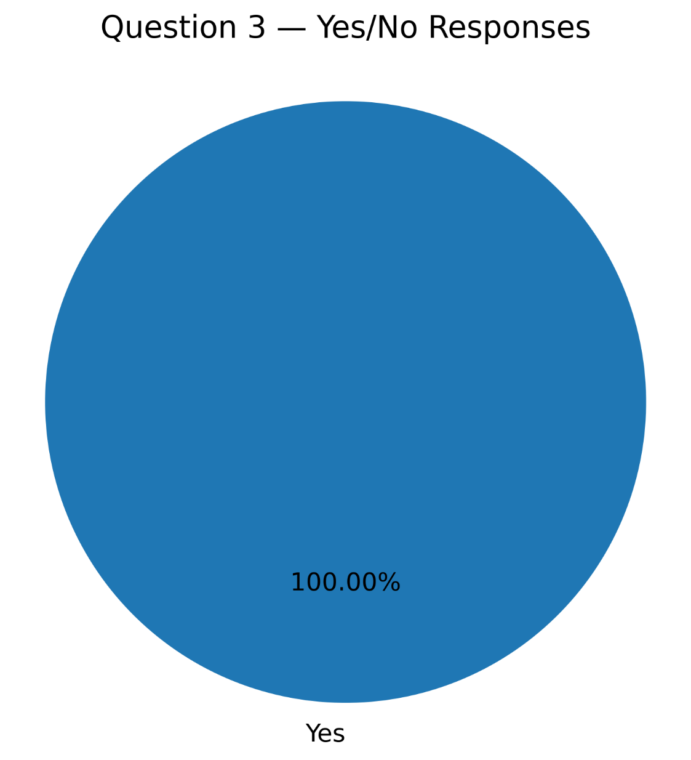
For this Yes/No response item, 186 respondents answered Yes, representing 100.00%, while 0 respondents answered No, representing 0.00%. This indicates a strongly positive response to the Yes/No item included in the evaluation.

Question 4
YES/NO RESPONSE
Response | Frequency | Percentage
Yes | 186 | 100.00%
No | 0 | 0.00%
Total | 186 | 100.00%
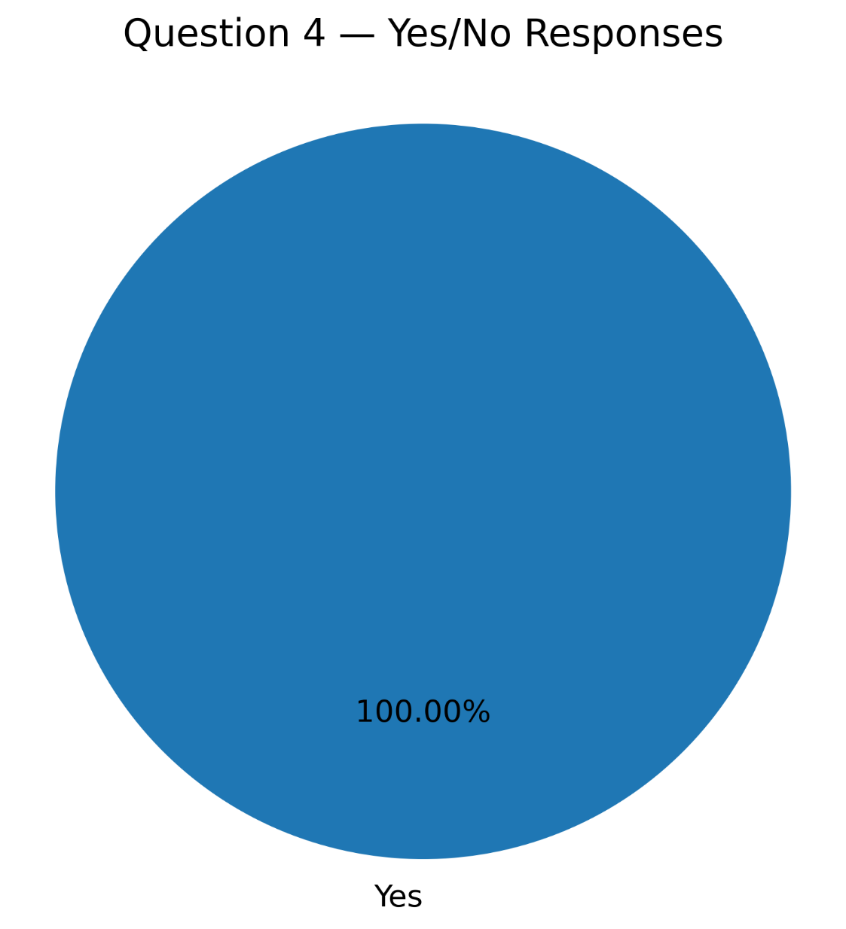
For this Yes/No response item, 186 respondents answered Yes, representing 100.00%, while 0 respondents answered No, representing 0.00%. This indicates a strongly positive response to the Yes/No item included in the evaluation.

Question 5
YES/NO RESPONSE
Response | Frequency | Percentage
Yes | 185 | 99.46%
No | 1 | 0.54%
Total | 186 | 100.00%
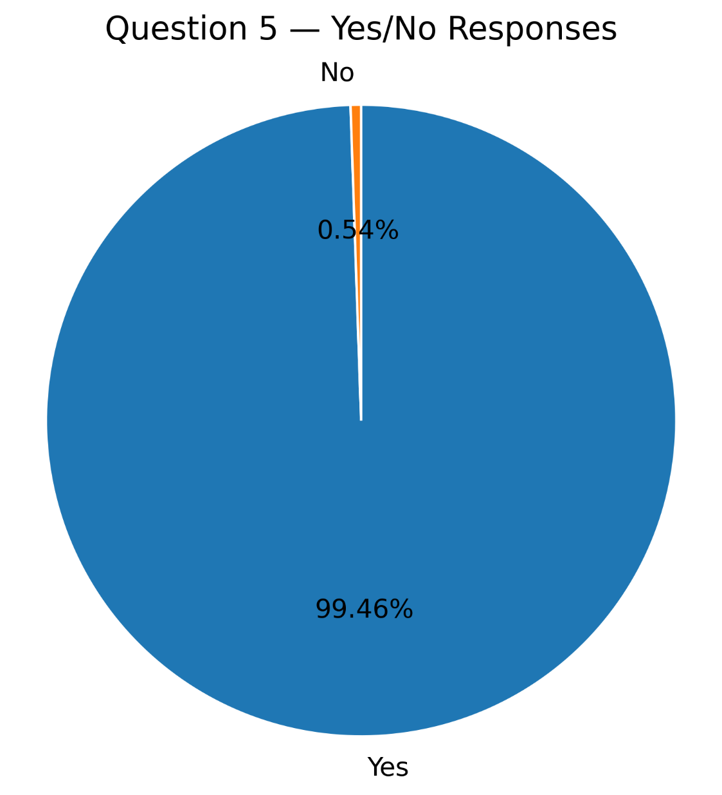
For this Yes/No response item, 185 respondents answered Yes, representing 99.46%, while 1 respondent answered No, representing 0.54%. This indicates a strongly positive response to the Yes/No item included in the evaluation.

Datamex College Of Saint Adeline Parañaque
8167- Datamex compound Dr. A. Santos
Avenue Sucat Parañaque City

CHAPTER V: SUMMARY, CONCLUSIONS, AND RECOMMENDATIONS

5.1 Summary of Findings
This study focused on the development of an Inventory Management and Online Ordering System for Eskinita Apparel. The proposed system was developed to address the limitations of the existing manual processes, particularly in inventory monitoring, product management, order processing, and the recording of business transactions. The study aimed to provide a computerized system that could improve operational efficiency, inventory accuracy, and customer accessibility.
A total of 200 respondents participated in the evaluation of the proposed system. The respondents evaluated the system based on its interface, ordering process, inventory functions, product availability management, reliability, usefulness, and willingness to use the system. Frequency, percentage, and weighted mean were used to organize and interpret the gathered data.
The findings regarding the system interface showed that the respondents generally had a favorable perception of the proposed website. For the statement regarding the clarity and ease of understanding of the interface, 60% strongly agreed, 32.5% agreed, and 7.5% were neutral. In terms of the organization of the website design and layout, 55% strongly agreed, 36% agreed, and 9% were neutral. Furthermore, 52.5% strongly agreed, 39% agreed, and 8.5% were neutral that the navigation menu was easy to follow. These results indicate that the proposed interface was generally perceived as clear, organized, and easy to navigate.
For the system and inventory functions, the results were also generally positive. Regarding the simplicity and understandability of the ordering process, 57.5% strongly agreed, 35% agreed, and 7.5% were neutral. For the system's ability to record customer orders accurately, 57.5% strongly agreed, 37.5% agreed, and 5% were neutral. Meanwhile, 50% strongly agreed, 41% agreed, and 9% were neutral that the system could effectively track product stock. For the management of product availability, 49% strongly agreed, 42% agreed, and 9% were neutral. No respondents selected Disagree or Strongly Disagree for these items.
The overall evaluation of the proposed system likewise produced favorable results. For the usefulness of the system in managing an online clothing business, 52.5% strongly agreed, 39% agreed, and 8.5% were neutral. Regarding the reliability of the system in handling product orders, 50% strongly agreed, 41% agreed, and 9% were neutral. In addition, 55% strongly agreed, 36.5% agreed, and 8.5% were neutral that they would consider using the system if it were available.
The Yes/No response item further supported the positive assessment of the proposed system. All 200 respondents, or 100%, answered Yes, while no respondent answered No. This result indicates a completely positive response to the particular Yes/No item included in the questionnaire.
Overall, the findings indicate that the proposed Inventory Management and Online Ordering System was favorably evaluated by the respondents. The results suggest that the system has the potential to support Eskinita Apparel in improving inventory management, product tracking, order processing, and online business operations.

5.2 Conclusions
Based on the findings of the study, the researchers conclude that the proposed Inventory Management and Online Ordering System for Eskinita Apparel is a suitable technological solution to the operational challenges identified in the study.
First, the proposed system can provide a more organized approach to inventory management. The positive responses regarding product stock tracking and product availability indicate that the system can assist the business in monitoring available products and maintaining more accurate inventory records. This can help reduce the difficulties associated with manual inventory recording.
Second, the proposed system can improve the online ordering process of Eskinita Apparel. The majority of respondents agreed or strongly agreed that the ordering process was simple and easy to understand. The positive assessment of the system's ability to record customer orders also indicates that the proposed ordering function can support more systematic transaction processing.
Third, the results demonstrate that the user interface and navigation of the proposed system were generally acceptable to the respondents. The high percentage of positive responses regarding the clarity, organization, and navigation of the website suggests that the system provides an interface that users can understand and navigate with relative ease.
Fourth, the overall evaluation indicates that the system is perceived as useful and reliable for an online clothing business. The majority of respondents expressed positive perceptions regarding the system's usefulness in managing an online clothing business and its reliability in handling product orders. The willingness of respondents to consider using the system further indicates its potential acceptability among intended users.
Finally, the study concludes that the proposed system can contribute to the digitalization of Eskinita Apparel's business operations. By providing centralized management of products, inventory, and orders, the system can help reduce dependence on manual processes and provide customers with a more accessible online ordering platform. However, the findings represent the evaluation conducted within the scope of this study and should not be interpreted as evidence that the system completely eliminates all operational challenges.

5.3 Recommendations
Based on the findings and conclusions of the study, the researchers recommend the following improvements and future enhancements for the proposed Inventory Management and Online Ordering System for Eskinita Apparel:
Implementation of Online Payment Integration.
Future versions of the system may include secure online payment options to provide customers with a more convenient and complete online purchasing experience. This feature was outside the current scope of the system.
Integration of Delivery and Order Tracking.
A delivery tracking feature may be incorporated in future development to allow customers to monitor the status of their orders from confirmation until delivery.
Enhanced Inventory Reporting.
The system may be enhanced with detailed inventory reports, low-stock notifications, sales summaries, and other analytical tools to provide the business owner with better information for inventory and business decisions.
Improved Security Features.
Additional security measures may be implemented to protect customer information, product records, order details, and administrative data. User authentication and access control may also be strengthened in future versions.
Mobile Responsiveness and Mobile Application Development.
Future researchers may improve the system's mobile responsiveness or develop a dedicated mobile application to provide customers and administrators with easier access using smartphones and other mobile devices.
Continuous User Feedback and System Improvement.
The business owner and customers should continue providing feedback after implementation. Their feedback may be used to identify usability issues, additional requirements, and possible improvements to the system.
Expansion of System Testing.
Future studies may conduct additional testing with a wider and more diverse group of users within the defined research scope. This may provide further information regarding the system's usability, reliability, performance, and overall acceptability.
Future Enhancement of Sales and Business Analytics.
Future developers may incorporate more advanced sales analytics and reporting features. These may help the business owner identify product demand, monitor sales performance, and support data-driven business decisions.

5.4 Final Statement
The development of the Inventory Management and Online Ordering System for Eskinita Apparel demonstrates how information technology can be applied to improve the management of a local clothing business. The positive evaluation from the 200 respondents indicates that the proposed system was generally viewed as clear, useful, reliable, and acceptable. The system provides a foundation for improving inventory monitoring, product management, order processing, and customer accessibility.
Although the proposed system addresses several of the operational concerns identified in the study, continuous improvement remains important. Future enhancements may expand its capabilities through payment integration, delivery tracking, stronger security, advanced reporting, and improved mobile accessibility. Through continuous evaluation and development, the system may further support Eskinita Apparel in adopting more efficient and technology-driven business operations.

