Rachel Martin

Coursera Data Science Capstone

June 15, 2020

Battle of the Neighborhoods: Placement for a Coffee Roasting Company

Introduction

An entrepreneur is interested in opening a coffee roasting company. Based on the popularity of New York’s Times Square as an attraction for tourists and locals alike, she would like to open her business there. She is concerned about the number of coffee roasters already in the area and would like to open her shop close to Times Square but not near other roasters.

Data

The data that will be used in this study is from Foursquare’s API for venues. I will use the search query “Coffee Roasters” to determine the twenty closest coffee roasters to Times Square within one kilometer.

Methodology

Using the search query “Coffee Roasters”, I have a list of the twenty closest roasters or coffee shops near Times Square based on the coordinates located with the geolocator function. I then restructured the data so that only the list of venues and their coordinates were displayed. Using this information, I plotted the venues using the function Map function from the folium package.

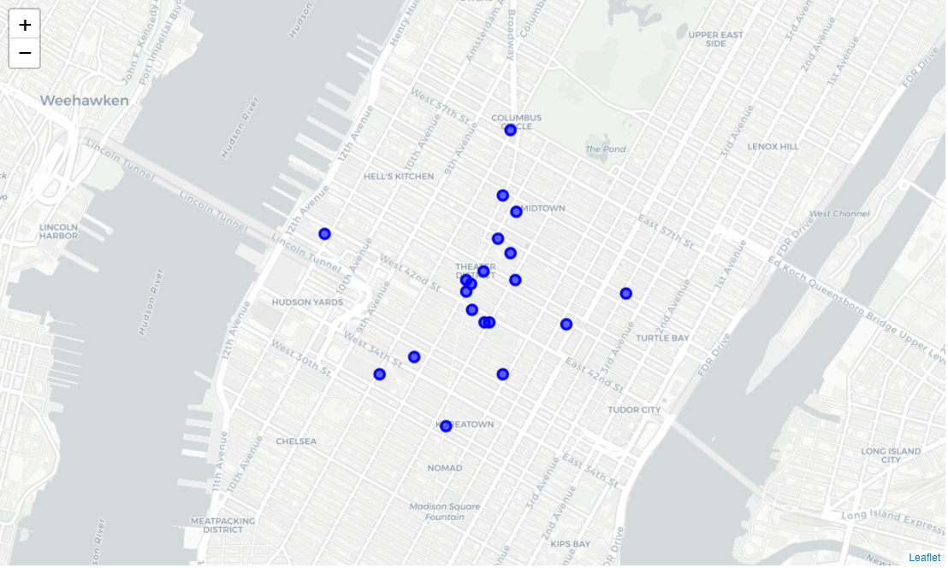

After plotting the venues, I wanted to compare their locations. Using the kmeans function, I used k-means clustering to cluster the coffee companies.

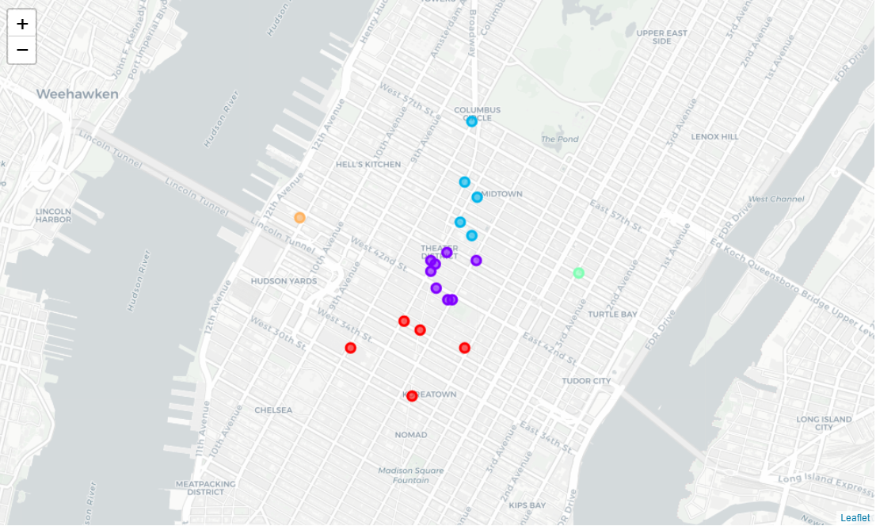

Zooming in on Times Square reveals the cluster identified by the purple circles.

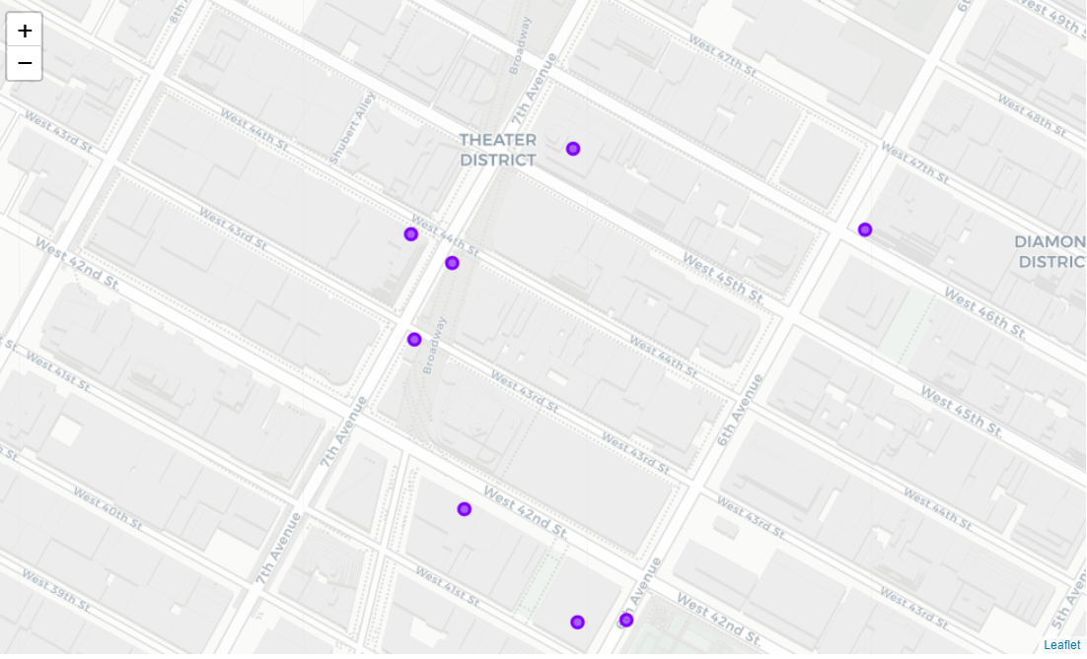

Results

The roasters nearest Times Square belong to Cluster 2. There appears to only be one roaster within the boundaries of Times Square, which is the intersection of West 42nd Street, 7th Avenue, and Broadway. Just southwest of Times Square is another roaster.

Discussion

Given that Broadway is lined with theatres, it is in my client’s best interest to open a coffee roasting company on 7th Avenue. Due to the popularity of this roadway and the foot traffic on this roadway, I predict she will obtain many customers. The midpoint between West 43rd and West 44th is the best location nearest Times Square, as it is not too close to the other two roasters.

Conclusion

I was able to find a location suitable for a coffee roasting company in Times Square for my client. I did come across a couple issues in my project. One, some of the results for my search query returned coffee shops that I did not feel met the definition of my market. Two, I did not have market data to assess the popularity of coffee roasters in New York. It may be that tourists do not care to buy coffee beans from a roaster. However, I was still able to make a recommendation for my client.