46 Hyperlink based propagation: weighted in-link
42 Sitemap based score propagation
25 BM25 of whole document

These are the top 3 most important features- linking having such a high importance may explain the misranking in our particular example.

Our incorrectly ranked relevant document has 46 at a complete 0. (QID 442)

42 - Higher on relevant document
25 - Higher on relevant document

initial value of 0.0:
54.28643679883913
30.590034964549837

Tested against max (1.0)
1.0:
54.28643679883913
41.181012569702446

10 test values generated and the scores they produced:
.805588 = 34.514882407853975
.500441 = 34.514882407853975
.230744 = 34.514882407853975
.946652 = 39.444642401639356
.727244 = 34.514882407853975
.101303 = 34.514882407853975
.551493 = 34.514882407853975
.272242 = 34.514882407853975
.364503 = 34.514882407853975
.007918 = 30.590034964549837

Considerably larger values (around +0.9) have an impact on the scores.
Small values close to the 0 don't have an impact.
Middling values seem to have the same impact.

Regardless, the changes made here have not switched the ranking with the incorrectly ranked document - which had a high value for feature 46 : 0.980352

This strong score clearly has a great impact combined with other features (lower down the list of importance, as the other in the "top 3" important features have higher values in the relevant document than the irrelavant document.
Just to see how important this was, I set this to 0.000000 and got the score: 10.132504235047557 which is lower than the relevant document with 0.000000. Should instead have been altering the feature in the irrelevant document.
Having recorded the values from the test on the relevant document, tested again on the irrelavant document

.805588 = 13.948531964050149
.500441 = 13.728403830486146
.230744 = 13.728403830486146
.946652 = 47.77603534335295
.727244 = 13.948531964050149
.101303 = 13.728403830486146
.551493 = 13.728403830486146
.272242 = 13.728403830486146
.364503 = 13.728403830486146
.007918 = 10.132504235047557

This follows a similar pattern to the other document. Only a high values (0.9+) seems to have a high enough impact on the irrelevant document to rank it above the relevant document- with a low or middling value there is no misrank.

Selected values between .805588 and 1.0 tested to determine the value which causes this switch:
.868692 = 18.071298124433163
.915593 = 24.024636811651803 (Not boundary crossing yet)
.926833 = 29.222891421700787 (very close)
.933742 = 31.614622839777944 (boundary crossed)
.941844 = 38.616557478072274 (crosses)

So far have determined that the value which the feature Hyperlink based propagation: weighted in-link needs to be on the irrelevant document is somewhere between .926833 and .933744.

Tests in this range:
0.929442 = 31.614622
0.92875 = 31.614622
0.927667 = 29.222891
0.928253 = 31.614622
0.927738 = 29.222891
0.928437 = 31.614622
0.9283 = 31.614622
0.9281 = 29.18889
0.928215 = 29.188891
0.928216 =29.188891

0.928217 = 31.614622

0.926217 is the point where the switch happens.

Realised I got graphs types completely wrong and I think I want a scatter chart not a line graph.

Graph for feature value between 0-1
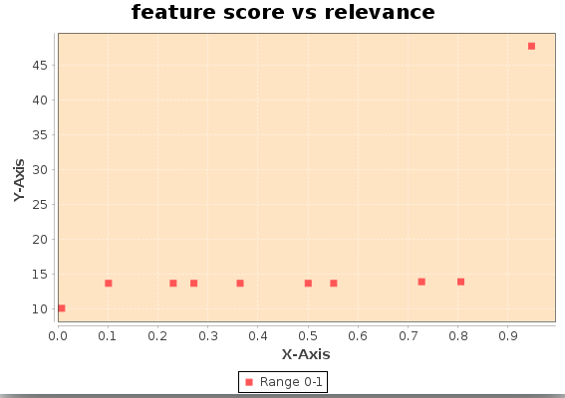

Graph for feature score between 0.8 and 1.0
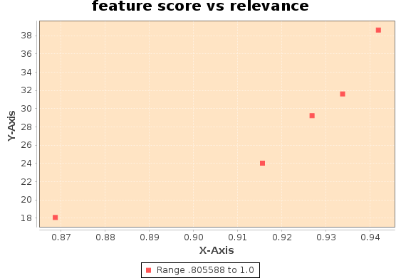

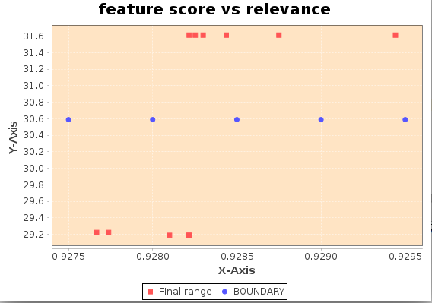
Graph for final range (0.9275 and 0.9295) with blue dots indicating relevant documents score

Issue with automating this – Ensemble with “SplitFeatures” higher than 1 creates an index out of bounds error. I am not sure what the cause of this is.

