# Lab 4 – Responsive App

In this lab, you will be using;

* Bootstrap
* Media Queries
* Angular
* AJAX

Create fully responsive web app using Twitter's REST API..

Check out: <https://dev.twitter.com/rest/public>

Grid Layouts using Bootstrap.

Twitter use OAuth to authenticate calls to the API before retrieving data. You will have to register for tokens with twitter:

<https://dev.twitter.com/oauth/overview/application-owner-access-tokens>

2 PHP files are provided to simplify calling the API, you need to set your tokens in get_tweets.php and make the AJAX from your page to get_tweets.php which in turn calls the Twitter API for you using TwitterAPIExchange.php.

Process data back from the AJAX call to the API using Angular.

The app should be responsive and use media queries in order to se the appropriate grid layout in Bootstrap (Note this is not normally necessary in real life as Bootstrap is inherently responsive)

for the purposes of this lab, however use a media query to set the grids to md or other based on desktop or mobile) extensive media querying is not necessary

Viewing in the desktop/smartphone can be emulated by resizing the browser window, or changing the display properties in Google Dev Tools.

You will be graded on the following;

Objective 1 - API : 10

Objective 1 – Bootstrap : 10

Objective 2 – Angular : 10

Creativity/Coding style : 10

Doc/README.md : 10

Example Implementation:

Desktop mode

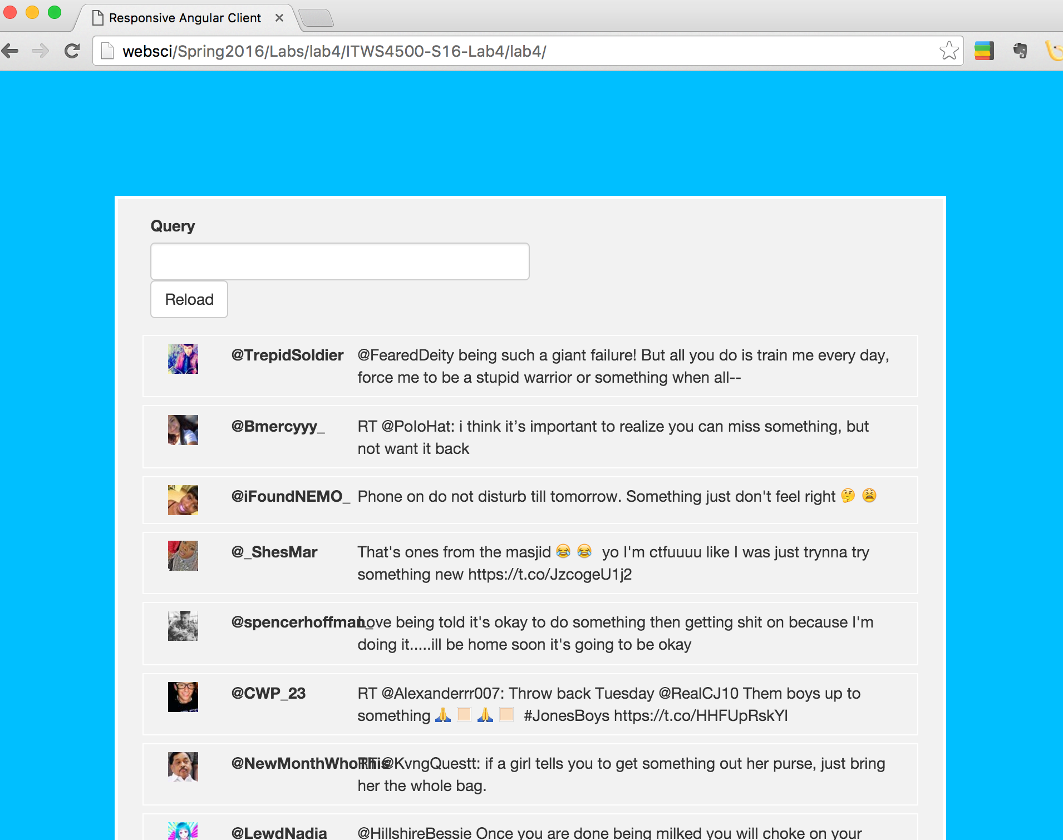

Mobile mode

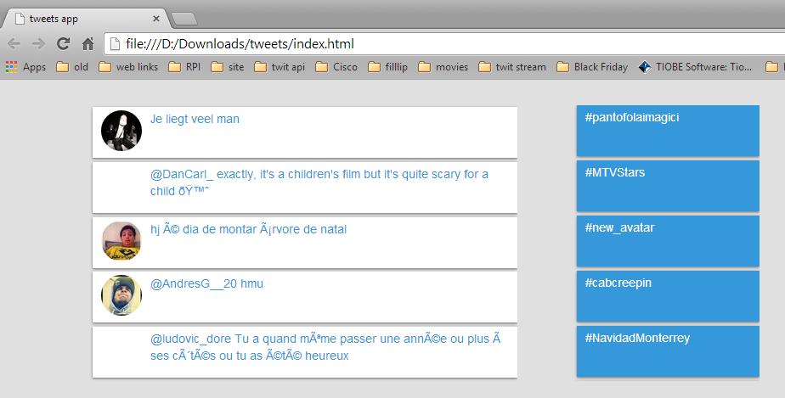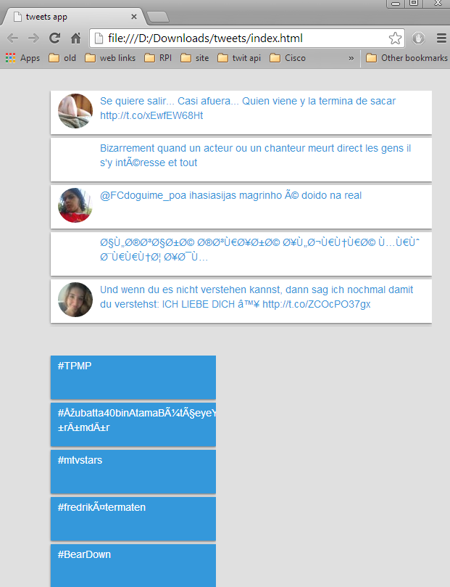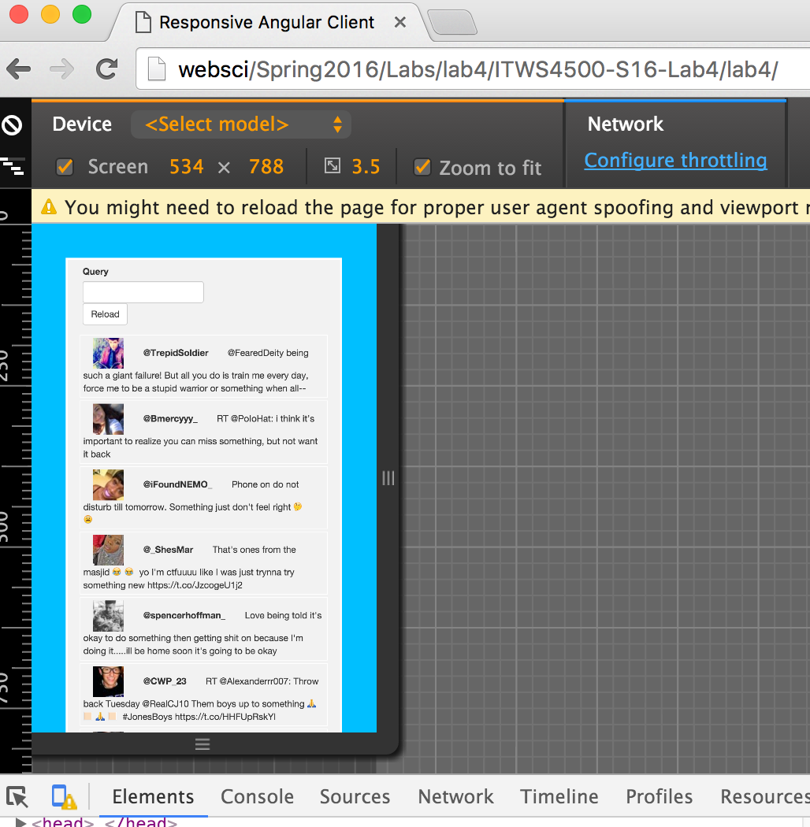

Example for responsive design:

Open <http://www.behance.net/> and resize the browser window manually to see different layouts for desktop, tablet and smartphone

Desktop

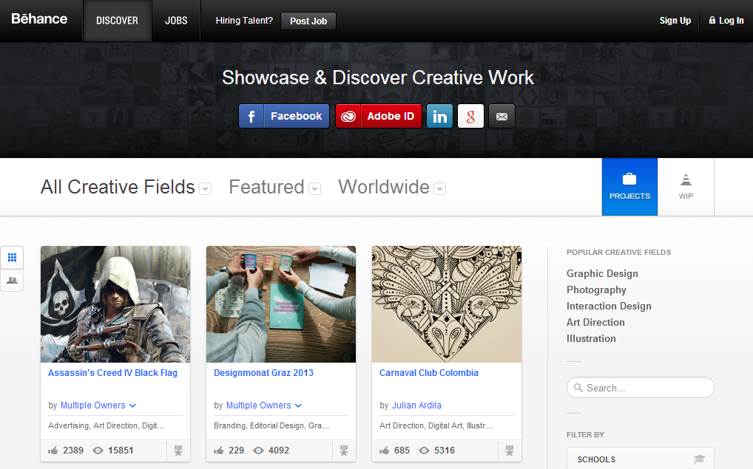

Tablet

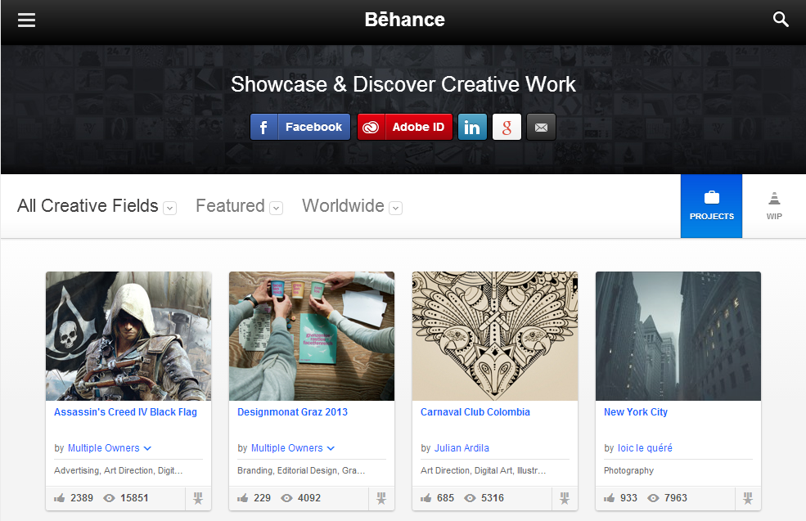

Smartphone

