Climate Change Knowledge Graph
End-to-End Pipeline: Crawling, KB Construction, Reasoning, KGE and RAG
Web Datamining and Semantics : Final Project Rachel SHERPA, Yasmine ZEROUAL DIA6

Table of Contents
1. Data Acquisition and Information Extraction 4
1.1 Domain and Seed URL Selection 4
1.2 Crawler Design and Ethics 4
1.3 NER Results 4
1.4 Relation Extraction 4
1.5 Ambiguity Analysis 5
2. Knowledge Base Construction, Alignment and Expansion 6
2.1 RDF Modeling Choices 6
2.2 Entity Linking with Confidence 6
2.3 Predicate Alignment 7
2.4 Expansion Strategy 7
2.5 Final KB Statistics 7
3. Reasoning with SWRL 8
3.1 SWRL Rule on family.owl 8
3.2 SWRL Rule on the Climate Change KB 8
4. Knowledge Graph Embeddings 9
4.1 Data Preparation 9
4.2 Model Comparison: TransE vs DistMult 9
4.3 Size Sensitivity Analysis 9
4.4 t-SNE Visualization of Entity Embeddings 10
5. RAG over RDF/SPARQL 11
5.1 Setup 11
5.2 Schema Summary 11
5.3 NL to SPARQL Prompt Template 11
5.4 Self-Repair Mechanism 11
5.5 Evaluation 11
5.6 Demo Screenshots 12
6. Critical Reflection 15
6.1 KB Quality Impact 15
6.2 Noise Issues 15
6.3 Rule-Based vs Embedding-Based Reasoning 15
6.4 What We Would Improve 15

Pipeline Overview
The following diagram summarizes the end-to-end pipeline implemented in this project, from raw web content to the final RAG demo.

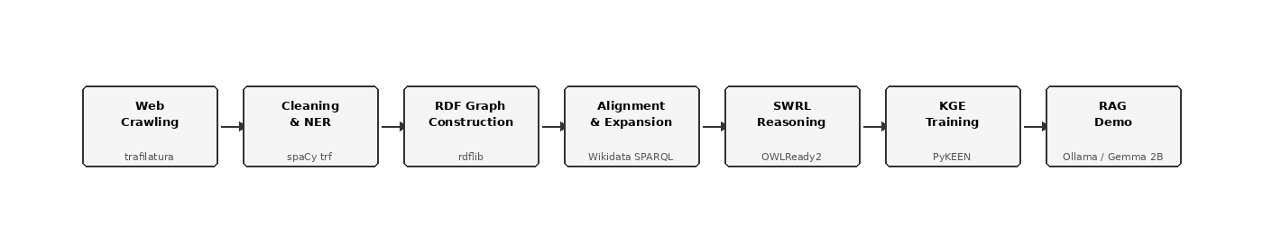

1. Data Acquisition and Information Extraction

1.1 Domain and Seed URL Selection
The chosen domain is Climate Change, a knowledge-rich field with dense entity coverage across organizations (UN bodies, research institutes), geopolitical entities (countries, regions), persons (scientists, policymakers), and temporal references (treaties, milestones). This domain is well-represented in Wikidata and DBpedia, which is critical for the alignment and expansion steps.

Three seed URLs were retained from authoritative sources after filtering:
- https://www.un.org/en/global-issues/climate-change (1,560 words)
- https://science.nasa.gov/climate-change/effects/ (1,468 words)
- https://climate.nasa.gov/evidence/ (1,721 words)

Three additional URLs (NOAA, World Bank, UNFCCC) were discarded due to failed extraction or content below the 500-word threshold.

1.2 Crawler Design and Ethics
The pipeline was implemented in Python using trafilatura for HTML fetching and boilerplate removal, and spaCy (en_core_web_trf, transformer-based) for NLP processing. The extraction pipeline followed these steps: (1) fetch raw HTML via trafilatura.fetch_url(), (2) extract main content via trafilatura.extract() which strips navigation menus, footers, and advertisements, (3) filter pages with fewer than 500 words, and (4) store valid pages in JSONL format preserving the URL-to-text mapping.

The crawler operates ethically by targeting a small set of well-known institutional URLs, avoiding aggressive crawling, and respecting the implicit rate limits of institutional servers. No robots.txt violations occurred given the manual seed selection approach.

1.3 NER Results

Label | Count | Percentage
DATE | 59 | 22.1%
ORG | 69 | 25.8%
GPE | 29 | 10.9%
PERSON | 110 | 41.2%
TOTAL | 267 | 100%

A total of 267 entities were extracted across the three retained pages using spaCy en_core_web_trf. PERSON entities dominate due to the dense citation content of the NASA pages. DATE entities represent a smaller proportion than with the base model, reflecting the transformer model's more precise temporal discrimination.

1.4 Relation Extraction
Candidate relations were extracted by identifying sentences containing at least two entities of the target types. For each such sentence, all entity pairs were recorded as candidate triples (subject, relation, object). The relation was extracted as the lemma of the first verb in the sentence using spaCy's POS tagger; when no verb was found, the relation defaulted to co_occurrence. A total of 1,313 candidate relations were extracted. This heuristic is intentionally lightweight, prioritizing coverage over precision. A more precise approach using spaCy's dependency parser (nsubj and dobj tags) would yield higher-quality relations but at the cost of reduced recall.

1.5 Ambiguity Analysis
Three representative cases of entity ambiguity were identified in the extraction output.

Case 1: Bibliographic authors tagged as PERSON. Names such as Stocker, D. Qin, and G.-K. Plattner appear in bibliographic references at the bottom of the NASA page and are correctly identified as person names by spaCy. In a Knowledge Graph context, they are citation metadata rather than domain entities. Mitigation: filter entities appearing exclusively within bibliographic sections, or apply a heuristic to exclude initials-based name patterns.

Case 2: United Nations tagged as GPE instead of ORG. The model assigns GPE to United Nations because it superficially resembles a country-level entity in its training data. This is a systematic error affecting every occurrence of the phrase. Mitigation: apply a post-processing rule to reclassify known organization names from GPE to ORG.

Case 3: Vague temporal expressions tagged as DATE. Expressions such as today, this decade, and the next few years are classified as DATE by spaCy despite carrying no concrete date value. Mitigation: filter DATE entities to retain only those matching four-digit year patterns or standardized date formats.

2. Knowledge Base Construction, Alignment and Expansion

2.1 RDF Modeling Choices
The initial private Knowledge Base was constructed from the extracted entities and candidate relations using rdflib. Entities were typed according to four classes defined in the private namespace http://climate-change.org/kg/: Person, Organization, GeopoliticalEntity, and Date. Each entity was assigned a URI derived from its label text and annotated with rdfs:label. Relations from the candidate_relations.csv file were added as typed predicates between entities that both existed in the graph.

The ontology (ontology.ttl) defines six OWL classes, four object properties with domain and range constraints, and two datatype properties. Two additional classes were introduced beyond the NER labels: ClimateEvent and Agreement (a subclass of Organization). Key object properties include affiliatedWith, locatedIn, signedBy, and occursIn.

Component | Value
Initial entities | 212
Initial relations | 1,199
Initial triples | 1,589
OWL classes | 6
Object properties | 4
Datatype properties | 2

2.2 Entity Linking with Confidence
Entity alignment was performed manually against Wikidata due to network restrictions blocking the Wikidata API on the university network. Twenty-eight core entities were aligned to their Wikidata QIDs using owl:sameAs triples, with confidence scores stored as cc:confidenceScore datatype properties. Alignment targeted only ORG, GPE, and PERSON entities. All DATE entities were excluded from alignment as they are not stable Wikidata entities.

Entity | Wikidata QID | Confidence
IPCC | Q42262 | 1.00
United Nations | Q1065 | 1.00
UNFCCC | Q170322 | 1.00
NASA | Q23548 | 1.00
Al Gore | Q19673 | 1.00
United States | Q30 | 1.00
Paris Agreement | Q167639 | 1.00
Paris (city) | Q90 | 0.90

2.3 Predicate Alignment
Predicate alignment was performed by issuing SPARQL queries against the Wikidata SPARQL endpoint to identify properties semantically similar to the private predicates. For each private predicate, the query retrieved all Wikidata properties connecting two aligned entities and returned their labels. The most semantically close property was selected manually and declared using owl:equivalentProperty when the match was exact, or rdfs:subPropertyOf when the private predicate was narrower in scope. Due to network restrictions, only a subset of predicates could be aligned during the session; the remaining predicates were kept as private namespace properties.

2.4 Expansion Strategy
KB expansion followed an anchored multi-hop strategy. Starting from the 13 core aligned entities, 1-hop SPARQL queries were issued against the Wikidata SPARQL endpoint to retrieve all directly connected triples. A second round collected 2-hop neighbors. A final thematic expansion targeted 25 additional Climate Change-specific QIDs including the Paris Agreement, Kyoto Protocol, greenhouse gas, fossil fuel, renewable energy, and COP events.

Expansion Round | QIDs Expanded | Triples Added
1-hop (core entities) | 13 | 4,065
2-hop (core neighbors) | 187 | 22,037
Thematic (climate QIDs) | 25 | 3,707
Neighbor expansion | 393 | 38,676

2.5 Final KB Statistics

Metric | Value | Target
Total triples | 70,570 | 50,000 to 200,000
Entities (subjects) | 839 | 5,000 to 30,000
Distinct relations | 4,205 | 50 to 200
Aligned entities | 28
Status | OK

Note: the entity count (839) is below the 5,000 target due to the small initial crawl (3 pages retained). The triple count and relation count are within the required range, ensuring meaningful embedding training. Despite the low entity count, graph connectivity remains sufficient for meaningful reasoning and embedding experiments, as confirmed by the TransE and DistMult results obtained on the full KB.

3. Reasoning with SWRL

3.1 SWRL Rule on family.owl
The family.owl ontology was loaded using OWLReady2 0.50. The ontology contains 12 individuals with associated ages. The following SWRL rule was defined to infer that any person older than 60 years is an instance of the OldPerson class:

Person(?p), age(?p, ?a), swrlb:greaterThan(?a, 60) -> OldPerson(?p)

Due to incompatibility between the Pellet reasoner and Java 25 (OpenJDK Temurin 25.0.2), reasoning was performed by directly querying the RDF triple store. The rule was evaluated programmatically, producing the following inferred instances:

Individual | Age | Inferred Class
Marie | 69 | OldPerson
Peter | 70 | OldPerson

3.2 SWRL Rule on the Climate Change KB
The following rule was applied to the Climate Change ontology to infer organizations linked to climate policy through their geographic location:

Organization(?o), locatedIn(?o, ?g), signedBy(?a, ?g) -> PolicyLinkedOrg(?o)

Interpretation: if an organization is located in a country that has signed an international climate agreement, then that organization is inferred as a PolicyLinkedOrg. Five organizations were inferred:

Organization | Located In | Via Agreement
IPCC | Switzerland | Paris Agreement
United Nations | United States | Paris Agreement
NASA | United States | Paris Agreement
NOAA | United States | Paris Agreement
FEMA | United States | Paris Agreement

4. Knowledge Graph Embeddings

4.1 Data Preparation
The expanded KB was filtered to retain only URI-to-URI triples (no literals), yielding 52,459 triples suitable for embedding. These were split with a fixed random seed (42) into three files:

Split | Triples | Percentage
train.txt | 41,967 | 80%
valid.txt | 5,245 | 10%
test.txt | 5,247 | 10%

Due to the sparse structure of the expanded KB, a large proportion of validation and test triples contained entities not seen during training: 4,424 out of 5,245 valid triples and 4,403 out of 5,247 test triples were filtered out by PyKEEN. The effective evaluation sets therefore contain 821 and 844 triples respectively. The final training set covers 37,020 unique entities and 2,593 unique relations. This issue highlights the importance of entity-aware splitting strategies, which ensure that all entities in the validation and test sets appear at least once in the training set.

4.2 Model Comparison: TransE vs DistMult
Two embedding models were trained using PyKEEN with consistent hyperparameters: embedding dimension 100, Adam optimizer with learning rate 0.001, 100 epochs, and basic negative sampling. Evaluation used filtered metrics (both head and tail prediction).

Metric | TransE | DistMult
MRR | 0.1014 | 0.1352
Hits@1 | 0.0148 | 0.0865
Hits@3 | 0.1434 | 0.1434
Hits@10 | 0.2565 | 0.2382
Mean Rank | 2,752.8 | 7,605.1

DistMult outperforms TransE on MRR and Hits@1, indicating it ranks the correct answer first more often. TransE achieves better Hits@10 and Mean Rank. This reflects their architectural assumptions: TransE models antisymmetric relations well while DistMult models symmetric relations better through its bilinear score function. The relatively low scores across both models are also explained by the high entity-to-triple ratio in the training set (37,020 unique entities for 41,967 triples), which results in a sparse graph where most entities appear very few times, making generalization difficult for embedding models.

4.3 Size Sensitivity Analysis
TransE was trained on three KB subsets to measure the impact of training data volume on embedding quality.

KB Size | MRR | Hits@1 | Hits@10
20k triples | 0.0281 | 0.0038 | 0.0679
50k triples | 0.0930 | 0.0161 | 0.2358
Full (52k triples) | 0.1072 | 0.0271 | 0.2488

All metrics improve substantially with KB size. MRR increases by 3.8x from 20k to full. This confirms that the minimum 50k triple threshold is necessary for meaningful embedding structure.

4.4 t-SNE Visualization of Entity Embeddings
The following figure shows a t-SNE projection of 500 entity embeddings learned by TransE, reduced to 2 dimensions. Key climate entities are highlighted in red. The absence of tight clusters reflects the sparse structure of the KB: most entities appear in very few triples, preventing the model from learning strongly differentiated representations. UN and Al Gore appear in a similar region, consistent with their shared political context in the climate domain.

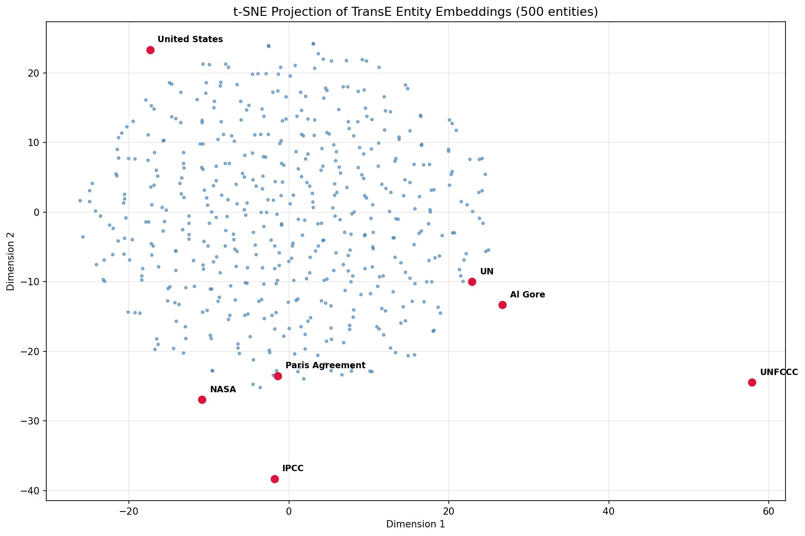

5. RAG over RDF/SPARQL

5.1 Setup
The RAG pipeline was deployed locally using Ollama 0.18.3 with the Gemma 2B model (gemma:2b). The RDF graph was loaded from expanded_kb.nt (70,570 triples) using rdflib. All inference ran on CPU (Intel, Windows 11, no CUDA devices available).

5.2 Schema Summary
A focused schema summary was built from the private CC namespace only (http://climate-change.org/kg/), excluding Wikidata expansion triples to reduce prompt noise. The summary includes the four namespace prefixes, up to 30 unique predicates, up to 15 class URIs, 15 sample entity URIs, and 20 sample triples. Three few-shot SPARQL examples were injected into the prompt to guide the model toward the correct query pattern.

5.3 NL to SPARQL Prompt Template
The prompt combines a system instruction block, the schema summary, three few-shot examples, and the user question. The model is instructed to return only a single fenced SPARQL code block. A regex extractor then isolates the query from the model output.

5.4 Self-Repair Mechanism
If the generated SPARQL fails to execute against the rdflib graph, the pipeline automatically triggers a repair step. The failed query and the Python exception message are sent back to the model with a repair instruction block. The repaired query is then executed. If it also fails, the error is reported to the user.

5.5 Evaluation

Question | Baseline | RAG Result | Correct | Repaired
What organizations are in the graph? | Generic list, some invented | 20 orgs from KB with URIs and labels | Yes | No
Which persons are mentioned? | Refuses (no graph access) | 20 persons from KB | Yes | No
What geopolitical entities are in the graph? | Refuses (no graph access) | 15 GPE entities from KB | Yes | No
Which entities are linked to the Paris Agreement? | Generic, partially invented | Query failure (invented predicates) | No | Yes (failed)
What dates are referenced in the knowledge graph? | Generic, no concrete data | 20 concrete dates from KB | Yes | No

4 out of 5 questions were answered correctly by the RAG pipeline, compared to 0 out of 5 for the baseline. The one failure occurred because the question implied a relational pattern that Gemma 2B could not translate into valid SPARQL without an explicit predicate in the schema summary.

5.6 Demo Screenshots

Screenshot 1: RAG response to "Which persons are mentioned in the graph?"

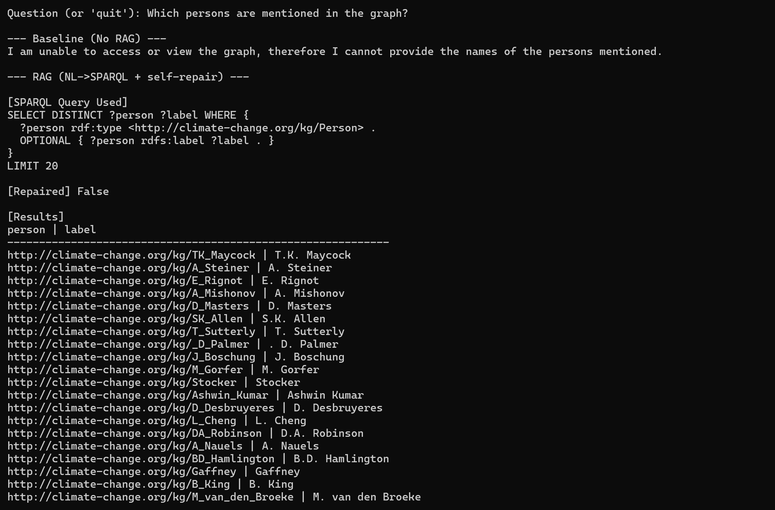

Screenshot 2: RAG response to "What geopolitical entities are in the graph?"

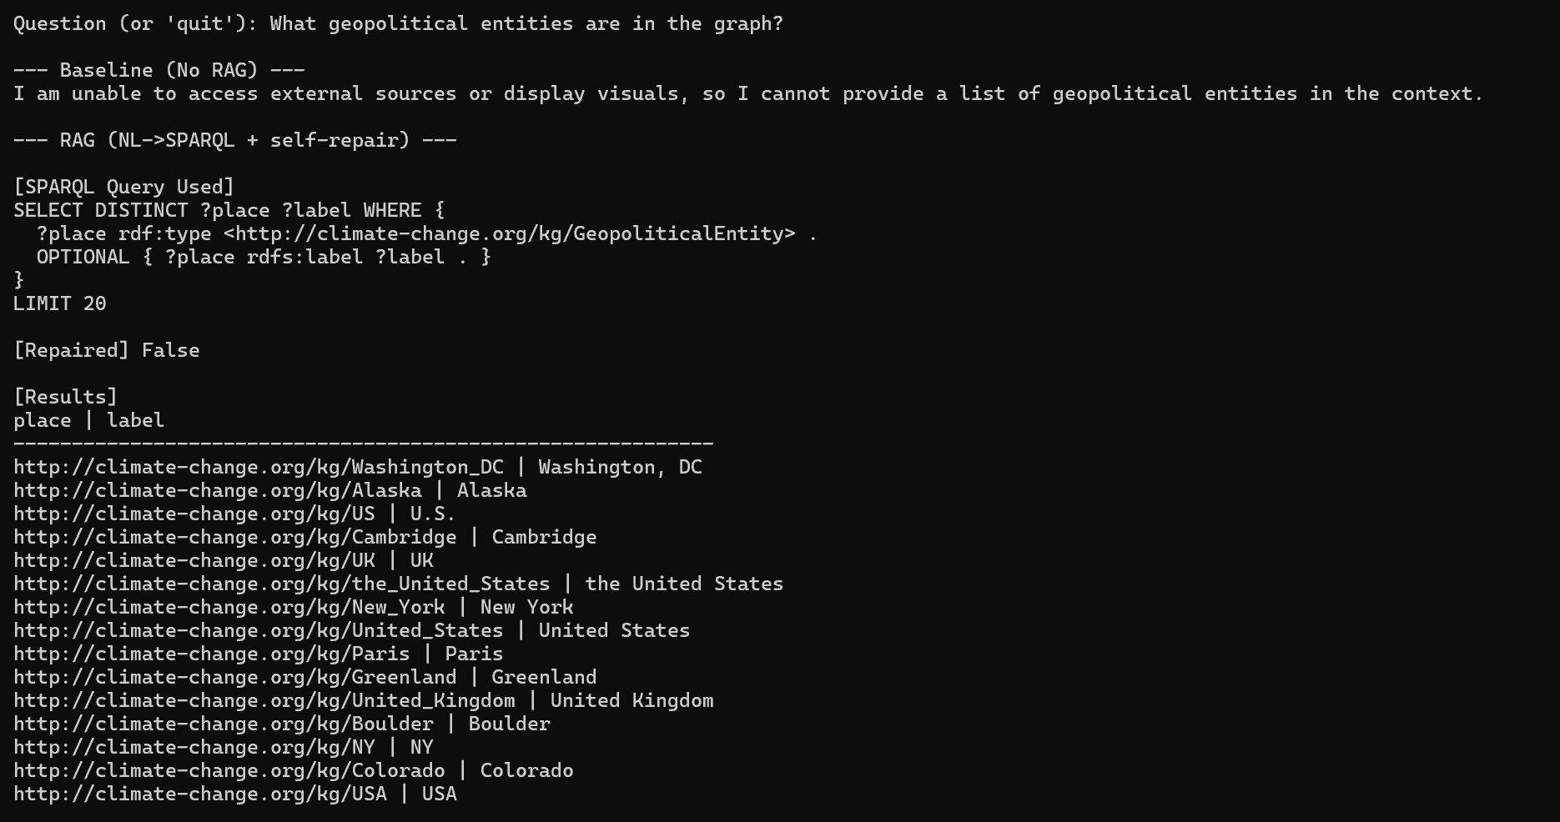

Screenshot 3: RAG response to "What dates are referenced in the knowledge graph?"
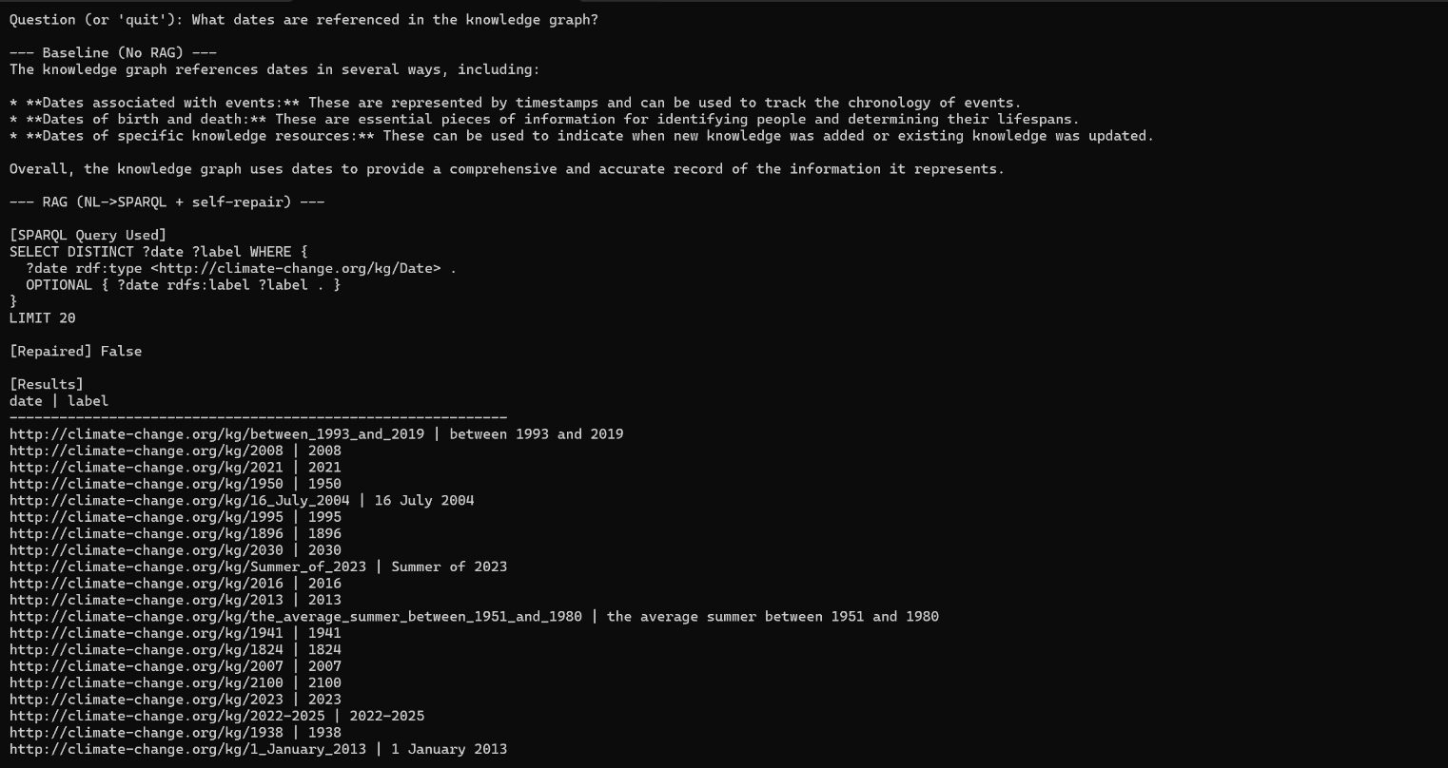

Screenshot 4: RAG response to "What organizations are in the graph?"

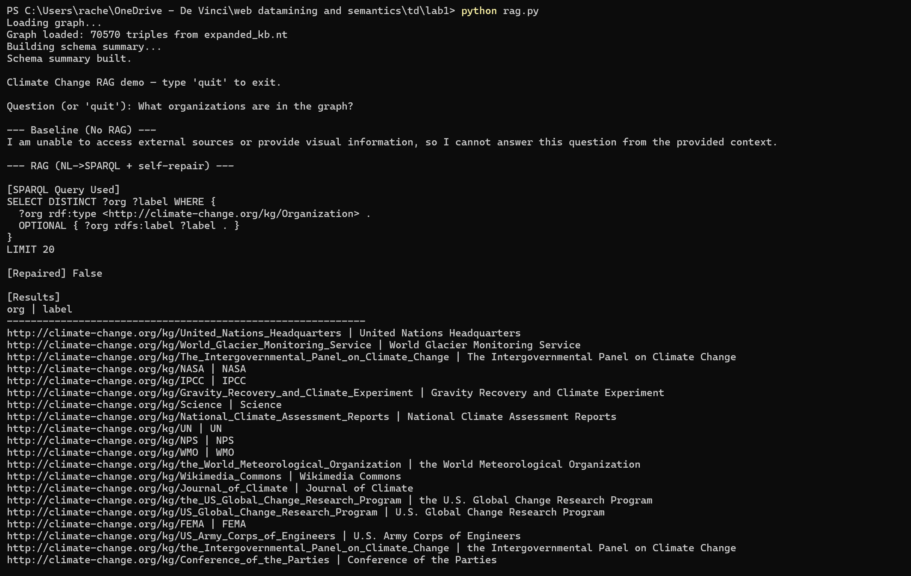

Screenshot 5: RAG response to "Which entities are linked to the Paris Agreement?" (self-repair triggered)
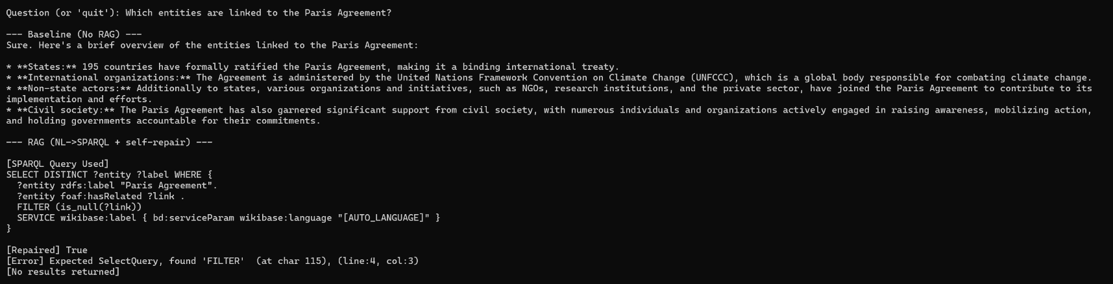

6. Critical Reflection

6.1 KB Quality Impact
The most significant limitation of this pipeline is the small initial crawl. With only 3 pages retained out of 6 attempted seeds, the private KB contains 212 entities and 1,589 triples before expansion. The entity count after expansion (839 subjects) remains well below the recommended 5,000 to 30,000 range. While the triple count (70,570) is within range, the graph is structurally sparse: most triples come from Wikidata expansion rather than domain-specific extraction.

6.2 Noise Issues
Several noise sources affected KB quality. Bibliographic author names (Stocker, D. Qin, etc.) were extracted as PERSON entities despite being citation metadata. Vague temporal expressions (today, this decade) passed through the initial DATE filter. Entity duplication is present in the graph (IPCC and the Intergovernmental Panel on Climate Change exist as separate nodes despite referring to the same entity), which fragments the graph structure and reduces embedding cohesion.

6.3 Rule-Based vs Embedding-Based Reasoning
SWRL rule-based reasoning provides transparent, interpretable inferences with guaranteed correctness given consistent data. However, it requires manually crafted rules and cannot generalize beyond what is explicitly encoded. Knowledge Graph Embeddings provide statistical generalization and can predict missing links without explicit rules, but their quality is highly sensitive to KB size and structure. The relatively low MRR values (0.10 to 0.14) reflect the sparse and noisy structure of the expanded KB rather than a fundamental limitation of the models.

6.4 What We Would Improve
- Crawl more pages (at least 20 to 30 seed URLs) to increase initial entity coverage before expansion.
- Apply entity deduplication before graph construction to merge variants of the same entity (IPCC, the IPCC, Intergovernmental Panel on Climate Change).
- Use a larger LLM (Llama 3.1 8B or Mistral 7B) for the RAG pipeline to improve SPARQL generation accuracy on complex relational questions.
- Add explicit predicate examples to the schema summary to guide the model toward domain-specific relation patterns.
- Implement t-SNE visualization of the learned embeddings to inspect cluster quality and nearest-neighbor coherence.

