**Module 2 Assessment**

Part 2: Design

Style Guide

**Color Scheme**

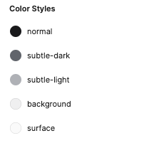

Font

* AG large 64/72
* AG Medium 48/56
* AG Small 40/48

Spacing rules

* Double spacing

Other rules

* Images all black and white