Rachel Theis
Module 11.2 Assignment
CSD 325
12.22.24

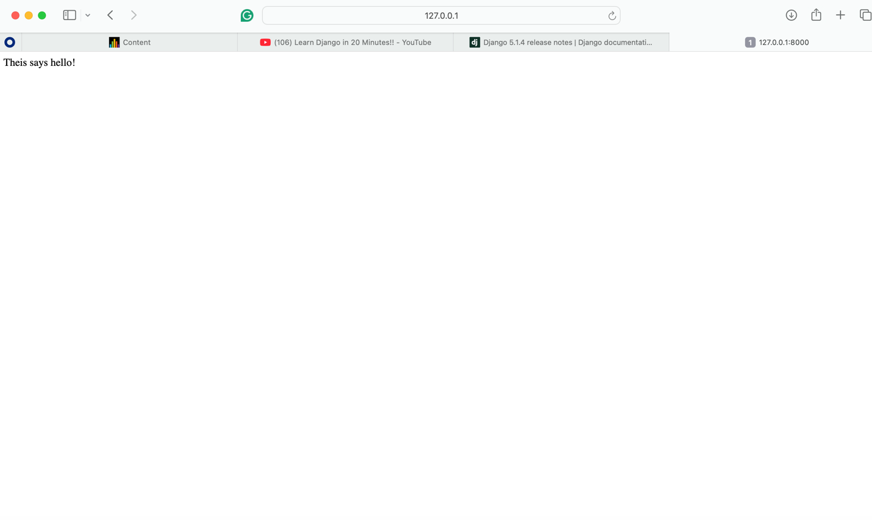
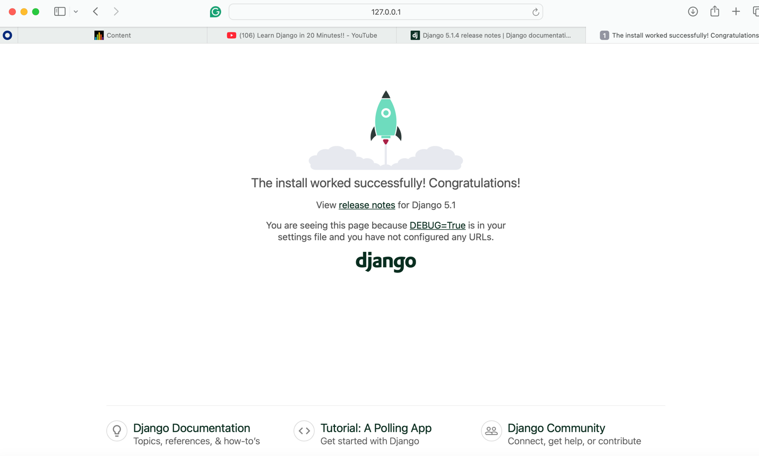
References
Tech With Tim. (2023, July 29). Learn Django in 20 Minutes!! Www.youtube.com. https://www.youtube.com/watch?v=nGIg40xs9e4

