Rachel Theis

Module 1.2 Assignment

CSD 340

1.12.24

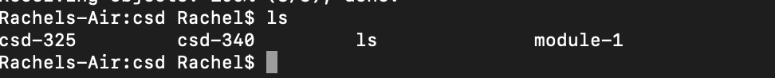 <https://github.com/racheltheis/csd-340>