Rachel Theis

Module 9 Assignment

CSD 420

5.4.25

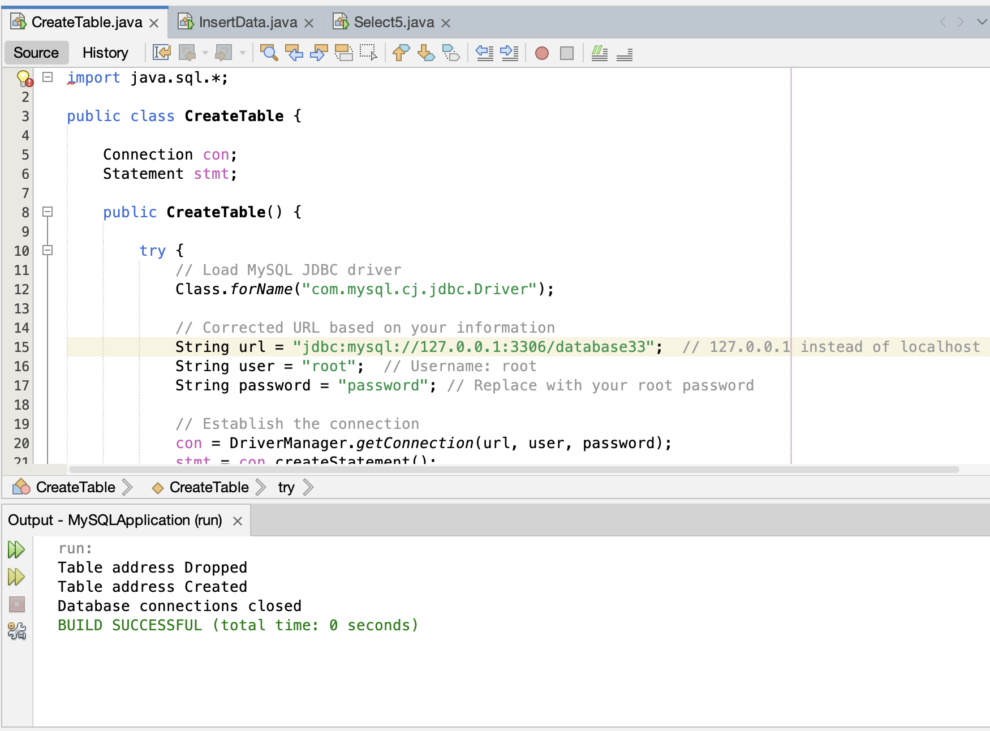Screenshot #1: Create Table

Screenshot #2: Select5

Screenshot #3: Insert Data