Common sensorstrings processing issues

Multiple serial numbers found in aM file

Error:

Solution:

** This should now only be a warning and a solution not stop code execution? Delete offset rows in aM file with no timestamp

Serial number NA does not match any serial numbers

Error:

Error in ss_compile_aquameasure_data(path = path, sn_table = sn_am, deployment_dates = deployment_dates, :

Serial number NA does not match any serial numbers in sn_table

Solution: Check for misaligned columns in the aquaMeasure data file. For example:

These rows can be realigned to have the data in the correct column.

0 rows of data after trimming/ Expected 11 fields but found 12 in aquaMeasure file

Error:

Error in check_n_rows(am_i, file_name = file_name, trimmed = trim) :

After trimming, there are 0 rows of data in file aquaMeasure-670354_2020-11-12_135334_UTC.csv

Solution:

Shift offset rows in aquaMeasure file with no timestamp and “Power Up Brownout” in far right column so they line up with the appropriate columns

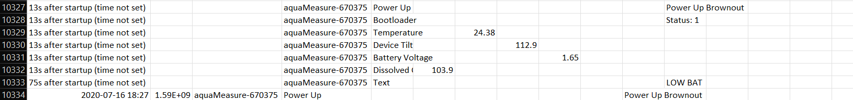

Dat_raw 50 or more warnings

Error:

Solution:

Make sure the station name is stored as text across the board: Log, STRING TRACKING, AREA INFO tab, configuration table. May need to put an apostrophe (‘) before the name in the cell.

Note that this may arise from an intentional station renaming – check the “water_quality_station_renaming.xlsx” tracking sheet to confirm. Remember to put ‘YES’ in the ‘Data Reprocessed’ column if the data has been successfully reprocessed.

Depth can’t be converted to numeric

Error:

Solution:

Delete “m” from the depth value in the log (e.g. 1.3m > 1.3)

No station with specific name/waterbody in Area Info Tab

Error:

Solution:

Check spelling in Log and Area Info tab. Update for consistency.

Error in matching logger serial number and sensor serial number in Hobo file

Error:

Solution:

Data has been exported in the wrong format – re-export from HOBO software with just Temp data checked (no min, max, avg)

Sensor data file saved as .xlsx instead of .csv

Error:



Solution: Open .xlsx file and ‘Save As’ .csv. If the .xlsx file has additional tabs, make sure to save the Excel sheet with the raw data from the sensor (not sorted or filtered data). Create a folder called ‘archive’ and store the old .xlsx file in there. If there are no additional tabs in the .xlsx file, it can be deleted instead.

Cannot convert temperature to numeric

Error:

Error in aquameasure sensor recording resulting in two different values being recorded with the same timestamp.

Solution: TBD

Index size incorrect

Error:

> ALL_data <- compile_all_data(path = path,

+ deployment.range = deployment.range,

+ area.name = area.name,

+ trim = TRUE,

+ # hobo

+ serial.table.HOBO = serial.table.HOBO,

+ correct.DO = FALSE,

+ Sal = NULL,

+ # aquaMeasure

+ serial.table.aM = serial.table.aM,

+ # vemco

+ depth.vemco = depth.vemco)

**Error in `mutate()`:**

ℹ In argument: `INDEX = as.character(c(1:n()))`.

**Caused by error:**

! `INDEX` must be size 0 or 1, not 2.

Solution: Ensure all data files have data within the deployment range. If you identify a hobo sensor which did not have data within the deployment range, double check that the file properly exported from HoboWare

Multiples of many column values in log, with long > 0

Error:

Solution: Results from merging of multiple rows with the same value in the log csv file. Manually unmerge and copy appropriate value to each row to fix.

Deployment not found in Configuration table

Error:

Solution: May happen when a station name has been changed. Check the configuration table for the deployment that matches the old station name and date. Update the configuration table with the new station name. If there is no deployment with the right date, then update the log to use a “Configuration” column instead of “Mount_type”.

Regular expression matching (grep) error with Temperature column name in Hobo file

Error:

Solution: Hobo file has been exported incorrectly – re-export

Missing tidbit files

Error:

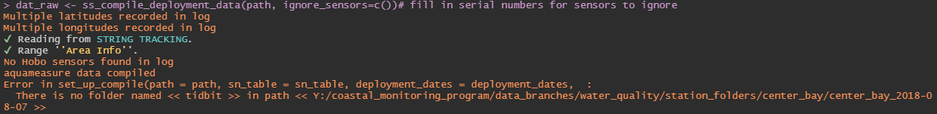

Solution: Check for raw csv files. Note that these may be stored in the ‘hobo’ folder. If they are not present, use the optional ‘ignore_sensors’ argument in the ss_compile_deployment() function to submit an array of sensor serial numbers to ignore. These serial numbers can be found in the log. For example:

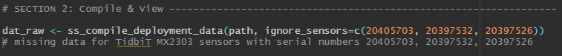

Timezone not UTC

Error:

Error in if (date_tz != "utc") { : missing value where TRUE/FALSE needed

Solution: TBD – maybe re-export?

Hobo file name does not match expected serial number

Error:

Solution: Check hobo file name, data inside hobo file, and log file to compare serial numbers. This will require further investigation. For example, there might be a typo, but it is also possible that two serial numbers have been mixed up and this data is assigned to the wrong deployment.

Vemco serial number in data file does not match log

Error:

Error in ss_compile_vemco_data(path = path, sn_table = sn_vem, deployment_dates = deployment_dates, :

Serial number in sn_table (54777)

does not match serial number in file VUE_Export.csv (545777)

Solution: Compare the serial numbers in the vemco data file and the log. This will require further investigation. For example, there might be a typo, but it is also possible that two serial numbers have been mixed up and this data is assigned to the wrong deployment.

Cannot combine temperature “double” and temperature “list”

Error:

**Error in `bind_rows()`:**

! Can't combine `..1$temperature_degree_c` <double> and `..2$temperature_degree_c` <list>.

Run `rlang::last_trace()` to see where the error occurred.

Warning message:

Values from `Data` are not uniquely identified; output will contain list-cols.

• Use `values_fn = list` to suppress this warning.

• Use `values_fn = {summary_fun}` to summarise duplicates.

• Use the following dplyr code to identify duplicates.

{data} %>%

dplyr::group_by(timestamp_, Description) %>%

dplyr::summarise(n = dplyr::n(), .groups = "drop") %>%

dplyr::filter(n > 1L)

> rlang::last_trace()

**<error/vctrs_error_ptype2>**

**Error in `bind_rows()`:**

! Can't combine `..1$temperature_degree_c` <double> and `..2$temperature_degree_c` <list>.

---

Solution: TBD

Invalid multibyte string

Error:

Error in nchar(x) : invalid multibyte string, element 1

Solution: TBD – maybe incorrectly exported aquameasure data? It seems to have an extra column called “Record Number”

Can’t parse date in format NA

Error:

> dat_raw <- ss_compile_deployment_data(path)

✔ Reading from STRING TRACKING.

✔ Range ''Area Info''.

Error in convert_timestamp_to_datetime(.) : Can't parse date in format NA

Solution: Check for an empty aquameasure data file. Try re-exporting the data in case Detections were exported instead of events. If the file is still empty, ignore that sensor.