**NS&B Hippocampus Molecular Module (July 18-30 2016)**

**Goals**

1) To learn modern molecular biology techniques and approaches.

2) To introduce students to our current understanding of the molecular mechanisms that underlie learning and memory processes.

3) To design research projects aimed to investigate how experience changes molecular mechanisms that shape neural networks (e.g. in the hippocampus) to support stored information.

**Learning Objectives**

* Students will learn to identify and recognize the distinct areas of the Hippocampus formation (e.g. DG, CA3, CA2, CA1) from brain slices and gain an understanding of how they process information (e.g. navigation, memory).
* Students will learn the foundations of molecular approaches that allow for the identification of target genes (Table 1) and gene expression profiles (e.g. qPCR).
* Students will learn how to access the mouse genome database and use bioinformatics tools to asses gene expression discovery.
* Students will be introduced to the Synaptic Plasticity and Memory Hypothesis (SPMH), which posits that synaptic plasticity mechanisms underlie learning and memory processes.
* Students will learn how to properly design research projects to answer questions of student’s interest.
* Students will learn how to communicate, discuss and interpret their findings on the efforts to identifying particular transcript profiles associated with experience within a neural network.

**Research Resources**

* Students will utilize the samples (tissue) collected from the different areas of the hippocampus (or the brain) from normal and genetically modified mice that has been conditioned with distinct experiences compared to control mice (e.g. home cage).
* Students will utilize RT-qPCR methods and informatics analyses to test for changes in transcript abundance associated with i) different regions of the hippocampus and ii) different behavioral conditionings.

**Overarching Hypothesis**

Learning changes network function to store information into memory. In particular, encoding of spatial information is expected to produce distinct and persistent gene expression changes within the hippocampus network thus shaping neuronal function to support stored information.

**Background**

1) Advance in a brain theory of cognition has been significant. The field has produced the synaptic plasticity and memory hypothesis (SPMH) that asserts that learned experiences are encoded by plastic functional changes in synapses (Bliss and Collingridge, 1993; Martin and Morris, 2002; Neves et al., 2008; Mayford et al., 2012). Support for the SPMH is overwhelming. Synapses can change under conditions that may mimic experience, such as electrical and chemical stimulation (Malenka and Bear, 2004; Kemp and Manahan-Vaughan, 2007; Abraham, 2008; Malleret et al., 2010). Learning itself can change hippocampal synapses in manners predicted by the SPMH (Castro et al., 1989; Green et al., 1990; Korol and Brunjes, 1990; Martin et al., 2000; Whitlock et al., 2006; Matsuo et al., 2008). Indeed, changes in neural ensemble function observed during learning are thought to be the consequence of learning-induced changes of synaptic weights within the neuronal network constituting the memory ensemble (McNaughton et al., 1996; Kali and Dayan, 2000; Nathe and Frank, 2003; Fyhn et al., 2004; Dragoi and Buzsáki, 2006; McNaughton et al., 2006; Hunsaker et al., 2008; Neves et al., 2008; Kelemen and Fenton, 2010). These changes in synaptic function are speculated to make it more likely that neural activity patterns during learning will replay for memory recall (Gelbard-Sagiv et al., 2008). In support of this view, optogenetic activation of neural activity patterns in specific neurons was sufficient to prompt mice to behave as if they had a synthetic memory (Garner et al., 2012; Ramirez et al., 2013).

Despite these advances, many fundamental questions remain unanswered (Mayford et al., 2012). For instance, how are learned experiences stored within synaptic circuits of the brain? We still lack a comprehensive formulation of how learning experiences sculpt synaptic circuits that underlie ensemble activity that supports memory.

2) We will center our research on the hippocampus network (Diagram 1). The hippocampus is essential for processing spatial information (McNaughton et al., 1996; Kali and Dayan, 2000; Nathe and Frank, 2003; Fyhn et al., 2004; Dragoi and Buzsáki, 2006; McNaughton et al., 2006; Hunsaker et al., 2008; Kelemen and Fenton, 2010). The properties of hippocampal neurons and synapses are well known (Jarsky et al., 2005; Nicholson et al., 2006; Dudman et al., 2007; Garden et al., 2008; Henriksen et al., 2010), and its anatomy and circuitry (Amaral and Witter, 1989; Deuchars and Thomson, 1996; Dolleman-Van Der Weel and Witter, 1996; Pikkarainen et al., 1999) makes it a very approachable system to investigate network changes associated with memory.

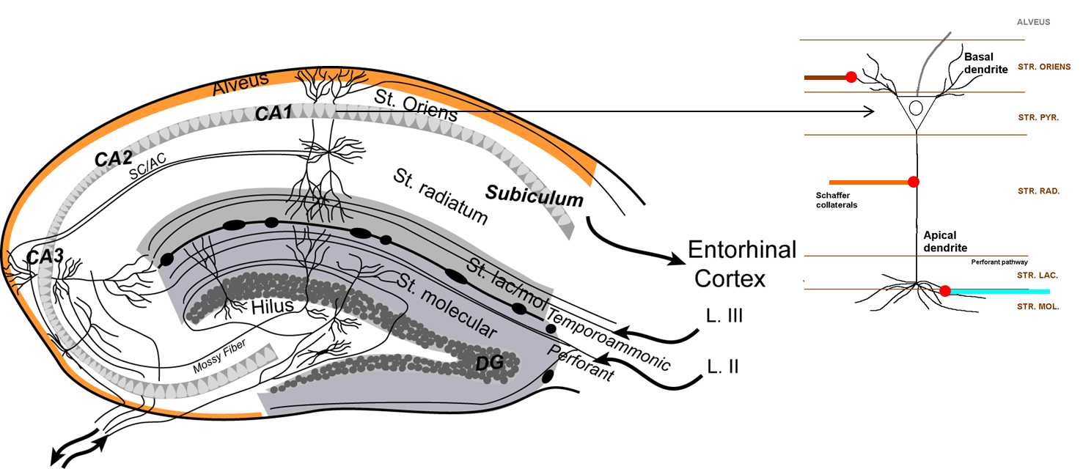

***Diagram 1 - The Hippocampus formation: regions, subfields (strata), dendrites domains and synaptic pathways.***

**Dentate Gyrus (DG) Area**

|  |  |  |  |
| --- | --- | --- | --- |
| **Fiber Input** | **Subfields** | **Dendritic domains** | **Glutamatergic synapses** |
| Lateral Perforant Pathway (PP) | Lateral stratum moleculare | Distal GC dendrites | Lateral Entorhinal Cortex (LEC) Layer II-Granule Cells (GC) |
| Medial PP | Medial s. moleculare | Proximal GC dendrites | Medial EC (Layer II)-GC |
|  | GC layer (cell bodies) |  |  |
|  | sub-ventricular zone (SVZ) neurogenesis occurs here |  |  |

**CA3 Area**

|  |  |  |  |
| --- | --- | --- | --- |
| **Fiber Input** | **Subfields** | **Dendritic domains** | **Glutamatergic synapses** |
| Commissural | s. oriens | Basal or basilar | contralateral hipp.- CA3 |
|  | s. pyramidale (cell bodies) |  |  |
| Recurrent Collateral | s. lucidum/ s. radiatum | Proximal Apical | CA3-CA3 |
| Mossy fibers/Rec. | s. radiatum | Proximal Apical | Granule Cell-CA3/CA3-CA3 |
| PP | s. lacunosum moleculare | Distal Apical | LEC(layer II)-CA3 |

**CA2 Area**

|  |  |  |  |
| --- | --- | --- | --- |
| **Fiber Input** | **Subfields** | **Dendritic domains** | **Glutamatergic synapses** |
| Commissural | s. oriens | Basal | contralateral hipp.-CA2 |
|  | s. pyramidale (cell bodies) |  |  |
| Schaeffer collateral/ EC direct | s. radiatum | Proximal Apical | CA3-CA2/EC-CA2 |
| Temporoammonic | s. lacunosum moleculare | Distal Apical | MEC/LEC-CA2 |

**CA1 Area**

|  |  |  |  |
| --- | --- | --- | --- |
| **Fiber Input** | **Subfields** | **Dendritic domains** | **Glutamatergic synapses** |
| Commissural | s. oriens | Basal | contralateral hipp.-CA1 |
|  | s. pyramidale (cell bodies) |  |  |
| Schaeffer collateral | s. radiatum | Proximal Apical | CA3-CA1 |
| Temporoammonic | s. lacunosum moleculare | Distal Apical | MEC/LEC(layer III)-CA1 |

**Subiculum (same as CA1 area)**

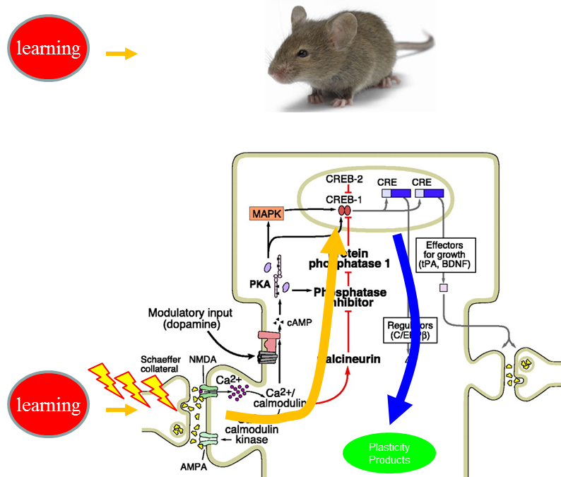3) Hippocampal synaptic function is key for spatial memory. Recruitment of synaptic plasticity mechanisms in the hippocampus is observed with the acquisition of a spatial (hippocampus-dependent) task; and enhancement or disruption of hippocampal synaptic plasticity has been correlated with enhanced or deficient spatial memory (Kandel, 2001; Malenka and Bear, 2004; Kemp and Manahan-Vaughan, 2007; Abraham, 2008; Makino and Malinow, 2009; Sacktor, 2011; Zhang and Lisman, 2012). Like memory, expression of synaptic plasticity has different stages: induction, expression, consolidation and maintenance; and the mechanisms that underlie the expression of each phase have been under intense investigation (Bliss and Collingridge, 1993; Martin and Morris, 2002; Neves et al., 2008; Mayford et al., 2012). A large body of evidence has identified a number of molecular factors (>800) relevant for the induction and expression of both synaptic plasticity and memory (Malenka and Bear, 2004; Kemp and Manahan-Vaughan, 2007; Abraham, 2008; Malleret et al., 2010). An important area of research is the investigation of the molecular mechanisms that underlie the transition between transient (short-term) to enduring (long-term) synaptic plasticity (or memory), which is ascribed to synaptic mechanisms that couple with translation and gene expression mechanisms (Fig. 1). Table 1 presents a list of candidates known to underlie the induction, expression, consolidation and maintenance of synaptic plasticity.

***Figure 1: Synaptic Plasticity mechanisms. Presynaptic activation induces postsynaptic signaling cascades that may recruit mechanisms for de novo protein synthesis and gene expression.***

*Table 1: Products important for the induction*, expression**, consolidation***, and maintenance**** of synaptic plasticity.*

|  |  |  |
| --- | --- | --- |
| **Protein factor** | **Plasticity function** | **Reference** |
| Neuronal calcium sensor 1 (NCS-1) | Presynaptic neurotransmitter release* | (Dason et al., 2012) |
| Ionotropic glutamate receptor 1 (GluR1) | Postsynaptic control of long-term potentiation (LTP) and depression (LTD)* | (Makino and Malinow, 2009) |
| Calcium-calmodulin kinase II (CamKII) | LTP expression** | (Zhang and Lisman, 2012) |
| Activity-regulated cytoskeleton-associated protein (Arc) | Spine cytoskeleton stability** | (Monti et al., 2012) |
| Fragile X mental retardation protein (FMRP) | Protein synthesis and LTD control** | (Weiler et al., 2004) |
| cAMP responsive element binding protein (CREB) | LTP and LTD consolidation*** | (Silva et al., 1998; Kandel, 2001) |
| Poly-ADP ribose polymerase 1 (PARP-1) | Epigenetic modulator of LTP*** | (Hernandez et al., 2009) |
| Protein kinases M  (PKM) and PKC/M  (PKM) | LTP maintenance**** | (Sacktor, 2011, 2012; Ren et al., 2013) |

**Putative Research Questions**

- Does experience change the expression of candidate plasticity products compared to control mice?

- Is transcript abundance the same across the hippocampal network (DG, CA3, CA2, CA1)?

- Do these (putative) changes correlate with behavior?

**How would you design experiments aimed at:**

- Detecting differences between different behaviorally conditioned mice?

- Generating correlations between the relative abundance of transcripts at different hippocampal regions for different groups of mice?

- Visualizing statistically significant correlations to identify whether behavioral parameters of memory performance positively (or negatively) link with changes in the expression of genes that are needed for synaptic plasticity.

**Which approach is right for your question?**

**Hippocampus-brain connections**

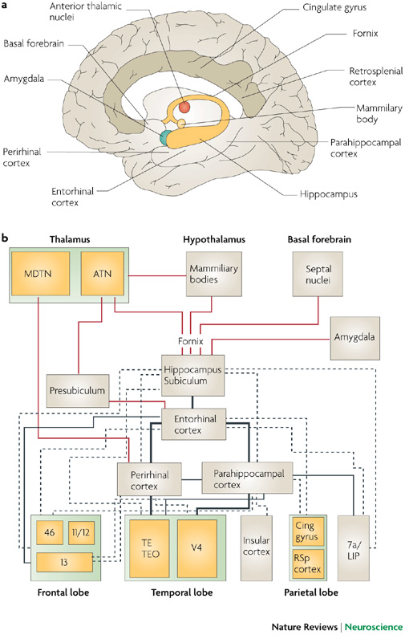

Moser et at., NRN, 15, 466–481, 2014

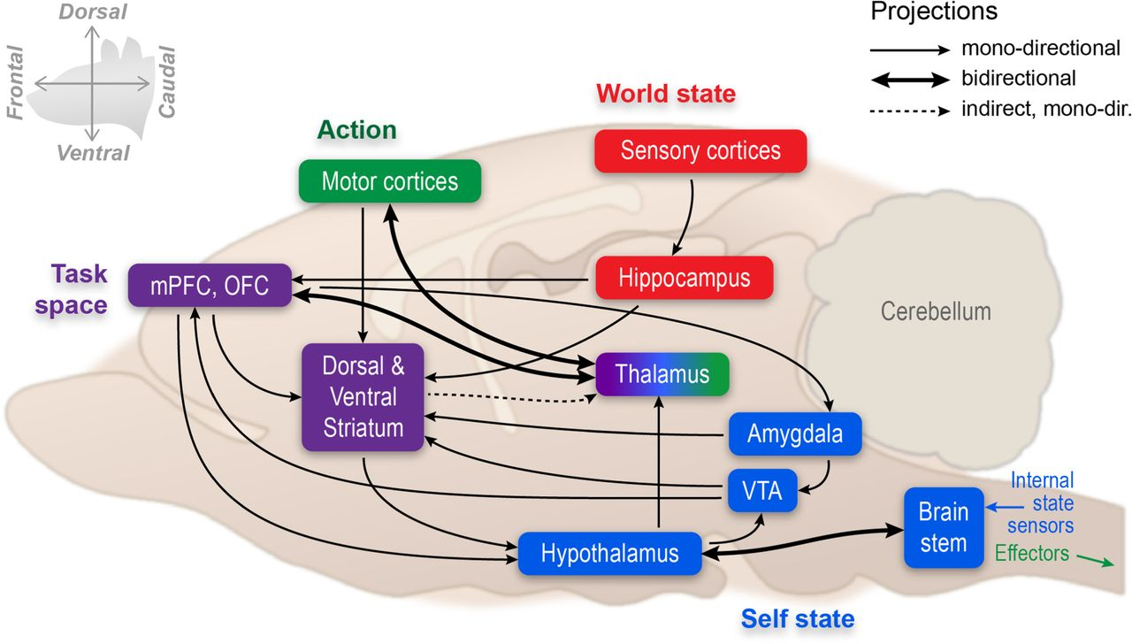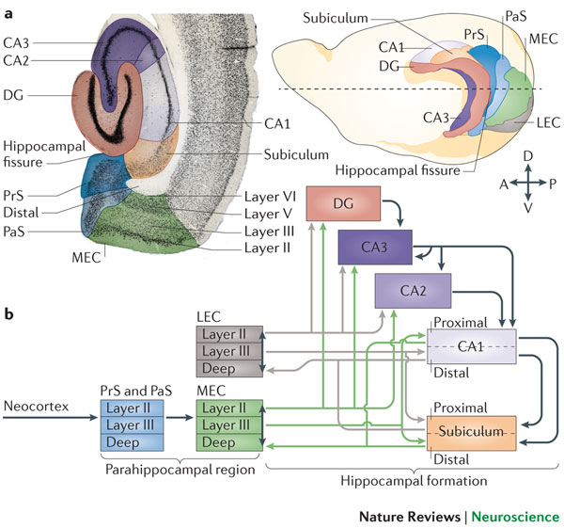

Bird & Burgess NRN 9, 182-194 , 2008