Assignment 1

Biomedical systems & signals

David St-Amand

Part A:

Signals:

1. Forced applied by a spring. This is a continuous process with time as its domain and force (N) as its range.
2. Moments when my cell phone rings. This is a point process with times at which my cell phone rings as its domain.
3. Blood sugar level. This is a continuous process with time as its domain and concentration (mg/dL) as its range.
4. Noise of a drum every time it gets hit. This is a marked-point process with time as its domain and noise (dB) as its range.
5. Amount of carbon in the stratosphere. This is a 4-Dimensional continuous process with time and space as its domain and concentration (mmol/L) as its range.

Systems:

1. Visual system V1. This system takes the action potentials of LGN neurons (Volt) as its input and outputs action potentials to V2. The domain for both input and ouput is time and the range is volt. We can manipulate the input experimentally by directly stimulating LGN neurons, or by showing a specific picture we think would activate specific LGN/V1 neurons.
2. Drums. This system takes percussions as inputs and outputs noise. Percussions are a marked point process with time as the domain and force (N) as the range. Noise would also be a marked point process with time as the domain and noise (dB) as the range. We can experimentally manipulate the input by hitting on the drums with drumsticks.
3. Biceps. This system takes as inputs action potentials from the musculocutaneous nerve and outputs force (N). The input has time and neuron as its domain and volt as its range. The output has time as its domain and force (N) as its range. We can manipulate the system experimentally by directly stimulating musculocutaneous nerve neurons, or more simply by asking someone to contract his biceps.
4. Springs. This system takes force as input and outputs force. The domain and range for both input and output are time (s) and force (N). We can experimentally manipulate the input by applying a force on the spring.
5. Water in a closed system. The input is heat and the output is pressure. The input has time as its domain and temperature (K) as its range. The ouput has time as its domain and pressure (N/m2) as its range. We can experimentally manipulate the input by starting a fire close to the water.

Part B:

X1:

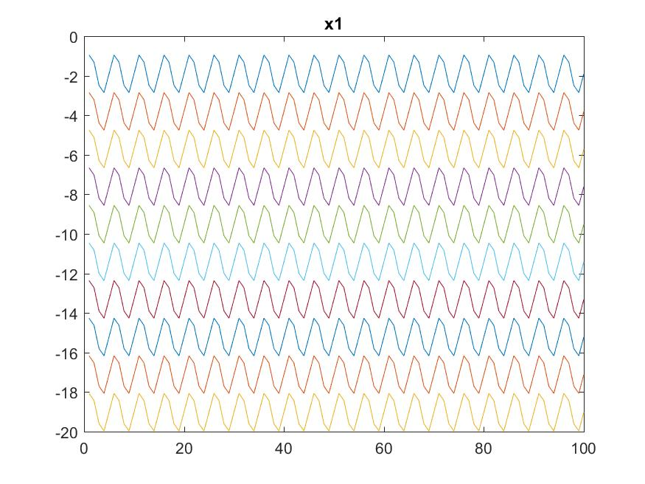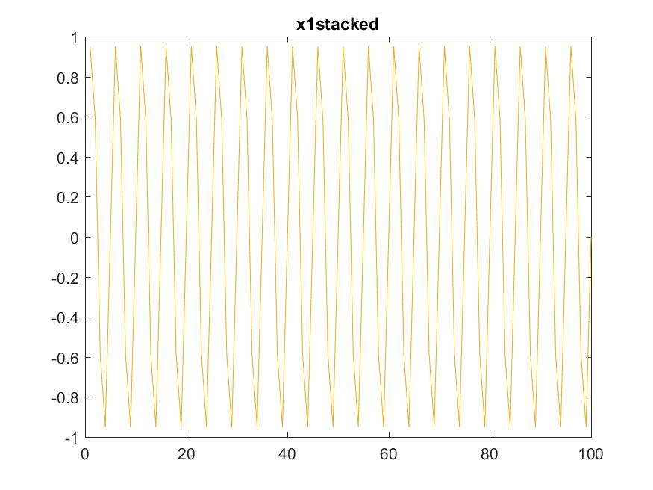

1. The signal is deterministic
2. Mean = 0 and mean of variance across realizations = 0.5051
3. NA
4. NA

X2:

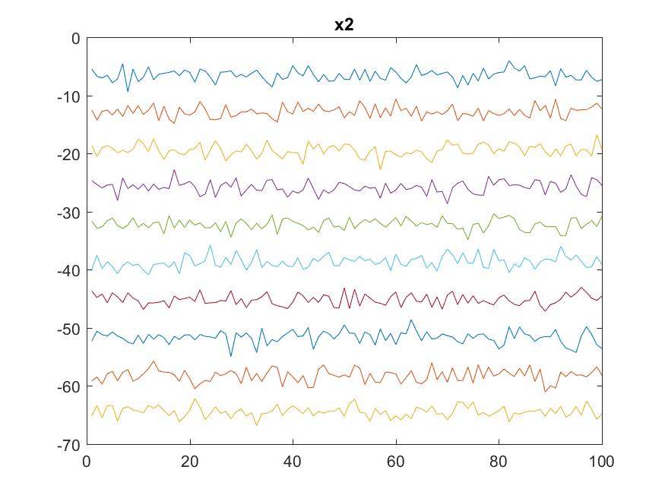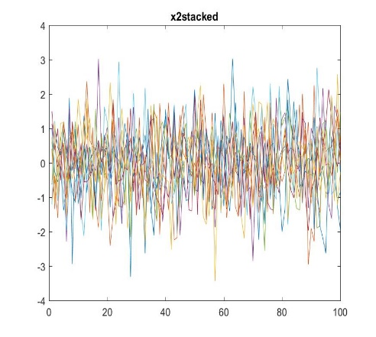

1. The signal is stochastic
2. Mean = 0.002 and mean of variance across realizations = 1.0218
3. The process seems to be ergodic. The linear regression of y as a linear function of time resulted in a p-value of 0.317. The variance across realizations (variance between the realizations’ means) represents 0.7% of the total variance. The variance for the first 10 samples across realizations is 1.22, and the variance for the last 10 samples across realizations is 0.83. That is deemed to be a reasonable difference due to noise.
4. NA

X3:

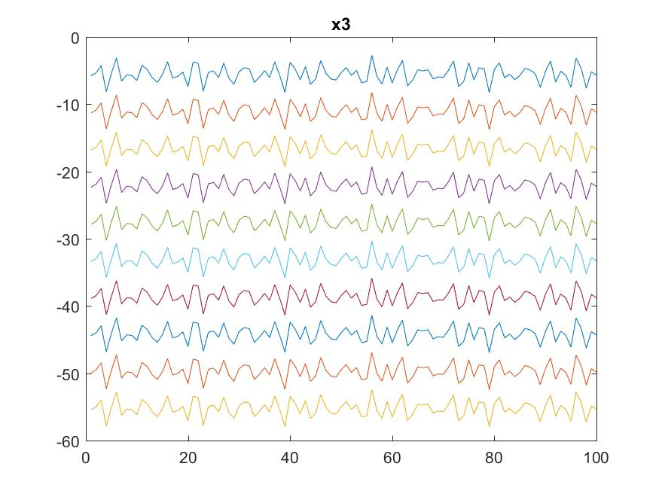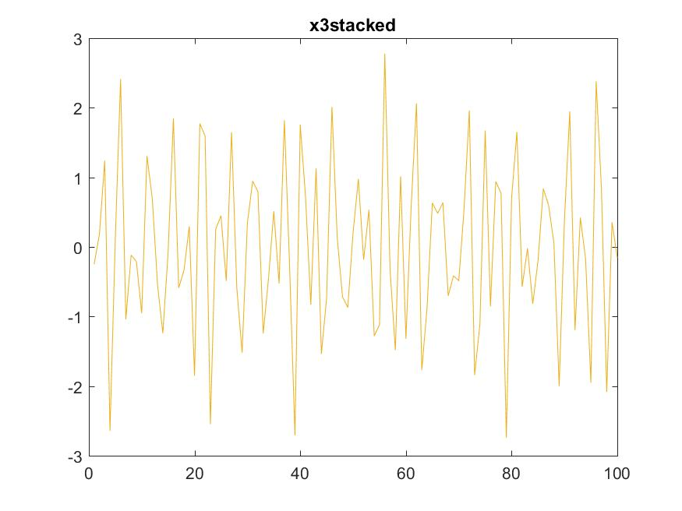

1. The signal is deterministic since all the realizations of the signal are identical.
2. Mean = -0.0066 and mean of variance across realizations = 1.5441
3. NA
4. NA

X4:

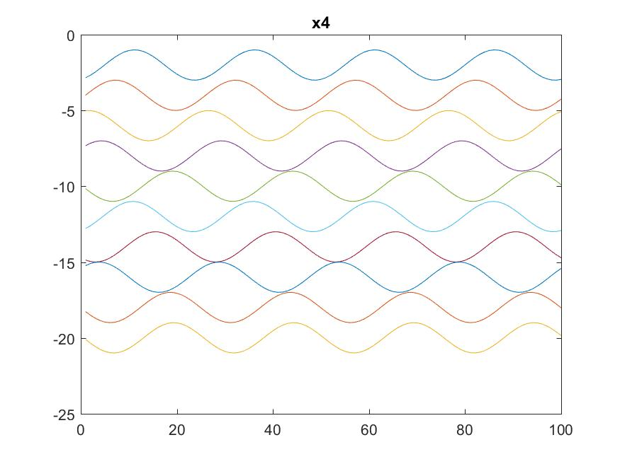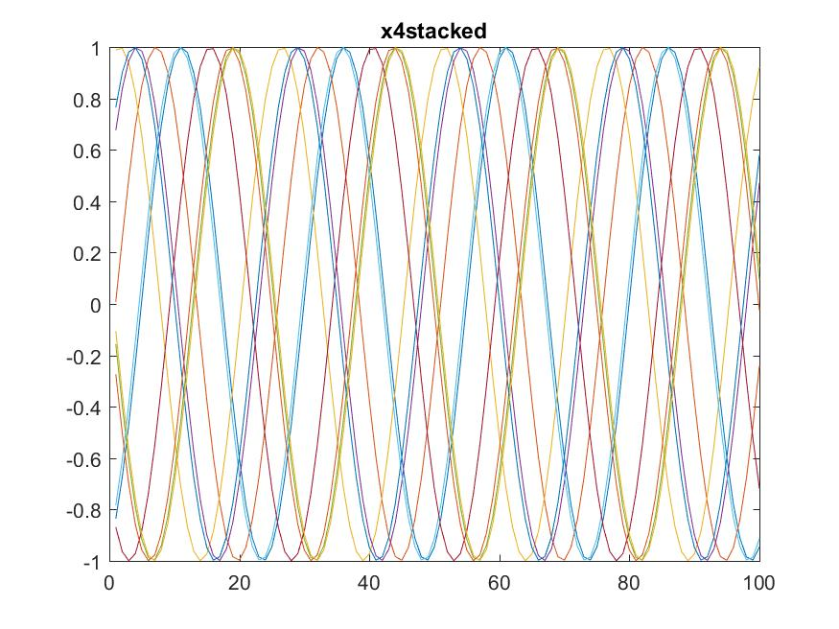

1. The signal is stochastic.
2. Mean = 0 and mean of variance across realizations = 0.5051
3. The process seems to be ergodic (at least if the sample is an integer multiple of the period. If not, it is stationary). The linear regression of y as a linear function of time resulted in a p-value of 0.91. The variance across realizations (variance between the realizations’ means) represents almost 0% of the total variance. The variance for the first 10 samples across realizations is 0.2441, and the variance for the last 10 samples across realizations is 0.183. That is deemed to be a reasonable difference due to noise.
4. It would be possible to make the ergodic independently of the sampling by changing the phase of each realization to be the same. This has not been performed here.

X5:

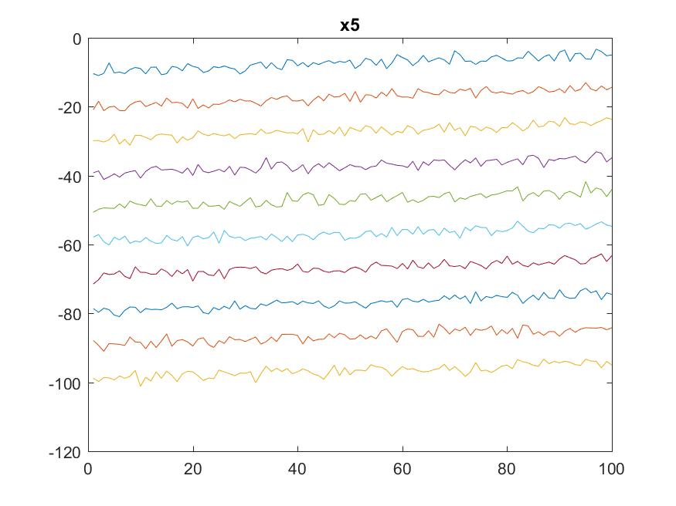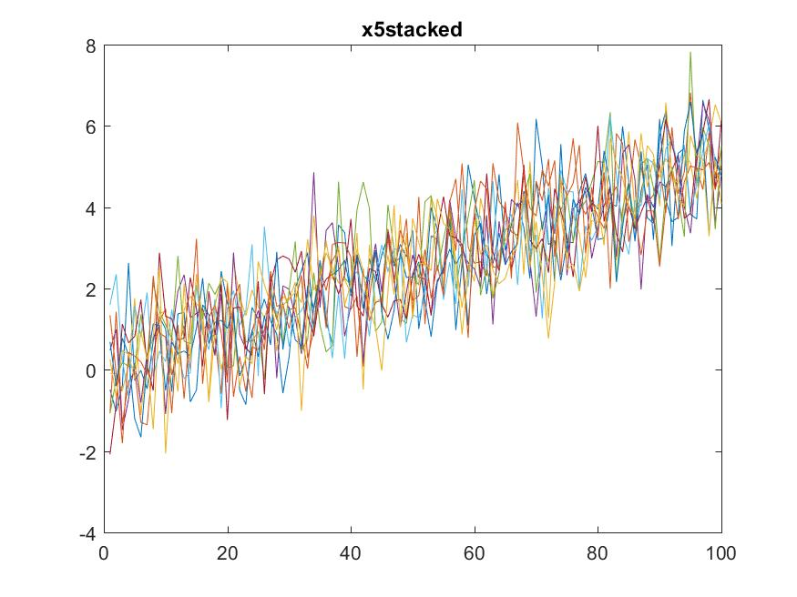

1. The signal is stochastic
2. Mean = 0.044 + 0.05x, Variance (residuals from linear model) = 0.987
3. The process is non-stationary. The linear regression of y as a linear function of time resulted in a p-value of 2.95e-251.
4. We transformed the signal to be ergodic by subtracting a linear slope of 0.05x from the signal. The results can be seen in the x5 stationary plot. 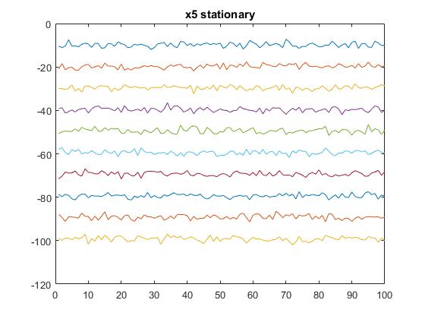

X6:

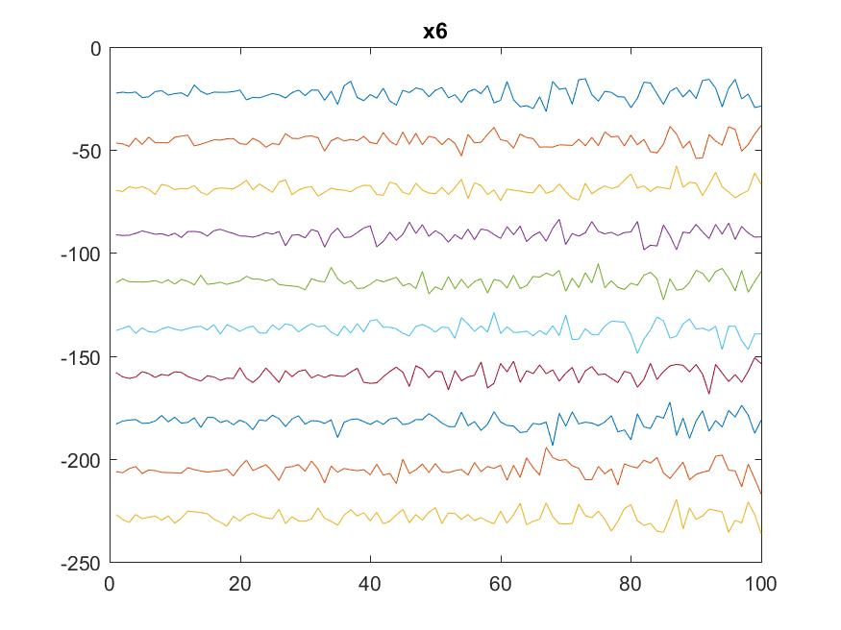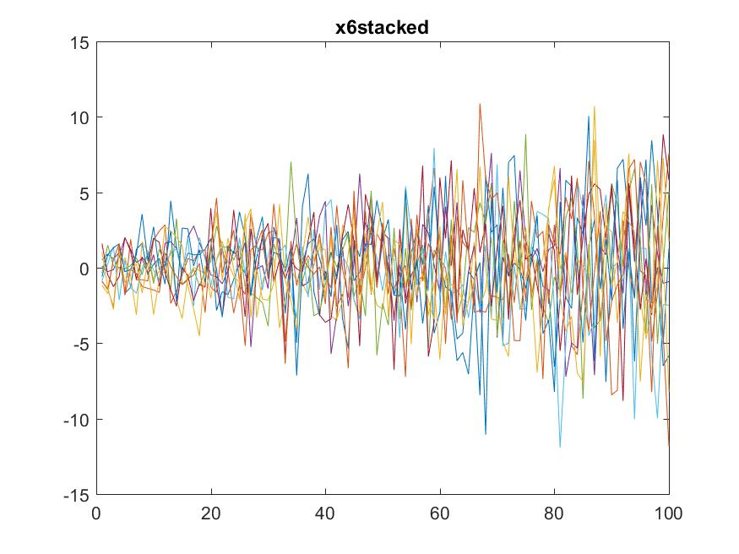

1. The signal is stochastic.
2. Mean = 0.1005 and Variance = 0.226x – 1.276
3. The signal is non-stationary as its variance increases over time. The variance across realizations (variance between the realizations’ means) represents 1.1% of the total variance. The variance for the first 10 samples across realizations is 1.47, and the variance for the last 10 samples across realizations is 21.93. This heavily suggests there is an increase of variance over time.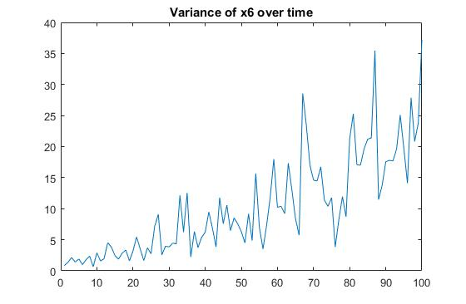
4. To make the signal ergodic, I divided every value at time x by the standard deviations of the values across realizations at time x. This resulted in the following graph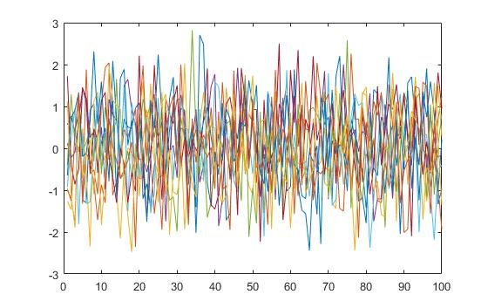

X7:

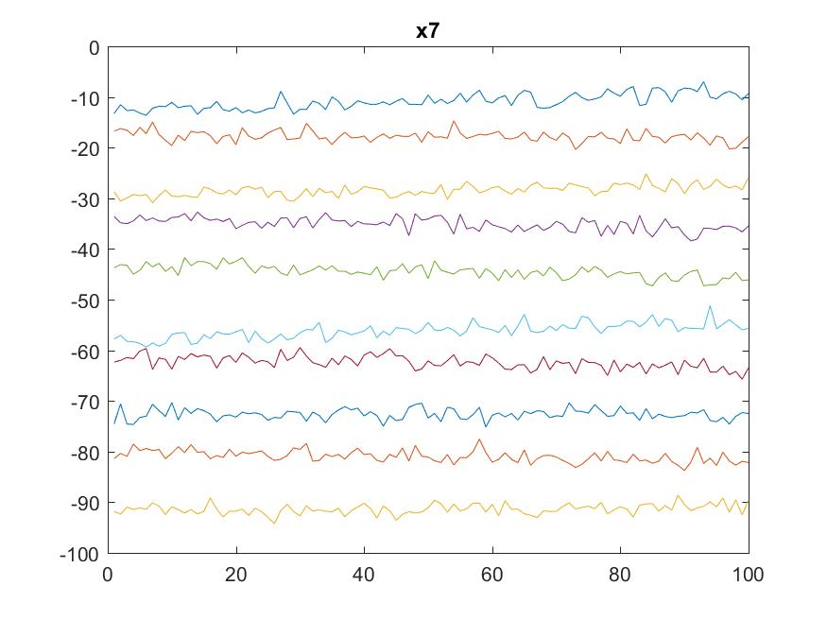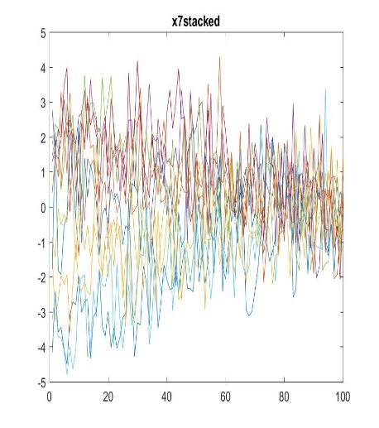

1. The signal is stochastic
2. Mean = -0.0027 and Variance = 1.5
3. The process seems to be non-stationary. Different realizations seem to be composed of noise + linear models with different slopes that converge to the same point at time = 100. The variance across realizations (variance between the realizations’ means) represents 91% of the total variance. The variance for the first 10 samples across realizations is 1.05, and the variance for the last 10 samples across realizations is 1.23. This suggests that variance does not increase within realization over time.
4. To make this signal ergodic, it would be possible to extract a linear slope out of each realization and consider the residuals to be the signal. This has not been performed here.

X8:

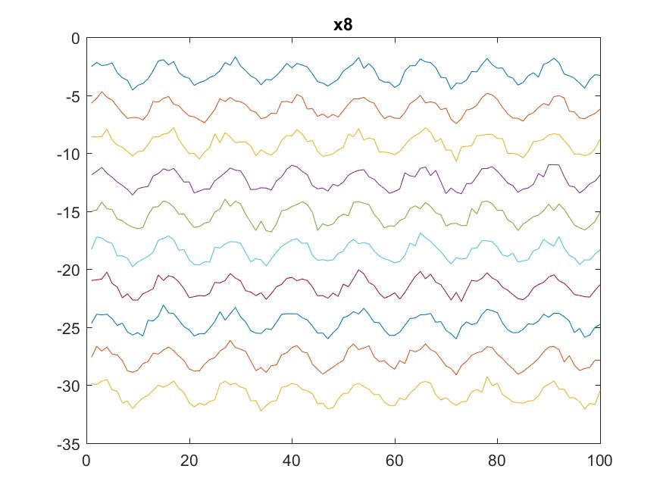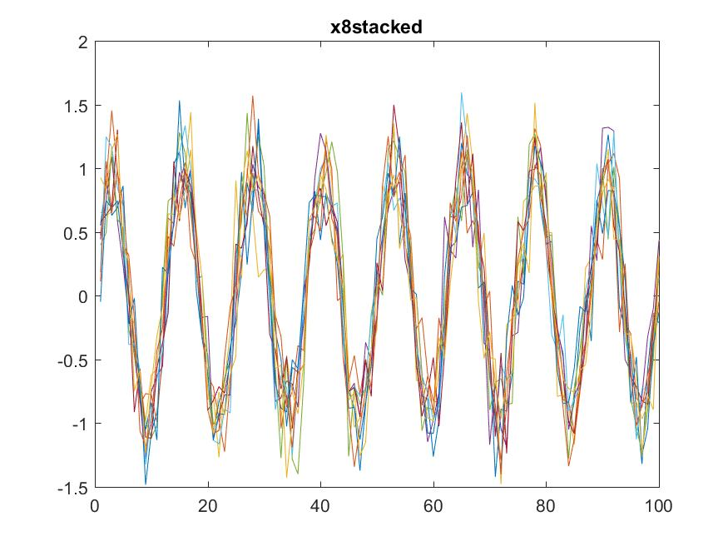

1. The signal is stochastic.
2. Mean = 0.016 and Variance = 0.55
3. The signal seems to be ergodic. The linear regression of y as a linear function of time resulted in a p-value of 0.03. However, this is assumed to be due to the fact the time at 0 is a maximum of the sinusoid, wherever the time at 100 corresponds to the minimum of the same sinusoid. The variance across realizations (variance between the realizations’ means) represents almost 0% of the total variance. The variance for the first 10 samples across realizations is 0.67, and the variance for the last 10 samples across realizations is 0.59. That is deemed to be a reasonable difference due to noise.
4. NA

X9:

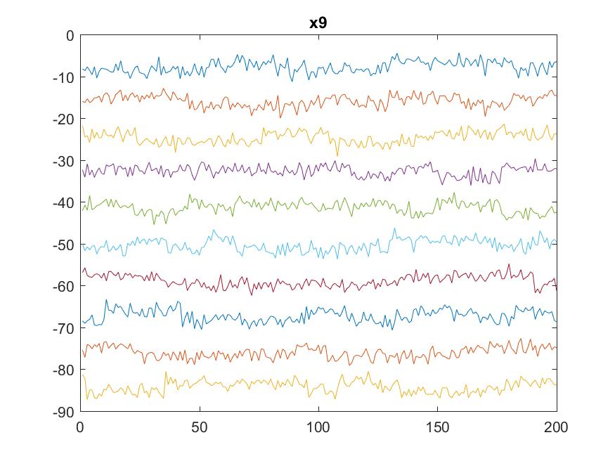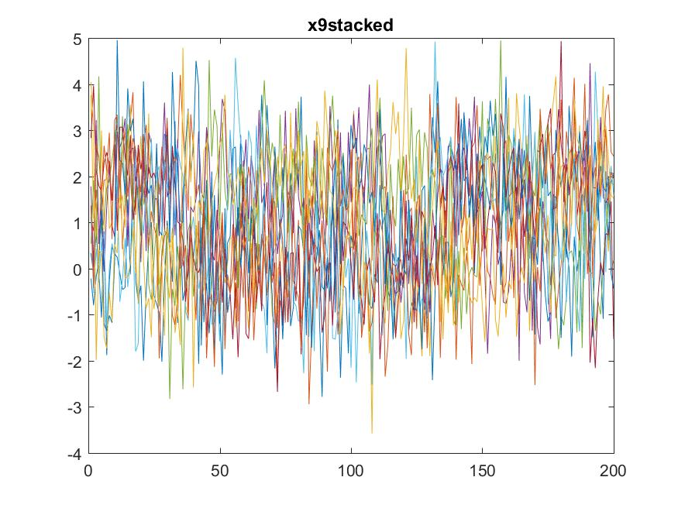

1. The signal is stochastic.
2. Mean = 1.02 and Variance = 2.02
3. The signal seems to be stationary. It seems to be the combination of a sinusoid wave with a stochastic component. The frequency of the sinusoid seems to vary across realizations. The variance across realizations (variance between the realizations’ means) represents 3% of the total variance. The variance for the first 10 samples across realizations is 1.21, and the variance for the last 10 samples across realizations is 1.22.
4. NA

X10:

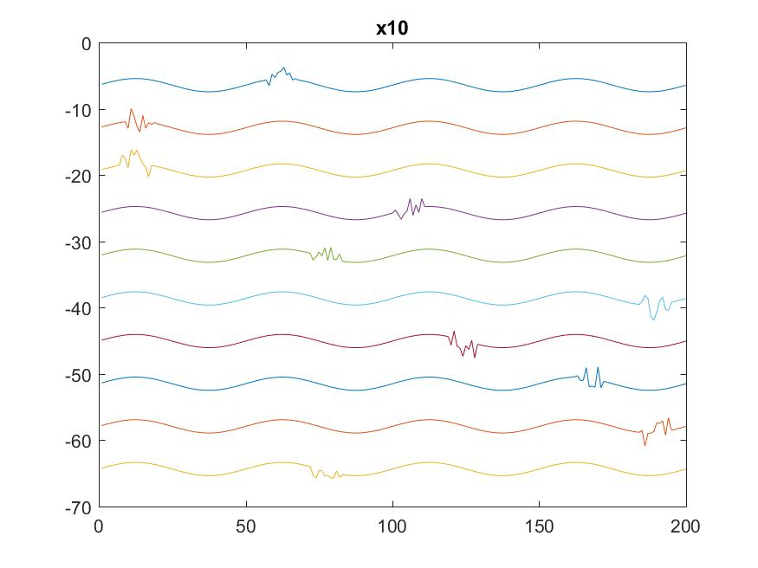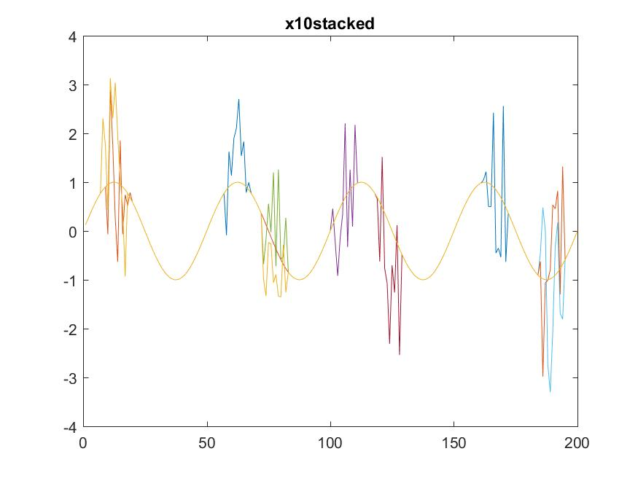

1. The signal is a combination of a deterministic (sinusoid wave) and of a stochastic signal.
2. Mean = -0.0012 and Variance = 0.5683
3. The process is stationary. It is not ergodic between all possible intervals of time (some would include the stochastic components and others wouldn’t), but one could possibly argue it is ergodic if your sample is large enough.
4. NA