For technical/time reasons, I was not able to complete part 1. However, here is my full report for the part 2 of assignment 3.

**Part 2**

In this part, we tried to better understand a list of 8 signals using Fourier transform and power spectrum. First, we plotted the signal (top-left of each A figure) with the magnitude of its fast Fourier transform (top-right of each A figure). For clarity purposes, every fast Fourier Transform has had its imaginary counterpart taken out; only the real part remains from this analysis. To take a closer look at the signal, we separated each signal into several segments. The number of segments was chosen as a multiple integer of the signal’s period (if it was periodic). We plotted the ensemble average of the segments (middle-left of the A figures) and the Fourier Transform of each individual segment (B figures).

We also compared the Fourier transform of the average of the segments (middle-right of the A figures) with the average magnitude of the Fourier transform of each segment (bottom left of the A figures). Not all our signals were deterministic; for this reason, we also analyzed all the signals using power spectra (bottom-right of A figures).

**Signal x1**

The signal is stochastic with a normal probability distribution (see figure 1).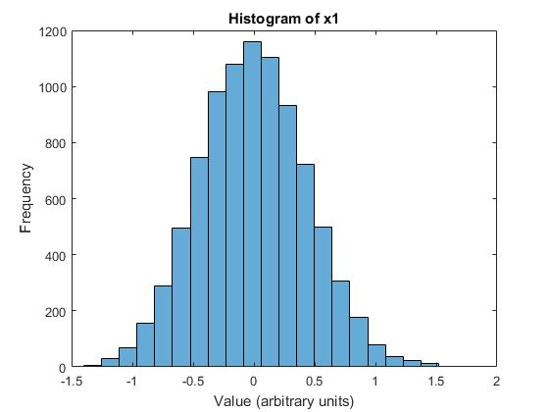

Figure 1: Histogram of x1

Randomness of the x1 signal is supported by the Fourier transform and the power spectrum which do not have any distinguishable peak (see top-right and bottom-right of figure 2A). The FFT clearly contains a lot of noise (figure 2A and 2B) Every segment seems to have a different FTT but with comparable properties (see figure 2A and 2B). This supports the fact that the signal is random (and hence not periodic).

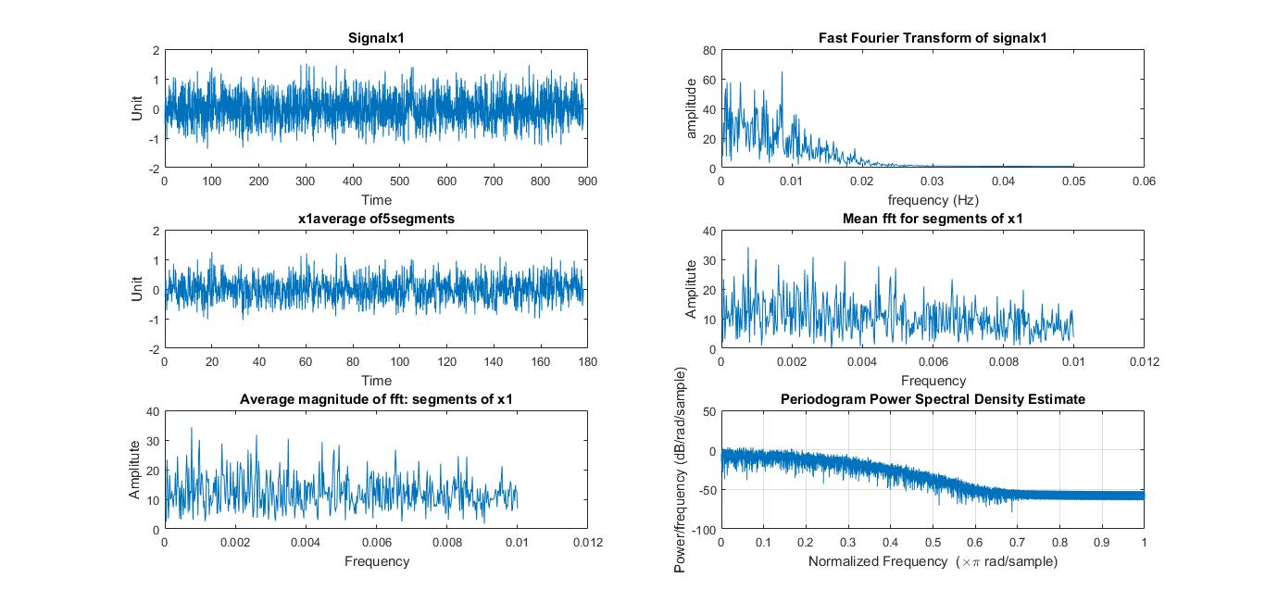

Figure 2A: Properties of signal x1.

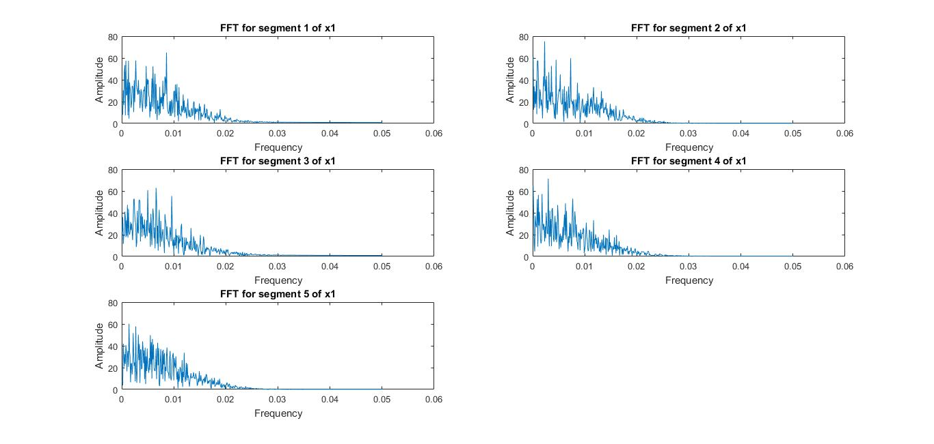

Figure 2B: FFT for every segment of x1. X1 was separated into 5 segments, each containing 1780 data points.

**Signal x2**

The signal x2 is deterministic. It seems to be a sum of 3 sinusoids (figure 3B and top-right of 3A) It is periodic (signal and mean of segments are the same): The first harmonic has a frequency of 0.0005 Hz (assuming the units are seconds) and the highest harmonic is 0.0044 Hz (see top-right corner of figure 3A).

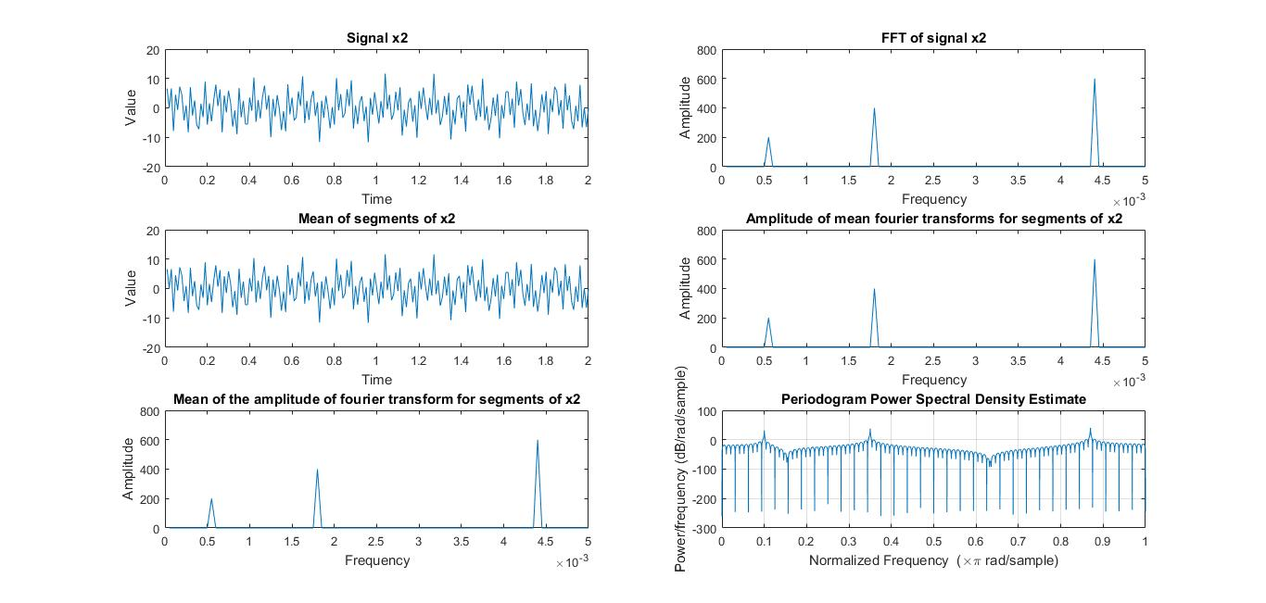

Figure 3A: Analysis of signal x2. For clarity purposes, only the first 2 seconds of x2 were represented in the top-left panel. The signal was separated into 40 segments of 2 seconds each.

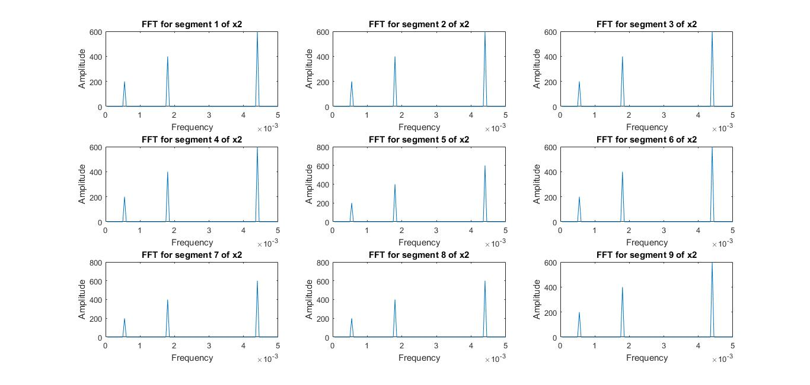

Figure 3B: FFT for segments of x2. X2 was separated into 40 segments of length 200; to demonstrate that the FFT of each segment is the same, only the 9 first FFT segments have been shown here.

**Signal x3**

The signal x3 is deterministic. It follows a clear pattern (figure 4B) and most of its frequencies have zero-amplitude (top-right of figure 4A). 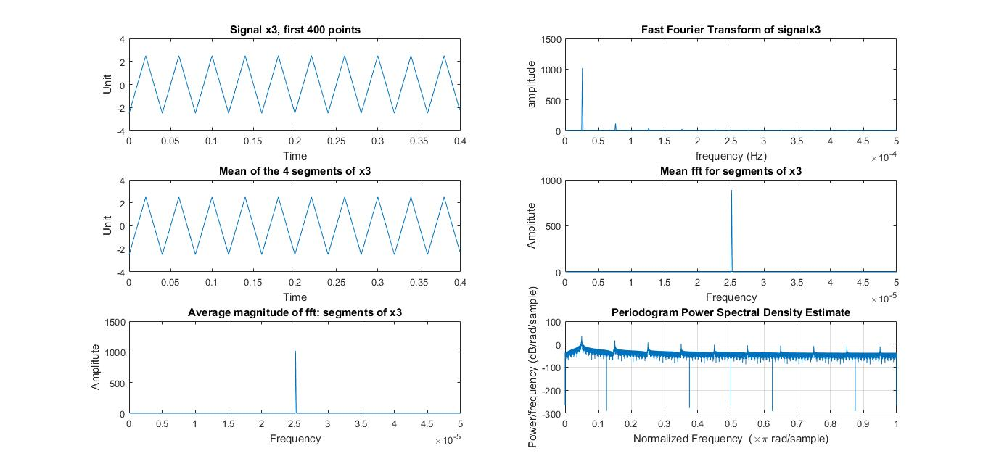

Figure 4A: Analysis of x3. For interpretability purposes, we only showed the first .4 seconds of the signal (top-left corner). The signal was separated into 4 segments of 0.4 seconds each (for interpretability reasons). Unfortunately, I couldn’t make the x-axis of the fft plots have the same range.

X3 is periodic, has a fundamental frequency of 2.6x10-5 Hz, and the fundamental frequency is the only one with a significant magnitude (see top-right corner of figure 4A).

**Signal x4**

The signal x4 is deterministic. The record length of x4 was not a multiple of its period (it had a record length of 1 sec and a period of 0.08 s). To make the signal’s record length a multiple of its period, we removed the last 0.2s of the data. X4 follows a clear pattern (figure 4A and 4B). X4 is periodic with a fundamental frequency of 5 x 10-6 Hz and the highest harmonic with a significant amplitude has a frequency of 3.3 x 10-5 Hz (see top-right corner of figure 4A). 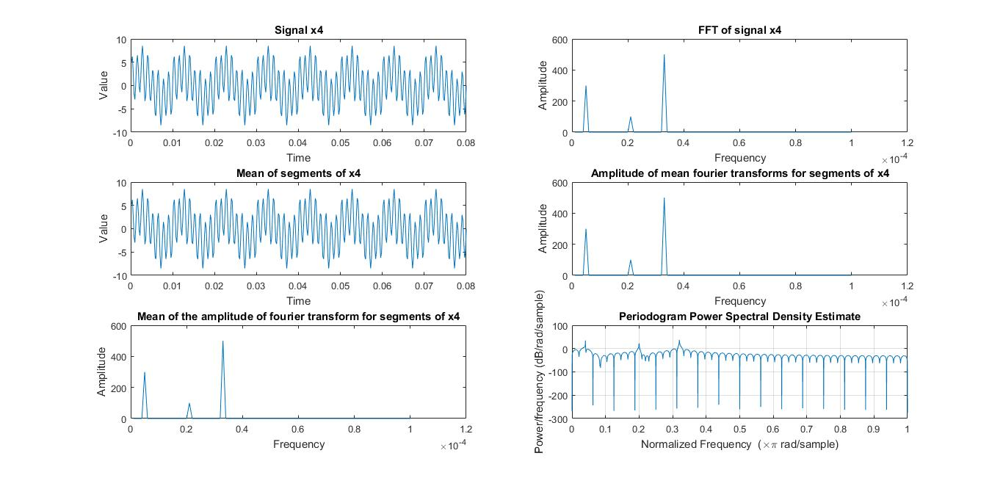

Figure 5A. Analysis of signal x4. For clarity purposes, only the first 0.08 s of the signal were shown. The segments were a subset of the signal; there were 9 segments of 0.08s each.

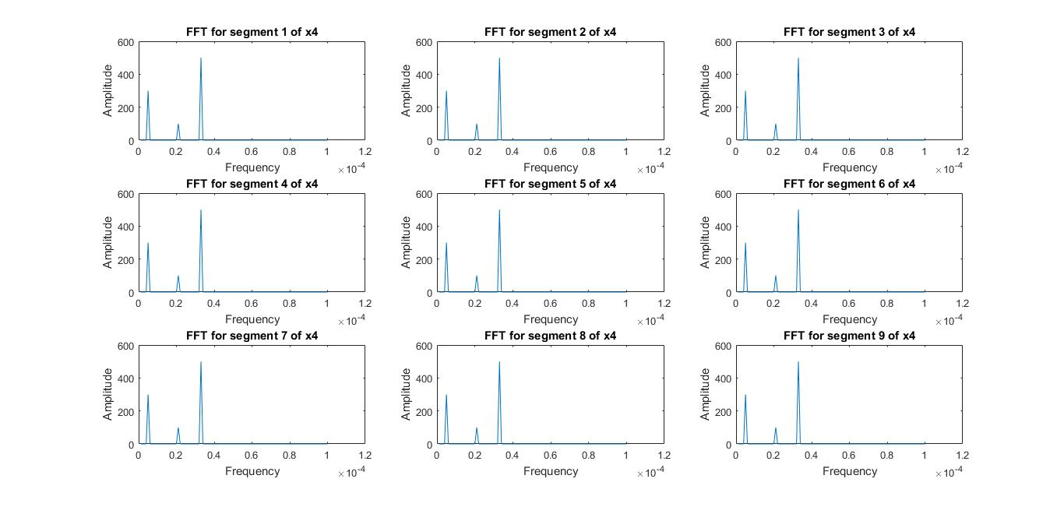

Figure 5B: 9 segments of signal x4. Each segment has a length of 0.08s.

**Signal x5**

Signal x5 is not deterministic. Its FFT has two peaks and the rest seems to be noise (see figure 6A). In other words, x5 seems to be composed of a combination of two sinusoids signals plus some noise (see figure 6A and 6B). The signal is not periodic. 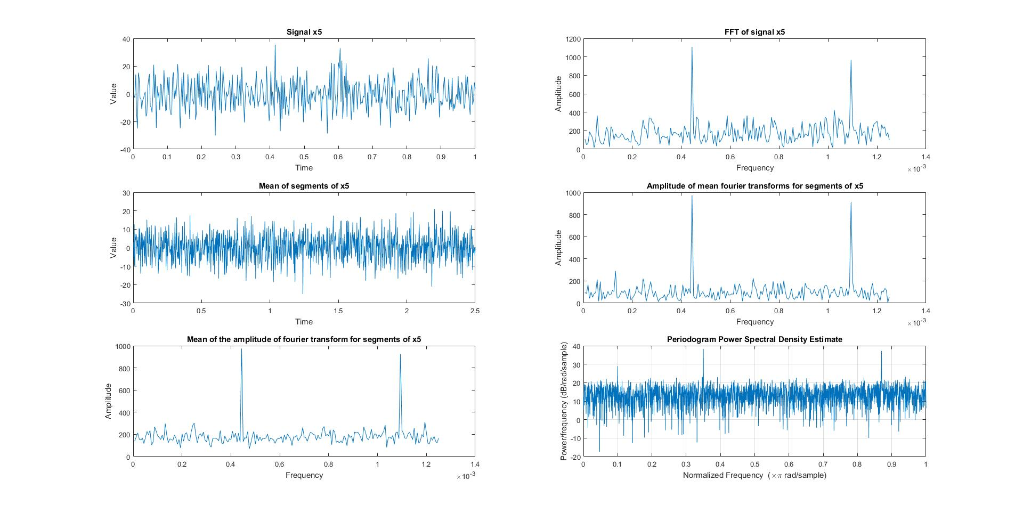

Figure 6A: Analysis of signal x5. There were 8 segments, each of a duration of 2.5s. 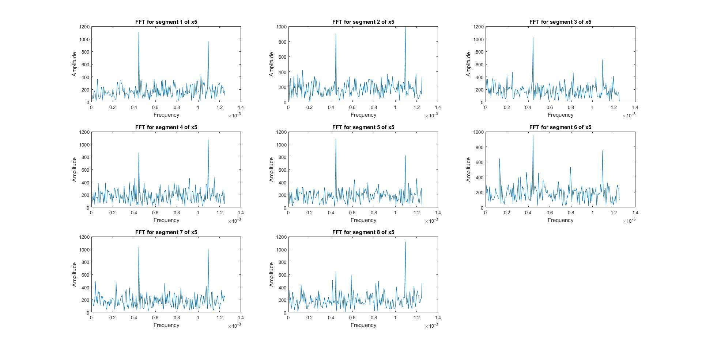Figure 6B: FFT of the segments of x5. There were 8 segments, each of a duration of 2.5s. As we can see, the two peaks can be detected in most segments but not all of them.

**Signal x6**

The signal is stochastic; the FFT shows that there is plenty of noise in the signal (figure 7A and 7B). The signal is not periodic. There seems to be some signal at 0.0001 Hz. However, it is hard to grasp because its period is longer than the record length. It is not periodic. 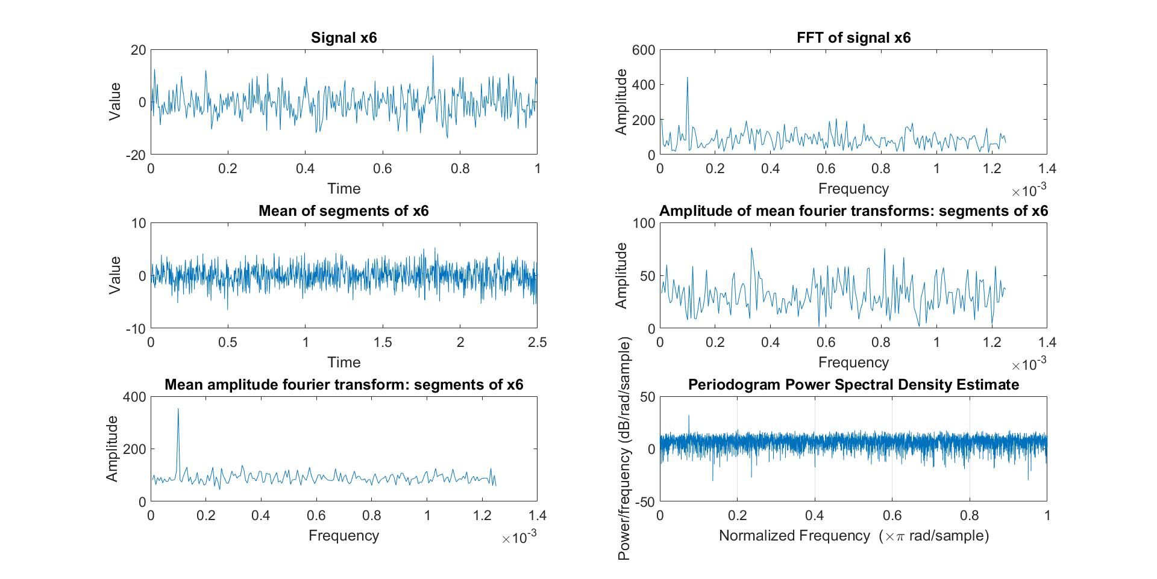

Figure 7A: Analysis of signal x6. The top-right and bottom-left corner suggest a signal that distinguishes itself from the noise at 0.0001 Hz. However, for unknown reasons, this signal did not emerge from the amplitude of mean Fourier transforms. A possible reason might be that the segment lengths were not a multiple of the fundamental frequency of the signal, as its fundamental frequency is longer than the record length itself.

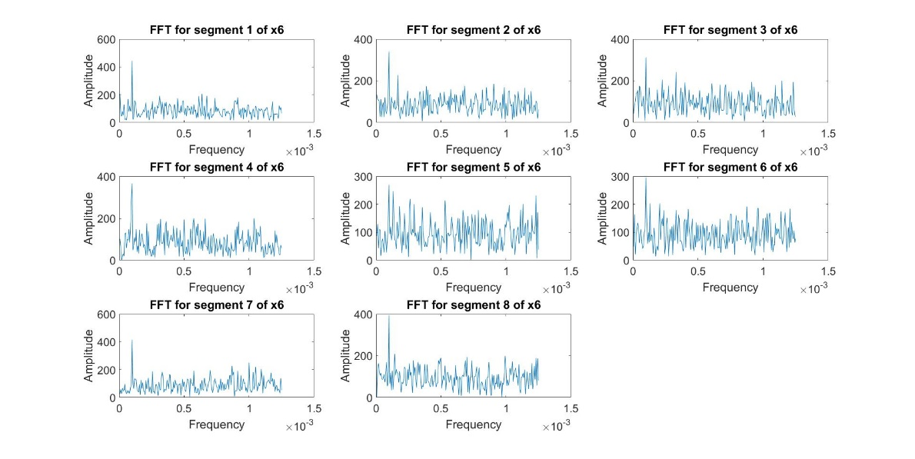

Figure 7B: FFT of 8 segments of length 2.5s from signal x6.

**Signal x7**

Signal 7 is stochastic, since it does not repeat itself within the record length. However, looking at the top-left panel of figure 8A suggests it might present itself as deterministic if we had a longer record length, as there does not seem to be ‘random noise’. Another possibility is that the frequency of the signal it random and follows a normal distribution (as suggested by the FFT and periodogram of figure 8A, as well as the FFT from 8B). It is not periodic.

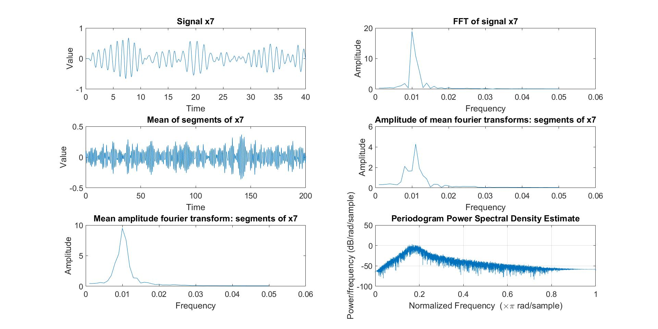

Figure 8A: Analysis of signal x7.

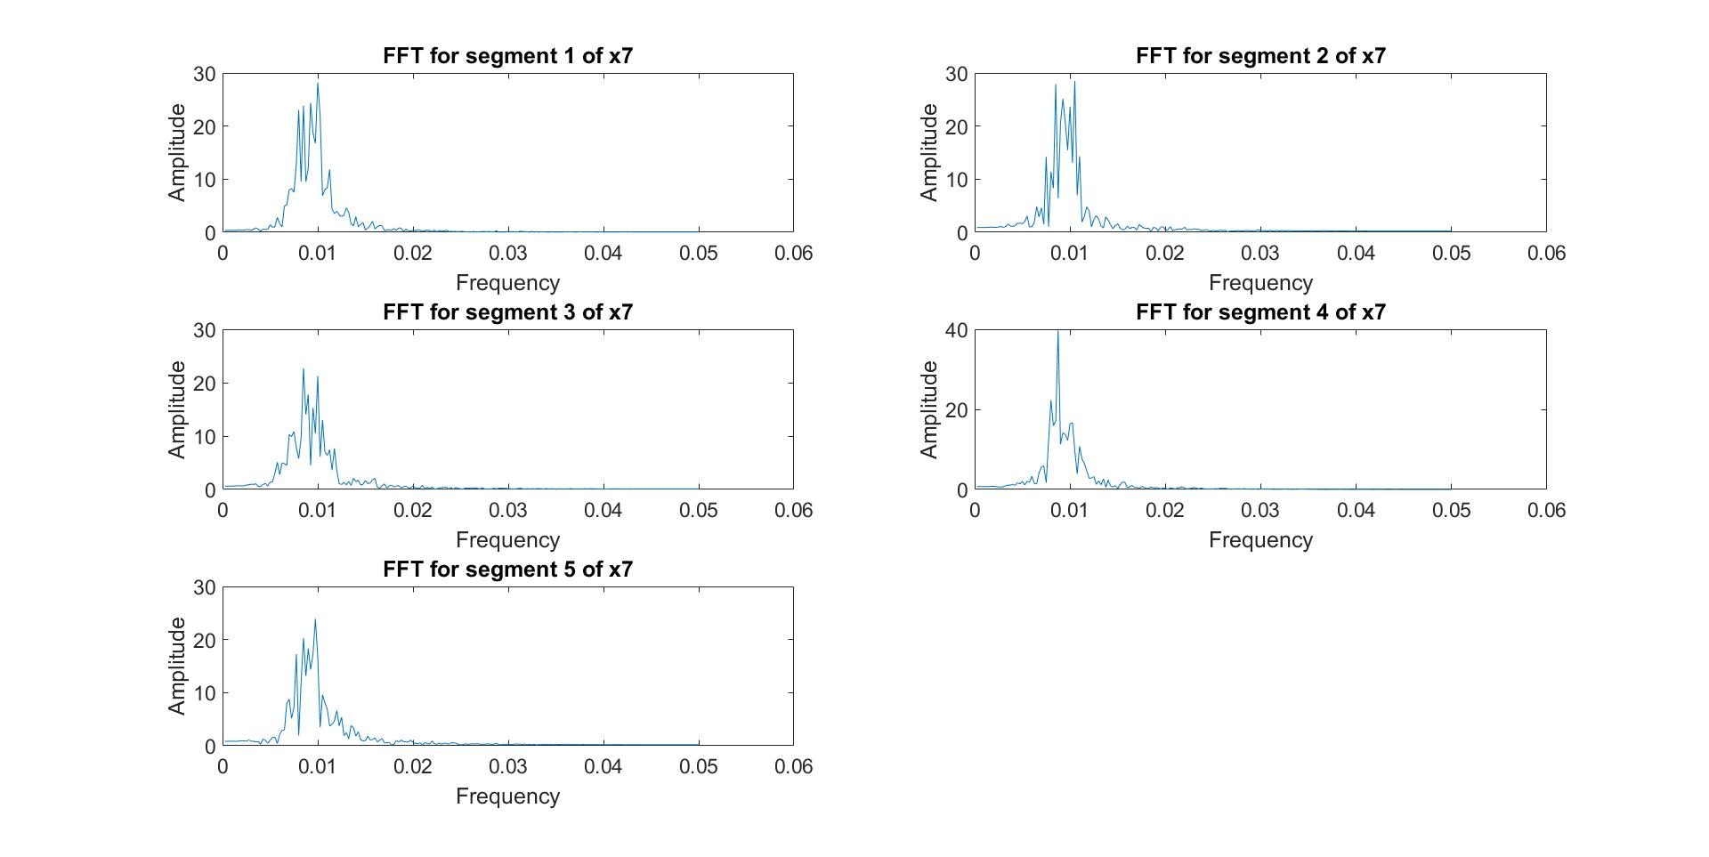

Figure 8B: FFT of 8 segments of signal x7, each with a length of 0.2s.

**Signal x8**

The signal x8 is stochastic. There is no clear peak in the FFT (top-right panel of figure 9A and 9B). The signal does not repeat itself: it is not periodic.

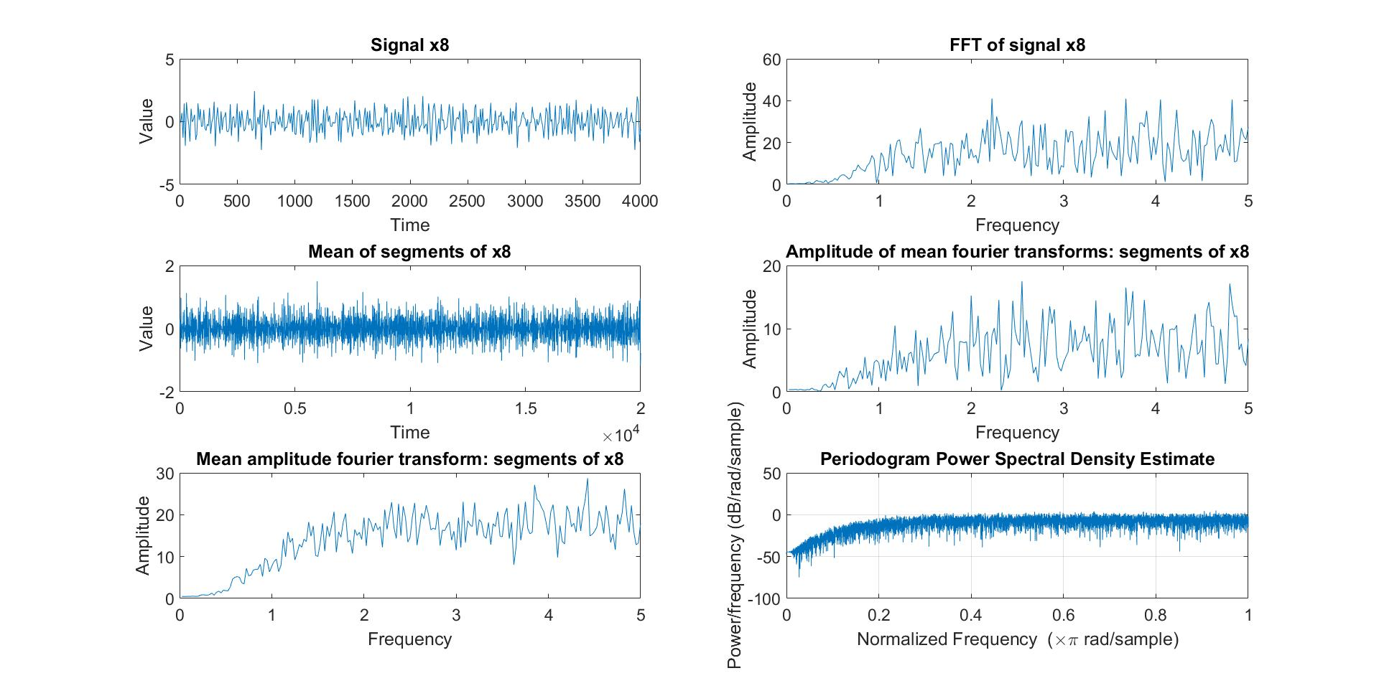

Figure 9A: Analysis of signal x8. The FFT shows no clear peak; the signal seems stochastic.

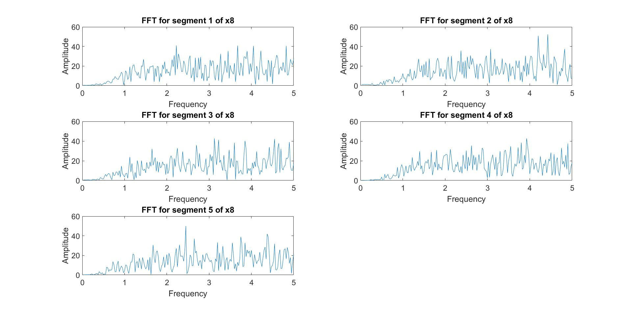

Figure 9B: FFT of signal x8 separated into 5 segments of 0.2s each. Similarly to the full FFT, each segment does not show any clear amplitude peak in its FFT.