**Assignment 4 part 1**

The components of a Fourier Series are orthogonal to each other, meaning that adding a new frequency to the signal is not going to change the estimates for the other frequencies. For this reason, I estimated the bode plot using a summation of multiple sinusoidal functions. This test signal was created adding 30000 sinusoid functions with frequencies generated randomly from a uniform distribution varying from 50 to 1600 Hz. The domain ranged from 0 to 1000 seconds in increments of 1s.

**Filter 1**

The estimated bode plot of filter 1 is shown in figure 2. This filter is band-pass; its passband includes frequencies between 15 Hz and 100 Hz, and the stopband are frequencies below 15 Hz and above 100 Hz.

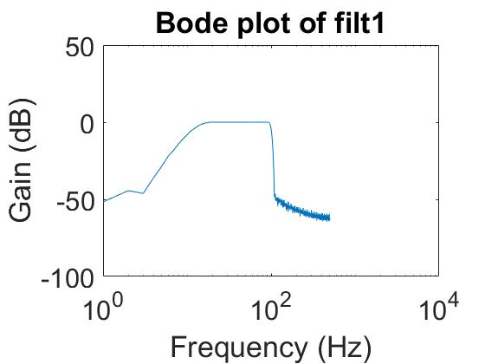

Figure 1: Bode plot of filter 1. The x-axis represents frequencies (in Hz) and the y-axis represents gain (in dB).

**Filter 2**

The estimated bode plot for filter 2 is shown in figure 2. Filter 2 is a band-stop filter; the stopband is between 15 Hz and 110 Hz. The passband includes frequencies below 15 Hz and frequencies above 110 Hz.

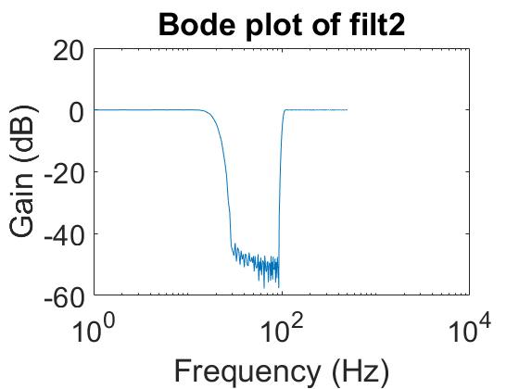

Figure 2: Bode plot of filter 2. The x-axis represents frequency (in Hz) and the y-axis the gain (in dB).

**Filter 3**

The estimated bode plot for filter 3 can be seen in figure 3. Filter 3 is a high-pass filter. Its passband includes frequencies above 15 Hz and its stopband is of frequencies below 15 Hz. 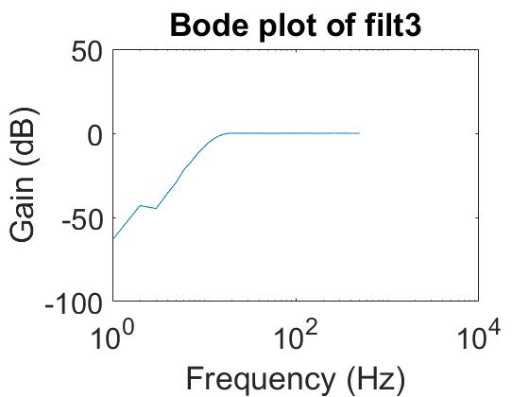

Figure 3: Bode plot of filter 3. The x-axis represents frequency (in Hz) and the y-axis the gain (in dB).

**Filter 4**

The estimated bode plot of filter 4 can be seen in figure 4. Filter 4 is a low-pass filter with a passband including frequencies below 200 Hz and a stopband with frequencies above 200 Hz.

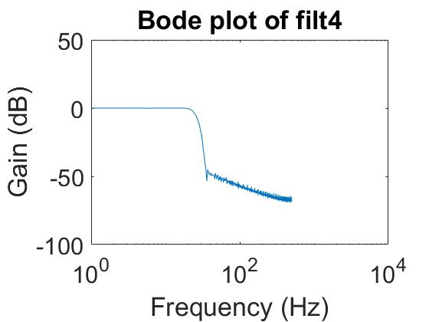

Figure 4: Bode plot of filter 4. The x-axis represents frequency (in Hz) and the y-axis the gain (in dB).

**Filter 5**

The estimated bode plot of filter 5 can be seen in figure 5. Filter 5 is a band-pass filter with a passband of frequencies approximately between 50 Hz and 55 Hz. It’s stopband filter is of frequencies below 50 Hz and above 55 Hz.

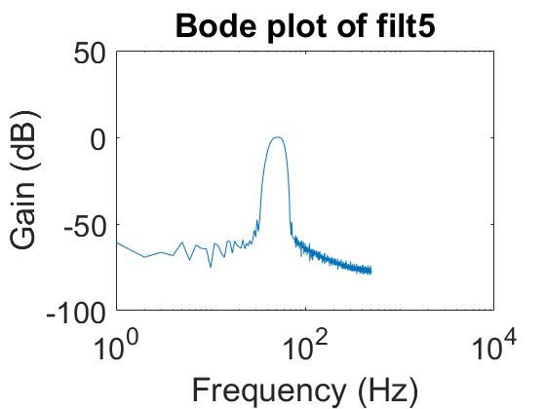

Figure 5: Bode plot of filter 5. The x-axis represents frequency (in Hz) and the y-axis the gain (in dB).

**Assignment 4 part 2**

Figures 6 to 10 represent the filtered and unfiltered versions of both the raw signal and its FFT. The unfiltered signals are on the top-left panel, the filtered signals are on the top-right panel, with the unfiltered FFT on the bottom-left panel and the filtered FFT on the bottom-right panel of the figures.

**Signal x1**

Signal x1 and its filtered version can be seen in figure 6. The periodic component of the signal is at 50.2 Hz. The stochastic components of the signal have frequencies between 0 and 500 Hz. However, there might be stochastic signals with frequencies higher than 500 Hz that we cannot detect, due to the limited duration length of the recorded signal. The signal has been filtered using filter 5, since it has a small passband (between 50 and 55 Hz) that includes 50.2 Hz. 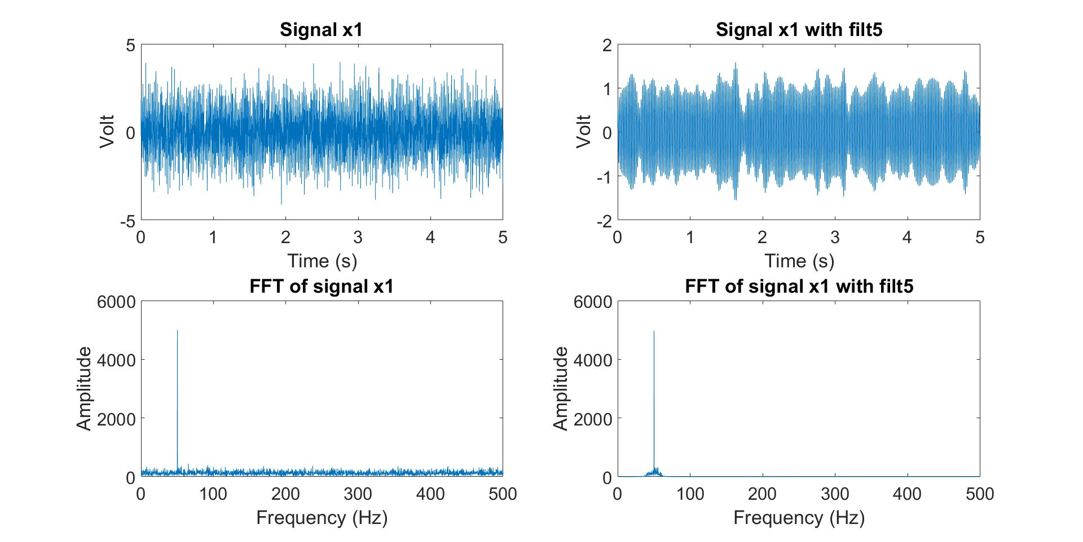

Figure 6: Analysis and filtering of signal x1.

**Signal x2**

Signal x2 and its filtered version can be seen in figure 7. The periodic component of the signal is at 5.2 Hz. The stochastic components of the signal have frequencies between 0 and 500 Hz. However, it might be possible that there are stochastic signals with frequencies higher than 500 Hz that we cannot detect, due to the limited duration length of the recorded signal. The signal has been filtered using filter 4, since filter 5 has the shortest passband that includes 5.2 Hz.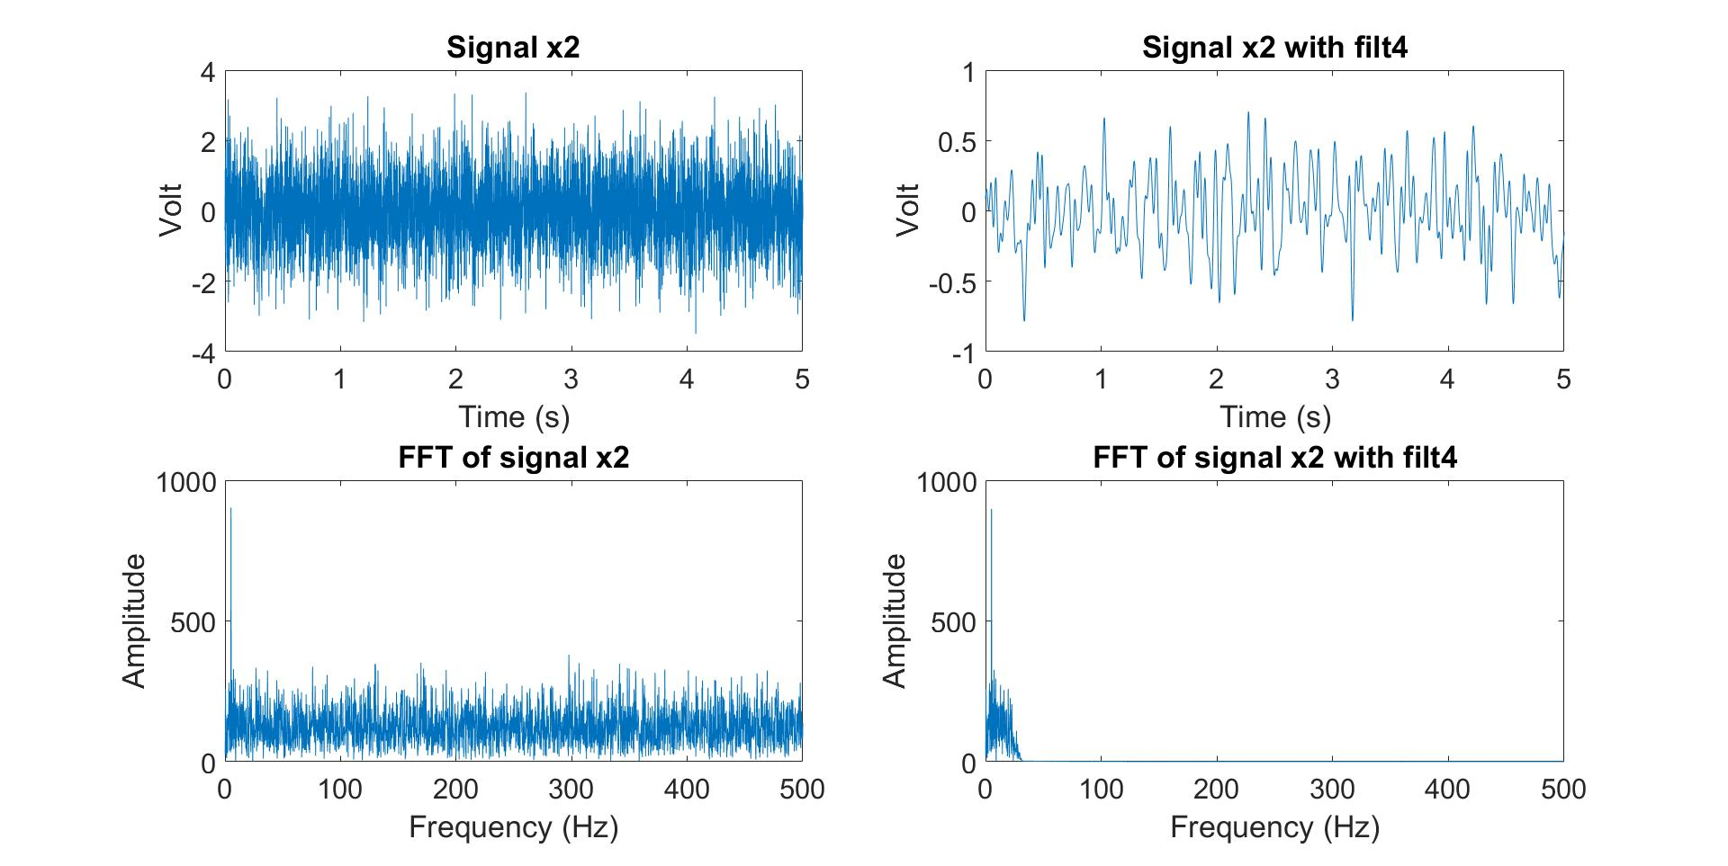Figure 7: Analysis and filtering of signal x2.

**Signal x3**

Signal x3 and its filtered version can be seen in figure 8. The periodic component of the signal is at 25.2 Hz. The stochastic components of the signal have frequencies between 0 and 500 Hz. However, it might be possible that there are stochastic signals with frequencies higher than 500 Hz that we cannot detect, due to the limited duration length of the recorded signal. The signal has been filtered using filter 1, since filter 1 is the only one that removes a considerable part of the stochastic components of the signal while keeping the periodic component of the signal intact.

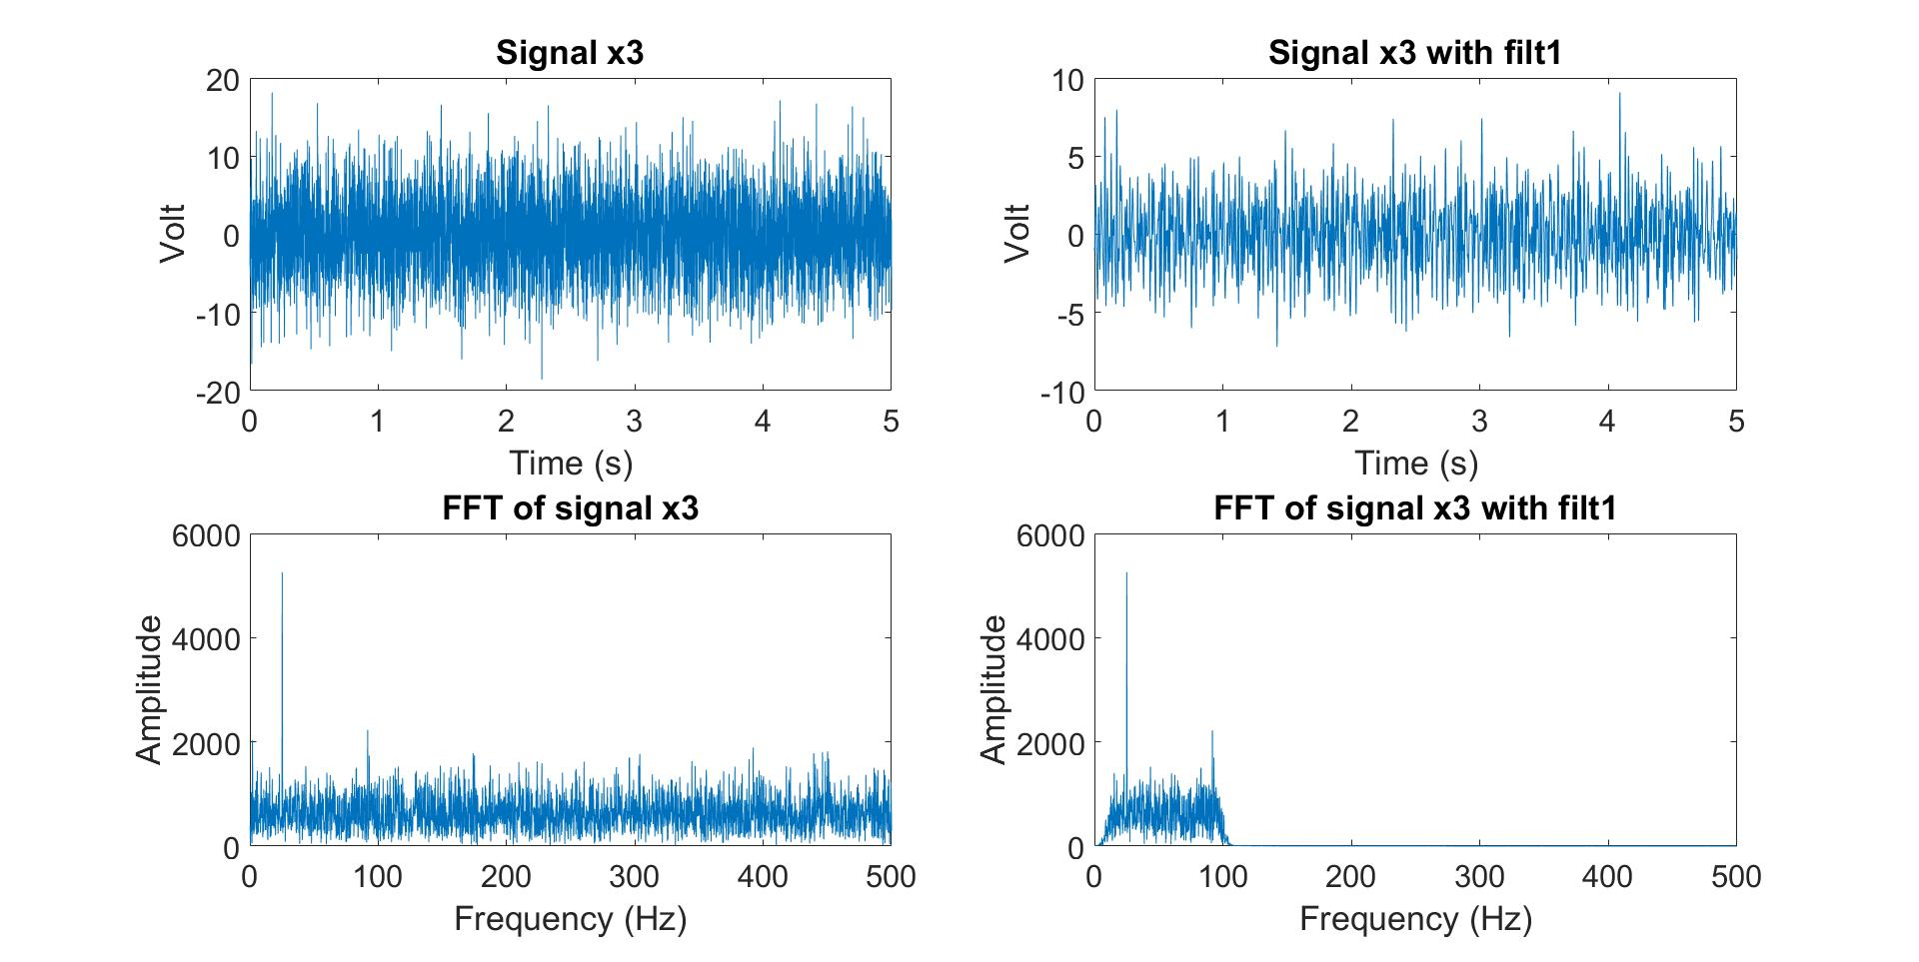

Figure 8: Analysis and filtering of signal x3.

**Signal x4**

Signal x4 and its filtered version can be seen in figure 9. The periodic component of the signal is at 15.2 Hz and 125.2 Hz. The stochastic components of the signal have frequencies between approximately 7.4 Hz and 160 Hz. The signal has been filtered using filter 2, since the stopband is within the two periodic frequencies of the signal; hence, it is the filter that removes most of the stochastic components of the signal while keeping the periodic components of the signal intact.

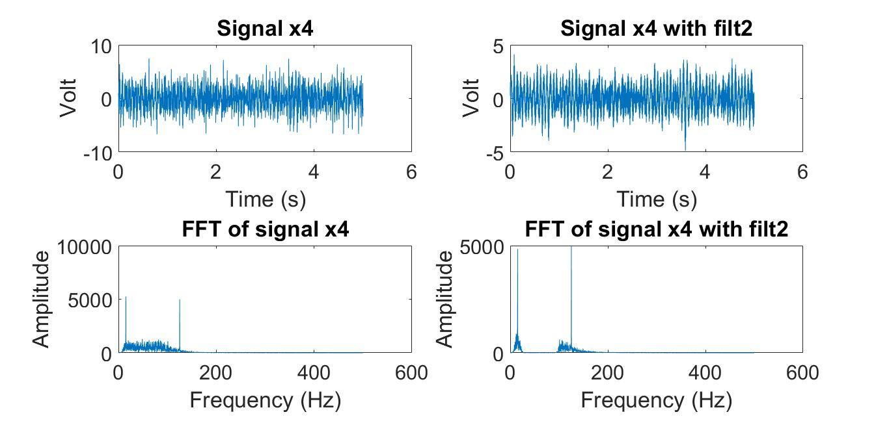

Figure 9: Analysis and filtering of signal x4.

**Signal x5**

Signal x5 and its filtered version can be seen in figure 10. The periodic components of the signal are at 20.2 Hz, 40.2 Hz and 60.2 Hz. The stochastic components of the signal have frequencies between 0 and 500 Hz. However, it might be possible that there are stochastic signals with frequencies higher than 500 Hz that we cannot detect, due to the limited duration length of the recorded signal. The signal has been filtered using filter 1, since it is the filter that removes most of the stochastic components of the signal while keeping the periodic component of the signal intact. It removes the noise with frequencies higher than approximately 100 Hz.

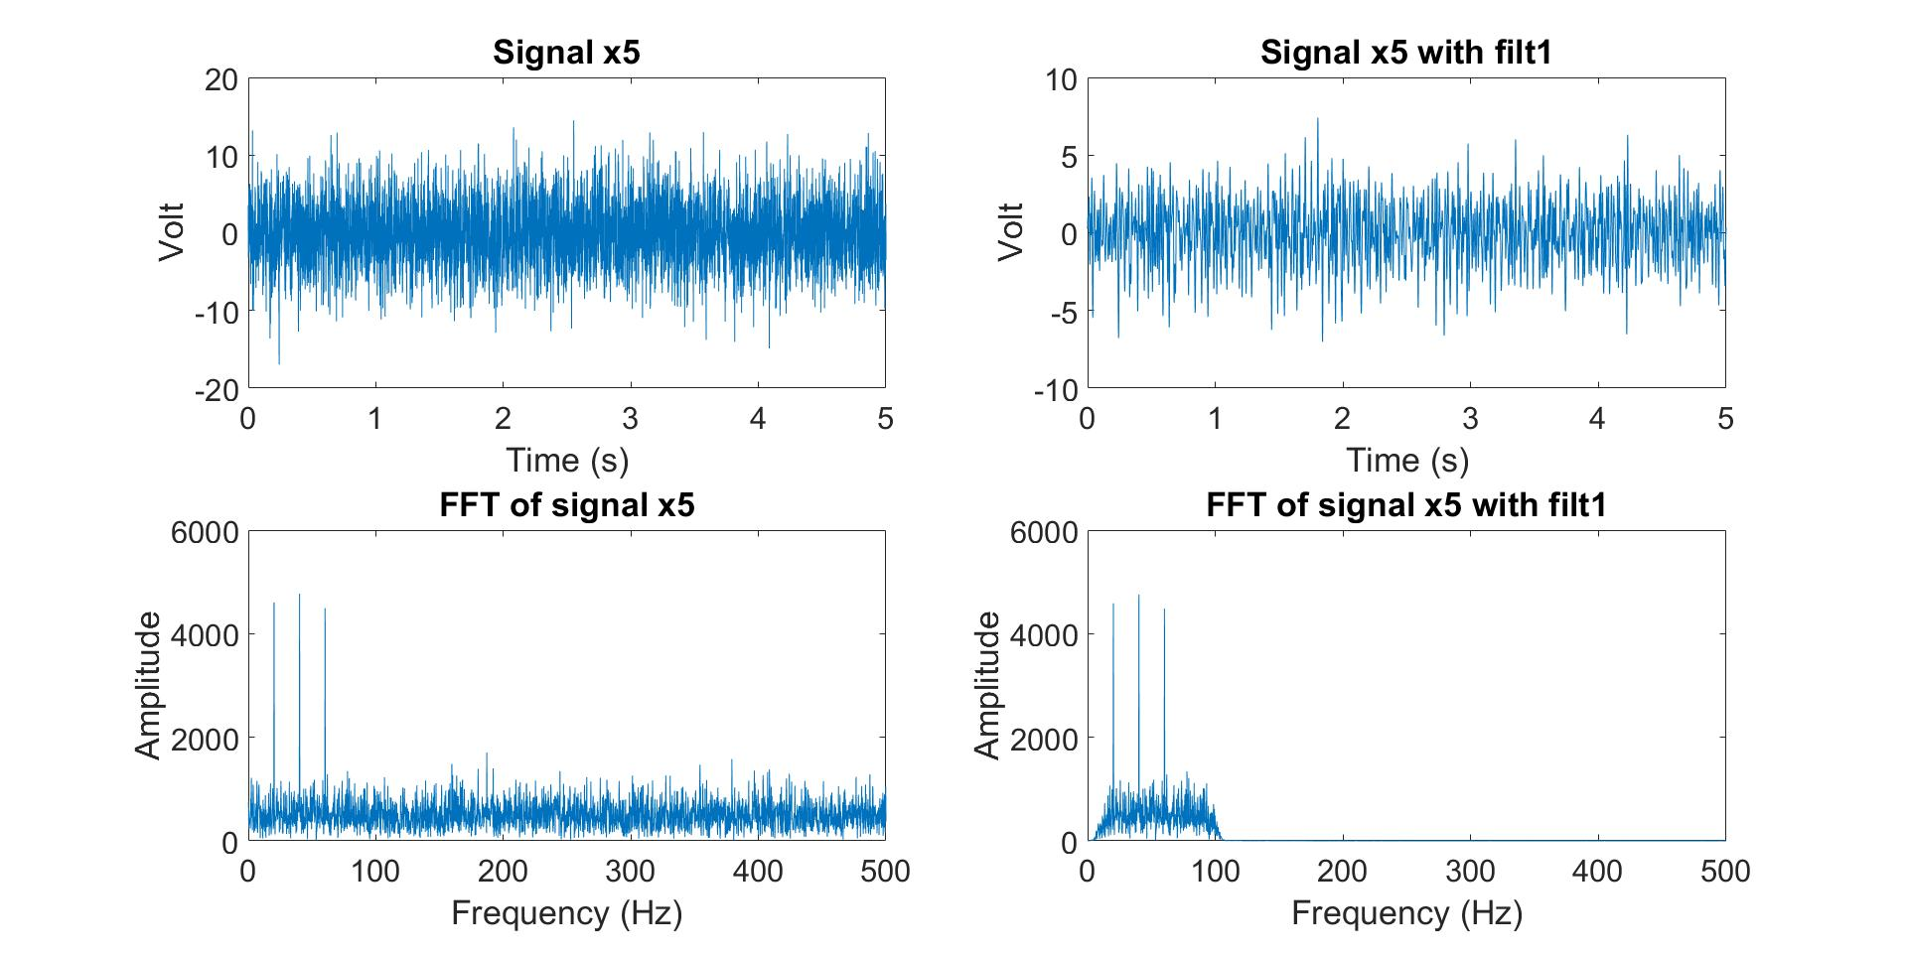

Figure 10: Analysis and filtering of signal x5.

**Assignment #4 part 3**

Yes, using Fourier transform techniques would allow better filtering than the analog filters we have at our disposal here. To demonstrate an example, we filtered x1 by removing every frequency from the Fourier Transform that was not at 50.2 Hz (the periodic component of the signal). The results of this filtering are shown in figure 11 and can be compared to figure 6.

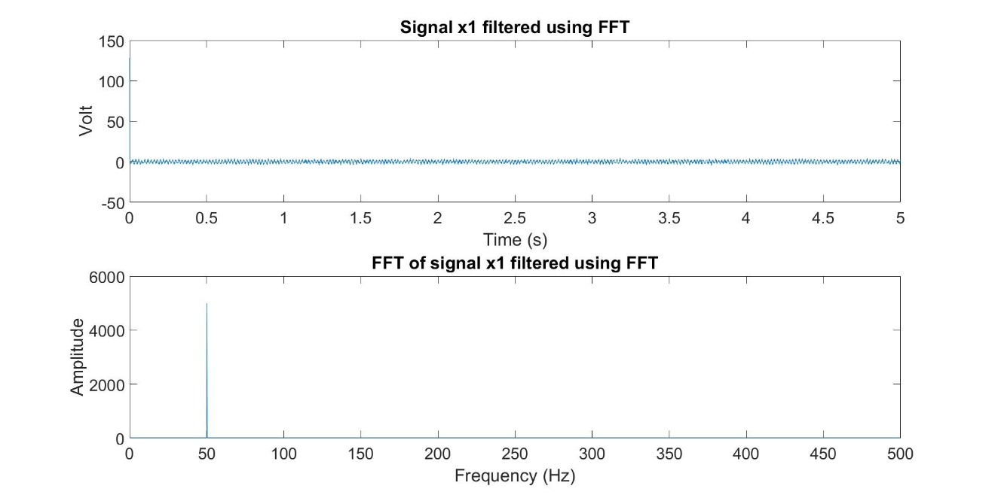

Figure 11: Filtering of signal x1 using a Fourier Transform technique. I am aware the top panel of this figure should have been ‘zoomed in’ and is very unclear as it is.