**Introduction**

Decision-making has for a long time been studied in isolation from memory processes. This is partially because we initially tried to understand how choices are made with full knowledge of the options at hand. In such paradigms, participants were told explicitly what choices they have and what they involve (e.g. receive 5$ or have a 50% chance to receive 10$). The information does not come from long-term memory; however, in our daily lives, we often must choose without being told exactly what the outcomes and probabilities of each options are. What we prefer to eat, which products we decide to buy or even whether we take the metro or the bus to get to work today are all decisions that rely, at least partially, on what we remember from taking these decisions previously. It eventually became clear that these decisions learned from trial-and-error are quite different from decisions learned from description (Kahneman & Tversky, 1979). Since then, a lot of efforts have been spent in trying to understand how people choose using their previous experiences as a guide (). However, memory is far from being a perfect recollection of what happens () and the mechanisms behind decision-making might very well rely on the way memory functions.

For a long time, episodic memory has been thought to be a form of declarative memory specific to the moment and place it was acquired (Tulving, 1983, 2002). For example, remembering a sequence of events last time you went to your favorite restaurant is a form of an episodic memory. Episodic memory is now seen as one of the major neurocognitive memory systems (Tulving, 2002), mainly compromised of the hippocampus and its related structures (Milner & Klein, 2015). It has been distinguished from semantic memory (Tulving 1972; 1985), which is another aspect of declarative memory not necessarily attached to any specific event and concerned with remembering more general information about the world. For example, you can probably recall the address or location of your favorite restaurant without necessarily remembering where and when you learned such information.

The episodic specificity induction is an experimental procedure where participants are briefly trained in recollecting details of recent experiences (Madore et al., 2016; Madore, Jing & Schacter, 2016; Madore & Schacter, 2016; Jing, Madore & Schacter, 2016; Madore, Gaesser & Schacter, 2014; Madore & Schacter, 2014; Madore, Addis & Schacter, 2015; Schacter & Madore, 2016). The episodic specificity induction contributed in supporting the Constructive Episodic Simulation Hypothesis: the idea that episodic memory does not only play a crucial role in reconstructing one’s own past experiences, but also in imagining potential future events (Schacter and Addis, 2007). The episodic specificity induction has been shown to not only increase the amount of recalled internal (episodic) details on the Autobiographical Interview, but not the amount of external (semantic) details recalled and imagined (Madore, Gaesser & Schacter, 2014). More important, the effect of the episodic specificity induction generalized to the amount of details generated in imagining the future, therefore suggesting that recalling the past and imagining the future both rely on episodic memory (Madore, Gaesser & Schacter, 2014). The episodic specificity induction has also been shown to improve performance on various cognitive tasks, such as divergent thinking (Madore et al., 2015) and the ability to solve hypothetical social problems (Madore and Schacter, 2014).

What we choose depends on what we think will happen; it hence seems plausible that episodic memory plays a role in decision-making. There are also several other reasons to think that episodic memory is involved in making decisions from experience. Murty, FeldmanHall, Hunter, Phelps and Davachi (2016) found that participants had to remember previously learned associations between lotteries and experienced rewards to choose lotteries adaptively. Wimmer and Shohamy (2012) have shown rewards associated with certain items to spread to other similar but previously unrewarded items, such that participants started choosing rewards that previously had never been rewarded. Duncan & Shohamy (2016) found that showing familiar scenes induced episodic memory use and made participants more likely to remember and chose high-valued objects they had encountered before. Madan, Ludvig & Spetch (2014) have more specifically investigated the role of memory in learning decisions from experience. They hypothesized an extreme-outcome rule where extreme outcomes in risky choice are remembered with more salience (Talarico & Rubin, 2003) and hence are given more weight when choosing from experience. Since people value losses more than wins, heavy loses should be better remembered than heavy wins, making people more risk-seeking for wins than for loses. This theory is supported by recent findings which have found people to be more risk-seeking for wins than for loses in decisions from experience (Ludvig, Madan & Spetch, 2014). To test their hypothesis, they designed a task where participants choose from experience between two options. Participants learn from experience to choose between a moderate gain and a 50% chance to give double the amount and a 50% chance to give nothing. They also had to learn to choose between a moderate loss or a 50% chance to lose double or nothing. At the end of the experiment they asked participants what was the first outcome that came to their mind for each option. Consistent with the extreme-outcome rule, people who remembered the high reward from the gain choice with risk were more risk-seeking in positive choices, and people who remembered the heavy loss from the risky loss choice were less risk-seeking in loss choices. This effect did not generalize to choices from decision (Madan, Ludvig & Spetch, 2016), suggesting that memory for extreme-outcome specifically influences risk-seeking in decisions learned from experience and not for the ones learned from description.

The current study aimed to experimentally evaluate the role of episodic memory in decision-making. To do so, we used the episodic specificity induction of Madore and Schacter (2014) to increase episodic memory, followed by the decisions from experience paradigm developed by Ludvig, Madan and Spetch (2014).

**Current experiment**

**Notes:**

1. **Put more citations in saying that ESI comes from CI**
2. **Explain that the control induction is there to control for the fact just talking about videos might have an effect**
3. **Relate their hypothesis to the fact the ESI might have an impact on decision-making**
4. **Put task in the scanner in stating what ESI does**
5. **I should actually explain in depth what the Constructive episodic memory theory is, since it is in line with why episodic memory would influence decision-making.**

**Methods**

In Experiment 1, participants were either briefly trained in recollecting details of a video or had to describe general information about the same videos. (Jing, Madore, & Schacter, 2016; Madore, Szpunar, Addis, & Schacter, 2016; Madore, Addis & Schacter, 2015; Madore et Schacter, 2014). Experiment 2 served as a control study, in which participants performed the gambling task without any prior video or induction.

*Experiment 1*

Experiment 1 was conducted as a within-subject design, with every participant undergoing both the general and episodic specificity induction procedures. Participants performed the episodic or general interview and then performed the gambling task. Due to apparent carryover effects between across the two sessions, below we report only the results from the first session of the experiment.

*Participants*

We analyzed the data of 43 participants who were recruited through McGill’s classified ads system. This study was approved by McGill’s Research Ethics Office (REB). We randomly assigned 21 participants to the Episodic condition, and 24 participants to the General condition. 25 participants were randomly assigned to the first-win condition, and 20 participants to the second-win condition. Participants were compensated $10 CAD for one hour, and received an average of $1.25 CAD, (*SD*= 0.069) for each of the two sessions. We administered the Positive and Negative Affect Schedule (PANAS; Watson et al., 1988) both at the beginning of the experimental session and at the end, and the Offer Self-Image Questionnaire (OSIQ; Patton & Noller, 1991) at the end of the experimental session. Three other participants were excluded from the analysis for choosing the risky option less than 15% of the time.

*Episodic specificity induction*

The experimental procedure began with an episodic specificity or control (“general impressions”) induction (Madore et al., 2016; Madore, Jing & Schacter, 2016; Madore & Schacter, 2016; Jing, Madore & Schacter, 2016; Madore, Gaesser & Schacter, 2014; Madore & Schacter, 2014; Madore, Addis & Schacter, 2015; Schacter & Madore, 2016). The goal of the episodic specificity induction is to provide brief training in recollecting details of recent experiences. The episodic specificity induction is an experimental manipulation that has been inspired by the Cognitive interview, which has been shown to enhance the number of accurate details eyewitnesses can recall about events (Memon, Meissner, & Fraser, 2010). The participants first watched a 4-minutes long videos of “Mr. Bean” and were told to pay close attention to it since questions would be asked afterward. These videos were previously shown to be effective for the episodic specificity induction (results not published).

At the end of the video, participants were interviewed and asked different questions depending on the memory condition (Episodic or Control), following past work (Jing, Madore, & Schacter, 2016; Madore, Szpunar, Addis, & Schacter, 2016; Madore, Addis & Schacter, 2015; Madore et Schacter, 2014). In the Episodic condition, participants were first asked to describe as many specific details as they could remember about the surroundings. They were then asked to do the same about the physical appearances of the participants in the scene. Finally, they were asked to describe the actions in the video in chronological and in as much detail as they could remember. In the Control (i.e., “General Impressions”) condition, participants were instructed to use adjectives to describe the setting/people/actions as well as general questions about the video to broad questions about the video. The role of the control induction is to control for any effect that would be due to the procedure independently from the training in recollecting details of recent events.

*Gambling task*

Immediately after the induction procedure, participants performed a gambling task based upon the gains task of Madan et al. (2014) and Ludvig et al. (2015). On each of 100 trials, participants chose between two doors which both yielded real-monetary rewards. One of the doors was safe and always yielded a reward of 1.25 cents, while the other door was designated as the “risky” door and had a 50% chance to give 2.5 cents and a 50% chance to yield nothing. After choosing a door, participants were shown the reward they received from that door. Participants were not told beforehand the possible outcomes associated with each door; they had to learn the task from their own experience. Participants performed 100 trials of the gambling task per session.

Previous studies using similar gambling tasks reveal that initial outcomes carry a disproportionately large influence on further decisions (Shteingart et al., 2013). In this experiment, each participant received an equal amount of good and bad outcomes when choosing the gamble for the first four times. Accordingly, we controlled the first four outcomes participants obtained when choosing the risky door: They received one of the following patterns: win-loss-win-loss (the “first-win” condition) or loss-win-loss-win (the “first-loss” condition). The first outcome manipulation allowed us to systematically evaluate the impact of the very first outcome on risk preferences while controlling for the overall probability of wins and losses in the first four trials.

*Memory Recall*

Immediately after the choice task, we assessed participants by asking them what was the first outcome that came to their mind when thinking about the risky door, following the procedure from Madan et al. (2014). Participants were shown each of the two doors, in random order, and asked what was the first outcome that occurred to their mind when seeing them. This allowed to see whether the experimental manipulations influence participants’ memories of the outcomes they received in the task, and if the memory of the outcomes guided behavior. Immediately following the recall task, participants were instructed to draw the two doors to the best they could remember with a paper and pencil and label the colors. These drawings were scored on a scale from 0 to 12. One point was assigned per side, color, frame, window, knob and background of each door that was drawn correctly. Points of 0.5 were assigned if the drawing of an aspect was relevant but only partially accurate. The rater was blind to the condition of the participant.

*Data Analysis*

To compare risk preferences across conditions, we computed the mean level of risk from trial 40 onward for each participant. Excluding early trials allowed us to compare decisions that were made after having sufficient prior experience with the task. Risk preferences across groups were compared by conducting ANOVAs upon proportions of risky choices. Learning effects were tested using mixed-effects logistic regressions with random intercepts and slopes for each participant. This was done using the lme4 package (Pinheiro & Bates, 2000) for the R programming language.

*Reinforcement Learning (RL) Model*

Following basic formulations of RL models (Gershman, 2015; Sutton & Barto, 1998), this model operates by developing and updating expected reward values for each option, *aj,* on each trial, *t.* these *Q-values* aredenoted here and elsewhere as *Q(aj, t)*. The Q-values for each option (in the present task there are two options) are used to determine the model’s probability for selecting each option via a softmax decision rule:

Here  is an exploitation parameter that determines the degree to which the option with the highest Q-value is chosen. As  approaches infinity the highest valued option is chosen more often, and as  approaches 0 all options are chosen equally often.

On each trial the option that is chosen ($a_{i}$) is updated for the next trial (*t*+1) based on a simple incremental updating rule:

$$δ_{t}= r\left(t\right)- Q\left(a_{i}, t\right)$$

$$Q\left(a_{i}, t+1\right)= \left\{\begin{aligned}Q\left(a_{i}, t\right)+ α_{pos}{∙δ}_{t} , δ_{t }> 0 \\ Q\left(a_{i}, t\right)+ α_{neg}{∙δ}_{t} , δ_{t }< 0 \end{aligned}\right.$$

In Equation 2 above $α_{pos}$  and $α_{neg}$ are learning rate parameters for positive and negative prediction errors, and *r*(*t*) is the reward received from the chosen option on trial *t*. As these learning rate parameters approach 1, greater weight is given to the most recent rewards in updating Q-values indicative of more active updating of Q-values on each trial, and as the learning rate parameters approach 0, recent rewards are given less weight.

Our model fitting procedure used the Nelder-Mead optimization algorithm to find parameter values that maximized the likelihood of participants’ choices given their previous rewards and choices. To avoid estimates at parameter range boundaries, we imposed a ‘pseudo-prior’ over parameters, which for the learning rates, took the form of a beta distribution with *a* = *b* = 2, and for the inverse temperature parameter ( )*,*a gamma distribution with *k*=1 and *θ*=3.

*Experiment 2*

Experiment 2 was comprised of a single “control” condition in which 23 participants completed the gambling task without any prior induction or video. Participants were paid $8 CAD for approximately 20 minutes of their time, plus a bonus averaging $1.242 CAD (*SD* = 0.076). One participant was excluded from the analysis for choosing the risky option less than 15% of the time. The gambling task and memory recall procedure was identical to that of Experiment 1 except that they were performed in the absence of an episodic or general impressions induction. The same data analysis and modeling procedure from Experiment 2 was used.

**Results**

*Experiment 1*

*Choice Task Behavior*

We first sought to determine if apparent risk preferences differed across memory conditions and the first outcome. Upon examining the mean level of risky choices for each participant (Figure 2A), we found a a significant main effect of memory condition on risk-taking (p = 0.0149), but no significant main effect of first risky outcomes on apparent risk-taking behavior (p-value = 0.566, R2 = 0.0047), and no interaction between memory condition and first risky outcome condition (p-value = 0.784, R2 = 0.007). We performed post-hoc t-tests in order to assess which memory conditions were significantly different from each other. Risk-taking in the episodic condition (*M* = 0.485, *SD*=0.179) was significantly higher than in the general condition (M = 0.311, SD = 0.198; p = 0.004, R2 = 0.181). Risk-taking in the episodic condition was not significantly different than in the control condition (mean = 0.443, sd = 0.216; p-value = 0.4956, R2 = 0.011). Risk-taking in the general condition was significantly lower than in the control condition (p-value = 0.03544, R2 = 0.097).

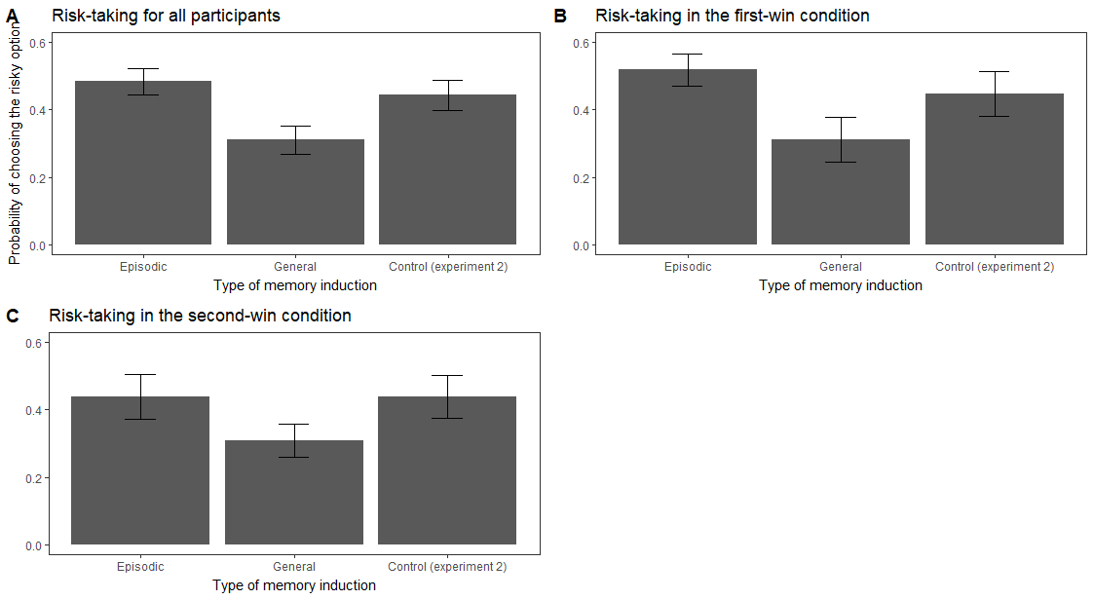

Figure 2: Proportion of risky choices for the three induction conditions (Episodic, General impressions and Control) from trial 40 to 100. Figure 2A represents the data aggregated across the first-win and second-win conditions. Figures 2B and 2C show the proportion of risky choices in the first-win and second-win conditions, respectively.

Examining choice behavior across blocks, we found that risk-taking in the episodic specificity condition tended to increase over time while it tended to decrease in the general condition (Figure 2B). A mixed-effects logistics regression revealed that participants in the episodic condition became significantly more risk-taking over time than participants in the general condition (condition X block interaction *p*= 0.0117). Thus, the two groups exhibited apparent differences in their timecourses of apparent risk preference. However, slopes in the episodic condition were not significantly different than in the control condition (p-value = 0.744). Slopes in the general condition were also not significantly different than in the control condition (p-value = 0.117). We found no significant main effect of first risky choice outcome (first-win versus second-win) on the slopes of choice over time (p-value = 0.611).

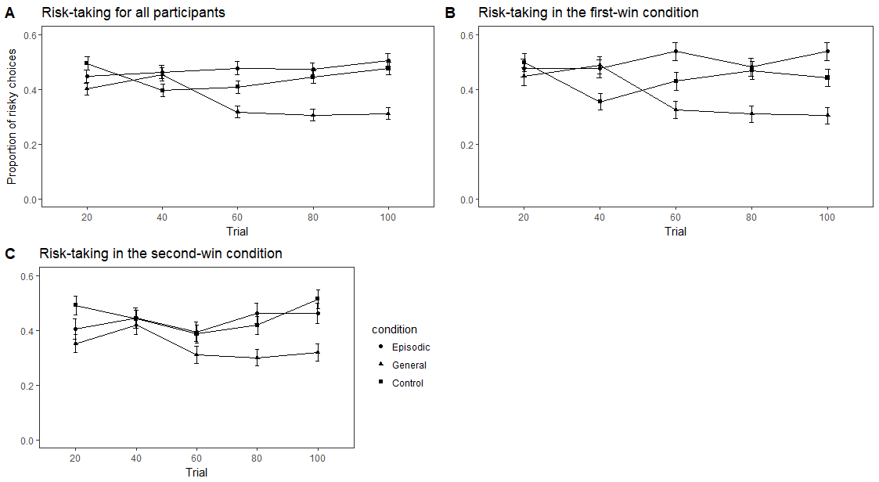

Figure 3: Changes in risky preferences over time in the three conditions (Episodic, General impressions and Control). Figure 3A represents the data aggregated across the first-win and second-win conditions. Figures 3B and 3C show the proportion of risky choices in the first-win and second-win conditions, respectively.

*Effects of Episodic Specificity Manipulation on RL Model Parameters*

The best-fitting RL model parameter estimates are reported in Table 1. Considering the entire sample, we found a significant main effect of PE valence (positive versus negative PEs) such that negative PE learning rates were significantly larger than positive PE learning rates (mixed-effects regression *β* = -0.15, *SE=*0.05, *p* = 0.026). Indeed, this observation corroborates previous observations of a ‘negativity bias’—a tendency to weigh negative PEs more strongly than positive PEs— in RL updating in similar tasks (Christakou et al., 2013; Gershman, 2015; Niv, Edlund, Dayan, & O’Doherty, 2012).

However, examining the Episodic and General conditions separately, we found that positive and negative PE learning rates were less asymmetric in the Episodic Specificity condition (Figure 5). In other words, participants who underwent the Episodic specificity induction appeared to weigh positive and negative more equally than participants who underwent the General (control) induction, who exhibited the typical negativity bias in learning rates (condition × PE type interaction *β* = .16, *SE=*0.06, *p* = 0.017).

../../../Downloads/pe_lr_v3.pdf

Figure 4: Best-fitting learning rate parameters for positive prediction errors and negative prediction errors, by condition. Error bars depict standard error of the mean.